CM2003 LAB4 REPORT

Benjamin Darçot, Siyuan Chen

TASK0

We use two different methods to achieve the 2D UNet model with the details can be seen in the code.

TASK1 a

We defined two functions with the name of ‘get_mask’ and ‘get_data’ to read the data as the requirement in the instruction. Below is the loss figure and the accuracy figure.

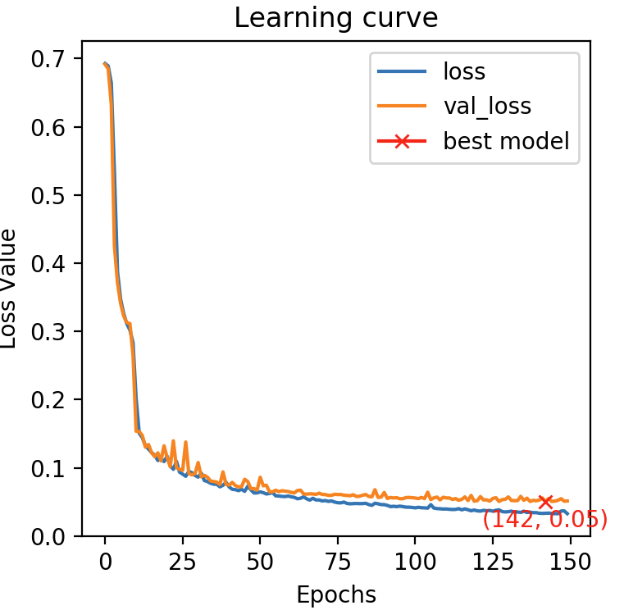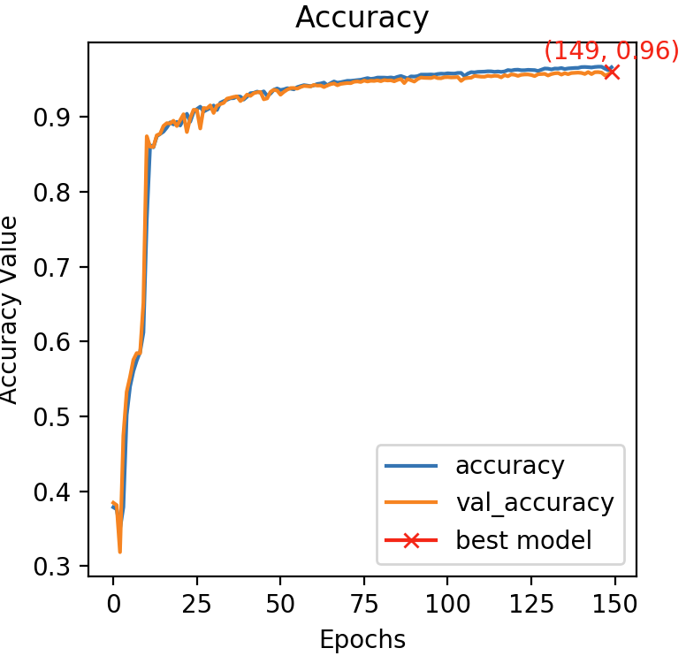

TASK1 b

The results with the ‘Dice loss’ function.

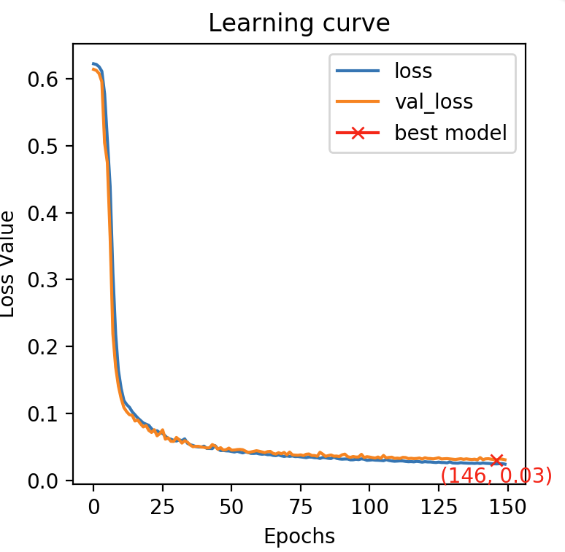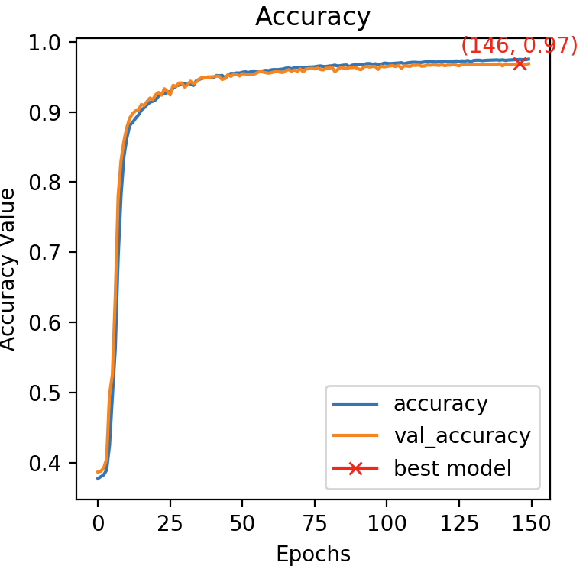

There is not much difference between the results with these two loss functions. With the ‘Dica_loss’, the accuracy is a bit higher (0.97vs 0.96). For the binary classification problem, we expect to observe the similar results because the developed UNET model has good performance on the image segmentation.

Dice_loss is better in the cases that the size of the target to be segmented would be much smaller than the image because it will give more weights for the smaller targets so that to make the training process easier and softer.

TASK1 c

With drop out below is the result with BCE loss function

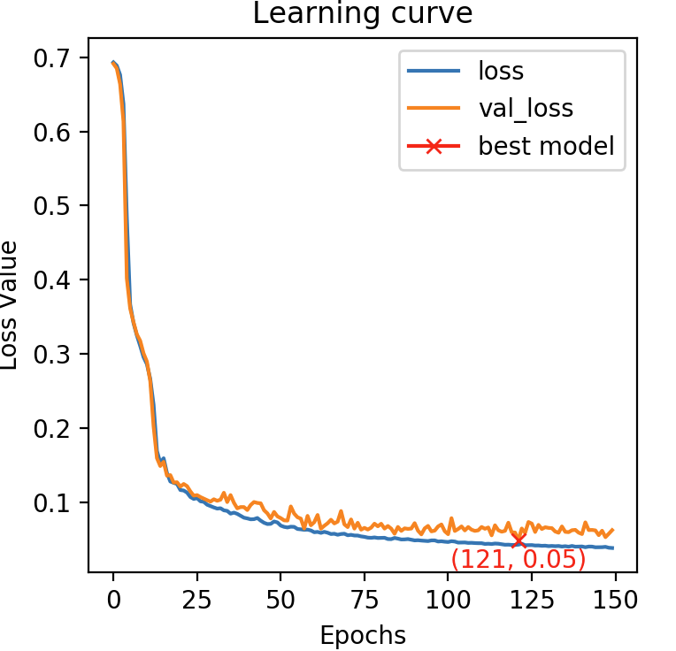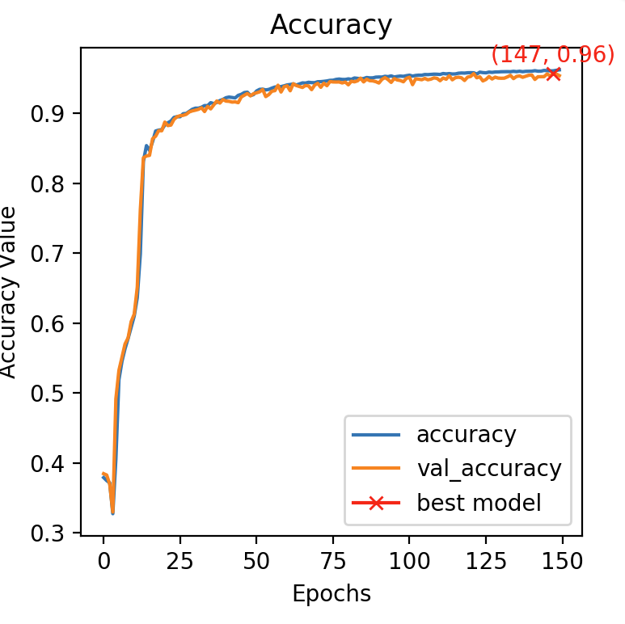

Below are the results with dice loss

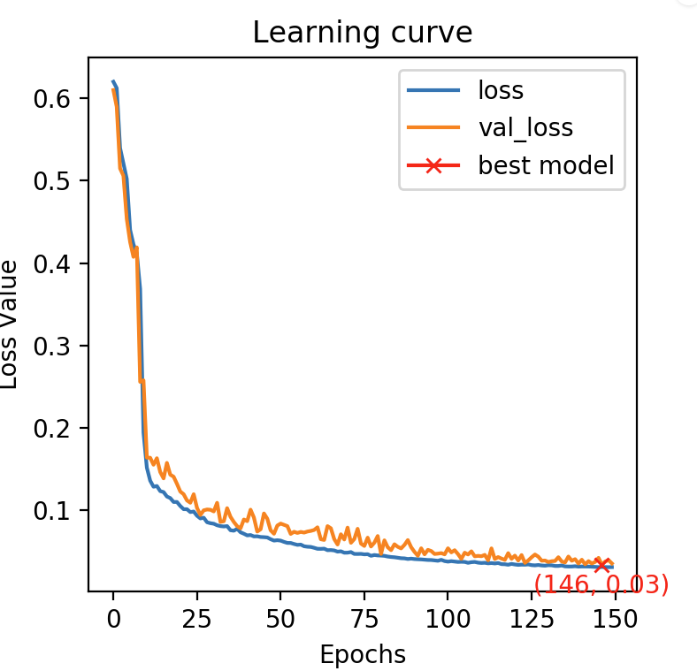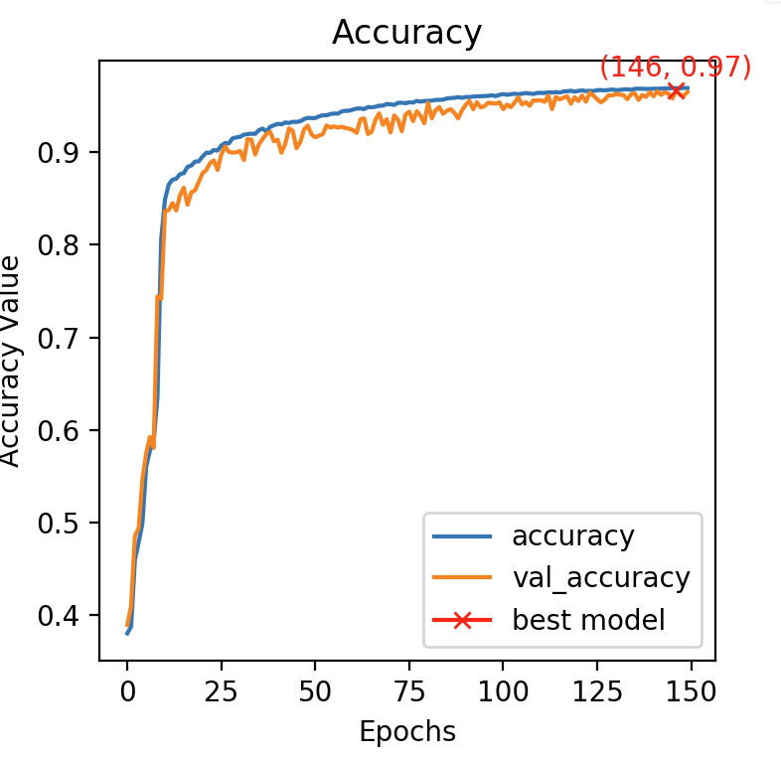

It doesn’t affect the model performance.

TASK1 d

The results with BCE loss function

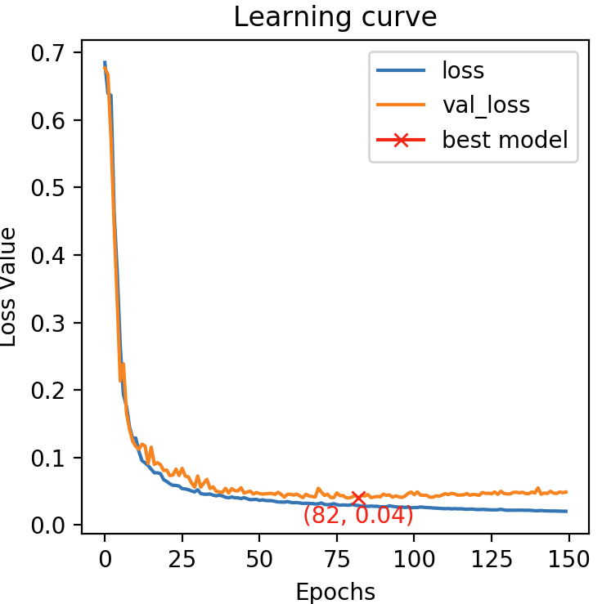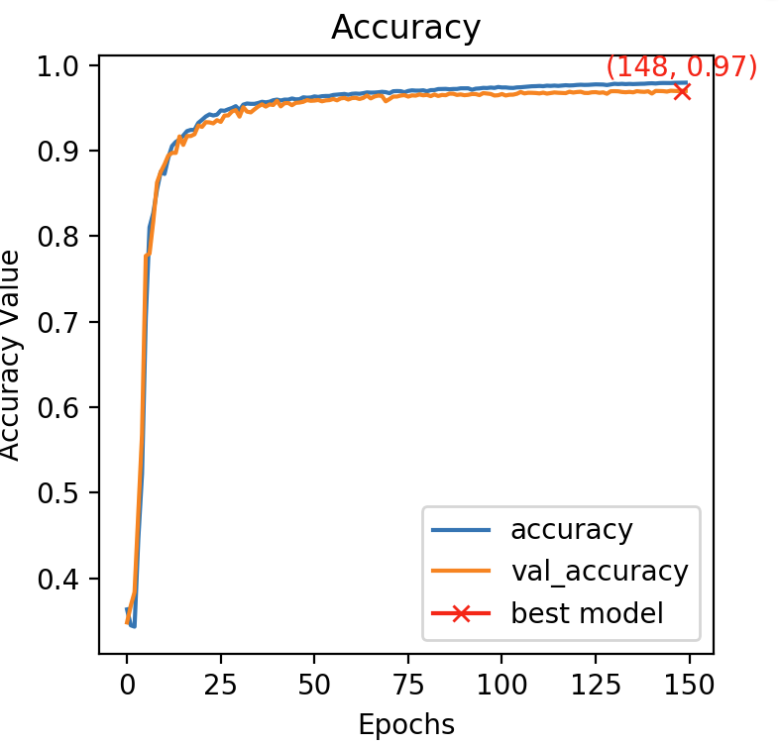

The results with DCL loss function

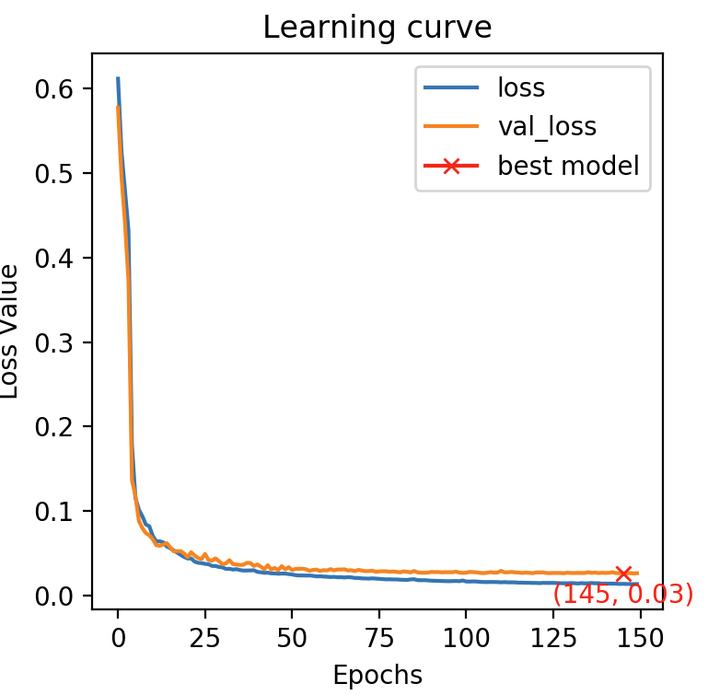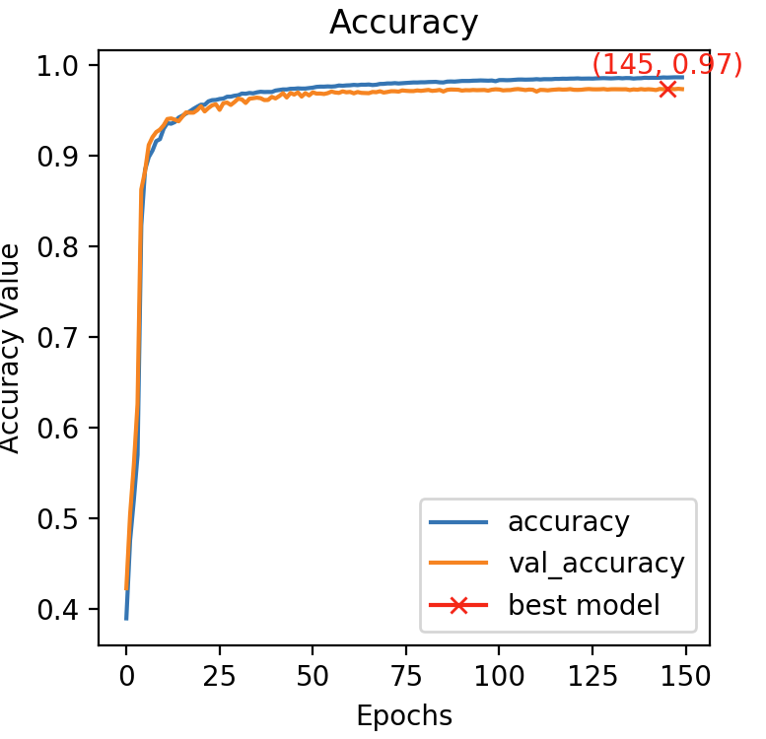

The results are similar.

TASK1e

Results with BCE

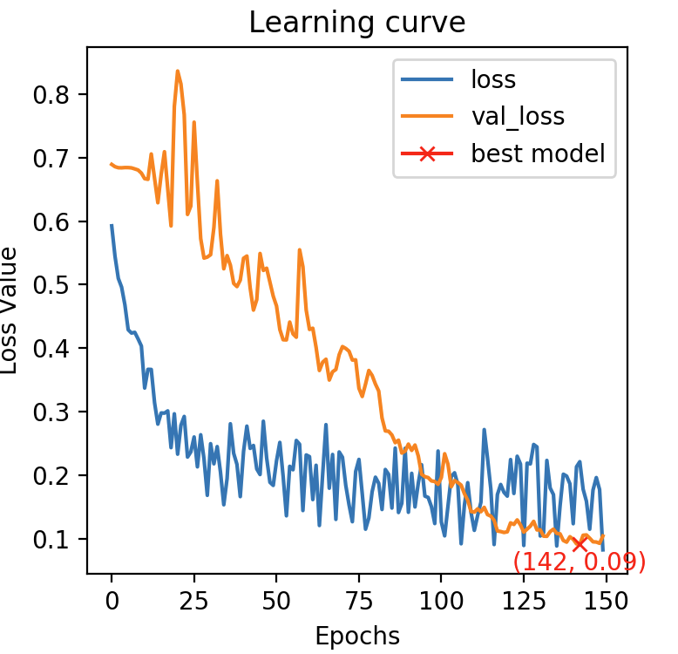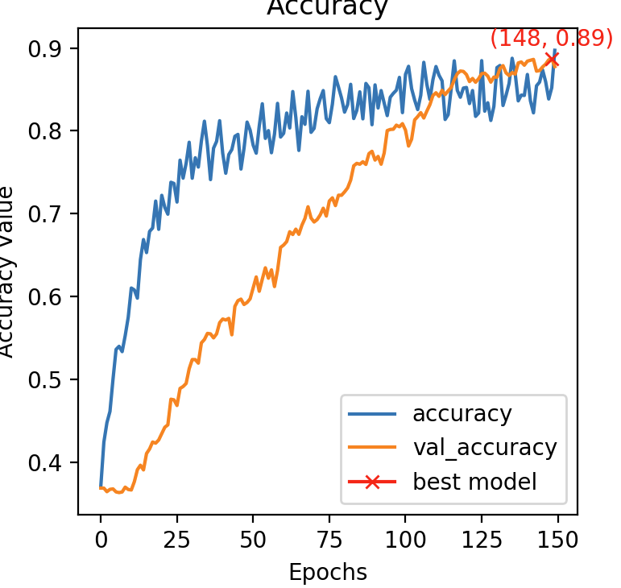

Results with DCL

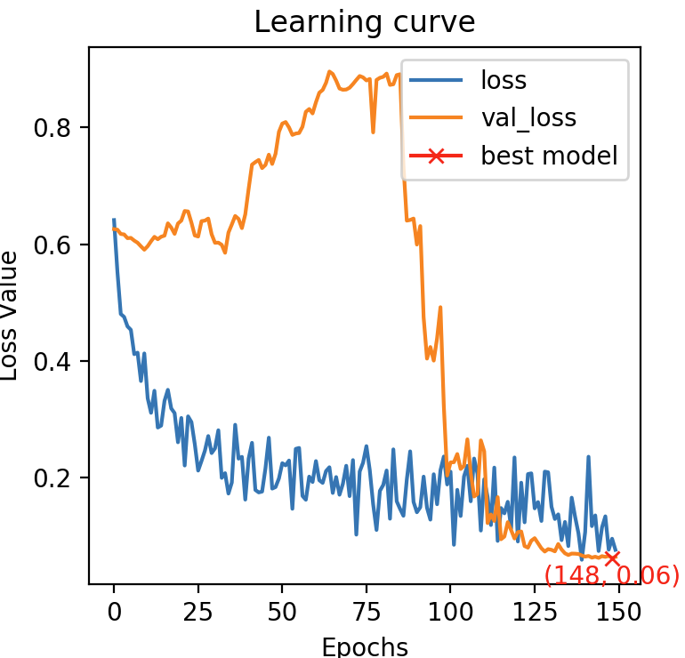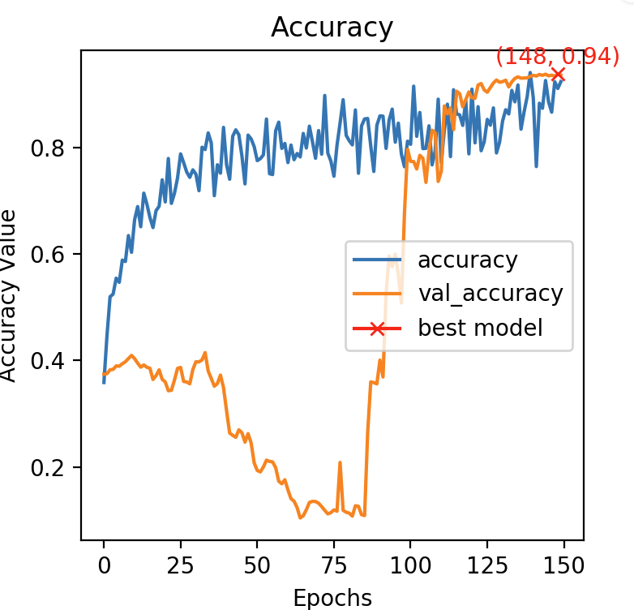

It didn’t improve the generalization power of the model.

TASK2a

We read the data and trained our model. Below are our results.

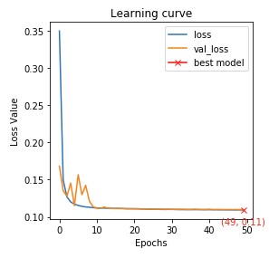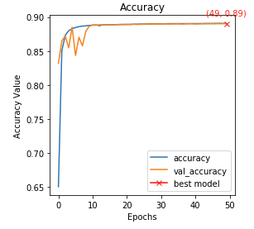

TASK2b

With dice_loss

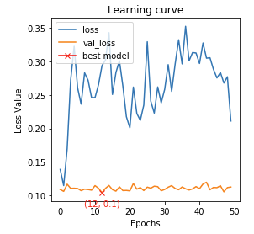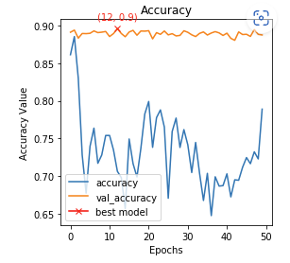

With precision and recall accuracy value

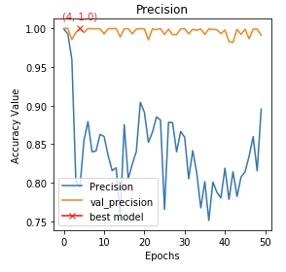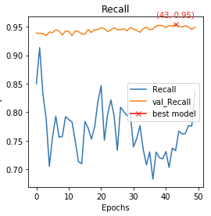

We can evaluate the model quality. With the higher precision and higher recall, our model is better.

TASK3

To achieve the target of multi-classification problem, we change the number of neurons and the activation function in the last layer. Use 3 neurons to represents the background, left lung and right lung. Using softmax as the activation function for multi classification problem.

Below are the results.

