

**TRIBHUVAN UNIVERSITY**

**FACULTY OF HUMANITIES AND SOCIAL SCIENCE**

**A Project Proposal**

**On**

**“Online Tech Shopping”**

**“InovaTech”**

**Submitted to**

**Department of Computer Application**

**Whitefield Int’l College**

In partial fulfillment of the requirements for Bachelor Degree in Computer Application

**Submitted By:**

**Name: Ayush Maharjan**

**Reg no:6-2-497-4-2020**

**Name: Sijan Mahato**

**Reg no:6-2-497-15-2020**



**TRIBHUVAN UNIVERSITY**

**FACULTY OF HUMANITIES AND SOCIAL SCIENCE**

# SUPERVISOR’S RECOMMENDATION

I hereby recommend that this project prepared under my supervision by Sijan Mahato and Ayush Maharjan entitled “Online Tech Shopping Website” in partial fulfillment of the requirements for the degree of Bachelor of Computer Application is recommended for the final evaluation.

…………………………

Signature

Sabita Koirala

Humanities and social science

Whitefield Int’l College

Nayabazar, Kathmandu



**Tribhuvan University**

**Faculty of Humanities and Social Sciences**

**Whitefield Int’l College**

# LETTER OF APPROVAL

This is to certify that this project prepared by Sijan Mahato and Ayush Maharjan entitled **“Whitefield Int’l College''** in partial fulfillment of the requirements for the degree of Bachelor in Computer Application has been evaluated. In our opinion it is satisfactory in the scope and quality as a project for the required degree.

|  |  |
| --- | --- |
| **……………………….**  **Sabita Koirala**  **Supervisor**  **Whitefield Int’l College** | **…………………………**  **Er. Sujan Shrestha**  **Coordinator**  **Whitefield Int’l College** |
| **……………….........**  **Internal Examiner** | **…………………....**  **External examiner**  **Bal Krishna Subedi** |

# ABSTRACT

Inovatech is a platform that allows users to buy technological products, view products and give feedbacks for the products. Users can view variety of products based on different categories.

The main objective of the eCommerce site is to provide a user-friendly platform for buying products without worrying about online frauds. With this the user can directly communicate with the admin and ask for anything they want. The admin can control the user and view the user profile. The user can put the products in wish-list for future shopping. The user can view the details about the products which becomes easier for them to buy the products.

Keywords: category, profile, product, feedbacks, wish-list.

# ACKNOWLEDGEMENT

Our earnest appreciation to our Supervisor Sabita Koirala for directing us all through the arranging and advancement period of the framework. Without his vital rule and direction, we would not have achieved the last phase of the improvement.

First and foremost, I would like to express my special thanks of gratitude to my Sabita Koirala**.** We would like to thank our close peers and classmates for being supportive and encouraging throughout our project development journey here in Whitefield Int’l College. Our sincere gratitude goes to Whitefield Int’l College for providing the platform where we were able to cherish and nurture our compassion and improve our technical skills. Much appreciation to Whitefield Int’l College for great support and all necessary academic materials that has taught us great helpful academic as well as life lessons.

Finally, yet importantly, we would like to thank our family. Their endless support has been unconditional. Their hopes and faith on us had us keep going even when days were challenging.

Sijan Mahato

Ayush Maharjan

December 2023

.

**Table of Content**

SUPERVISOR’S RECOMMENDATION i

LETTER OF APPROVAL ii

ABSTRACT iii

ACKNOWLEDGEMENT iv

CHAPTER 1 1

INTRODUCTION 1

1.1 Introduction 1

1.2 Problem Statement 1

1.3 Objective 2

1.4 Scope and Limitation 2

1.5 Report Organization 3

CHAPTER 2 4

BACKGROUND STUDY AND LITERATURE REVIEW 4

2.1 Background Study 4

2.2 Literature Review 4

CHAPTER 3 6

SYSTEM ANALYSIS AND DESIGN 6

3.1 System Analysis 6

3.1.1 Requirement Identification 6

i. Use Case Diagram 10

ii. Data Modeling (ER Diagram) 11

iii. System Flowchart 12

iv. DFD (Data Flow Diagram) 13

CHAPTER 4 14

IMPLEMENTATION AND TESTING 14

4.1 Implementation 14

i. Tools Used 14

ii. Implementation Details of Modules 15

4.2 Testing 16

i. Test Case for System Testing 17

CHAPTER 5 21

CONCLUSION AND FUTURE RECOMMENDATON 21

5.1 Lesson Learnt / Outcome 21

5.2 Conclusion 21

5.3 Future Recommendation 22

# CHAPTER 1

# INTRODUCTION

## 1.1 Introduction

eCommerce means commercial transactions conducted electronically on the Internet. This means buying and selling things over the internet and carrying the transactions for those sales and purchase over the internet as well. eCommerce simply means doings purchase or sell stuffs over the internet.

The name of the project is E-Commerce, word “E-Commerce” has its own meaning that is to buy and sell products online. In this project we are selling tech product related personal computers. [1]

## 1.2 Problem Statement

In today’s Digital era, many shops have shifted from traditional to E-commerce which saves a lot of time. People buying form online has become a trend. E-commerce provides an easy way to sell products to a large customer base. However, there is a lot of competition among multiple e-commerce sites.

Buying tech products or tech related product online is too much hassle. It is hard to find products even in shops. Tech products such as cooling fans, touchpad, antenna, wireless card, video card etc. are hardly found in shops. As a normal computer user if your computer parts are damaged and you want to replace it, you have to visit the retail store. Even if you visit the store it is not guarantee that they will provide you the items.

There isn’t website in Nepal where you can buy your desired tech products. You cannot buy all tech product related to computers. Most of the websites don’t provide a customer service which is very difficult for customer. Customer service is top priority for any online business which is very lacking in context of Nepal. [2]

## 1.3 Objective

Our website focuses on providing quality services for the customer. The main aim of the website is listed below:

* To provide all the tech products.
* To provide satisfactory customer service.
* To provide user friendly GUI.
* To make and buying and paying for the product is made much simpler.

## 1.4 Scope and Limitation

Every website has its own unique features and its limitations website offers the following scope and lacks following things:

**Scope**

* User of any or no experience can easily browse through the website.
* User friendly environment.
* User can directly contact to the sellers.
* User can select different product before checking out.
* User can order product even if it’s not on the website

The E-Commerce website meets the above-mentioned objectives and features in the earlier stages however, no any system is perfect. It is quite difficult to design a system with full accuracy and efficiency. Some limitations of system are:

**Limitation**

* Limited shopping categories: There are only five shopping categories. At later stage we will be adding some more categories.
* Admin will not be directly reply to the customer.
* User cannot custom their own pc.

## 1.5 Report Organization

This report document contains five chapter and appendices. The chapter one includes Introduction of the project with its problem statement, objective and its scope & limitation. The chapter two includes Background study and Overview of related existing pros and cons. Chapter three presents System Analysis and Design including Requirement Analysis and Feasibility Analysis. Chapter four presents Implementation, Testing and Debugging are explained. In Chapter Five Conclusion, Limitations and Future Enhancement are briefly explained

# CHAPTER 2

# BACKGROUND STUDY AND LITERATURE REVIEW

## 2.1 Background Study

In today's world the use and access to the internet is so high so most of the people are busy on their own work so we have developed this module so that user can create and access to their account through the use of internet and general concept and terminologies are mentioned below:

1. **Create New Account:** A user can create an account through registration process and user can create an account when there is access of internet through this module.
2. **Login:** After creation of account user can login through their detail and can access to their e-commerce through this module.
3. **Surfing:** After successful login user can surf through different categories to buy whatever they need.
4. **Add to cart:** After finding the desired items you can add them to cart and proceed to cash out.
5. **Payment:** After adding items to cart, user can add or delete those items and proceed for the final payment.

## 2.2 Literature Review

The e-commerce industry is one of the most enlightened sectors of the economy and is growing rapidly. The design of a commercial website plays an important role in attracting, sustaining, and retaining the interest of a customer. E-commerce websites often use animation, video, music, and other multimedia effects to capture customers' attention.

The Electronic Commerce, or E-commerce, industry is one of the most enlightened sectors of the economy. The industry is growing very rapidly, so data collection and estimation are particularly difficult. Therefore, one has to rely largely on research by both government and private organization.

According to the U.S. Survey Department, manufacturing sector is the largest supplier to e- commerce sales which has 47.4% of their total shipments, followed by vendors which is having 28.6% of their total sales. These two sectors make the business-to-business groups. Electronic commerce is generally considered to be the sales feature of e-business. It also consists of the exchange of data to facilitate the financing and payment aspects of business transactions.

E-commerce today gained so much popularity because its essential technologies are worked out at huge steps. We are even offered to feel the product to better understand its shape, size and quality. In these benefits why to go out somewhere else when all you have to do is make an order, choose the delivery method, put up your feet and wait till the order is supplied right to your door- step.

Product characteristic is also another factor that will influence the consumer's intention to purchase in the internet. Product characteristic can be tangible or intangible; standardized or customized. In an online context, lower tangibility of a product is caused by the lack of physical contact and assistance in the shopping process; consumer's intention to shop on the internet will be low when there is a need to seek advice from a salesperson regarding the considered product (Monsuwe, et. al., 2004). Products such as car, computers, perfume, perfume or lotion has the lower potential to be purchased by the consumer because it requires more personal

# CHAPTER 3

# SYSTEM ANALYSIS AND DESIGN

## 3.1 System Analysis

Waterfall model will be used for this particular project as the requirements are well-defined and unlikely to change significantly throughout the development process. We expect there won’t be a lot of changes/iterations during the lifecycle of the project so waterfall model can be beneficial. It can provide a straightforward and systematic approach, allowing us to plan and execute the project in a linear manner. Overall the Waterfall Model can be a good fit as it provides clear structure, documentation, and predictability. [3]

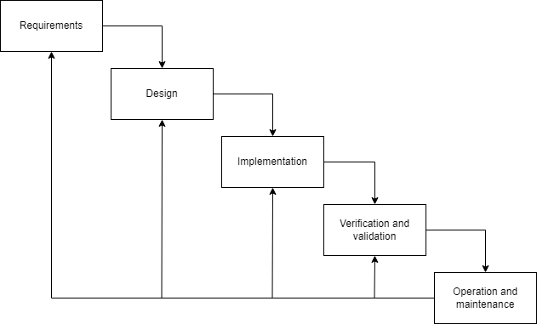

Figure: Waterfall Model

### Requirement Identification

Requirement identification is the gathering of relevant requirement that will be used to develop a system. Different methods have been adopted to gather requirement for this project.

* + - 1. **Requirement Collection-**

Requirements will be collected through personal evaluation of different existing systems, along with suggestions from mentors, supervisors and classmates.

1. **Functional Requirement**

The functional requirements define the main functionality of the system. They are ordered here according to their importance, the most critical (and those that are to be developed first) are listed first.

1. **User Module**

* User will be able to register and login.
* Users with wrong username will neither be validated nor allowed to login.
* User with correct credential must be able to perform CRUD operation.
* The site should be able to display actual products searched by the user.
* The site should include logout.
* They can search for products without logging in.

1. **Admin Module**

* Admin can login the system.
* Admin can add or delete or update products.
* Admin has privilege to delete the users.
* Admin can see registered users.
* Admin can logout from the system.

1. **Non-Functional Requirements**

The non-functional requirement specifies how the system works. The non-functional requirements are mentioned below:

* System uses different database for storing the attribute for each entity.
* User can see the transaction detail after performing transaction.
  + 1. **Feasibility Study**

A feasibility Study is done to determine whether the project is feasible to persuade forward or not. It is done to identify any potential issues or obstacles that may arise during its implementation.

1. **Technical Feasibility**

* The UI of our project is very simple.
* User will require internet browser and internet to use it.
* It will run on any existing browser with latest version and even on smartphones.

**Recommended hardware parts**

|  |  |  |
| --- | --- | --- |
| Sn no. | Hardware | Specification |
| 1. | monitor | 13.3 inch / 33.74 cm |
| 2. | Hard drive | 256 GB |
| 3. | RAM | 2 GB |
| 4. | Processor | Intel Pentium |
| 5. | Graphics | Integrated Graphics |

**Recommended software**

The following software will be required to create the system-

1. Vs-Code
2. MySQL
3. Apache[Xampp]
4. **Operational Feasibility-**

These include the reliability, maintainability, usability, supportability. The proposed system is operationally feasible as it is reliable for all type of user i.e. whether or not the user has knowledge of the computer. This proposed system is supported for a small or large-scale organization. It is simple to use due to simple user interface and its operational feasible.

1. **Economic Feasibility**-

To complete this project, existing free of cost technologies (hardware, software, internet) will be used. So, there will not be any risk and challenges due to economic feasibility. The system does not have any requirement of expensive hardware and software. The platforms are open source and the resources required for this project are also open source. Hence the project is said to be economically feasible.

1. **Schedule Feasibility-**

The system that we develop is scheduling feasible as it does not require more time for the development phase. The data collection takes more time to collect data about various products and their quality. After data is collected, the other development phase can be within the month.

**Gantt charts-** Gantt chart is a bar chart that provides a visual view of tasks schedule over time. A Gantt chart is for planning projects of all sizes and it very useful for showing what work is scheduled to be done on a specific day.

In our project, we used MS-Excel for developing Gantt chart which is shown below.

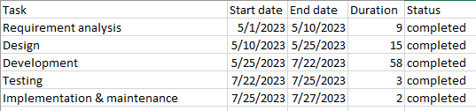

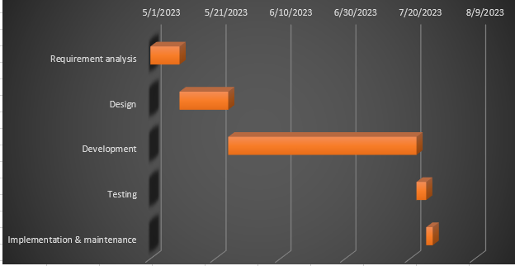

Figure: Gantt Chart

### Use Case Diagram

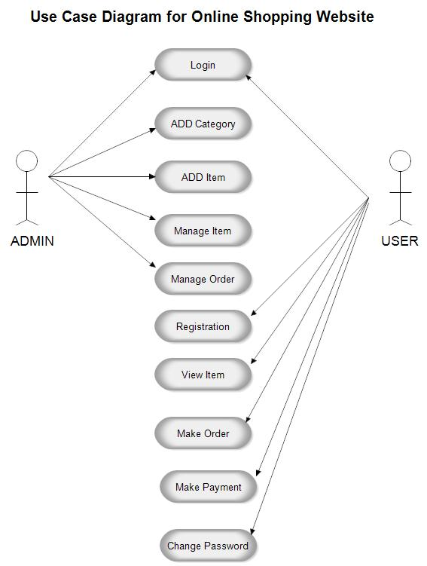

Figure: Use Case Diagram

In the above figure we can see how different users & admin perform task in our system. Here, the user can login, register unlike admin, users can view products, make order, make payment, change password and message the admin, while there is only one admin and admin can add category, add products, manage products and manage the order as well as the users.

Figure: Use Case Diagram

### Data Modeling (ER Diagram)

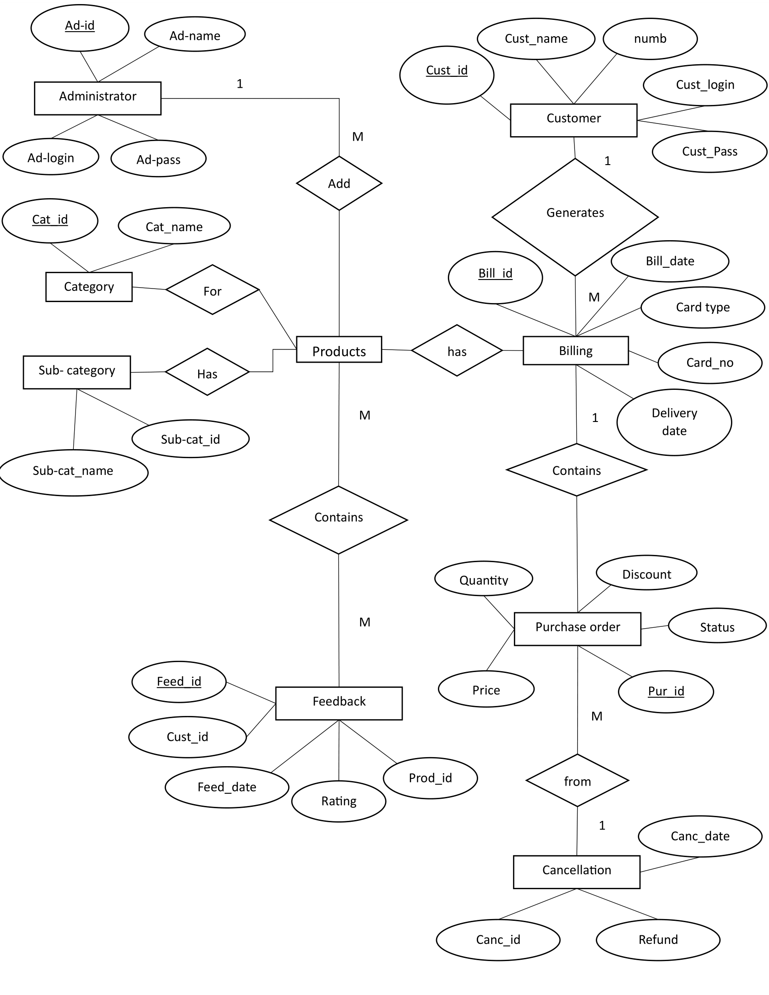

Fig. Entity Relationship Diagram

In the above figure we can see how our site works. Administrator adds products to the system which can be accessed by the user and it contains feedbacks. The products contain category as well as sub category. The products contain billing generated by users which are viewed by the admin also known as purchase order. The purchase order can be cancelled by the admin only.

### System Flowchart

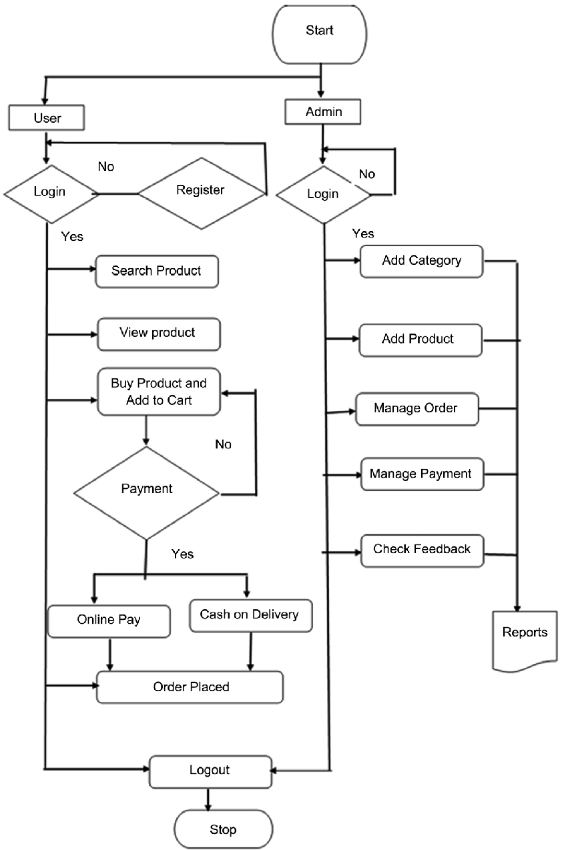

Figure: System Flowchart

In the above flowchart, it shows how the flow of system works. First admin has to login and add products, manage order, manage payments and checks feedbacks given by the user. Admin checks the daily reports and finally can logout of the system.

The user can access the website without login unlike admin, but can only view the products but cannot buy the products, after login the user can search products add in wish-list purchase the products and see the order pending. The user can logout of the system.

### DFD (Data Flow Diagram)

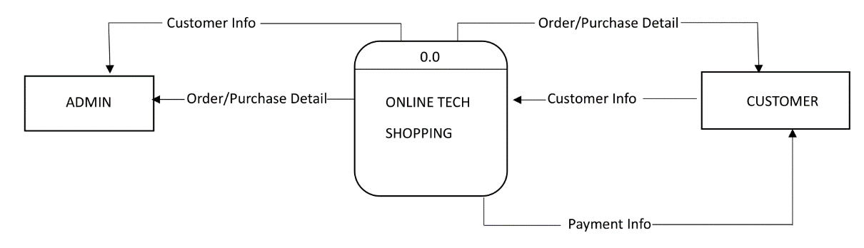

Figure: Level Zero DFD

In the above figure, there are two key entities, user and admin. Both of these entities are connected through our blogging system. User logs in to the system and is redirected to the home page and the admin overviews the entire system including user's posts, comments and categories.

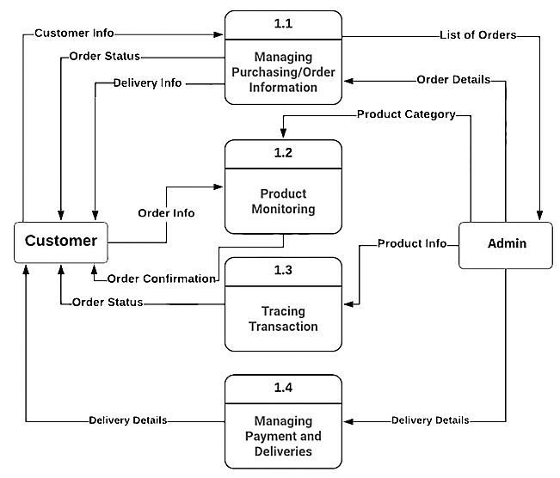

Figure: Level 1 DFD

In the above figure the system involves user and admin entities connected to the key processes: log in/ sign up, add category, create/edit profile and add/edit/delete product. User provides the user information for the purpose of logging in or signing up which is stored in registered user. Same goes for admin. The admin overviews the user information and manages the entire system. The user makes payment and admin manages the payment. The user views the product added by the admin.

# CHAPTER 4

# IMPLEMENTATION AND TESTING

## 4.1 Implementation

Implementation basically means the phase where the system is actually being built. Firstly, all the information that we gathered is studied and analyzed and implemented a system in operation for users. It is one of the most important phases of any project. Implementation usually consists of coding, testing, installation, documentation, training and support. Different tools and technologies that have been used to develop the system which are already discuss in the previous chapter. It is basically converting system design specification into working software.

### Tools Used

The various system tools that have been used in developing both the front-end and back- end of the project are being discussed in this chapter.

* **Front-end**

Bootstrap, HTML5, CSS3, and JavaScript are used for developing the front-end.

* **HTML5 (Hyper Text Markup Language)**

HTML is a syntax used to format a text document on the web.

* **CSS3 (Cascading Style Sheets)**

CSS is a style sheet language used for describing the look and formatting of a document written in a markup language.

* **Java Script**

Java Script is a dynamic computer programming language. It is most commonly used as part of web browsers, whose implementations allow client-side scripts to interact with the user, control the browser, communicate asynchronously, and alter the document content that is displayed. Java Script is used to create popup windows displaying different alerts in the system like “Added to cart successfully”, “Login successful”, “Purchase successfully” etc.

* **Back-end**

The back-end is implemented using PHP and MySQL. MySQL is used to design the database.

* **PHP**

PHP is a server-side scripting language designed for web development but also used as a general-purpose programming language. PHP code is interpreted by a web server with a PHP processor module, which generates the resulting web page: PHP commands can be embedded directly into an HTML source document rather than calling an external file to process data. PHP is free software released under the PHP License. PHP can be deployed on most web servers and also as a standalone shell on almost every operating system and platform, free of charge. [4]

* **MySQL**

MySQL is the world's second most widely used open-source relational database management system (RDBMS). The SQL phrase stands for Structured Query Language. MySQL is also used in many high-profile, large-scale websites, including Google (though not for searches), Facebook, Twitter, Flickr and YouTube.

### Implementation Details of Modules

After the design was made and the problems arising from the design process were clarified and dealt with, it was time to start implementing the application. Implementing application of this scale requires lots of resources and explaining the whole implantation process will not be clarified in this paper. However major important aspects in the implementation will be described. Some modules of the shopping websites are listed below:

* **Slider:** It displays the images or articles as a carrousel. It is used in the homepage to display multiple images of clothing pieces of different categories.
* **Header:** It displays the header with the logo of the shopping website, social media or the login. It is used in the navbar of the homepage. It is used in order to provide links to different pages of the website.
* **Breadcrumbs:** It is used to automatically display the path taken to get to the page.
* **Register Form:** It is used in order to register the new users to the website. It contains the text field like email, username and password. The information entered is further stored to be used in the login page.
* **Login Form:** It is used in order to provide the user the gateway to the website. It uses the data like username and password from register form to authenticate the user and give further access.
* **Shopping Cart:** It displays the quantity of products and the prices of the products which is to be bought by the user.
* **Product Modules:** Since the shopping website offers two different Shopping categories, Product modules divides different products according to their categories, i.e. Men and Women Section. Users can select the products according to their choices.
* **User Module:** It provides information related to the user. It Provides information like cart detail, product detail, login, register and logout.
* **Admin Module:** It provides information to the admin. It provides information like user detail, Admin can add or remove products etc.

## 4.2 Testing

Testing is done to check the behavior of a complete and fully integrated software product based on the software requirement specification document. For the application or website to be deployed it has to be tested. Hence test cases will be written to test this application. They are many types of test to be carried out on a web application from performance, functionality, database loading time, response time, server time handling, user's actions and many others. We will not carry out all types of test for the application considering the time scale to present this project. Hence performance check related to upload time, memory usage will be part of a future test. We will focus the test cases on functionality, security and performance. So that various types of testing procedures were performed in order to check the working mechanism and correctness of the system. Some of the types of testing that we did are described below:

1. Verify that all the specified fields are present on the registration page.
2. Verify that for better user interface dropdowns, radio buttons and checkboxes, etc. fields are displayed wherever possible instead of just textboxes.
3. Verify that clicking submits button after entering all the required fields, submits the data to the server.
4. Verify that clicking cancels/reset button after entering all the required fields, cancels the submit request, and reset all the fields.
5. Verify that not filling the optional fields and clicking the submit button will still send data to the server without any validation error.
6. Check validation on the date and email fields (only valid dates and valid email Ids should be allowed.
7. Check validation on numeric fields by entering alphabets and special characters.
8. Verify that after making a request to the server and then sending the same request again with the same unique key will lead to server-side validation error.

### Test Case for System Testing

**USER TEST CASE FOR LOGIN AND REGISTRATION**

|  |  |  |  |  |  |
| --- | --- | --- | --- | --- | --- |
| Sno. | Test case  description | Test Data | Expected  Result | Actual  Result | Pass / Fail |
| 1. | Open  Application | http://localhost/pro/home.php | Opens  Home page | As,  expected | pass |
| 2. | User  Registers | Username: Ayush  Email: [ause@gmail.com](mailto:ause@gmail.com)  Password: 1234  Confirm Password: 1234 | Registered  Successfully | As,  expected | pass |
| 3. | User  Login  (invalid password) | Email: [ause@gmail.com](mailto:ause@gmail.com)  Password: 1236 | Incorrect  Email or  password | As,  expected | pass |
| 4. | User  Login  (invalid  Email) | Email: [ausw@gmail.com](mailto:ausw@gmail.com)  Password: 1234 | Incorrect  Email or  password | As,  expected | pass |
| 5. | User  Login  (valid  Data) | Email: [ause@gmail.com](mailto:ause@gmail.com)  Password: 1234 | Logined  Successfully | As,  expected | pass |
| 6. | User  Send  message | Name: ayush  Email: [ause@gmail.com](mailto:ause@gmail.com)  Number:9876353638  Message: need refurbished I phone. | Message sent successfully | As,  expected | pass |

**CART TEST CASE**

|  |  |  |  |  |
| --- | --- | --- | --- | --- |
| Sno. | Test  description | Expected Result | Actual result | Pass/  fail |
| 1. | Adds product to the card (limit 100) | Added to cart! | As,  expected | pass |
| 2. | Continue shopping | Returns to the homepage. | As,  expected | pass |
| 3. | Proceed to checkout (directly) | Your cart is empty! | As,  expected | pass |
| 4. | Proceed to checkout | Shows your order with price.  Form to fill up. | As,  expected | pass |
| 5. | Place order | Form fill up. (after completion)  Order placed successfully! | As,  expected | pass |
| 6. | Product search | If available products= ‘shows’  Unavailable=’No Products Found!’ | As,  expected | pass |

**ADMIN TEST CASE FOR LOGIN**

As for the admin default username=” admin” and password=”111” is set.

|  |  |  |  |  |  |
| --- | --- | --- | --- | --- | --- |
| Sno. | Test case  description | Test Data | Expected  Result | Actual  Result | Pass / Fail |
| 1. | Open  Application | http://localhost/pro/admin/admin_login.php | Opens  login page | As,  expected | pass |
| 2. | Admin  Login  (invalid Data) | Username: admin  Password: 123 | Incorrect  username or  password | As,  expected | pass |
| 3. | Admin  Login  (valid  Data) | Username: admin  Password: 111 | Opens  Dashboard/  Homepage | As,  expected | pass |
| 4. | New Admin  registration | Username: sizan  Password: 1234  Confirm Password: 1234 | Registered  Successfully | As,  expected | pass |

**ADMIN PRODUCT TEST CASE**

|  |  |  |  |  |
| --- | --- | --- | --- | --- |
| Sno. | Test  description | Expected Result | Actual result | Pass/  fail |
| 4. | Admin  Adds  Product | Enters product name.  Enter product price.  Enter image of product.  Enter Product details. | As,  expected | pass |
| 5. | Admin  Deletes/  update  Product | Select delete/Update option.  (pop up shows up if you actually want to delete the product)  Selects ok. (for delete)  admin can change/update anything related to product. | As,  expected | pass |
| 6. | Admin  deletes user | Select delete option.  (pop up shows up if you actually want to delete the user) | As,  expected | pass |
| 7. | Admin  Update  orders | Admin changes pending order to completed order.(After payment) | As,  expected | pass |
| 8. | Users query | Admin checks message | As,  expected | pass |

# CHAPTER 5

# CONCLUSION AND FUTURE RECOMMENDATON

## 5.1 Lesson Learnt / Outcome

When this project is completed, the users will be able to buy various products. After filling the register form, user can view and buy different products online through web browser. User can easily add and remove products from the cart. Users can easily pay for their products.

## 5.2 Conclusion

After the successful completion of the website, people can perform easy shop online. The current application has fulfilled all the objectives. We followed the specifications strictly but enhanced some of the features when there was need for it to be done. There have been challenges especially when it came to backend and making sure that the application responses in a predictable manner.

Choosing PHP for this project is because it is very simple and easy to use, it could handle a lot of data and easily manipulation compared to another scripting language, this is widely used all over the world. it is Open source; we can freely download and use. And it is platform independent as well.

As we came to the end of the project, we realized that there are many enhancements that can be made on the application. Some of these ideas came from those who tested the application and some of them from both of us. We decided to follow the specification because there were realistic to achieve in this given amount of time. Any other enhancements to the application can be done in future development of the application.

## 5.3 Future Recommendation

Here is what can be added in the future on this website to increase its usability, user experience and portability of the website. There is a lot to be done hence this application can be considered as a starting point for something big to come. It will need more time and resources for all these to be done but it is still very realistic and possible to achieve.

* Addition of buyout features,
* Addition of transaction methods,
* Addition of new categories,
* Addition of customization of features,

# References

|  |  |
| --- | --- |
| [1] | R. L. Brandt, One-Click: Jeff Bezos and the Rise of Amazon.com, San Francisco, 2011. |
| [2] | Addison-Wesley, Professional: Scalability Rules: 50 Principles for Scaling Web Sites, Boston, 2011. |
| [3] | "Tutorial Point," [Online]. Available: https://www.tutorialspoint.com/sdlc/sdlc_waterfall_model.htm#.. |
| [4] | L. Ullman, PHP for the Web(5th Edition), Ohio: Peachpit Press, 2016 . |
| [5] | B. D. Steve Blank, The Startup Owner's Manual: The Step-By-Step Guide for Building a Great Company, Pescadero, California, 2012. |