ST10114043: S. Majola

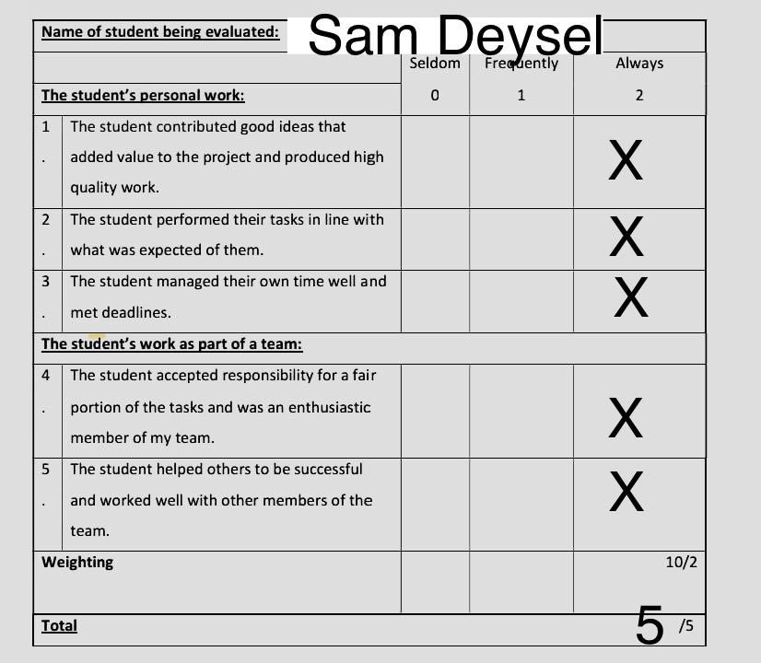

ST10114043: S. Majola

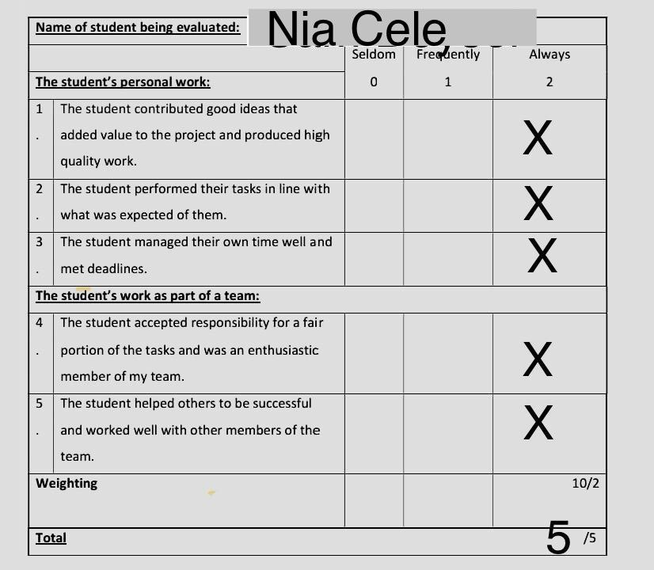

ST10114043: S. Majola

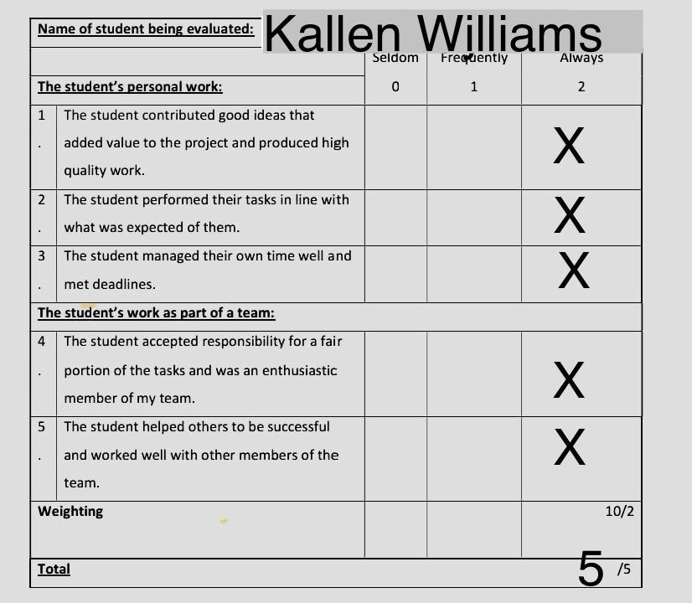

ST10114043 S. Majola

Self Reflection Report:

Introduction

The aim of this project was to plan and design an SOS Emergency App as a group. I saw the value in learning how the different project tools connect, like the charter, WBS, breakdown, and network diagram. It showed me how planning steps fit together and why teamwork is important to finish a project like this.

Skills Learnt

I gained technical skills in using Excel to build the project breakdown and link activities with costs, time, and predecessors. I also learned how to research examples of emergency apps and apply that knowledge. In teamwork, I took part in discussions, gave feedback, and made sure my work matched the group’s goals. For management skills, I realised I need to improve my time management. I did my part, but I wish I had finished earlier so I could help others more.

Role in the Team

My role was to focus on the project breakdown. I followed the group’s plan but also made sure my section was detailed and correct. This helped the team move forward. I worked well with others, and even though there were no big conflicts, I tried to keep communication clear and respectful.

Research and Technology

I researched how emergency apps work and how project breakdowns are usually set up. I used online searches and templates to guide me. Excel was the main tool I used to capture and present the information, and it helped me see how tasks, costs, and timelines connect.

Personal Strengths and Weaknesses

My strengths were being detail‑oriented, committed to finishing my work, open to feedback, willing to learn, and able to organise complex tasks. My weakness was time management. I underestimated how long my part would take, which meant I couldn’t help others as much as I wanted. To improve, I need to set earlier deadlines for myself.

Stakeholder Relationships

I worked well with my group members. We respected each other’s roles and shared ideas fairly. What worked well was the teamwork and clear division of tasks. To improve, I could have checked in more often and offered help sooner.

Impact

My contribution added value by making sure the project breakdown was complete and aligned with the assignment. This gave the group a strong base for the Gantt chart and overall plan. If I had managed my time better, I could have supported the group even more.

Conclusion

This project taught me how project tools connect and how important teamwork is. I learned about planning, communication, and aligning tasks with milestones and budgets. My main lesson is to improve my time management so I can contribute more in future projects. Overall, I am proud of my work and the skills I gained.