Technical Challenge #01
The Tunnel Is Up. Are We Safe?
Analyst: Sizwe Marole | Subject account: j.smith (Jordan Smith) | Incident date: 2026-09-02
All timestamps UTC unless marked local. Jordan is UK-based (BST = UTC+1 in September).
Evidence integrity: all seven files verified against SHA256SUMS.txt = OK.

1. Initial Verdict
Verdict: COMPROMISED Confidence: MEDIUM
The j.smith account was accessed and used by an unauthorised party. Access was gained by password guessing followed by MFA fatigue, from a device never associated with the user, and the session was used to reach a resource outside the user's role (finance) and to move a large volume of data out of the network. Confidence is Medium rather than High because the evidence cannot distinguish an external attacker from an insider staging a false compromise (see Section 6).

2. Timeline (UTC)
Time | Source | Event
2026-09-02 19:48:11 | E07 | Real laptop DEV-JS-441 last EDR check-in, then goes offline
20:51:12 | E03 | AUTH_FAILURE (wrong password) from 198.51.100.24
20:52:03 | E03 | AUTH_FAILURE
20:53:41 | E03 | AUTH_FAILURE
20:54:08 | E03 | AUTH_FAILURE (4 fails in a row = guessing)
20:55:21 | E03 | PRIMARY_AUTH_SUCCESS (5th attempt succeeds)
20:55:23 | E04 | MFA push SENT to Jordan-iPhone
20:55:41 / 20:55:58 / 20:56:14 / 20:56:31 | E04 | MFA NO_RESPONSE x4 (ignored = MFA fatigue)
20:56:44 | E04 | MFA APPROVED (user reports being asleep)
20:57:01 | E03 | VPN_SESSION_ESTABLISHED, vpn_ip 10.66.0.11
20:57:18 / :24 / :31 | E05 | DNS lookups: git.internal, files.internal, finance.internal (recon)
20:58:13 / 20:58:36 | E05 / E02 | HTTP to 10.66.0.1:8080 (curl/8.7.1 - see Section 5; inner pcap confirms same seconds)
20:59:01 | E05 | SMB connect to file share 10.40.20.25:445
20:59:14 | E05 | HTTPS git.internal (10.40.30.18)
20:59:27 | E05 | HTTPS finance.internal (10.40.40.15) (never in 30-day baseline)
20:59:42 | E03 | Session active: tx_bytes = 487,329,118 (~487 MB out)
21:00:12 | E05 | SMB HIGH_VOLUME_READ = 483,729,118 bytes (~483 MB) from 10.40.20.25
2026-09-03 04:46:03 | E07 | Real laptop DEV-JS-441 next EDR check-in (offline across whole incident)
2026-09-03 08:17 (local) | E06 | User statement: "I was asleep... did not intentionally connect."
The active phase is ~9 minutes (20:51-21:00). ~483 MB read from the share is matched by ~487 MB sent out of the tunnel: the signature of data exfiltration rather than normal browsing.
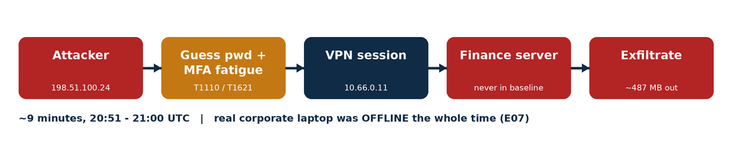
Figure 1. Attack flow (E01-E07), 20:51-21:00 UTC.

2b. Evidence source map
Analysis treats E01-E07 as one combined dataset. Each source and its contribution:
File | Type | What it contributes
E01 | VPN outer pcap | Confirms encrypted WireGuard tunnel from 198.51.100.24 to VPN server 203.0.113.10 udp/51820 (source-IP + session confirmation)
E02 | VPN inner pcap | Decrypted intra-tunnel HTTP to 10.66.0.1:8080; User-Agent curl/8.7.1; timings corroborate E05
E03 | VPN auth log | Authentication events: 4x failure then success; MFA validated; session established; tx_bytes ~487 MB
E04 | MFA CSV | MFA activity: 4x push NO_RESPONSE then APPROVED (fatigue)
E05 | Internal access log | Internal resource access: DNS recon, SMB to share, git + finance, HIGH_VOLUME_READ ~483 MB
E06 | User baseline | Baseline context: hours, location, device, normal volume/resources; user denial statement
E07 | Endpoint context | Endpoint context: device fingerprint UNKNOWN-7C91 (non-compliant); DEV-JS-441 EDR gap 19:48-04:46
Cross-source relationships: E02 8080 timings match E05 to the second; E05 SMB read (~483 MB) matches E03 tx (~487 MB) = exfiltration; E03/E04 timestamps interleave to show guessing-then-fatigue; E07 shows the real device was offline while E01/E03 show a session from an unknown one. Apparent inconsistency explained: E04 shows MFA "APPROVED" yet this is attributed to an attacker - resolved by the four preceding NO_RESPONSE prompts (fatigue), not a deliberate owner approval.
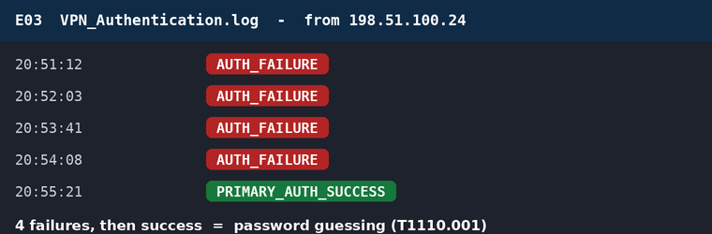
Figure 2. E03 - four failed logins then success (password guessing).
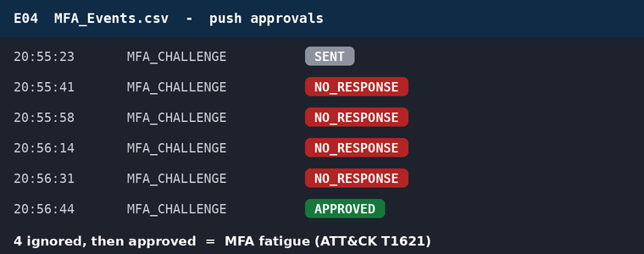
Figure 3. E04 - four ignored MFA pushes then approval (MFA fatigue).
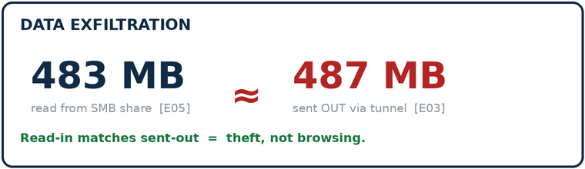
Figure 4. E05/E03 - bulk read matches bytes sent out (exfiltration).

3. Reasoning (observation vs assumption)

Confirmed observations (directly in the evidence)
- Four consecutive AUTH_FAILURE then success, all from 198.51.100.24 [E03].
- Four MFA NO_RESPONSE then a single APPROVED [E04].
- Connecting device fingerprint UNKNOWN-7C91, never associated with j.smith, compliance NOT_AVAILABLE [E07].
- Real corporate laptop DEV-JS-441 had no EDR telemetry from 19:48 to 04:46 [E07].
- Access to finance.internal, which has no access in the previous 30 days [E05 vs E06].
- ~483 MB SMB read [E05] and ~487 MB tx out of the tunnel [E03].
- Internal web access to 10.66.0.1:8080 issued by curl/8.7.1, a command-line client, not a browser [E02].
- Outer capture confirms the tunnel ran from 198.51.100.24 to VPN server 203.0.113.10 udp/51820 [E01].
- Inner capture 8080 timings match the access log to the second [E02 vs E05].
- User denies initiating the session [E06].

Reasonable inferences
- Four failures then success indicates credential guessing, not owner error.
- Four ignored pushes then approval indicates MFA fatigue / push-bombing.
- DNS lookups immediately after login indicate reconnaissance.
- curl usage indicates scripted / command-line access rather than interactive browsing (supporting indicator, not proof - developers also use curl).
- The matched read/out volumes indicate exfiltration.

Assumptions (not proven by evidence)
- That the actor is external rather than the user. Cannot be confirmed from the data.
- That the finance data was the objective (plausible but not proven).

4. What supports, weakens, and is unknown
Supports COMPROMISED: credential guessing, MFA fatigue, unknown non-compliant device, real laptop offline, off-hours, out-of-role finance access, scripted curl access, bulk exfiltration, user denial. Multiple independent sources agree.
Weakens / complicates: MFA was technically approved (explained by fatigue); curl is dual-use (also a developer tool); E07 itself cautions that missing endpoint telemetry is not by itself proof of malice.
Unknown: geolocation of 198.51.100.24 (not in evidence); owner of UNKNOWN-7C91 (not in evidence); destination of the ~487 MB; the actual contents of the data taken.
Most significant events: the MFA fatigue sequence [E04] and the finance access + matched exfiltration volumes [E05/E03]. One strong contradiction (unknown device + offline real laptop) outweighs the single "MFA approved" point.

5. Packet capture analysis (E01 / E02)
E01 (outer): encrypted WireGuard traffic between attacker IP 198.51.100.24 and the VPN server 203.0.113.10 on udp/51820. Payloads are not readable; value is independent confirmation of the source IP and that a genuine WireGuard tunnel was established. (Both IPs are RFC 5737 documentation addresses used for the exercise.)
E02 (inner): decrypted intra-tunnel traffic. Three requests to 10.66.0.1:8080 (GET /, HEAD /, GET /?source=cybrz), all with User-Agent: curl/8.7.1. This shows the internal web resource was accessed with a command-line tool / script, not a browser, which is inconsistent with a developer casually browsing in the evening. Treated as a supporting indicator. The 8080 timestamps match E05 exactly, giving two independent sources for the same events.

6. Alternative hypothesis considered
Insider false-flag. The user could have used a separate device, deliberately ignored his own MFA prompts to fake a fatigue attack, taken the data, and denied it the next morning. This is consistent with the evidence but not supported by any specific artefact. The two facts that would decide external-vs-insider (geolocation of the source IP, ownership of the device) are absent from the evidence. Because the simpler external-compromise explanation fits every artefact with fewer assumptions, it is reported as the verdict, and the insider possibility is recorded as an open question. This unresolved ambiguity is the reason confidence is Medium, not High.

7. MITRE ATT&CK mapping
Observed behaviour mapped to ATT&CK (Enterprise). Each technique is tied to the evidence that supports it; techniques are attributed to the actor only where the evidence does so.
Tactic | Technique (ID) | Evidence
Initial Access / Persistence | External Remote Services (T1133) | Access via corporate WireGuard VPN [E01/E03]
Initial Access / Defense Evasion | Valid Accounts (T1078) | Use of legitimate j.smith credentials [E03]
Credential Access | Brute Force: Password Guessing (T1110.001) | 4x AUTH_FAILURE then success, one IP [E03]
Credential Access | MFA Request Generation "MFA fatigue" (T1621) | 4x push NO_RESPONSE then APPROVED [E04]
Discovery | Remote System Discovery (T1018) | DNS lookups git/files/finance.internal [E05]
Discovery | Network Service Discovery (T1046) | Enumeration of internal services post-access [E05]
Command and Control / Collection | Application Layer Protocol: Web (T1071.001) | curl/8.7.1 HTTP to internal 8080 [E02]
Lateral Movement | Remote Services: SMB/Windows Admin Shares (T1021.002) | SMB to file share 10.40.20.25:445 [E05]
Collection | Data from Network Shared Drive (T1039) | SMB HIGH_VOLUME_READ ~483 MB [E05]
Exfiltration | Exfiltration Over Alternative Protocol (T1048) / Over C2 Channel (T1041) | ~487 MB tx out via the VPN tunnel [E03]; matches SMB read [E05]
Defense Evasion (possible, unconfirmed) | Impair Defenses: Disable/Modify Tools (T1562.001) | EDR telemetry gap on DEV-JS-441 19:48-04:46 [E07] - NOT attributable to the actor from evidence; recorded as a lead only

8. Vulnerability / CVE context
There is no single CVE for this incident, and that is an important finding in itself. No software vulnerability was exploited. The attack abused identity and authentication design: guessable/known credentials plus a push-approval MFA factor susceptible to fatigue. CVEs describe flaws in specific software versions; this is a control-and-configuration weakness, so it maps to weakness classes and control frameworks rather than a CVE:
- CWE-307 - Improper Restriction of Excessive Authentication Attempts (no lockout after 4 failures) [E03].
- CWE-308 / CWE-1390 - Use of single-/weak-factor authentication; weak authentication mechanism (push-approval without number matching) [E04].
- CWE-521 - Weak Password Requirements (password was guessable) [E03].
- NIST SP 800-63B - guidance on phishing-resistant authenticators and rate limiting.
- MITRE ATT&CK T1621 - MFA Request Generation, with documented mitigations (number matching, limits).
Real-world precedent (same technique, not the same org): MFA-fatigue was central to the 2022 Uber and Cisco intrusions and is a signature of groups such as Lapsus$ and Scattered Spider. This places the observed pattern in a well-documented threat context.

9. Mitigations (technique-mapped)
Weakness observed | Fix
Password guessing, no lockout (T1110.001 / CWE-307) | Account lockout / exponential backoff; detect repeated failures; block/monitor high-risk source IPs
MFA fatigue (T1621) | Move to phishing-resistant MFA (FIDO2 / passkeys); enable number matching; cap and rate-limit push prompts; alert on repeated denials
Unknown / non-compliant device (T1078 / T1133) | Device-trust / posture check at connection; block unmanaged endpoints; certificate-bound device identity
Flat internal access after VPN (T1018/T1021/T1039) | Per-application authorisation (ZTNA), network segmentation, least privilege; developer role should not reach finance
Bulk exfiltration undetected (T1048/T1041) | DLP and egress volume alerting; session recording for sensitive apps; anomaly detection on data transfer size
Off-hours / impossible-context login | Conditional access on time, geo, and risk; step-up auth for sensitive resources

10. What I would investigate next
- Geolocation / ownership of 198.51.100.24 and correlation with the user's known location.
- Asset ownership and MAC/hostname behind fingerprint UNKNOWN-7C91.
- Destination and contents of the ~487 MB egress.
- Full EDR/host forensics on DEV-JS-441 to explain the telemetry gap.
- HR / behavioural context on the user (to address the insider hypothesis).
- Whether finance data later surfaced anywhere linked to the account.

10b. Additional Evidence (Phase 2) - status
Original position (locked, kept visible): COMPROMISED / MEDIUM. No additional evidence has been released yet. When it is, this section will record Maintain / Revise / Withdraw and explain which new evidence mattered, what it changed, what it did not, and how confidence moved. Pre-committed triggers:
- If new data geolocates 198.51.100.24 far from the user and ties UNKNOWN-7C91 to no known asset -> confidence rises toward HIGH (external compromise).
- If it places the source near the user or ties the device to the user -> the insider false-flag strengthens; verdict likely still reflects account misuse but the attribution and rationale would be REVISED.
- If it shows the MFA approval or session was legitimate/authorised -> reassess toward Suspicious/Legitimate and WITHDRAW as appropriate.

11. Architecture Decision (Phase 3): VPN vs ZTNA vs Hybrid
Decision: Hybrid, with ZTNA as the default and legacy VPN retained only as a controlled exception.
This incident is a textbook failure of the traditional perimeter/VPN trust model. A classic VPN authenticates once at the edge and then places the user inside a trusted network. That is exactly what happened: after one credential + MFA event the session had broad reach and moved laterally to an SMB share and to finance.internal, a resource wholly outside the user's role. CompTIA Security+ (Module 6) and NIST SP 800-207 describe this as deperimeterization: the inside/outside distinction is gone, so trust must move from the network boundary to the individual user, device, and resource, "never trust, always verify," with access continuously verified rather than granted once at login.
How ZTNA would have changed the outcome, in framework terms:
- Control plane vs data plane (NIST SP 800-207). A Policy Decision Point (Policy Engine + Policy Administrator) evaluates each request; a Policy Enforcement Point brokers each session per-resource. The developer session would never have been granted a path to finance, because policy, not network location, decides access.
- Continuous verification + session context. Off-hours, an unknown device fingerprint, and a run of denied MFA prompts are exactly the signals a policy engine scores. Access could be denied or stepped-up mid-session instead of trusted for hours.
- Device trust / posture. ZTNA checks device posture at and during connection. The non-compliant UNKNOWN-7C91 endpoint (compliance NOT_AVAILABLE) would fail posture and be blocked.
- Least privilege + microsegmentation. Per-application authorisation replaces flat network access, containing lateral movement and the bulk SMB read.
Why Hybrid rather than pure ZTNA: some access cases do not fit an application-broker model (non-web legacy protocols, emergency break-glass). For those, a tightly segmented, heavily logged traditional VPN remains the pragmatic exception.
Access scenario | Model | Control emphasis
Managed remote employee | ZTNA | Strong identity + managed-device posture; per-app least privilege; continuous session scoring
BYOD / contractor | ZTNA (strict) | Hard posture checks, narrow scope, time-boxed access, browser isolation; no flat network access
Internal web application | ZTNA | Ideal fit: broker per-app with identity-aware proxy; no network exposure
Legacy non-web service | VPN (segmented) | The exception; isolate on its own segment, restrict to named users, log heavily
Privileged administrator | ZTNA + PAM | Phishing-resistant MFA, just-in-time elevation, session recording, tight scope
Emergency / break-glass | Controlled VPN | Dedicated path, pre-issued, alarmed on use, full audit, expires fast

12. Response and Detection (Phase 4)

Immediate containment
- Terminate VPN session VPN-260902-JS01 and disable the j.smith account.
- Block / sinkhole source IP 198.51.100.24 at the VPN gateway and perimeter.
- Quarantine device UNKNOWN-7C91; isolate the touched file share (10.40.20.25) and finance host (10.40.40.15) for review.

Credential and session response
- Force password reset for j.smith; revoke all active sessions and tokens; re-enrol MFA from a trusted device.
- Check for reuse of the same credentials on other services.

MFA controls (directly addresses T1621)
- Enable number matching and cap/rate-limit push prompts; alert on repeated denials.
- Migrate high-value and privileged accounts to phishing-resistant FIDO2 / passkeys.

Device verification
- Full EDR/host forensics on DEV-JS-441 to explain the 19:48-04:46 telemetry gap.
- Enforce device-posture/compliance at connection; block unmanaged endpoints.

Access policy
- Apply least privilege: a Software Developer role should not reach finance.internal. Segment finance behind per-app authorisation.
- Add conditional access on time, geolocation, and device risk; step-up auth for sensitive resources.

Logging, telemetry and detection opportunities
- Detections to build: repeated auth failures then success (T1110.001); a burst of MFA denials followed by an approval (T1621); logins outside 08:00-18:30 or impossible travel; access to resources with no baseline history; egress/transfer-volume anomalies (DLP) for the ~483/487 MB pattern.
- Correlate identity, MFA, VPN, endpoint and access logs centrally (SIEM) so these fire together.

Post-incident review
- Scope exactly what finance data was read and whether it left the estate; notify per policy/regulation.
- Resolve the external-vs-insider question (Section 10); feed lessons into the ZTNA rollout.

13. Final submission self-check
Question | Answer
1. What happened? | An unauthorised party used j.smith's account over VPN (guessing + MFA fatigue, unknown device) and exfiltrated ~487 MB including finance data, in ~9 minutes.
2. What supports it? | E03 guessing, E04 fatigue, E07 unknown device + EDR gap, E05 finance + bulk read, E03 tx match, E02 curl, E06 denial - multiple independent sources agree.
3. What weakens it? | MFA was technically approved; curl is dual-use; missing endpoint telemetry is not itself proof (per E07).
4. Still uncertain? | External vs insider; IP geolocation and device ownership are absent from evidence; exfil destination unknown.
5. Did new evidence change it? | None released yet; triggers pre-committed (Section 10b).
6. Why Hybrid/ZTNA? | The incident is the classic VPN "trust once, roam freely" failure; ZTNA enforces per-resource, continuously verified access; VPN retained only for legacy/break-glass.
7. Do now? | Kill session, disable account, block IP, quarantine device, reset creds + re-enrol MFA, isolate touched hosts.
8. Change long-term? | Phishing-resistant MFA + number matching, device posture, least privilege/segmentation, DLP + detections, SIEM correlation.
9. Defend in 5 min? | Yes - timeline + four converging evidence lines + one honest caveat (Medium confidence).

Appendix A. Evidence screenshots
Terminal captures of the supplied evidence files (programme name removed).
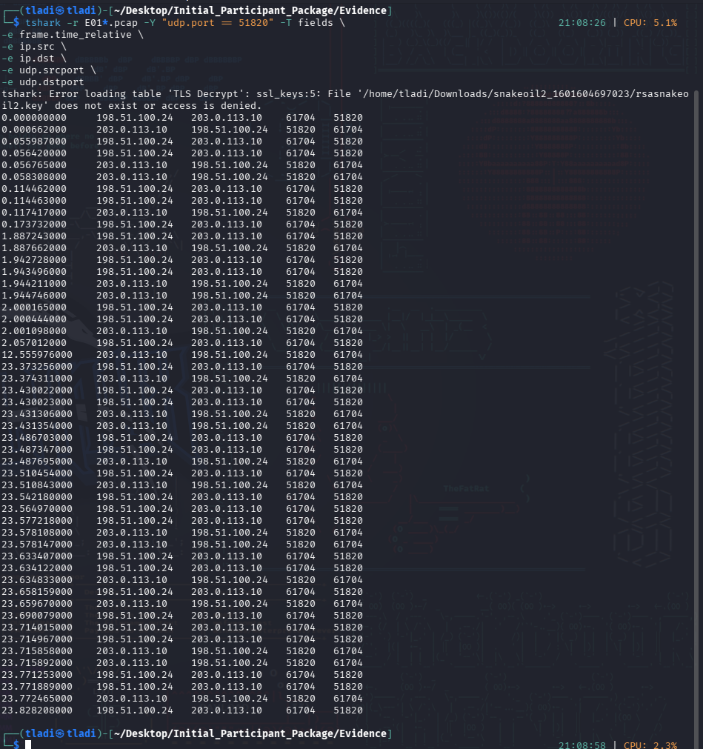
E01 - outer capture: encrypted WireGuard tunnel, attacker IP to VPN server.
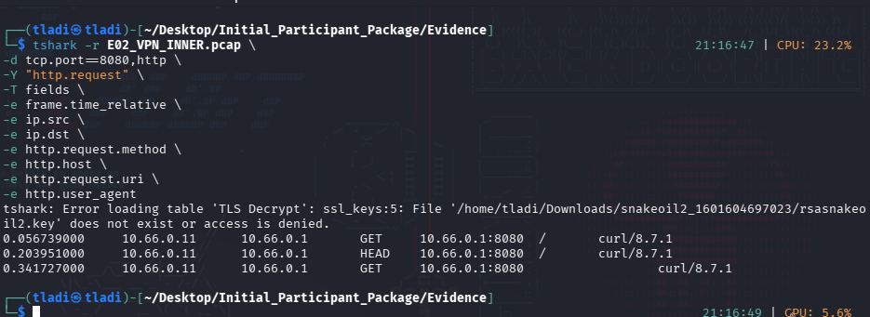
E02 - inner capture: HTTP to 8080 via curl/8.7.1.
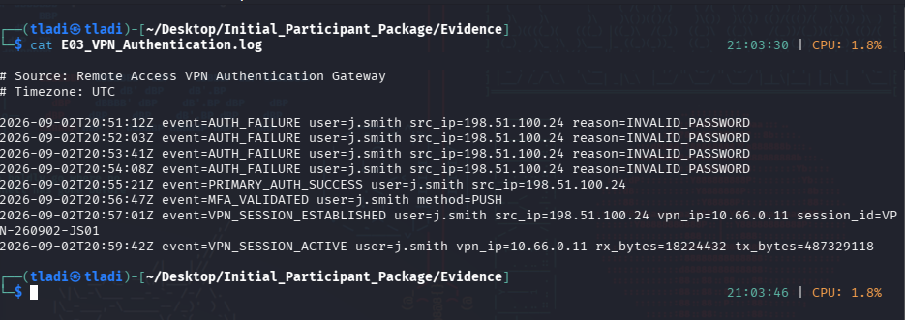
E03 - authentication log: four AUTH_FAILURE then success.
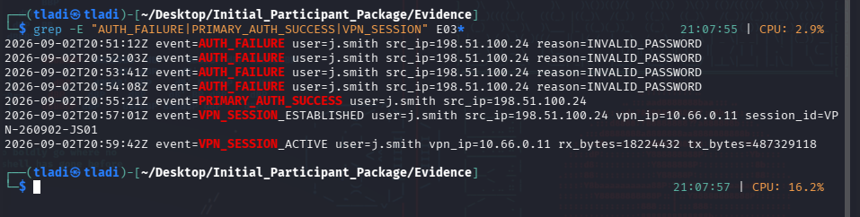
E03 - failures and success isolated with grep.
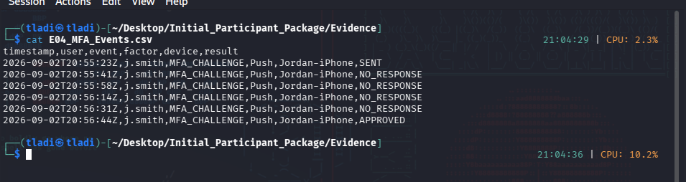
E04 - MFA events: four NO_RESPONSE then APPROVED.
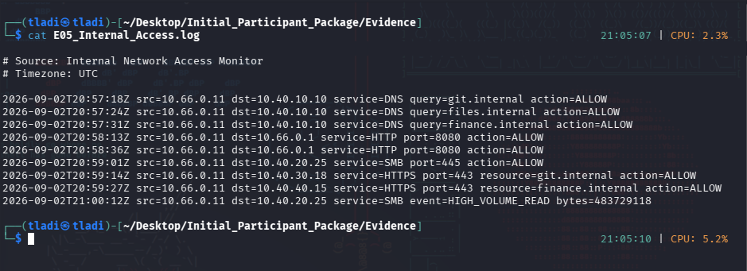
E05 - internal access: recon, finance, HIGH_VOLUME_READ.
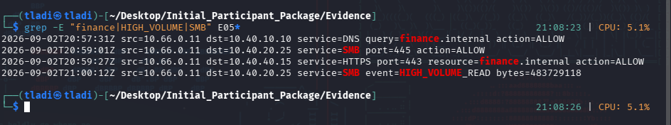
E05 - finance access and bulk read isolated.
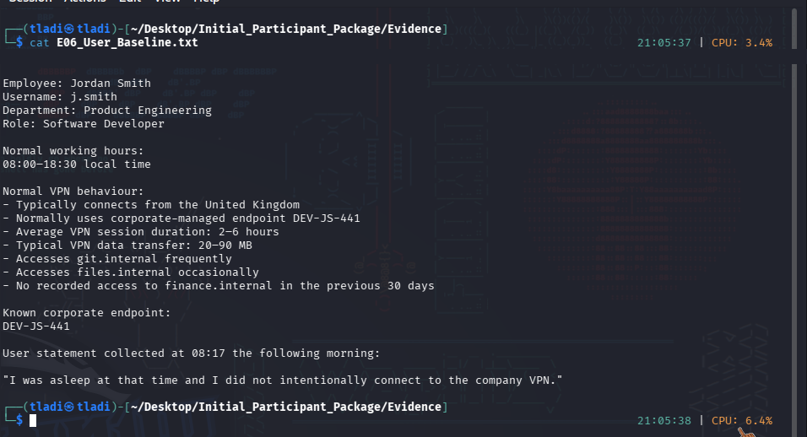
E06 - user baseline and denial statement.
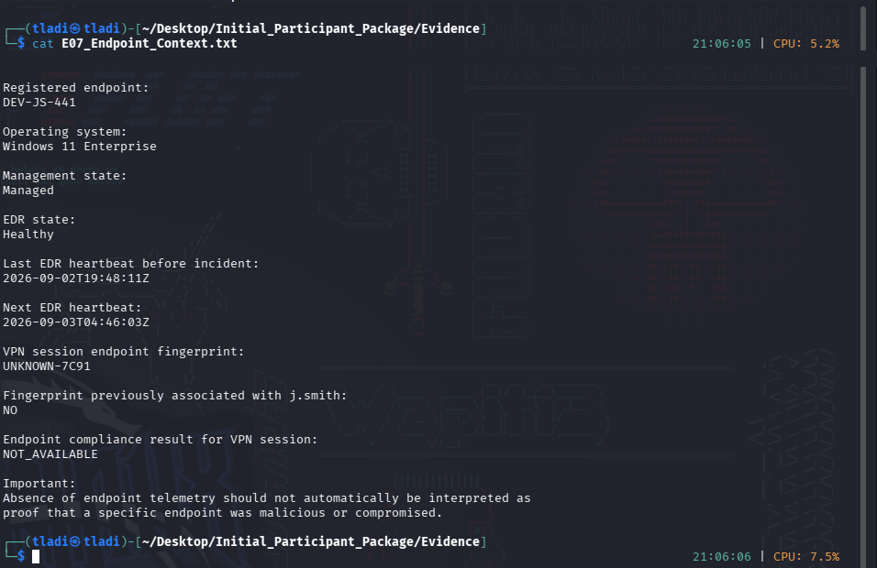
E07 - endpoint context: UNKNOWN-7C91 and EDR gap.
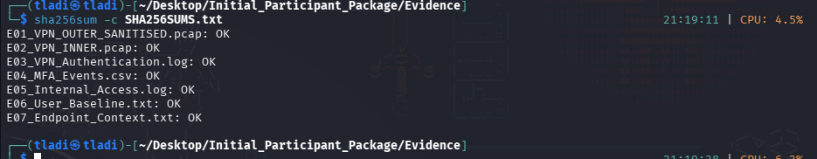
Evidence integrity verified with sha256sum -c.

