ResFunder: sign-up and sign-in spec
Nov 12, 2026 · @Stephen

Summary
Students and faculty sign up and sign in through one school-email flow, then answer a short setup. Students take 4 steps; faculty take 2. The last step for both is connecting a MetaMask wallet. Researchers use the student answers to target surveys.
- Who: students and faculty or advisers, with a school email only. The email itself shows that someone belongs to a school. The setup asks the rest.
- What students give: age range, sex, school, college, program, year level, region, city (optional) and working-student status.
- Short lists: every choice list stays short and ends in Others, which opens a "Please specify" box.
- Proposal rules kept: magic-link sign-in (Better Auth), with the school domain checked on the server. Personal data stays off-chain in Postgres. The email never goes on-chain; only the wallet address and a hash of the decision reason do. Each student is paid once per survey. Everything follows the Data Privacy Act of 2012 (RA 10173).
- Design: Apple design principles. One idea per screen, clear progress, Back always available, and nothing asked that isn't used.

Auth model: how sign-up feeds the build pipelines
One proof of wallet ownership at sign-up covers every pipeline. The account carries a verified email and a verified wallet. The submit and decision-log routes trust the signed-in session instead of asking for a new signature each time.
Pipeline | Who acts | Proof the server checks | Change from the pipeline notes
Sign-up (this doc) | Student or faculty | Magic link or code for the school email, then a personal_sign message for the wallet (section 3a) | New: email and wallet are both verified once
Fund a survey | Researcher | MetaMask signs createSurvey; the server reads SurveyCreated by tx hash and checks researcher equals the account's wallet_address | Adds the account match
Submit answers | Respondent | Signed-in session. The server uses the account's verified wallet_address and email | Deferred: connecting and signing per survey. Respondents no longer type an email or connect on the survey page
Decision log | Researcher | Signed-in session whose wallet_address equals surveys.researcher | Replaces the per-visit signature
Close survey | Researcher | MetaMask signs closeSurvey; the server reads Closed by tx hash | Unchanged
- One submission each, unchanged: the database keeps UNIQUE (surveyId, wallet) and UNIQUE (surveyId, emailHash). emailHash = HMAC(email + surveyId, server secret), computed from the account email.
- Pasted, unverified wallets (section 3a) can't answer paid surveys until the person connects and signs. Otherwise anyone could claim someone else's address.
- Open question: the pipeline notes open surveys to anyone, but this sign-up requires a school email. For the MVP, "anyone" means anyone with a supported school email.
- Deferred: signing per survey answer, kept as an option if a session is ever not enough.
Mobile is responsive web only. There is no native app or installable app. The phone mockups show the same Next.js pages at phone width. On phones, MetaMask works through "Open in MetaMask app", which loads these same pages in MetaMask's in-app browser.

1. The flow
There is one door, Continue with your school email, with no separate "Sign up" and "Log in" buttons. The server decides what comes next, so nobody has to remember whether they already have an account.
- Email. One field. The domain is checked against the list of supported schools, first in the browser and again on the server.
- Check your email. A magic link plus a 6-digit code in the same email. On phones the link often opens in a different browser than the one the person started in. The code lets them finish where they are.
- Branch on the account:
  - New email: Who are you? (Student or Faculty), then that role's setup.
  - Known email, setup done: straight to next, or the dashboard.
  - Known email, setup unfinished: resume at the step they left.
- Done. "You're all set", then on to next.
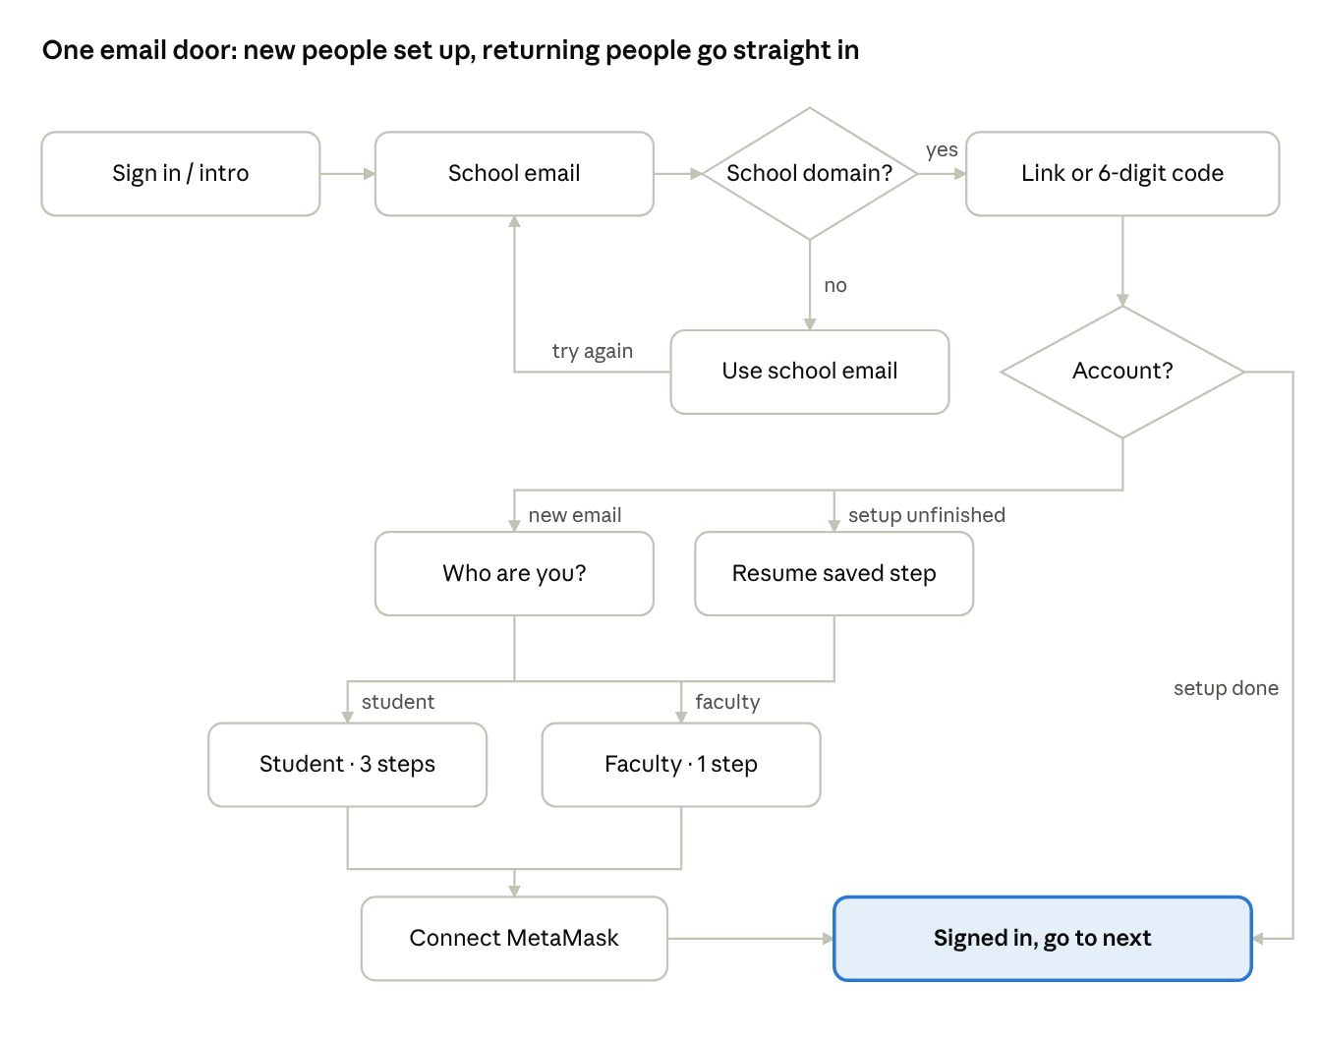
sign-up and sign-in flow · one door, 2 decisions
Every path ends signed in. Only new and unfinished accounts pass through setup.
Entry points. The header's Sign in button opens this flow. So does the last button of the landing intro ("Fund the survey" or "See open surveys") when the person is signed out. The developer sets PUBLISH_URL and ANSWER_URL in web/src/lib/links.ts to /sign-in?next=/publish and /sign-in?next=/answer. A signed-in person skips straight to the page.
Faculty and students share one email domain, so the role is self-declared. Faculty powers stay gated: an adviser reads a survey's decision log only when the researcher invites that email.

2. Student setup: 3 steps, then the wallet
Students answer 9 fields over 3 screens, about 1 minute in total. Each screen shows "Step N of 4" and a progress bar; step 4 is the wallet (section 3a). Each screen saves when the person taps Continue.
Step | Field | Choices | Required
1 · About you | Age range | 18–20 · 21–23 · 24–26 · 27 or older · Under 18 | Yes
1 · About you | Sex | Female · Male · Prefer not to say · Others → specify | Yes
2 · Your school | School | Filled in from the email domain and locked; "Not your school? Change email" | Auto
2 · Your school | College | Arts and sciences · Business · Computing / IT · Education · Engineering · Health sciences · Others → specify | Yes
2 · Your school | Program or course | Free text with suggestions, e.g. "BS Psychology" | Yes
2 · Your school | Year level | 1st · 2nd · 3rd · 4th · 5th or more · Graduate · Others → specify | Yes
3 · Where you are | Region | The 17 Philippine regions (select) · Prefer not to say | Yes
3 · Where you are | City or municipality | Free text | No
3 · Where you are | Working student | No · Part-time · Full-time · Prefer not to say | Yes
3 · Where you are | Consent | Two checkboxes (section 5) | Yes
Under 18 stops the setup: "ResFunder is for students 18 and older for now." The account stays, but it can't answer or publish. Minors would need guardian consent under RA 10173, which is out of scope for the hackathon.
Why these fields: they are the ones a thesis demographic profile usually reports, and each one can be used to target a survey (section 8). Nothing else is asked.

3. Faculty setup: 1 step, then the wallet
Faculty answer 2 fields and the consent on one screen. They don't answer paid surveys, so they get no personal demographic questions.
Field | Choices | Required
Department | The same college list as students · Others → specify | Yes
Role | Thesis adviser · Instructor · Panel member · Others → specify | Yes
Consent | Checkbox 1 only (section 5) | Yes
Faculty can publish surveys too. They can read a decision log only for surveys whose researcher invited their email.

3a. Your wallet: last step, required
Everyone connects a wallet before setup finishes. It is Step 4 of 4 for students and Step 2 of 2 for faculty. The screen says why in one line: "This is where your tBNB payments arrive." For researchers it reads "This wallet funds your surveys."
Connect MetaMask (the primary button):
- Ask MetaMask for the account (eth_requestAccounts). The button reads "Waiting for MetaMask…" until MetaMask answers.
- If the wallet isn't on BSC Testnet (chain 97), ask MetaMask to switch to it (wallet_switchEthereumChain). If MetaMask doesn't know the network, ask it to add it (wallet_addEthereumChain).
- Ask for a free signature that proves the address is theirs (personal_sign). Signing costs no gas. The message reads: "ResFunder: link this wallet to {email}. Code {nonce}. {time}". The nonce comes from the server and works once.
- The server checks the signature, saves the address and marks it verified. The screen shows the short address (0x12ab…9f3c) with a check mark and a copy button. Finish setup is now enabled.
No MetaMask:
- Desktop: "Install MetaMask" opens metamask.io in a new tab. Then "I've installed it" tries the connection again.
- Phone: "Open in MetaMask app" reopens this page inside MetaMask's own browser, where steps 1–3 work.
- Fallback: "Paste a wallet address instead". It accepts a 0x address and checks the format and checksum. It is saved as not verified, and payouts go to it. Helper text: "Make sure it's yours. Payments to a wrong address can't be undone."
Later: the account menu gets Change wallet, which runs the same steps. A new address only affects future payouts.
The contract records one decision per respondent wallet per survey. The database also blocks a second response per email hash. Changing wallets therefore never unlocks a second payout for the same survey.
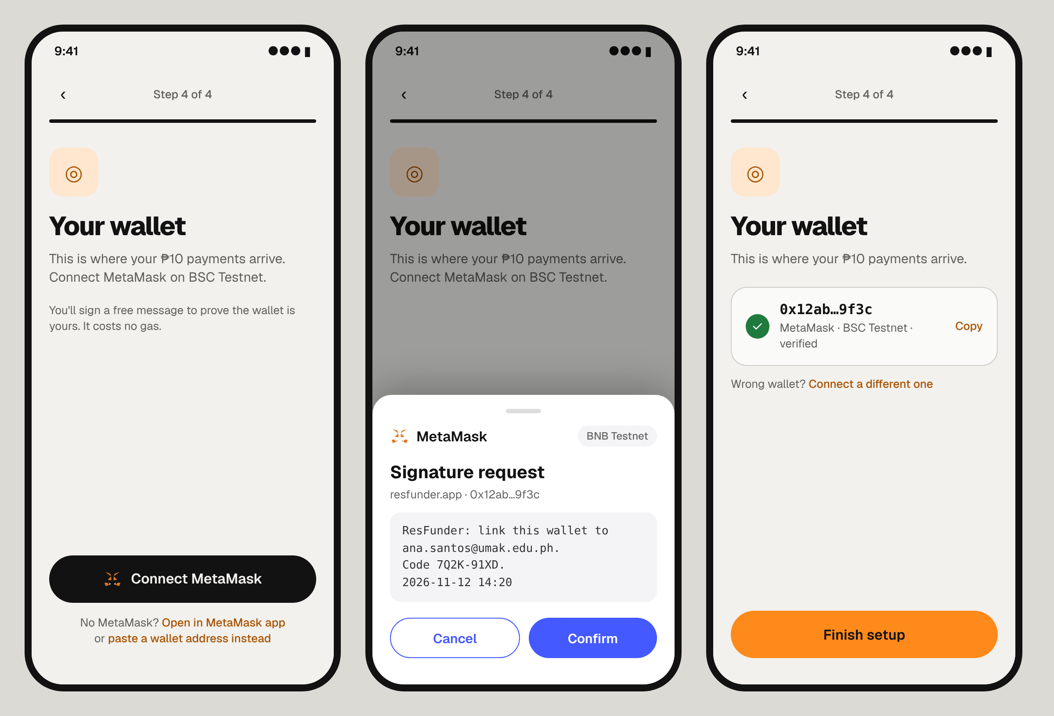
The screen uses one dark button with the MetaMask fox, and keeps the fallbacks quiet below it. The signature request shows exactly what is being signed, and once connected the address is shown short and copyable.

4. The "Others" pattern
Every choice field ends in Others, and picking it opens a required "Please specify" box right under the choices. This keeps every list at 7 options or fewer without leaving anyone out.
- Choices: pills in a radio group (one pick), at least 44 px tall, wrapping onto 2 rows at most on a phone. Region is the one exception: with 17 options it is a native select.
- Picking Others: a text input slides open under the pills and takes focus. Its label is "Please specify" and it allows 60 characters. The reveal is a 200 ms ease-out change of height and opacity; with reduced motion it only fades.
- Validation: with Others picked and the box empty, Continue shows "Tell us which one, or pick an option above." The error appears on Continue or blur, never while typing.
- Switching away from Others: the box closes and its text is kept until they leave the step, so switching back costs nothing.
- Stored as { "value": "other", "other": "<their words>" }, so researchers can group the free text later.
Prefer not to say appears only on sensitive fields: sex, region and working status. Under it, helper text says plainly: "Surveys that need this won't be shown to you." Age range has no such option, because the 18+ rule needs it.

5. Consent and privacy
Setup can't finish until both boxes are ticked. Neither box is ticked by default.
- "I've read the privacy notice. ResFunder keeps my email and details off-chain. Only my wallet address and payment records go on the blockchain."
- "Researchers see my details only alongside my answers, never my name or email. I can edit or delete them anytime." (students only)
- Privacy notice: one short page that names the data collected, why, who sees it, how long it is kept, and how to delete it. It cites the Data Privacy Act of 2012 (RA 10173).
- Stored: consent_version and consented_at. When the notice changes, people tick the boxes again at their next sign-in.
- Not part of sign-up: the notice that answers go to a third-party LLM stays on each survey's own consent screen, as in the proposal.
- Minimum data: only what researchers can target or report. No birthday, no student number, no phone number.

6. Apple design principles applied
Each screen asks one thing, shows where the person is, and lets them go back. It uses the landing page's existing tokens and motion, so sign-up feels like the same product.
Principle | What it means on these screens
Clarity | One idea per screen. Labels sit above fields and never live only in a placeholder. The title says the task: "About you", "Your school".
User control | Back is always top-left. Skipping isn't offered because every field is used, but each step saves on Continue, so leaving and returning resumes.
Feedback | Errors appear inline under the field, in plain words that say how to fix it, on Continue or blur, never while typing. The primary button shows a spinner while it saves.
Progress | "Step 2 of 3" plus a thin progress bar. "Check your email" shows the address it sent to.
Deference | Chalk background, Onyx text and one Tangerine primary button per screen. No illustrations on form steps.
Ergonomics | On phones the primary button sticks to the bottom, above the safe area, within thumb reach. Tap targets are at least 44 px, and inputs use 16 px text so iOS doesn't zoom.
Native inputs | type=email, autocomplete=email, inputmode=numeric + autocomplete=one-time-code for the 6-digit code, so iOS offers the code from Mail.
Motion | Steps slide in 250 ms using the existing .page-in / .page-back animations, reversed on Back. Buttons use the existing .pressable scale. With reduced motion, everything only fades.
Layout | Phones get a full-screen page. Desktop gets a centred card about 30 rem wide, like the landing intro sheet. Light and dark use the existing theme tokens.
The mockups below show the key phone screens.
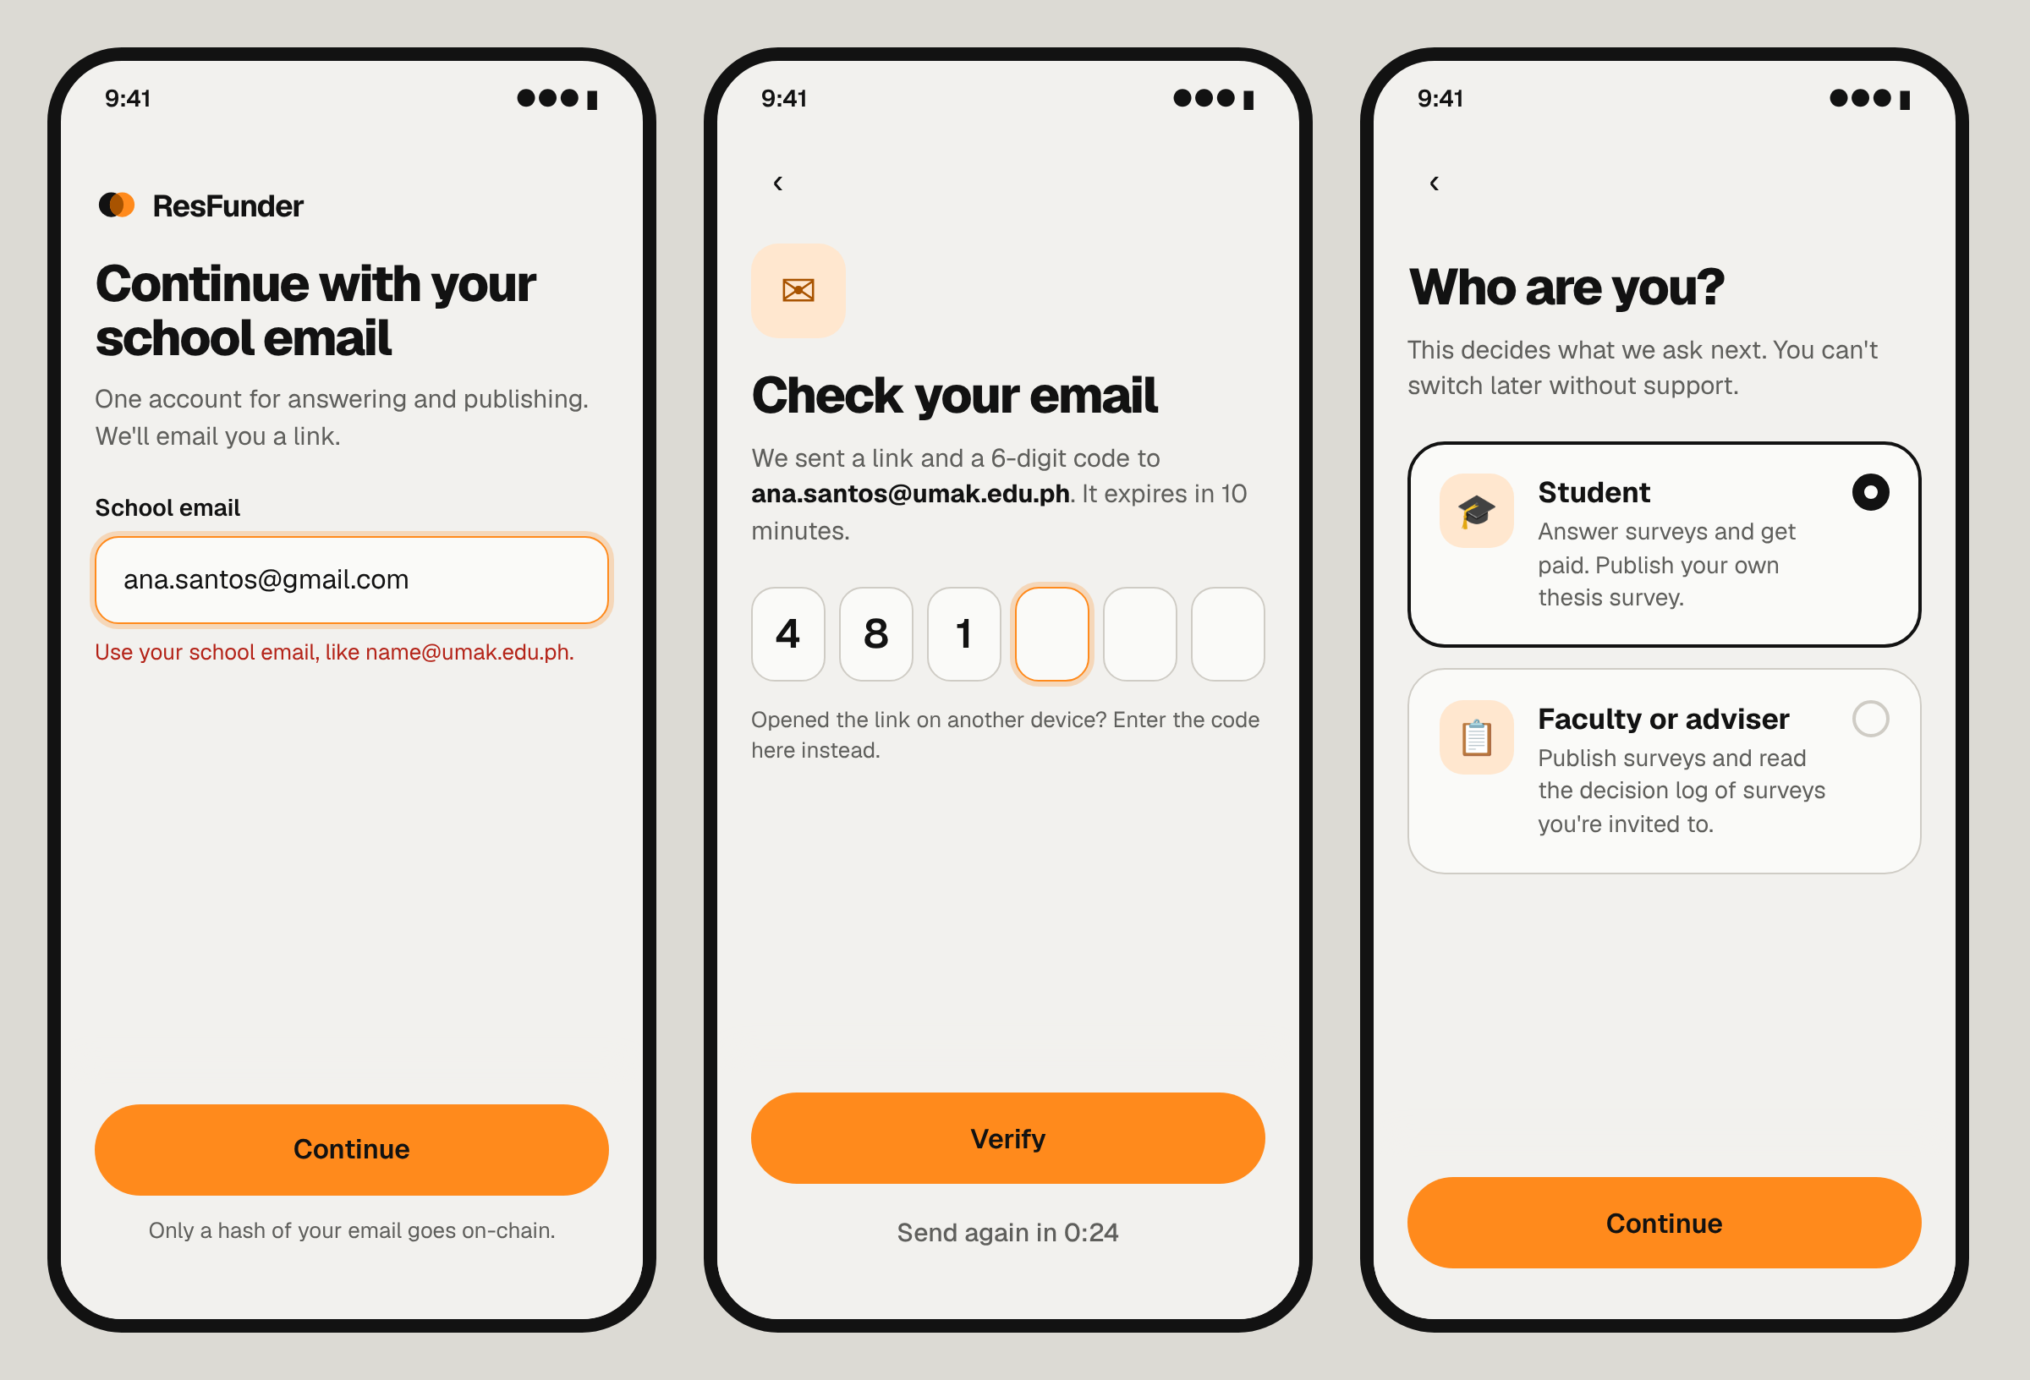
The email step catches a personal address before anything is sent. The code boxes accept iOS's one-time-code autofill. The role choice uses two large cards rather than a dropdown.
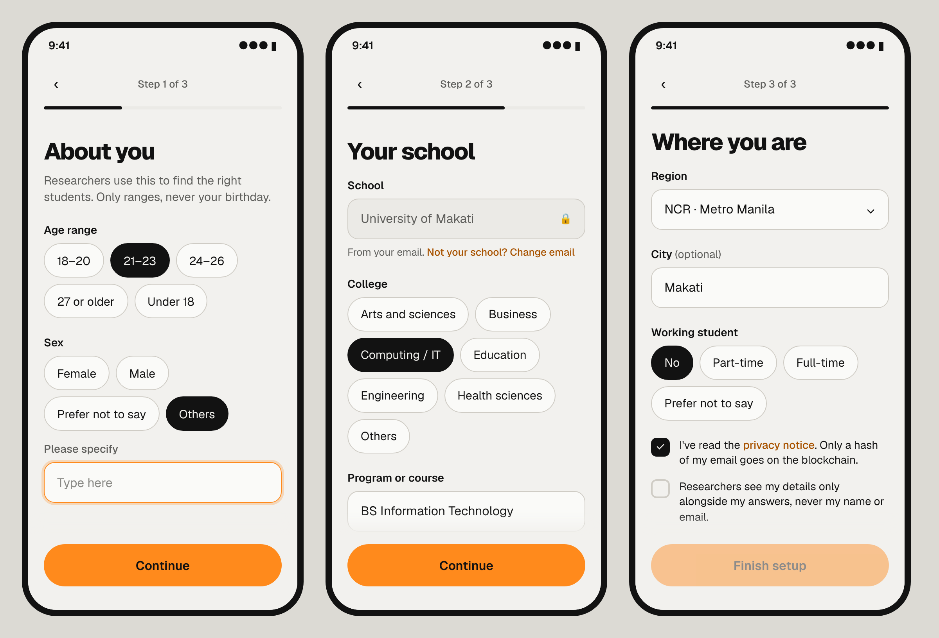
Step 1 shows the Others pattern open. Step 2 scrolls under its sticky Continue button; Year level sits below Program. Its button now reads Continue (the wallet is step 4) and stays disabled until both consent boxes are ticked.

7. Profile, sign-out and delete
Everything from setup can be changed later, on one page, from the account menu.
- Account menu (the avatar at the top right): Your details · Sign out. It also shows the email and the role.
- Your details: the same fields as setup, all on one page in the same three groups, with one Save button. School and email can't be edited there; "Change email" starts the email step again.
- Past answers keep their snapshot: each response stores the demographics as they were at submission. Editing the profile never changes old data a researcher already has.
- Sign out: instant, no confirmation. A session lasts 30 days.
- Delete account (at the bottom of Your details, behind a confirmation): the email and profile are deleted. Decision-log rows stay, because they only ever held the hash, and the on-chain hash can't be removed. The confirmation says this plainly.
- Switching between Student and Faculty goes through support only, so people can't flip roles to get around targeting.

8. Data model and targeting
One users table holds the account and a typed profile. The option lists live in one shared constants file, so setup, Your details and the survey targeting form can never drift apart.
Column | Type | Note
id | uuid | Primary key
email | text, unique | Lower-cased; never leaves the server
email_hash | text | keccak256 of the email, as in ResponseRecord.respondentHash in web/src/lib/types.ts
role | enum | student · faculty
school_domain | text | From the email, e.g. umak.edu.ph
profile | jsonb | The type below; null until setup is done
setup_step | int | Where to resume; null when done
consent_version, consented_at | text, timestamptz | Section 5
created_at, updated_at | timestamptz
wallet_address | text, unique | Checksummed 0x address; where payouts go and what funds surveys
wallet_verified | boolean | True after a signature check; false when pasted
wallet_linked_at | timestamptz | Set on connect and on Change wallet
type Choice<T extends string> = { value: T } | { value: "other"; other: string };
type StudentProfile = {
ageRange: "18-20" | "21-23" | "24-26" | "27+";
sex: Choice<"female" | "male" | "prefer_not">;
college: Choice<"arts_sciences" | "business" | "computing" | "education" | "engineering" | "health">;
program: string;
yearLevel: Choice<"1" | "2" | "3" | "4" | "5+" | "graduate">;
region: string | "prefer_not"; // PSA region code, e.g. "NCR"
city?: string;
working: "no" | "part_time" | "full_time" | "prefer_not";
};
type FacultyProfile = {
department: StudentProfile["college"];
facultyRole: Choice<"adviser" | "instructor" | "panel">;
};
- Validation: a zod schema next to the existing one in web/src/lib/schema.ts, used in both the form and the API route. The server checks the domain and the 18+ rule again, never trusting the browser.
- Targeting: in the survey builder, a researcher can limit who may answer by college, year level, age range, sex, region or working status. Each filter is a multi-select of the same options. The builder shows "About N eligible students", a count from users.
- Eligibility: students only see surveys they qualify for. "Prefer not to say" never matches a filter on that field, and "Others" matches only when the researcher includes Others.
- Snapshot: each response stores the profile as it was at submission. The researcher's results and CSV export include that snapshot, never the email or the hash.
- One payout per student per survey: unchanged. The database has UNIQUE (survey, wallet) and UNIQUE (survey, emailHash), and the contract refuses a second decision for the same wallet.
- Wallet: payouts and funding use wallet_address. The sign-in nonce is stored server-side, expires in 10 minutes and works once, so a captured signature can't be replayed.

9. Copy deck and edge cases
The exact words for each screen are below. Titles state the task; buttons say what happens next.
Screen | Title | Helper text | Primary button
Email | Continue with your school email | One account for answering and publishing. We'll email you a link. | Continue
Check your email | Check your email | We sent a link and a 6-digit code to {email}. It expires in 10 minutes. | Verify (after the code)
Who are you? | Who are you? | This decides what we ask next. You can't switch later without support. | Continue
Student 1 | About you | Researchers use this to find the right students. Only ranges, never your birthday. | Continue
Student 2 | Your school | We filled in your school from your email. | Continue
Student 3 | Where you are | Almost done. Your wallet is next. | Continue
Faculty | Your role | Advisers can read the decision log of surveys they're invited to. | Continue
Wallet (last step) | Your wallet | Student: "This is where your tBNB payments arrive." Faculty: "This wallet funds your surveys." Below the button: "No MetaMask? Install it, or paste a wallet address instead." | Connect MetaMask → Finish setup
Done | You're all set | Student: "Surveys you can answer are waiting." Faculty: "You can publish or review now." | Continue → next
The next table lists what happens in each unusual case, and the words people see.
Case | What happens | Copy
Not an email | Inline error on Continue | "Enter your school email, like name@umak.edu.ph."
Personal email (gmail.com etc.) | Inline error | "Use your school email, like name@umak.edu.ph."
School not supported yet | Inline error with a link | "{domain} isn't on ResFunder yet. Tell us your school."
Email already has an account | Same flow, no error; it just signs in | none
Link or code expired or used | Message on the Check-your-email screen | "That link has expired. We can send a new one." + Send again
Wrong code | Inline error | "That code doesn't match. Check the latest email."
5 wrong codes | Code entry locked for 10 minutes | "Too many tries. Try again in 10 minutes, or use the link."
Resend | Allowed after 30 s, with a countdown | "Send again in 0:24" → "Send again"
Under 18 | Setup stops | "ResFunder is for students 18 and older for now."
Others picked, box empty | Inline error | "Tell us which one, or pick an option above."
Setup left halfway | Next sign-in resumes at that step | "Welcome back. Let's finish setting up."
Network error on save | Inputs keep their values; a retry button appears | "Couldn't save. Check your connection and try again."
MetaMask connection rejected | Button returns to Connect MetaMask | "You cancelled the connection. Connect when you're ready."
Wrong network, switch declined | Inline error with a Switch network button | "Switch to BSC Testnet to continue."
Signature rejected | Address is not saved; try again | "We need the signature to check the wallet is yours."
Wallet already linked to another account | Server refuses; pick another account in MetaMask | "This wallet is linked to another ResFunder account."
MetaMask locked or a request already open | Button stays in its waiting state | "Open MetaMask to finish."
Pasted address invalid | Inline error on Continue | "That isn't a valid wallet address. It starts with 0x and has 42 characters."

