I want to solve forced undamped vibration of cantilever beam with zero initial conditions and uniformly distributed ramp force so that initial acceleration is also zero using a hybrid method of Finite Element Method and Physics informed neural network. The idea is to apply a Physics informed neural network(PINNs) in space and discrete the time domain and train the PINNs at each time step. As we know in PINNs there is PDE loss and vibration of cantilever beam is a forth order euation in space and second order in time. So the second order time derivative term that is the acceleration term I want to replace it with the Newmark equation –

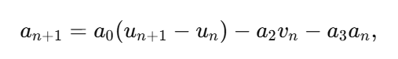

Where ,

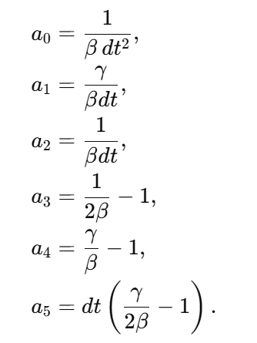

As we can see the acceleration term depends upon the current displacement, previous step displacement, velocity and acceleration. Since we are training the PINNs network at each time step so the values of acceleration, displacement and velocity can be saved from the previous step and can be used to calculate the acceleration for the current time step. The velocity calculation can be done using the following equation-



Also to be note that the collocations points used in the previous and current step should be same to maintain the consistency. Since we are using ramp loading initial acceleration will be zero as the initial force is zero. The loss function will include the pde loss and boundary losses. So using this hybrid approach I want to solve the above vibration problem using PINNs only in the time domain combaining it with the finite element method to take care of time part.