**4 Project Organization**

All organizational aspects of the projects are recorded here. Internal and external entities and how they will collaborate with one another will be defined here.

**4.1 External Structure**

The client for this project is David Brown. The team leader will communicate with said client via email or meeting and relay information to the rest of the team.

Another external entity is the MLS website and its affiliates. The team leader will be communicating with affiliates via email.

**4.2 Internal Structure**

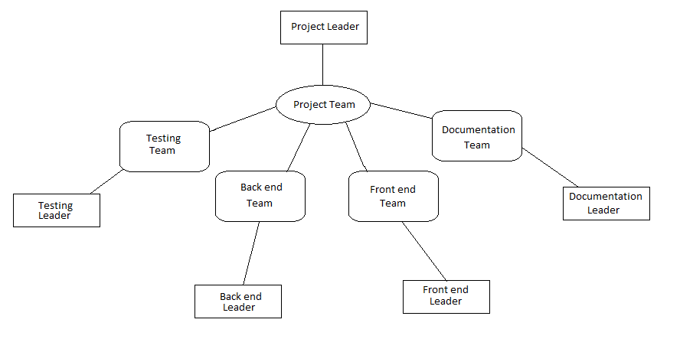

The internal structure of the team is based around 4 distinct divisions. Each division of the project team assigns a leader that represents said division. They are expected to attend regular meetings with other leaders to discuss progress in their division. The project leader represents the entire team and will be communicating with all external entities.

Each division will be expected to organize regular meetings that all members of the division will attend.

Communication with all members of the team and/or division will be done using Slack as the primary tool.

Decisions will be made democratically where members will vote (leaders votes are worth the same as regular members).

**4.3 Roles and Responsibilities**

|  |  |
| --- | --- |
| Role | Responsibilities |
| Project Leader | * Attend regular meetings with other team leaders as well as meetings with assigned division * Lead communicator with client (David Brown) * Lead communicator with MLS affiliates * Help other team members to best of their knowledge |
| Team Leader | * Attend regular meetings with other team leaders as well as meetings with assigned division * Lead their division into executing tasks to the best of their ability * Organize teams to deliver work on time as expected |
| Front End Members | * Deliver working code as expressed in project guidelines * Create an appealing, user-friendly experience * Work with back end team to integrate all parts to be working as intended |
| Back End Members | * Deliver working code as expressed in project guidelines * Create an easy-to-navigate, working back end server * Work with front end team to integrate all parts to be working as intended |
| Documentation Members | * Document **all** code done by front end and back end teams * Organize all documentation to be easy navigable * Create a page that is user-friendly and easy to understand |
| Testing Members | * Test all code to be correctly working and functioning as intended * Notify other team members if work does not meet team standards * Document what has been tested and confirm that it is working |

In addition to this, all members are expected to:

* Work with team to produce best possible result
* Meet expected deadlines to deliver work
* Attend regular meetings with rest of group members

**5 Management Process Plan**

The project start-up plan, risk management plan, project work plan, project control plan and project closeout plan are defined here

**5.1 Project Start-up Plan**

The resources to start the project are defined here. This sub clause will include the estimation plan, staffing plan, resource acquisition plan and training plan.

**5.1.1 Estimation Plan**

The team hopes to have the project done by the end of the semester. If re-estimation is inevitable, the team will set up a meeting to discuss how the schedule will be re-estimated using their confidence in their skills. Re-estimation will not be done on a planned basis, but when needed.

**5.1.2 Staffing Plan**

The project team has a fixed staff that was made at the start of the project.

**5.1.3 Resource Acquisition Plan**

The project team has been given all required resources at the beginning of the project. All team members are expected to have:

* A Github account that is in the project repository
* A Slack account to communicate with project members
* An Ezemployee account to record time spent on project
* A computer to work on
* A development tool to work on project

**5.1.4 Project Staff Training Plan**

Project staff will be trained to work on project through regular attendance of class.

Github training is to be held to teach members how to use this project repository platform.

**5.2 Work Plan**

Work activities and the schedule and resources are defined here

**5.2.1 Work Activities**

To be defined with project team

**5.2.2 Schedule and Resource Allocation**

To be defined with project team

**5.3 Control Plan**

The metrics, reporting mechanisms, and control procedures necessary to measure, report, and control the product requirements, the project schedule, budget, and resources, and the quality of work processes and work products are defined here

**5.3.1 Requirements Control Plan**

All changes in requirements will call a team meeting to discuss all changes in guidelines, scope, and quality.

Two main techniques include:

* Traceability - Any change in the project can be directly traced back to the requirements plan.
* Impact Analysis - Team will discuss impact of change

**5.3.2 Schedule Control Plan**

Each member of the team will make their own individual efforts to consult the project schedule and meet deadlines. Upon missing a deadline, the schedule will be updated accordingly through discussion among division members.

Each team member is expected to record time spent working on each part of the project and whether they will meet the deadline that is set on the schedule.

**5.3.3 Quality Control Plan**

Each member of the team is expected to produce work that is correct and maintains the team’s standards of quality. To ensure this, the Testing team will be regularly testing code to be working as intended and take action if it does not meet team standards. They will be expected to notify the team that produced the fault to be corrected as quickly as possible.

**5.3.4 Reporting Plan**

There will be 3 main reporting mechanisms that will be used by the project team

They are as follows:

* Regular meetings: The team will regularly get together and reporting may be done verbally among group members
* Slack: Reports can be done through the team’s main communication tool
* Asana: Tickets can be made in Asana that will notify members that a report has been made and the details of said report

**5.3.5 Metrics Collection Plan**

The website Ezemployee will be used to collect project metrics. Project members will be expected to log their time spent working through the website to be easily validated, analyzed, and reported.

**5.4 Risk Management Plan**

Risk factors that the project will face includes work that does meet deadline due to class conflicts, external responsibilities, unforeseen circumstances. This will be constantly tracked and if a conflict is met, actions will be taken place including an attempt to have another team member take over to meet deadline.

Integration between front end and back end may not work as expected and will be met with a meeting between all members of both teams to discuss necessary steps to take.

The use of a version control system will allow the team to revert back to working code in the event of a fault-introducing commit.

**5.5 Project Closeout Plan**

Upon completion of the software project in December of 2017, the client will be given:

* the final copy of the project
* all documentation for the project
* a log of all commits and events from September 2017 to December 2017