

**4th Year Plan**

|  |  |
| --- | --- |
|  |  |

**Information**

Student Name: Sjors van Gelderen

Student ID: 090338

Variation: PR/~~VA/DP~~

Home address: Nieuwstraat 10, 3311XR, Dordrecht

Mobile phone: +31(0)623177461

Link to portfolio: http://sjors.musings.eu/

Date: 28-09-2016

Credit status: 141 credits

Starting block: A/~~B/C/D~~

Supervisor preferred choice: Fernando Cabello Domingo

**Please indicate which option you have chosen for the current semester of your Graduation year:**

* ~~Work placement~~
* Personal Project
* ~~Own company~~
* ~~Echange (First half of your 4th year)~~
* ~~Minor (Block A & B only)~~

**Personalised learning plan**

1. **Competency profile:**

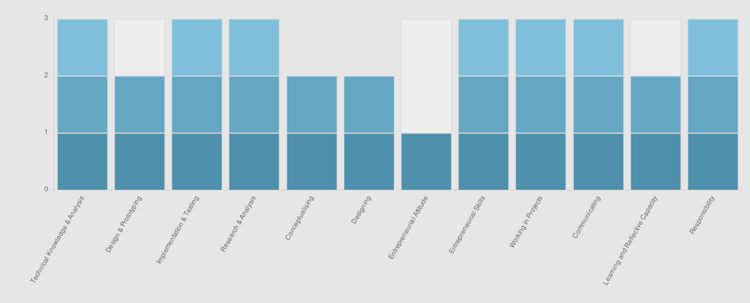

1. **Identify the objectives you wish to address during this year in order to progress your competency profile (or complete if this is your final semester):**

**Python 3 programming**

Threading, asynchronous processes, regular expressions, classes, iterators and more.

Intimate familiarity with programming in Python 3.

Done through writing a series of programs demonstrating these concepts.

**C# programming**

Design patterns, iterators, interfaces, lambdas, asynchronous processes and more.

Intimate familiarity with programming in C#.

Done through writing a series of programs demonstrating these concepts.

**F# programming**

Lambdas, monads, asynchronous processes and more.

Done through writing a series of programs demonstrating these concepts.

**Note: This objective was removed with the supervisor’s permission**

**C++ programming**

Providing Python 3 bindings for a basic C++ library.

Done through writing a library and demonstrating the Python 3 bindings with a script.

**Analysis**

Understanding empirical and complexity(Big O) analysis.

Lists, stacks, queues, hash tables, binary trees, graphs.

Elementary dynamic programming.

Studied using books and online articles. Notes demonstrated where available.

**Note: Set theory / category theory removed with the supervisor’s permission**

**Mathematics**

Mathematical induction proof, basic set theory, basic category theory.

Studied using books and online articles. Notes demonstrated where available.

1. **Planning**

Complete and update this during your first 3 weeks.

**The project did not start with a detailed planning due to the uncertainty of my new job’s schedule. Instead of this, there has been regular contact with the supervisor about the project status and priorities.**

**Assignment Description**

The aim of the project is to prepare for professionally teaching students selective aspects of computer science. I will be studying a variety of concepts in programming and mathematics, and demonstrate my understanding of them as described in the relevant sections of this document.

**Background**

*Leading figures in relevant areas:*

Python 3

*Guido van Rossum*

*Author of the Python programming language.*

*Author of the web-based code review system Mondrian*

*Currently employed by Dropbox*

*Pieter Spronck*

*Author of “The Coder’s Apprentice”*

*PhD from research into adaptive game artificial intelligence*

*Associate professor at Tilburg Center for Cognition and Communication*

F#

*Don Syme*

*Designer and architect of the F# programming language*

*Creator of generics in the .NET CLR*

*Co-author of the book “Expert F# 3.0”*

C#

*Anders Hejlsberg*

*Lead architect of the C# programming language*

*Core developer of TypeScript*

*Author of Turbo Pascal and chief architect of Delphi*

Category theory

*Giuseppe Longo & Andrea Asperti*

*Authors of “Categories, Types and Structures”*

*Bartosz Milewksi*

*PhD in Theoretical Physics*

*Co-designer and implementer of the D programming language*

*CEO of Reliable Software*

***Information sources relevant to the research area:***

Longo & Asperti (1991). Categories, Types and Structures.

*Excellent book on category theory for programmers.*

Syme, Granicz & Cisternino (2015). Expert F# 4.0.

*In-depth book about advanced F# programming.*

Troelsen (2012). Pro C# 5.0 and the .NET 4.5 Framework.

*In-depth book about advanced C# programming.*

Spronck (2016). The Coder’s Apprentice.

*In-depth book about advanced Python programming.*

Trudaeu (2003). Introduction to Graph Theory.

*Introductory graph theory book.*

Sedgewick & Wayne (2011). Algorithms.

*In-depth book about algorithms.*

Cormen, Stein, Rivest & Leiserson (2009). Introduction to Algorithms.

*In-depth book about algorithms.*

***Current level of knowledge, interest and research***

At the start of this project I have basic knowledge of Python 3, intermediate knowledge of C#, F# and C++, and limited knowledge of complexity analysis.

I’m interested in concurrent and asynchronous programming, as well as modern functional concepts. In addition, I want to learn about complexity analysis.

My work placement introduced me to category theory, functional programming with F# and design patterns in C#. Part of the project is a continuation of the research performed during my work placement.

Since I have limited knowledge of mathematics, the analysis aspect of the project will be the most challenging.

It is important to me that I gain an intimate understanding of the related concepts, so that I may improve as a computer scientist.

**Assignment Learning outcomes and deliverables**

Learning Outcomes:

*Please consult the objectives section, which contains the subjects I intend to study. The goal is to gain a solid understanding of the mentioned concepts.*

Final deliverables:

**Python 3 programming**

Several programs clearly and correctly demonstrating the mentioned concepts.

**C# programming**

Several programs clearly and correctly demonstrating the mentioned concepts.

**F# programming**

Several programs clearly and correctly demonstrating the mentioned concepts.

**Note: This objective was removed with the supervisor’s permission**

**C++ programming**

A library and script demonstrating the Python 3 bindings.

**Analysis**

Documentation and scripts relating to empirical analysis experiments performed by me.

Personal notes demonstrated where available.

**Mathematics**

Personal notes demonstrated where available.