**ONLINE REPUTATION MANAGEMENT**

What is ORM?

* ORM stands for Online Reputation Management.
* Online Reputation Management about improving your business or brand’s good standing.
* Your online identify is determined not only by what you post , but also by what others post about you-whether a mention in a blog post , a photo tag or a reply to a public status update.

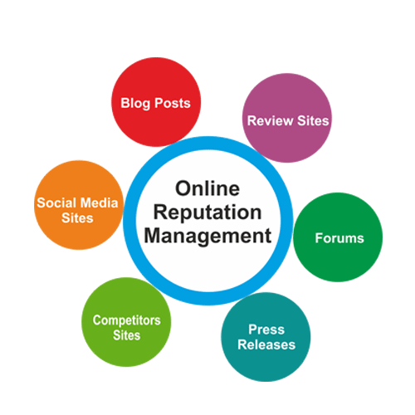

Creating a brand image and substantially maintaining it requires years of commitment and efforts by the marketing team of any company.Protecting are the same is the major concern as every line of business today is growing global with advanced usage of internet. Reputation Management is a boon to the online business.

Importance of

Online Reputation Management

With a positive reputation on the right sites, you can steal opportunities away from your competitors.

But a negative reputation will send customers running for your dealership.

Brands are sold on reputation, so they need to maintain their image and reputation to protect their brand.**ORM is important** for branding, to add sincerity in the brand communication and make it more attractive for customers. For celebrities, their name is their brand.

**Some key statistics…..**

* More than 80% reputation damage risks come from a mismatch between the buzz and the reality (Digimind)
* Reputation risk is the greatest risk facing companies, with us much as 75% of a company’s value based on reputation (Economics Intelligence Unit)
* 92% of Internet Users read product reviews and 89% of people say that reviews influence their purchasing decisions.

“A **Good** Business **Reputation** Gives You a Competitive Advantage. Having an online presence and **good** products and services is **great** for getting customers.

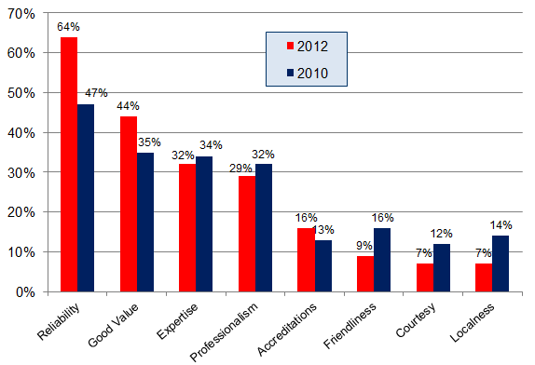**Reputation Management Focus:**

* Maintain confidentiality of clients, products and services.
* Analysis of negative & positive posts.
* Strategic planning & implementation

**Why Online Reputation Management Matters**

How you look online directly impacts your career. Negative items showing up online can damage your career whereas having a positive online reputation leads to career opportunities. There are 4 main reasons why building & managing your online reputation is so important:

1. **People are looking you up online & making decisions about you based on what they find.** Every day, over one billion names are searched on Google and 77% of job recruiters are required to look potential employees up online during the hiring process. While you may not have looked yourself up, it's certain that someone else has - and they are making judgments about you based on what they find. 45% of people have found something in an online search that made them decide NOT to do business with someone.
2. **Anyone can say anything about you online without getting in trouble, whether it’s true or not.** If you upset *anyone* - an ex, a fired employee, someone you received a promotion over - they can go virtually anywhere online and trash you. It happens all the time and there are very little laws in place to protect people under these situations.
3. **Everything we do is now recorded online forever, which means we need more tools to make sure this doesn’t harm us.** We do everything online and we now have the technology to track and store all that activity. That means everything we post on Facebook or Twitter and every item we search for, website we visit, online transaction we make and conversation we have through text or messenger exists *somewhere*. A Facebook status update you made year ago may eventually get you fired. Even more scary, a private email or message you sent to a friend - even if you deleted it - could come back and bite you. We’ve seen hackers invade the privacy of everyone from celebrities on snapchat to major politicians running for president. But, it isn’t just hackers you need to worry about. Outdated laws that have not kept up with Technology - like the ECPA - make it easier than ever for people to access information you thought was private.
4. **Having good content online helps you, but most people don’t know how to do it:** In an increasingly competitive economy, more and more companies, schools and customers are looking for positive information about you on the web. However, most people don’t know what they can do to increase the positive footprint they can have on the web and build a positive online reputation.

https://www.reputationmanagement.com/#intro-09