**What is ReTargeting and How Does it Work?**

Retargeting, also known as remarketing, is a form of online advertising that can help you keep your brand in front of bounced traffic after they leave your website. For most websites, only 2% of web traffic converts on the first visit. Retargeting is a tool designed to help companies reach the 98% of users who don’t convert right away.

**How Does ReTargeting Work?**

Retargeting is a cookie-based technology that uses simple Javascript code to anonymously ‘follow’ your audience all over the Web.

Here’s how it works: you place a small, unobtrusive piece of code on your website (this code is sometimes referred to as a pixel). The code, or pixel, is unnoticeable to your site visitors and won’t affect your site’s performance. Every time a new visitor comes to your site, the code drops an anonymous browser cookie. Later, when your cookied visitors browse the Web, the cookie will let your retargeting provider know when to serve ads, ensuring that your ads are served to only to people who have previously visited your site.

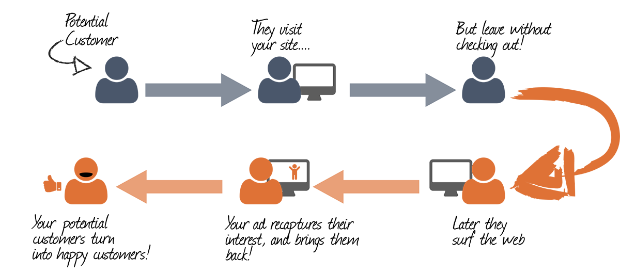

Retargeting is so effective because it focuses your advertising spend on people who are already familiar with your brand and have recently demonstrated interest. That’s why most marketers who use it see a higher ROI than from most other digital channels.

**When Does ReTargeting Work?**

Retargeting is a powerful branding and conversion optimization tool, but it works best if it’s part of a larger digital strategy.

Retargeting works best in conjunction with inbound and outbound marketing or demand generation. Strategies involving content marketing, AdWords, and targeted display are great for driving traffic, but they don’t help with conversion optimization. Conversely, retargeting can help increase conversions, but it can’t drive people to your site. Your best chance of success is using one or more tools to drive traffic and retargeting to get the most out of that traffic.

here’s a lot of technology out there right now around marketing to people who’ve already come in contact with your brand. Whether they visited your site, saw an ad someplace else, clicked on a PPC ad, or filled out a form on your site, you now have the capability to market to them again.

The great thing about these tools is they give marketers the ability to target users already interested in your product or service. You can market to customers already in the buying cycle (and that have expressed a high level of purchase intent) and since these tools are typically pretty inexpensive, you can create some incredible ROI.

## Here’s a quick overview of retargeting in action:

1) A user visits your website.

2) They leave the site without completing any call to action.

3) They browse other sites.

4) Your ad appears on another web page that the user is visiting (thanks to ‘cookies’).

5) The user, having previously been interested in your website, clicks on the ad and returns to your site, where they complete the call to action (for example, they purchase your product).

## What’s the difference between retargeting and remarketing?

While the words ‘retargeting’ and ‘remarketing’ are sometimes used interchangeably, they have some important differences.

When it comes to retargeting vs. remarketing, the main difference is in the strategy. Retargeting is mostly about serving ads to potential customers based on cookies while remarketing is usually based on email. Remarketing works by collecting the information of users and creating lists, which are used later to send sales emails.

Retargeting and remarketing are both effective methods in their own right, yet a combination of both may be the best strategy to boost your digital marketing activity and improve your bottom line.

Successful retargeting needs a solid ad campaign, high-quality content marketing, and other strategies that can help drive traffic to your site (after all, they have to visit your website first in order to be retargeted.) Retargeting is one part of a complete digital marketing strategy – it doesn’t happen in a vacuum.

One way to approach retargeting is using a professional retargeting service, such as [Retargeter](https://retargeter.com/), [Perfect Audience](http://www.perfectaudience.com/) or [Google Remarketing](http://www.google.com/ads/innovations/remarketing.html). Services such as these can assist with creating effective ads, manage your tracking, and provide customized data to help optimize your retargeting campaigns.

For those with sufficient performance marketing experience, you might want to manage your own retargeting campaigns. Check out [these advanced retargeting tips](https://www.outbrain.com/blog/advanced-retargeting-tips/) to help maximize your success.

## Who is retargeting good for?

Retargeting is an effective and helpful digital marketing strategy for every type of business, selling any kind of product or service, Small to medium businesses, and large corporations alike can benefit from retargeting, which is all about turning potential customers into paying customers.

You already know [what retargeting is](https://www.criteo.com/what-is-retargeting/), but did you know that not all retargeting campaigns work the same way? For instance, retargeting campaigns can be static or dynamic, depending on your marketing goals. At the end of the day, you want to see a return on your retargeting investment, but this doesn’t mean the most technologically advanced solution will always create the most value.

Whether you use static or dynamic retargeting to re-engage customers who leave your website depends on:

* Your type of business
* The type of conversions you’re looking to drive

Below is a self-assessment to help you choose between the two.

### ****What is dynamic retargeting?****

[Dynamic retargeting](https://www.criteo.com/for-marketers/products/criteo-dynamic-retargeting/) creates unique ads for each individual customer. In most instances, this involves machine learning technology that analyzes individual behaviors to figure out which creative elements will entice an individual to return and make a purchase. Dynamic tends to be the solution that gets the most attention.

You should use dynamic retargeting if you’re running an ecommerce business with a massive product catalog. When and why someone buys one item or another depends on countless factors, so using a technology that crunches the numbers for you will save you money and time.

Here’s what dynamic retargeting looks like in action. Jeff arrives on a sports apparel company’s website, looks at a thermal running jacket, and then leaves. The retargeting partner gathers data on Jeff’s behavior [across other websites, social media platforms, and devices](http://www.criteo.com/resources/cross-device-commerce-report-h2-2016/). The machine learning algorithm determines when Jeff is most likely to convert, creates a personalized ad based on Jeff’s preferences, and then delivers that ad when he intends to buy the jacket.

Read More: [*3 Travel Companies that Soared with Dynamic Retargeting*](https://www.criteo.com/insights/travel-dynamic-retargeting/)

### ****What is static retargeting?****

A static retargeting strategy creates several formats of the same advertisement as a part of a greater marketing campaign. After placing them on your ad serving platform, you set predetermined conditions that dictate which ads people see based on the pages they visit on your site.

Overall, static campaigns are ideal if you’re trying to aggregate leads or spread awareness of a specific product or service. You want people to revisit your site to gather more information, whether that be through a gated asset or on a product page.

Say you developed a marketing campaign around an eBook. You create four ads that direct people to the eBook. Each one is triggered when a visitor browses a specific product page or article on your site. One ad may target people who looked at the product, while another may appeal to those who read articles about a topic similar to that of your eBook.

### ****Consider static retargeting if …****

* **You’re a B2B business**: The purpose of your website is to generate leads and inform your target audience.
* **Your product/service portfolio is small or custom**: You may only offer a few services or price products based your client’s needs.
* **You want to run a specific campaign or offer**: You want to retarget your visitors but are only promoting a single product or offer.
* **You target marketing personas**: You want your ads to be specific to a few different types of customers, but not individual customers .
* **You need control over creative**: If you’re running a specific type of campaign, you may want to dictate the look and character of your ads.

**Consider dynamic retargeting if …**

* **You’re an ecommerce business**: Your site exists to sell products or services, and your inventory contains thousands of items that appeal to a range of customers.
* **You have a large inventory**: You sell several different items and have several product categories.
* **You target a broad customer base**: You may actually target hundreds of thousands, or millions of customers, all of which have different intentions when they visit your website.
* **Your customers have specific tastes**: The products within your inventory may appeal to people with very different wants and needs. For example, two people may really like Nike running shoes, but prefer different colors and levels of arch support.