南京航空航天大学
计算机学院

计算机网络实验设计报告

课 题： 模拟nat协议
姓 名： 李元成
学 号： 161630216
班 级： 1616302
指导教师： 杜庆伟
时 间： 2019.5.4

- 绪论（可以包括实验目的、实验内容）
1、实验目的：
要求学生掌握Socket编程技术，以及模拟nat的工作过程
2、实验内容：
i. 要求学生掌握利用Socket进行编程的技术
ii. 系统有3个内部主机（进程代替，下同）、一个NAT代理主机、一个外部主机。
iii. 内部主机A向外部主机发动连接发送报文。
iv. NAT代理主机获取报文，找到空闲的端口，替换IP地址和端口，发送给外部主机
v. 外部主机返回应答报文，
vi. NAT代理主机获取报文，找到A的信息，替换IP地址和端口，发送给外部主机
vii. 必须采用图形界面，查看处理的过程

- 设计思路
数据交互格式定义为Message类。
数据接受者抽象为MessageReceiver类。
数据发送者抽象为MessageSender类。
计算机抽象为一个包含一个MessageReceiver成员变量和一个MessageSender成员变量的类，名字为Computer。
NAT转换器继承Computer类，并添加NAT维护功能。
WEB服务器继承Computer类，并添加一个回复功能。
用例图

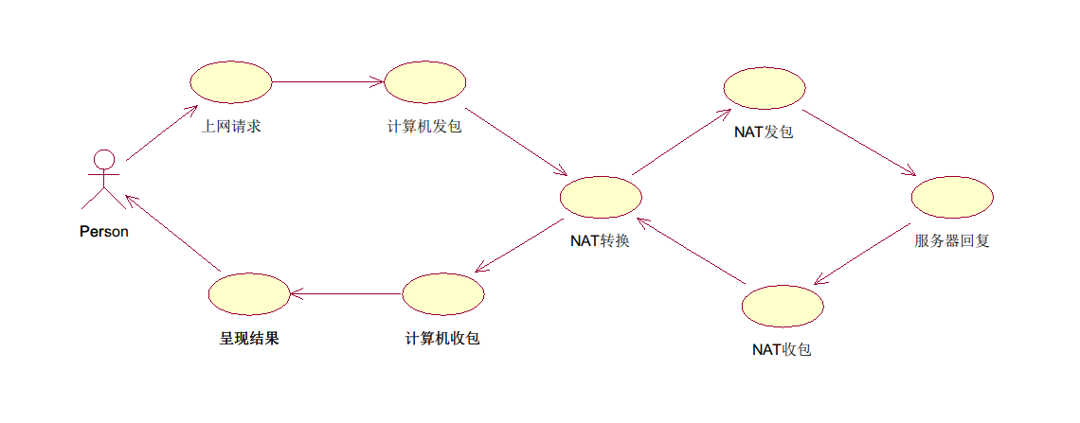
活动图
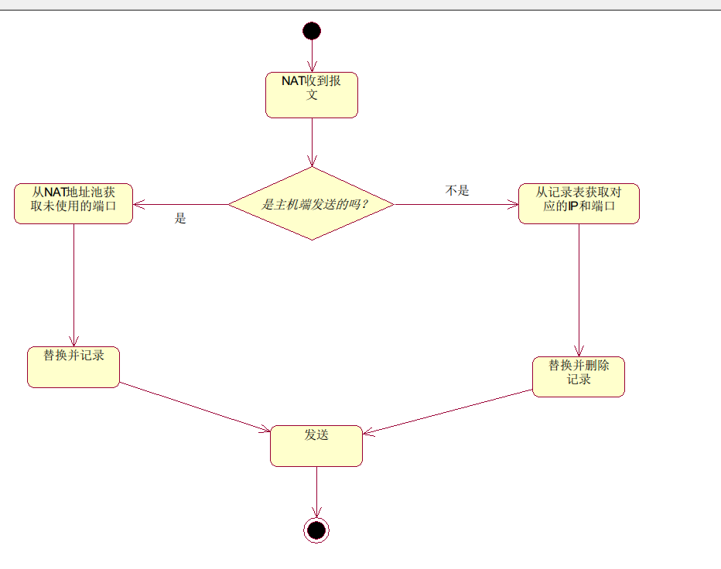

时序图
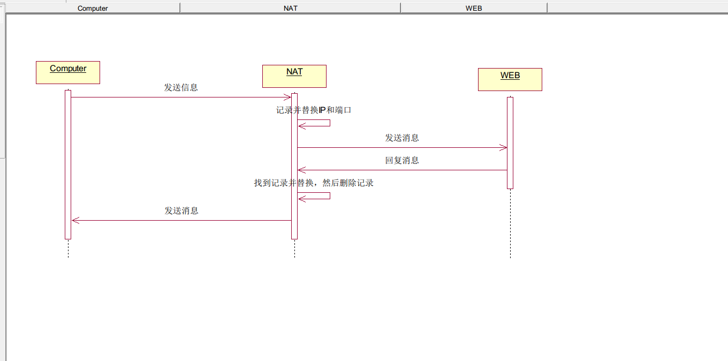
图形界面
主机
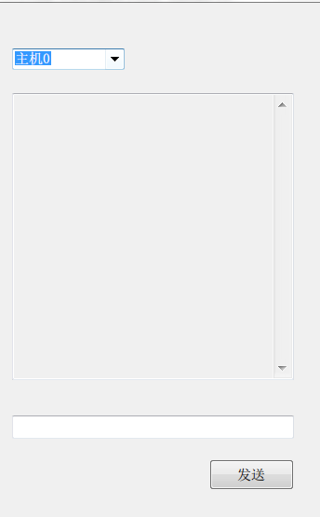
NAT
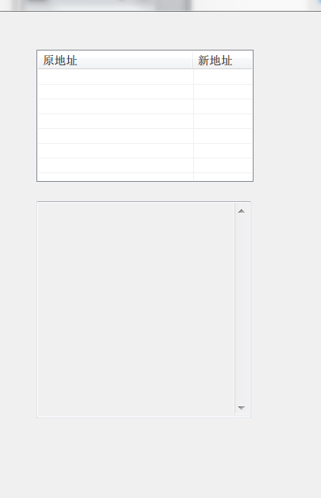
WEB

- 算法实现及分析（重点）
- class Message
- {
- private IPAddress SourceIpAddress;
- private IPAddress TargetIpAddress;
- private int Sourceport;
- private int Targetport;
- private string message;
- public Message(IPAddress IpAddress, int port, string message)；
- }
- void Transform(Message message)
- {

- if (message.getTargetport()==Computer.port)
- {
- for ( port in PortlList)
- {
- if (port.Value==null) //找到未使用的端口
- {
- Message(message.getTargetIpAddress(),message.getTargetport(),message.getMessage());
- tranMessage.setSourceIpAddress(ipAddress);
- tranMessage.setSourcePort(port.Key); //替换端口和IP
- NATList.Add(port.Key,temp); //更新列表
- Send（）；
- break;
- }
- }
- }

- else
- {

- NATList.Remove(message.getTargetport());
- PortlList[message.getTargetport()].StopListen();
- PortlList[message.getTargetport()] = null; //找到并删除记录
- message.setTargetPort(temp.Port);
- message.setTargetIpAddress(temp.Address); //替换端口和IP
- Send();
- }
- }

Message类有源地址的IP端口和目标地址的IP端口，以及一个string包含信息。
NAT收到包之后判断是内部端还是外部端，如果是内部端，则从维护的NAT表中取出一个未使用的端口，并把它标记为已使用并启用监听，然后把包的源地址的IP和端口替换为NAT的IP和取出的端口并记录下映射关系。如果是外部端，则找出NAT表中和包中目标端口相等的端口，把它标记为未使用。根据映射关系把NAT表中目标IP端口替换，删除映射关系。发送替换后的包。

4. 设计体会与小结
我通过这次课设加深了关于NAT的理解，训练了多线程和事件编程。回顾起此课程设计，至今我仍感慨颇多，从理论到实践，在这段日子里，可以说得是苦多于甜，但是可以学到很多很多的东西，同时不仅可以巩固了以前所学过的知识，而且学到了很多在书本上所没有学到过的知识。通过这次课程设计使我懂得了理论与实际相结合是很重要的，只有理论知识是远远不够的，只有把所学的理论知识与实践相结合起来，从理论中得出结论，才能真正为社会服务，从而提高自己的实际动手能力和独立思考的能力。在设计的过程中遇到问题，可以说得是困难重重，但可喜的是最终都得到了解决。

5. 附录(源代码，要有每一段代码的注释)
Message.cs
- class Message
- {
- private IPAddress SourceIpAddress;
- private IPAddress TargetIpAddress;
- private int Sourceport;
- private int Targetport;
- private string message;

- public Message(IPAddress IpAddress, int port, string message)
- {
- TargetIpAddress = IpAddress;
- Targetport = port;
- this.message = message;
- }

- public IPAddress getTargetIpAddress()
- {
- return TargetIpAddress;
- }

- public int getTargetport()
- {
- return Targetport;
- }

- public void setTargetPort(int port)
- {
- Targetport = port;
- }

- public void setTargetIpAddress(IPAddress ip)
- {
- TargetIpAddress = ip;
- }

- public void setSourceIpAddress(IPAddress ip)
- {
- SourceIpAddress = ip;
- }

- public void setSourcePort(int port)
- {
- Sourceport = port;
- }

- public IPAddress getSourceIpAddress()
- {
- return SourceIpAddress;
- }

- public int getSourceport()
- {
- return Sourceport;
- }

- override
- public string ToString()
- {
- return String.Format("{{\r\n Source {0}:{1}\r\n Target {2}:{3}\r\n Message:{4}\r\n}}\r\n", SourceIpAddress,Sourceport,TargetIpAddress,Targetport,message);
- }

- public string getMessage()
- {
- return message;
- }

- }

MessageReceiver.cs
- class MessageReceiver
- {

- public event Helper.MessageReceivedEventHandler MessageReceived; //注册监听事件
- public Socket listener;
- private Thread workerThread;//多线程监听，可以同时监听多个端口
- private Thread receiveThread;

- public MessageReceiver(int port)
- {

- workerThread = new Thread(()=>ListenThreadMethod(port))
- {
- IsBackground = true
- };
- workerThread.Start(); //启动线程

- }

- private void ListenThreadMethod(int port)
- {
- IPAddress localIp = IPAddress.Parse(Helper.GetInternalIP().ToString());
- listener = new Socket(AddressFamily.InterNetwork, SocketType.Stream, ProtocolType.Tcp);
- listener.Bind(new IPEndPoint(localIp, port)); //绑定IP地址：端口
- listener.Listen(10); //设定最多10个排队连接请求

- while (true)
- {
- if (listener != null)
- {
- try
- {
- Socket clientSocket = listener.Accept();
- receiveThread = new Thread(()=>MessageListener(clientSocket));
- receiveThread.Start();
- }
- catch
- {

- break;
- }
- }
- }
- }

- private void MessageListener(Socket clientSocket)
- {
- byte[] size=new byte[4];
- clientSocket.Receive(size,0,4,SocketFlags.None);
- int baglength = BitConverter.ToInt32(size,0);//包大小
- byte[] buffer = new byte[8192];
- var ms = new MemoryStream();
- int numberOfBytesRead=0;
- int bytesRead; //协商完毕，开始收包
- do
- {
- bytesRead = clientSocket.Receive(buffer, 0, 8192, SocketFlags.None);
- ms.Write(buffer, 0, bytesRead);
- numberOfBytesRead += bytesRead;
- } while (numberOfBytesRead<baglength);
- ms.Seek(0, SeekOrigin.Begin);//收包完毕，调整迭代器
- if (MessageReceived != null)
- {
- BinaryFormatter b = new BinaryFormatter();
- Message temp = b.Deserialize(ms) as Message;
- ms.Close();
- MessageReceived(temp); // 已经收到消息
- }
- }

- public void StopListen()
- {
- try
- {
- listener.Close();
- listener = null;
- workerThread.Abort();

- }
- catch (Exception e)
- {
- e.ToString();
- }
- }

- }

MessageSender.cs
- class MessageSender
- {
- private Socket client;
- private IPEndPoint ip;
- public delegate void MessageSendEventHandler(Message message);
- public event MessageSendEventHandler MessageSend; //注册发送事件

- public bool Send(IPAddress ip, int port, Message message)
- {
- try
- {
- this.ip = new IPEndPoint(ip, port);
- client = new Socket(AddressFamily.InterNetwork, SocketType.Stream, ProtocolType.Tcp);
- client.Connect(this.ip);//尝试连接

- }
- catch(Exception e)
- {
- e.ToString();
- return false;
- }
- try
- {
- BinaryFormatter b = new BinaryFormatter();
- var ms = new MemoryStream();
- b.Serialize(ms, message);//序列化message
- byte[] datasize = new byte[4];
- datasize = BitConverter.GetBytes(ms.GetBuffer().Length);
- client.Send(datasize);//发送包大小
- client.Send(ms.GetBuffer());//发包
- MessageSend(message);//发包完毕
- return true;
- }
- catch(Exception)
- {
- return false;
- }
- }

- public void SignOut()
- {
- if(client!=null)
- client.Dispose();
- }
- }
Computer.cs
- class Computer
- {
- public MessageSender sender;
- public MessageReceiver receiver;
- public IPAddress ipAddress;
- private int port;

- public Computer()
- {

- }

- public Computer(IPAddress ip,int port)//初始化
- {
- ipAddress = ip;
- this.port = port;
- sender =new MessageSender();
- receiver=new MessageReceiver(port);

- }

- public void SendMessage(IPAddress targetip, int targetport, Message message)
- {
- message.setSourcePort(port);
- message.setSourceIpAddress(ipAddress);//设定源IP和端口
- sender.Send(targetip,targetport,message);//发送
- }

- public void Close()
- {
- sender.SignOut();
- receiver.StopListen();
- }

- public int getport()
- {
- return port;
- }

- public event Helper.MessageReceivedEventHandler MessageReceived //MessageReceived映射给receiver.MessageReceived
- {
- add
- {
- receiver.MessageReceived += value;
- }
- remove
- {
- receiver.MessageReceived -= value;
- }
- }

- public event MessageSender.MessageSendEventHandler MessageSend //MessageSend映射给sender.MessageSend
- {
- add
- {
- sender.MessageSend += value;
- }
- remove
- {
- sender.MessageSend -= value;
- }
- }

- }

NAT.cs
- class NAT:Computer
- {
- public Dictionary<int, IPEndPoint> NATList;//NAT记录表
- public Dictionary<int, MessageReceiver>PortlList;//端口表
- public event Helper.MessageReceivedEventHandler NATReceived; //注册事件

- public event Helper.NATHandler Update;
- public NAT(IPAddress ip, int port):base(ip,port)
- {
- MessageReceived += Transform;
- NATList=new Dictionary<int, IPEndPoint>();
- PortlList=new Dictionary<int, MessageReceiver>();
- for(int i=6700;i<6710;i++)
- PortlList.Add(i,null);

- }

- private void Transform(Message message)
- {
- NATReceived(message);
- Thread.Sleep(1000);
- if (message.getTargetport()==8888)
- {
- foreach (var port in PortlList) //找到未使用的端口
- {
- if (port.Value==null)
- {
- IPEndPoint temp =new IPEndPoint(message.getSourceIpAddress(),message.getSourceport());
- PortlList[port.Key]=new MessageReceiver(port.Key);
- PortlList[port.Key].MessageReceived += Transform;//添加事件
- var tranMessage=new Message(message.getTargetIpAddress(),message.getTargetport(),message.getMessage());
- tranMessage.setSourceIpAddress(ipAddress);
- tranMessage.setSourcePort(port.Key);//替换端口和IP
- NATList.Add(port.Key,temp); //更新列表
- Update();
- sender.Send(message.getTargetIpAddress(),message.getTargetport(),tranMessage);
- break;
- }
- }
- }

- else
- {
- IPEndPoint temp = NATList[message.getTargetport()];
- NATList.Remove(message.getTargetport());
- PortlList[message.getTargetport()].StopListen();
- PortlList[message.getTargetport()] = null;//找到并删除记录
- message.setTargetPort(temp.Port);
- message.setTargetIpAddress(temp.Address);
- sender.Send(temp.Address,temp.Port,message);//替换端口和IP
- Update();
- }
- }

- }

Web.cs
- class WEB:Computer
- {
- public event Helper.MessageReceivedEventHandler WEBReceived;
- public WEB(IPAddress ip, int port) : base(ip, port)
- {
- MessageReceived += Response;
- }

- private void Response(Message message)
- {
- WEBReceived(message);
- Thread.Sleep(1000);
- string temp;
- if (message.getMessage()=="hello") //添加回复
- {
- temp = "hi";

- }
- else if(message.getMessage().Equals("how are you"))
- {
- temp = "I'm fine";
- }

- else
- {
- temp = "what?";
- }
- Thread.Sleep(1000);
- var response = new Message(message.getSourceIpAddress(), message.getSourceport(),temp);
- SendMessage(response.getTargetIpAddress(), response.getTargetport(),response);//发送信息
- }
- }

