要求代码和实验报告规范，在算法思想中：对实验涉及的数据结构进行有效设计和分析；对算法进行分析并给出时间、空间复杂度的结论；清晰表达实验思路、出现的问题及解决方法。

一、调试成功程序及说明
1、
题目：ADT Graph 基本操作13个算法思想：
运行结果：
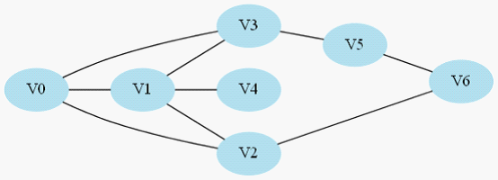
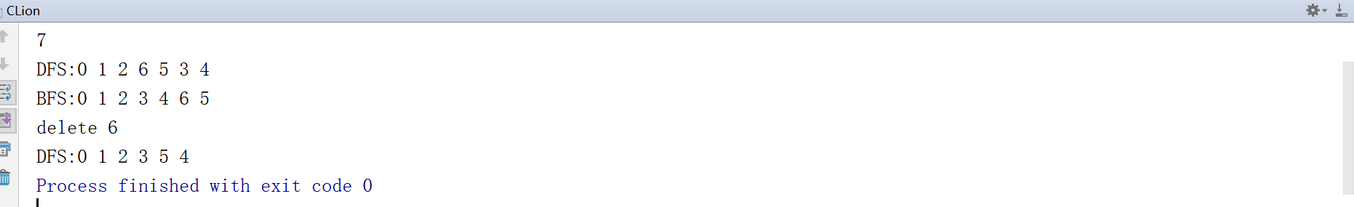
结果分析：正确
附源程序。
#include <iostream>
#include <algorithm>
#include <queue>

using namespace std;
int num[100];
int n;
class treenode {
public:
int data;
treenode *lch;
treenode *rch;
treenode(int s)
{ data=s;
lch=NULL;
rch=NULL;
}

};

void destroy(treenode *node)
{
if(node->lch!=NULL)
destroy(node->lch);
if(node->rch!=NULL)
destroy(node->rch);

delete []node;
}

int main()
{
cin>>n;
for(int k=0;k<n;k++)
scanf("%d",&num[k]);

sort(num,num+n);
treenode *treenode1=new treenode(num[0]);
treenode *treenode2=new treenode(num[1]);
treenode *node=new treenode(num[0]+num[1]);
node->lch=treenode1;
node->rch=treenode2;
for(int k=2;k<n;k++)
{ treenode *temp=node;
treenode *t=new treenode(num[k]);
node=new treenode(num[k]+node->data);
if(node->data>num[k])
{
node->rch=temp;
node->lch=t;
}
if(node->data>num[k])
{
node->lch=temp;
node->rch=t;
}

}
queue<treenode*> q;
q.push(node);
while(!q.empty())
{
treenode *temp=q.front();
if(temp->lch!=NULL)
q.push(temp->lch);
if(temp->rch!=NULL)
q.push(temp->rch);
if(temp->lch==NULL&&temp->rch==NULL)
printf("%d",temp->data);

q.pop();
}

}

2、
题目：输入N个权值（1-100正整数），建立哈夫曼树。
算法思想：无
运行结果：
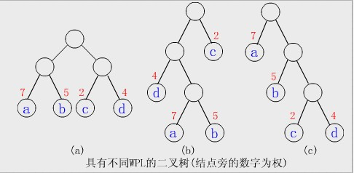
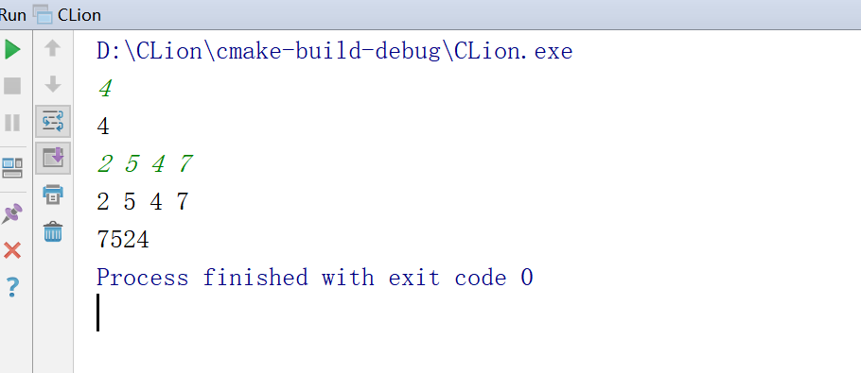
结果分析：正确
附源程序。
#include <iostream>
#include <algorithm>
#include <queue>

using namespace std;
int num[100];
int n;
class treenode {
public:
int data;
treenode *lch;
treenode *rch;
treenode(int s)
{ data=s;
lch=NULL;
rch=NULL;
}

};

void destroy(treenode *node)
{
if(node->lch!=NULL)
destroy(node->lch);
if(node->rch!=NULL)
destroy(node->rch);

delete []node;
}

int main()
{
cin>>n;
for(int k=0;k<n;k++)
scanf("%d",&num[k]);

sort(num,num+n);
treenode *treenode1=new treenode(num[0]);
treenode *treenode2=new treenode(num[1]);
treenode *node=new treenode(num[0]+num[1]);
node->lch=treenode1;
node->rch=treenode2;
for(int k=2;k<n;k++)
{ treenode *temp=node;
treenode *t=new treenode(num[k]);
node=new treenode(num[k]+node->data);
if(node->data>num[k])
{
node->rch=temp;
node->lch=t;
}
if(node->data>num[k])
{
node->lch=temp;
node->rch=t;
}

}
queue<treenode*> q;
q.push(node);
while(!q.empty())
{
treenode *temp=q.front();
if(temp->lch!=NULL)
q.push(temp->lch);
if(temp->rch!=NULL)
q.push(temp->rch);
if(temp->lch==NULL&&temp->rch==NULL)
printf("%d",temp->data);

q.pop();
}

}
3、4
题目：建立一棵以孩子-兄弟链表表示的树、分别输出每一层的结点。
运行结果：
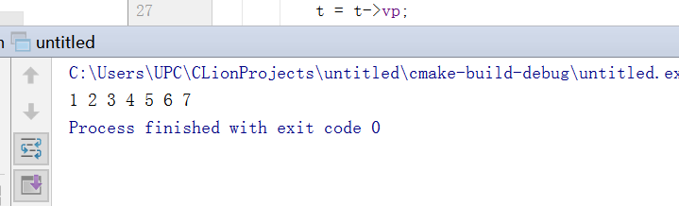
结果分析：正确
附源程序。
#include <iostream>
#include <malloc.h>
#include <queue>

using namespace std;
bool vis[7];
class tree
{
public:
int data;
tree* vp;
tree* hp;
};
void visit(tree *t)
{queue<tree *>q;
q.push(t);
while(!q.empty())
{ t=q.front();
if(vis[t->data]== false)
{
vis[t->data] = true;
printf("%d ", t->data);
}
q.pop();
if(t->vp!=NULL)
{
t = t->vp;
q.push(t);
}

while(t->hp!=NULL)
{
q.push(t->hp);
t=t->hp;
}

}

}
int main()
{
tree *a, *b, *c, *d, *e, *f, *g;
a = (tree *)malloc(sizeof(tree));
b = (tree *)malloc(sizeof(tree));
c = (tree *)malloc(sizeof(tree));
d = (tree *)malloc(sizeof(tree));
e = (tree *)malloc(sizeof(tree));
f = (tree *)malloc(sizeof(tree));
g = (tree *)malloc(sizeof(tree));
a->data = 1;
b->data = 2;
c->data = 3;
d->data = 4;
e->data = 5;
f->data = 6;
g->data = 7;
a->vp = b;
a->hp = NULL;
b->vp = d;
b->hp = c;
c->vp = NULL;
c->hp = NULL;
d->vp = NULL;
d->hp = e;
e->vp = g;
e->hp = f;
f->vp = NULL;
f->hp = NULL;
g->vp = NULL;
g->hp = NULL;
visit(a);
free(a);
free(b);
free(c);
free(d);
free(e);
free(f);
free(g);

}

......

三、小结

