CS349 ASSIGNMENT NUMBER - 4

Application Number – 2
Group Number – 44
Group Members - Saurabh kumar (170123045)
- Rupam sahu (170123041)
- Abhinav anand (170123002)

(1.) Wired TCP Network

Node2___________R1__________R2___________Node3
100Mbps,20ms 10Mbps,50ms 100Mbps,20ms

________ : Wired link

Packet Size (Bytes) | Fairness Index | Average Throughput (Kbps)
40 | 0.792074 | 0.373643
44 | 0.778373 | 0.390663
48 | 0.765761 | 0.407684
52 | 0.754135 | 0.424704
60 | 0.768332 | 0.503218
250 | 0.606155 | 1.40042
300 | 0.604301 | 1.65765
552 | 0.575185 | 2.88526
576 | 0.572457 | 2.98739
628 | 0.573957 | 3.25313
1420 | 0.55652 | 7.11151
1500 | 0.55677 | 7.49639
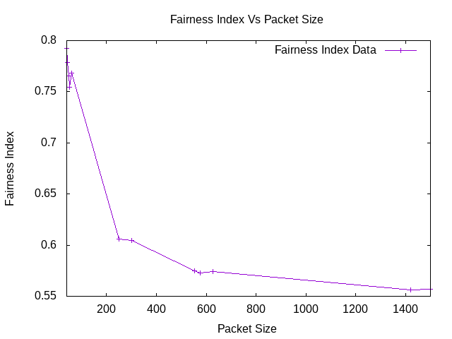
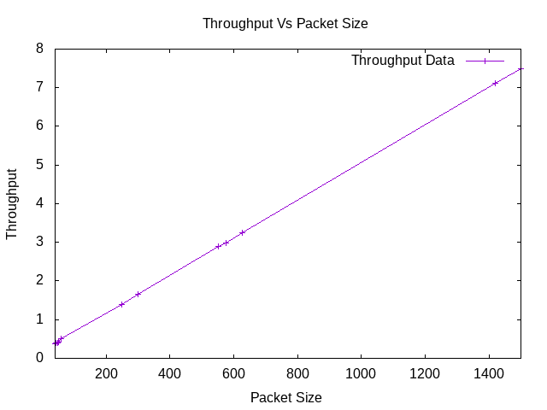

(2.) Wireless TCP Network

Node0---------------BS1__________BS2---------------Node1
100Mbps,20ms 10Mbps,100ms 100Mbps,20ms

________ : Wired
------------ : Wireless

Packet Size (Bytes) | Fairness Index | Average Throughput (Kbps)
40 | 0.768227 | 5.10589
44 | 0.760151 | 5.28753
48 | 0.752712 | 5.41409
52 | 0.745738 | 5.56944
60 | 0.730755 | 5.85345
250 | 0.595852 | 13.0558
300 | 0.583616 | 14.9099
552 | 0.549389 | 24.382
576 | 0.547657 | 25.3872
628 | 0.544104 | 27.224
1420 | 0.520479 | 57.4515
1500 | 0.519423 | 59.9501

