DATATYPES:
DATATYPE IS AN ATTRIBUTE WHICH SPECIFIES WHAT TYPE OF DATA IS STORED INTO A COLUMN.ORACLE SUPPORTS THE FOLLOWING DATATYPES ARE
1) NUMERIC DATATYPES
2) CHARACTER DATATYPES/ STRING DATATYES
3) LONG DATATYPE
4) DATE DATATYPES
5) RAW & LONG RAW DATATYPES
6) LOB DATATYPES(LARGE OBJECTS DATATYPES)
1) NUMERIC DATATYPES:
i) INT
ii) NUMBER(P,S)
INT: STORING INTEGER FORMAT VALUES ONLY.
INT = NUMBER(38)
NOTE: WHEN WE USE “INT” DATATYPE ON COLUMN AT THE TIME OF TABLE CREATION THEN INTERNALLY ORACLE SERVER WILL CONVERT INTO “NUMBER” DATATYPE WITH MAXIMUM SIZE IS 38 DIGITS.
NUMBER(P,S): STORING BOTH INTEGER & FLOAT FORMAT VALUES. HERE THIS DATATYPE IS HAVING FOLLOWING TWO ARGUMENTS ARE PRECISION(P),SCALE(S).
WHEN WE USE ----> NUMBER(P)------> STORE INTEGER VALUES
WHEN WE USE ----> NUMBER(P,S)----> STORE FLOAT VALUES

PRECISION(P):
> COUNTING ALL DIGITS INCLUDING LEFT & RIGHT SIDES OF GIVEN FLOAT EXPRESSION.
Ex: 25.12
PRECISION = 4
Ex: 856.45
PRECISION = 5
Ex: 9999.99
PRECISION = 6
SCALE(S):
> COUNTING ONLY RIGHT DIGITS OF A FLOAT EXPRESSION.
Ex: 25.12
SCALE = 2
PRECISION = 4
Ex:
7456.123
SCALE = 3
PRECISION = 7
2) CHARACTER DATATYPES: STORING "STRING" FORMAT DATA ONLY.IN DATABASE STRING IS REPRESENT WITH SINGLE QUOTES ' <STRING> '.CHARACTER DATATYPES ARE STORING TWO TYPES STRING FORMAT DATA.THOSE ARE
- CHARACTERS ONLY STRING DATA ii) ALPHANUMERIC STRING DATA.

Ex:
CHARACTER DATATYPES
|
< STRING FORMAT DATA >
|
| |
CHARACTERS ONLY ALPHANUMERIC CHAR's
STRING DATA STRING DATA
[ A - Z (or) a - z ] [ A - Z (or) a – z & 0 - 9 &
@,#,$,%,&,_,.......etc ]
Ex: 'SAI', 'ALLEN ',......etc Ex: ' sai123@gmail.com ',....etc
NOTE: CHARACTER DATATYPES ARE AGAIN CLASSIFIED INTO TWO CATEGORIES THOSE ARE
1) NON - UNICODE DATATYPES:SUPPORTING TO STORE LOCALIZED DATA( ONLY ENGLISH LANGUAGE)THESE ARE AGAIN TWO TYPES.
1) CHAR(SIZE):
- IT IS A FIXED LENGTH DATATYPE(STATIC).
- WILL STORE NON-UNICODE CHAR's IN THE FORM OF 1 CHAR = 1 BYTE.
- MAXIMUM SIZE OF CHAR DATATYPE IS 2000 BYTES(2000 CHAR's).
2) VARCHAR2(SIZE):
- IT IS A VARIBALE LENGTH DATATYPE(DYNAMIC).
- WILL STORE NON-UNICODE CHAR's IN THE FORM OF 1 CHAR = 1 BYTE.
- MAXIMUM SIZE OF VARCHAR2 DATATYE IS 4000 BYTES(4000 CHAR's).

DIFFERENCES BETWEEN FIXED LENGTH DATATYPES AND VARIABLE LENGTH DATATYPES:
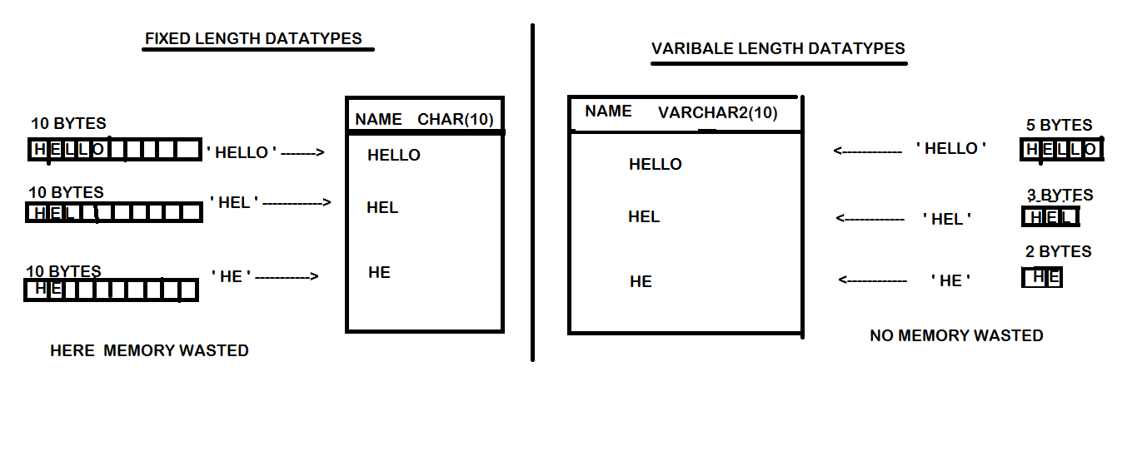
2) UNICODE DATATYPES: THESE DATATYPES ARE STORING "GLOBALIZED DATA" SUPPORTING "ALL NATIONAL LANGUAGES".THESE ARE TWO TYPES,
1) NCHAR(SIZE):
- IT IS FIXED LENGTH DATATYPE(STATIC).
- WILL STORE UNICODE CHAR's (ALL NATIONAL LANG's) IN THE FORM OF
1 CHAR = 1 BYTE.
- MAXIMUM SIZE OF NCHAR DATATYE IS 2000 BYTES(2000 CHAR's).
2) NVARCHAR2(SIZE):
- IT IS A VARIBALE LENGTH DATATYPE(DYNAMIC).
- WILL STORE UNICODE CHAR's IN THE FORM OF 1 CHAR = 1 BYTE.
- MAXIMUM SIZE OF nVARCHAR2 DATATYE IS 4000 BYTES(4000 CHAR's).
3) LONG:
- IT IS VARIBALE LENGTH DATATYPE(DYNAMIC).
- WILL STORE NON-UNICODE & UNICODE CHAR's IN THE FORM OF 1 CHAR = 1BYTE.
- MAXIMUM SIZE OF LONG DATATYE IS 2GB.
4) DATE DATATYPES:
- STORING DATE AND TIME INFORMATION OF A PARTICULAR DAY.
- RANGE OF DATE DATATYPES IS FROM "01-JAN-4712 BC " TO "31-DEC-9999 AD ".
i) DATE: STORING DATE & TIME INFORMATION BUT TIME IS OPTIONAL.IF NOT ENTERED TIME BY USER THEN ORACLE "12:00:00AM".DEFAULT FORMAT OF DATE DATATYPE IS 'DD-MON-YYYY / YY HH: MI: SS '.IT OCCUPIED 7 BYTES OF MEMORY (FIXED MEMORY).
ii) TIMESTAMP: STORING DATE & TIME INFORMATION ALONG WITH MILLISECONDS.DEFAULT FORMAT OF DATE DATATYPE IS 'DD-MON-YYYY / YY HH: MI: SS.MS'. IT OCCUPIED 11 BYTES OF MEMORY (FIXED MEMORY).
5) RAW & LONG RAW: STORING IMAGE / AUDIO / VIDEO FILES IN THE FORM OF 010010101001 BINARY FORMAT.THE MAXIMUM SIZE OF RAW DATATYPE IS 2000 BYTES AND LONG RAW SIZE IS 2 GB.
6) LOB DATATYPES (LARGE OBJECTS):
i) BLOB (BINARY LARGE OBJECT): STORING IMAGE / AUDIO / VIDEO FILES IN THE FORM 010010101001 BINARY FORMAT.THE MAXIMUM SIZE IS 4GB.
ii) CLOB (CHARACTER LARGE OBJECT): STORING NON-UNICODE CHARACTERS.THE MAXIMUM SIZE IS 4GB.
iii)N CLOB(NATIONAL CHARACTERS LARGE OBJECT):STORING UNICODE CHARACTERS.THE MAXIMUM SIZE IS 4GB.
NOTE:
> CHAR IS UPTO 2000 BYTES > NCHAR IS UPTO 2000 BYTES
> VARCHAR2 IS UPTO 4000 BYTES >NVARCHAR2 IS UPTO 4000 BYTES
> CLOB IS UPTO 4 GB >NCLOB IS UPTO 4 GB
> RAW IS UPTO 2000 BYTES > LONG RAW IS UPTO 2GB
> BLOB IS UPTO 4 GB.

