**Objective**

**Satish Kumar**

React Developer

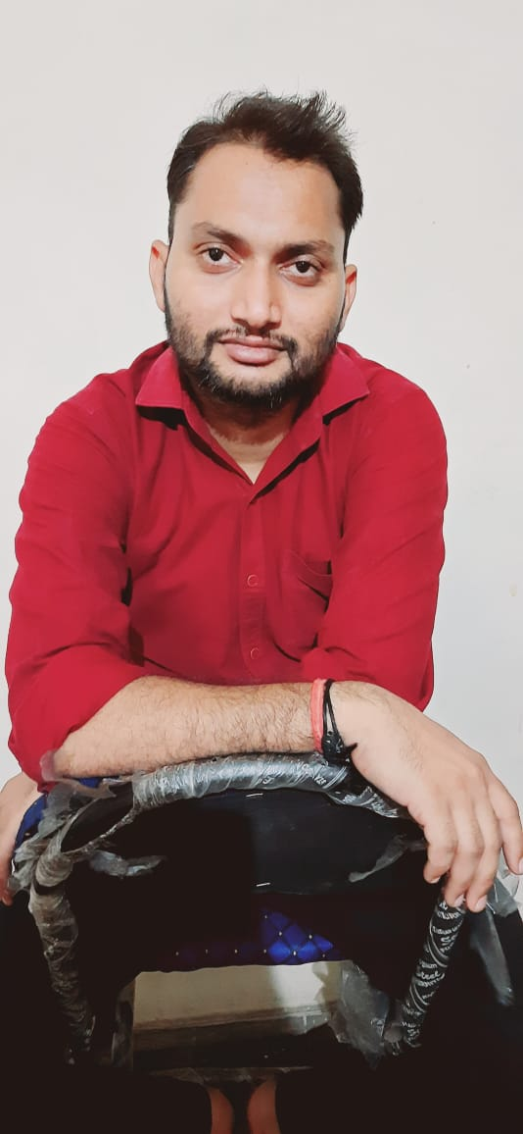

To work for an organization which provides me the opportunities to improve my skills and knowledge to grow along with the organization objective.

**Education**

**ABOUT ME**

A professional React Developer from past 1 years and a working Professional as a Process Associate in Paytm Payments Bank.

|  |  |  |  |
| --- | --- | --- | --- |
| **Qualification** | **Institute** | **Board** | **Completion Year** |
| B.E | Institute of Technology & Management | RGPV | 2017 |
| Xiith | Dr. Radhakrishnan International School | CBSE | 2012 |
| Xth | Dr. Radhakrishnan International School | CBSE | 2010 |

**Experience**

* 4 years of working experience as a Process Associate in Paytm Payments Bank.
* 5 Months working experience in E-commerce Company as an E-commerce Executive.
* 6 Months working experience in Axis Bank as an Associate in Gold Loan.

**Projects**

**kumarsatish4895@gmail.com**

* E-Commerce Admin Panel.
* Project was based on modern interface development For Ecommerce Admins to Manange All Things. IT is developed using REact, Node Js, MongoDB, Bootstrap.

**+91-9354038857**

* Online Food Website.

Project was based on modern interface development For Online Food Orders. IT is developed using HTML,CSS & Javascript.

**LANGUAGES**

**English     **

**Hindi     **

**Skills**

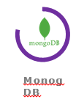

Fluent grip on HTML, CSS and Javascript concepts.

Understanding of core react concepts like DOM manipulation, Babel transpiler and directory structure.

Knows how to sync workflows from different modules