**2022-08-Backend Final Project**

**Shannon Hahn**

**GitHub Repository Link: https://github.com/SkHahn/FinalProjectPromineo**

**Youtube Link: https://youtu.be/1EihTbkYePg**

Tables shown after building Food Truck database in MySQL workbench:

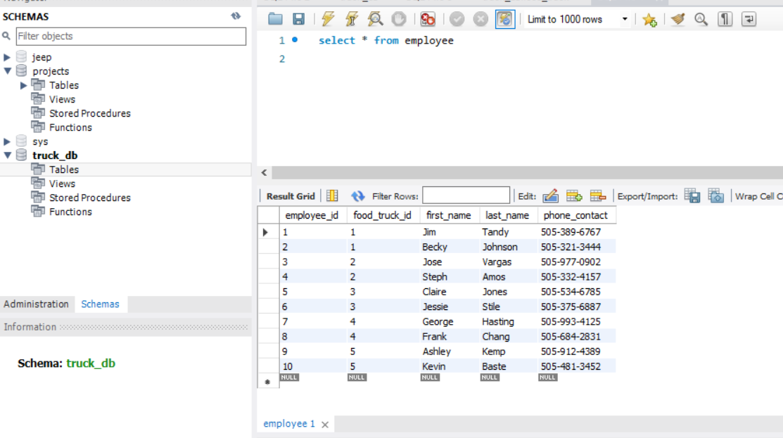

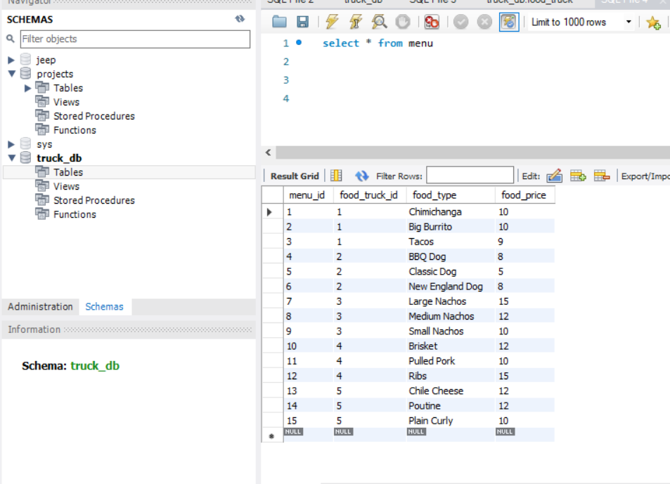

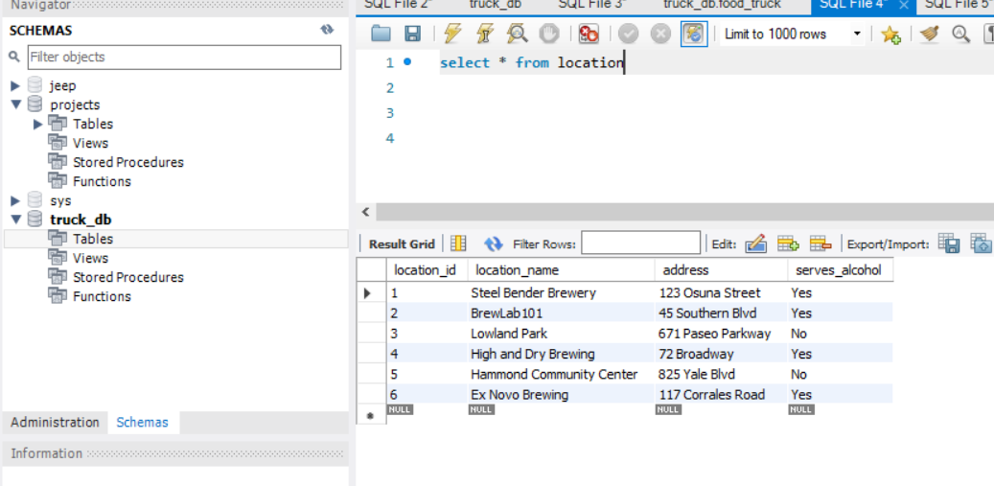

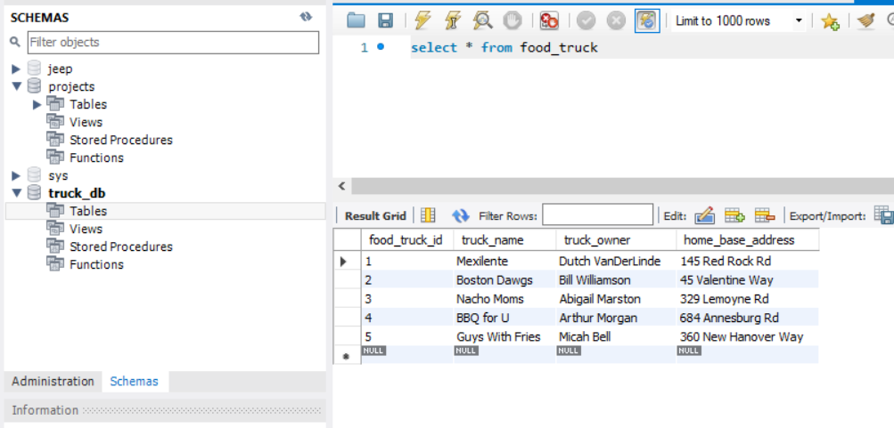

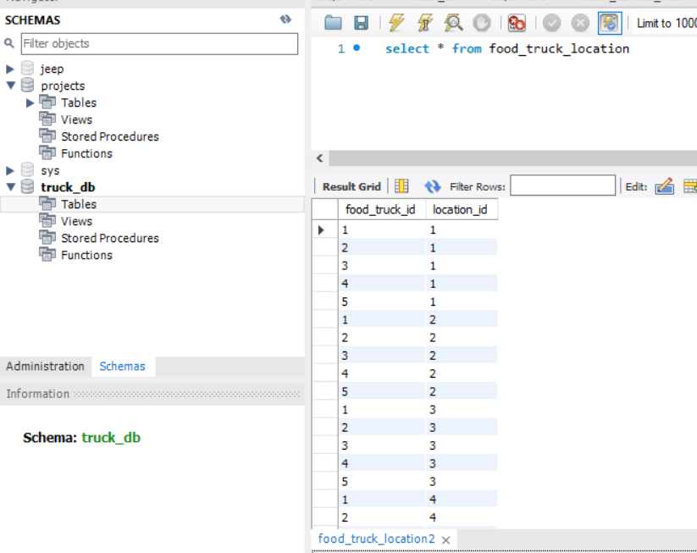

Entity Relationship Diagram:

