Project_submission

* Jenkins (login page, configuration settings, execute step commands)

Login page:

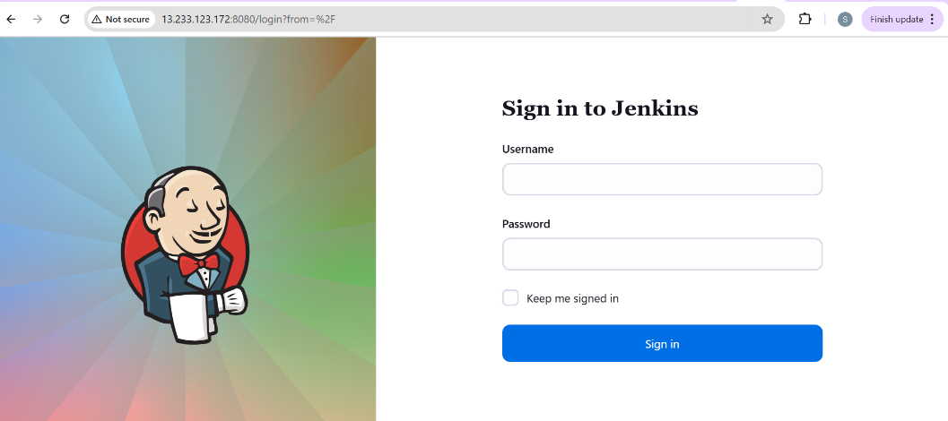

Configuration settings:

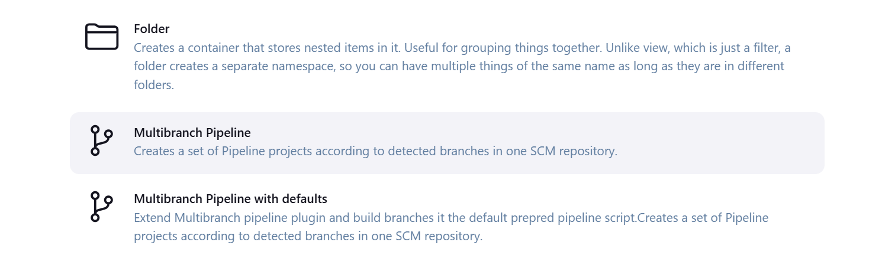

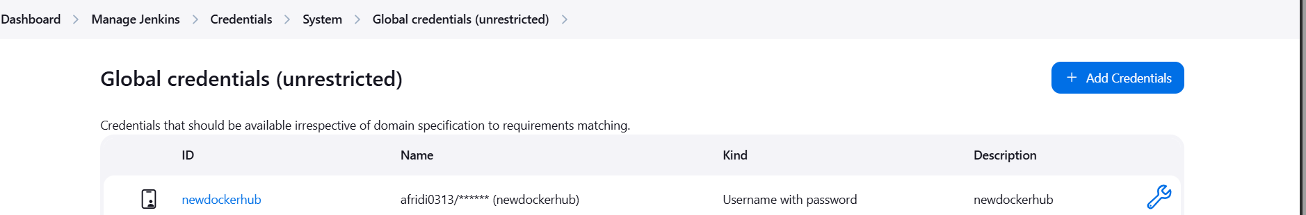

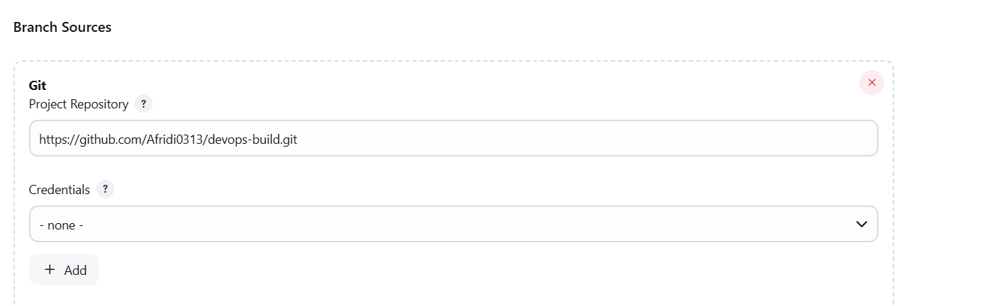

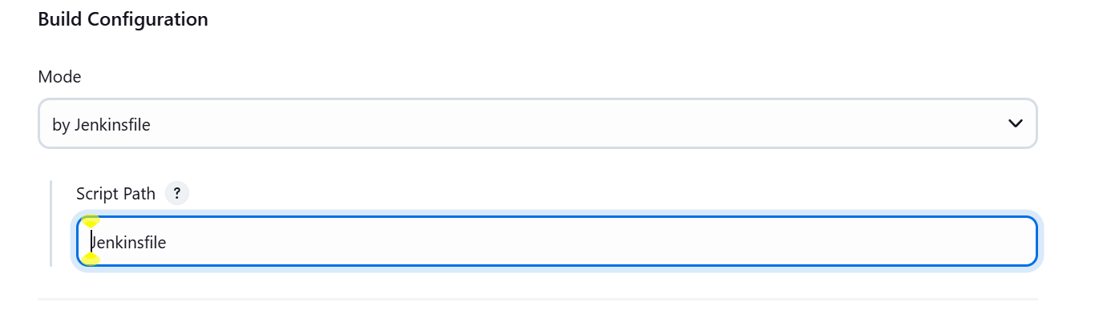

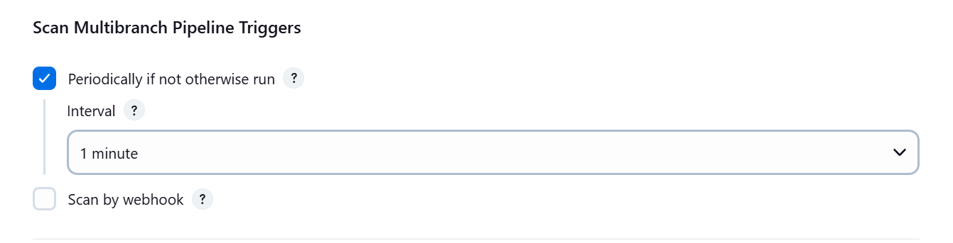

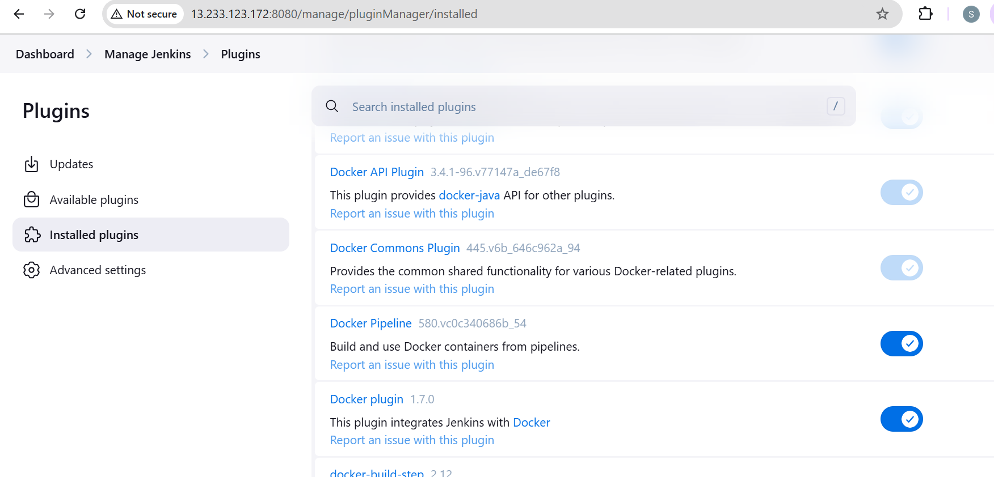

sAWS (EC2-Console, SG Configs)

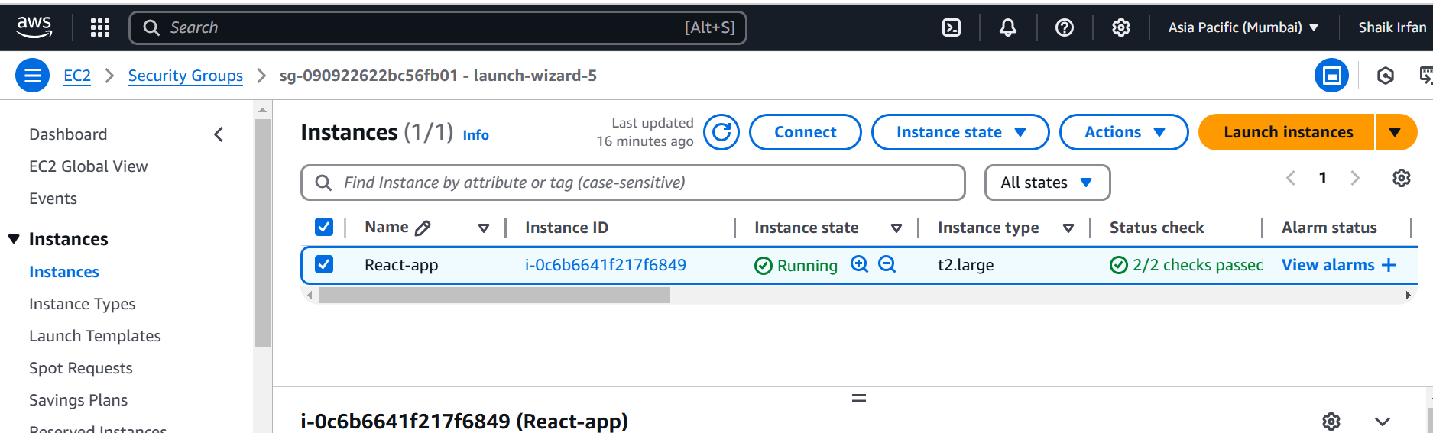

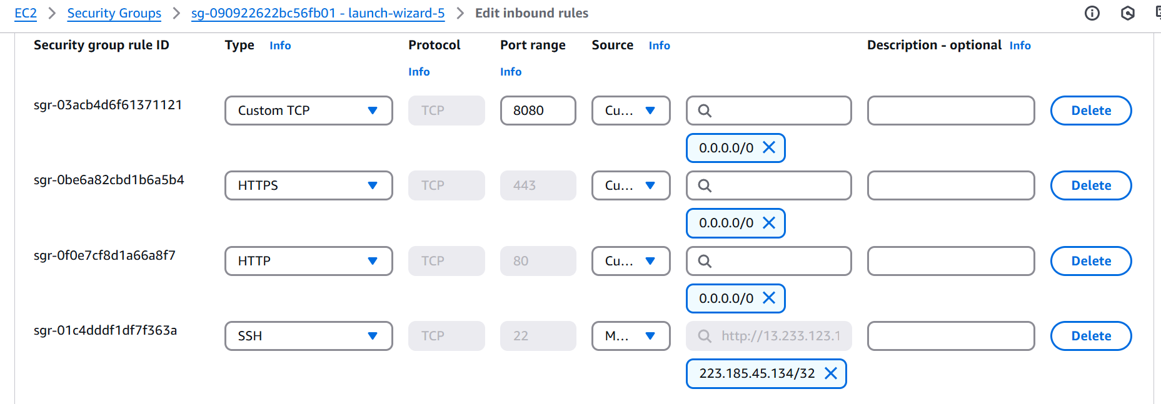

Docker hub repo with image tags

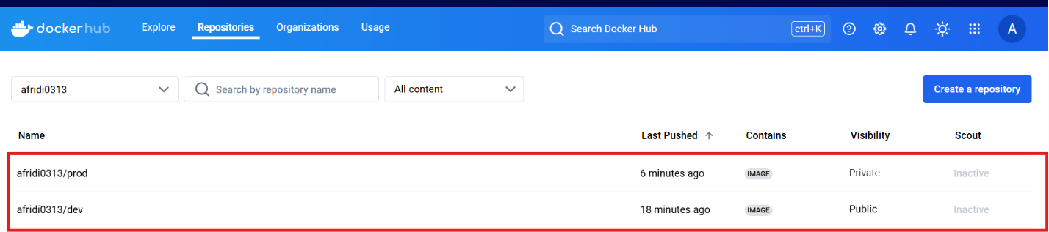

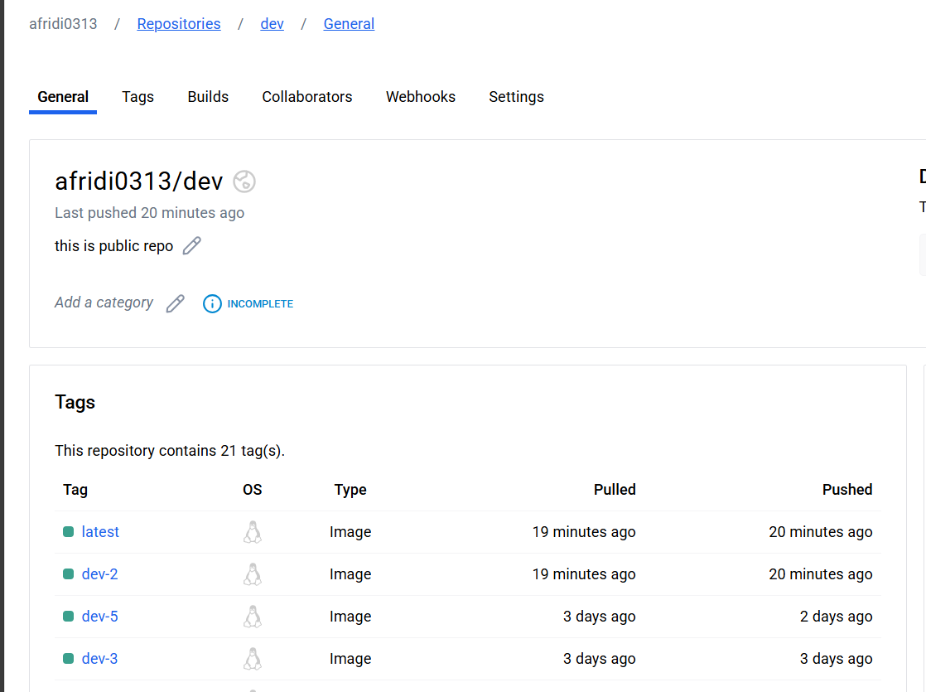

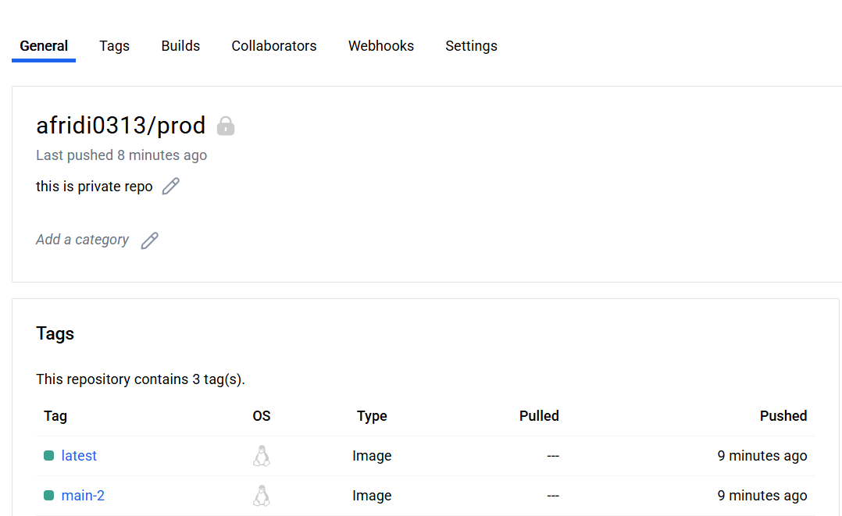

•

Deployed site page

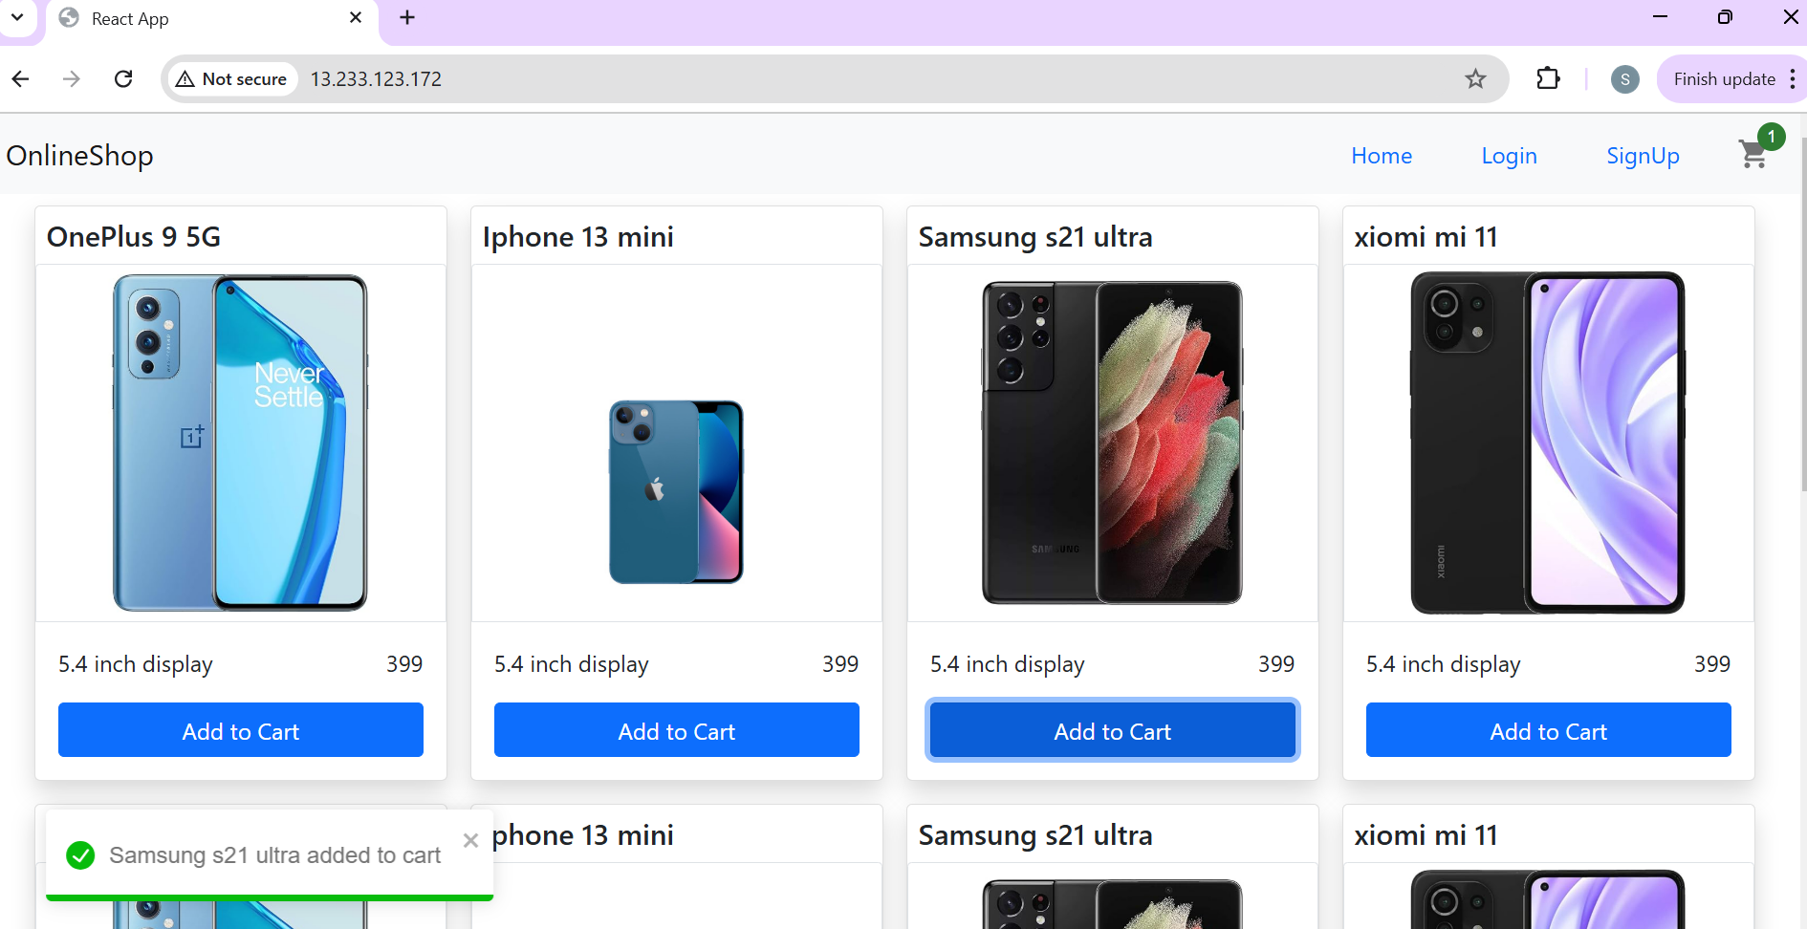

Monitoring health check status

