Create a chatbot in Python

* Introduction

This document presents the development and implementation of a chatbot using the PALM API. The chatbot is designed to engage in natural language conversations with users, providing information, answering questions, and assisting with various tasks.

1. API Integration Integration of the PALM API into the chatbot application.
2. Chatbot Functionality: Development of chatbot capabilities, including natural language understanding, context management, and response generation.
3. User Interaction: Implementation of user interfaces for interacting with the chatbot, such as web interfaces or messaging platforms.

* API Integration

To enable the chatbot to utilize the PALM API, the API credentials and endpoints were configured. These credentials are used to make API calls for text generation and conversation management.

* Chatbot Functionality

The chatbot is designed to understand and generate human-like text responses. It leverages the PALM model's capabilities to engage in dynamic, context-aware conversations. The chatbot can be initialized with a conversation history, enabling it to remember and respond coherently to user queries.

Example code for initializing the chatbot and generating responses:

import google.generativeai as palm

palm.configure(api_key="YOUR API KEY")

defaults = {

'model': 'models/chat-bison-001',

'temperature': 0.25,

'candidate_count': 1,

'top_k': 40,

'top_p': 0.95,

}

context = ""

examples = []

messages = []

messages.append("NEXT REQUEST")

response = palm.chat(

**defaults,

context=context,

examples=examples,

messages=messages

)

print(response.last) # Response of the AI to your most recent request

* User Interaction

User interaction with the chatbot can be facilitated through various channels such as web applications, messaging platforms, or voice interfaces. These interfaces allow users to input their queries, and the chatbot responds accordingly.

* Testing and Optimization

The chatbot undergoes rigorous testing to evaluate its performance and accuracy. Testing includes real-user interactions and automated testing scripts to cover a wide range of use cases. Optimizations are applied to improve response quality and ensure context-aware conversations.

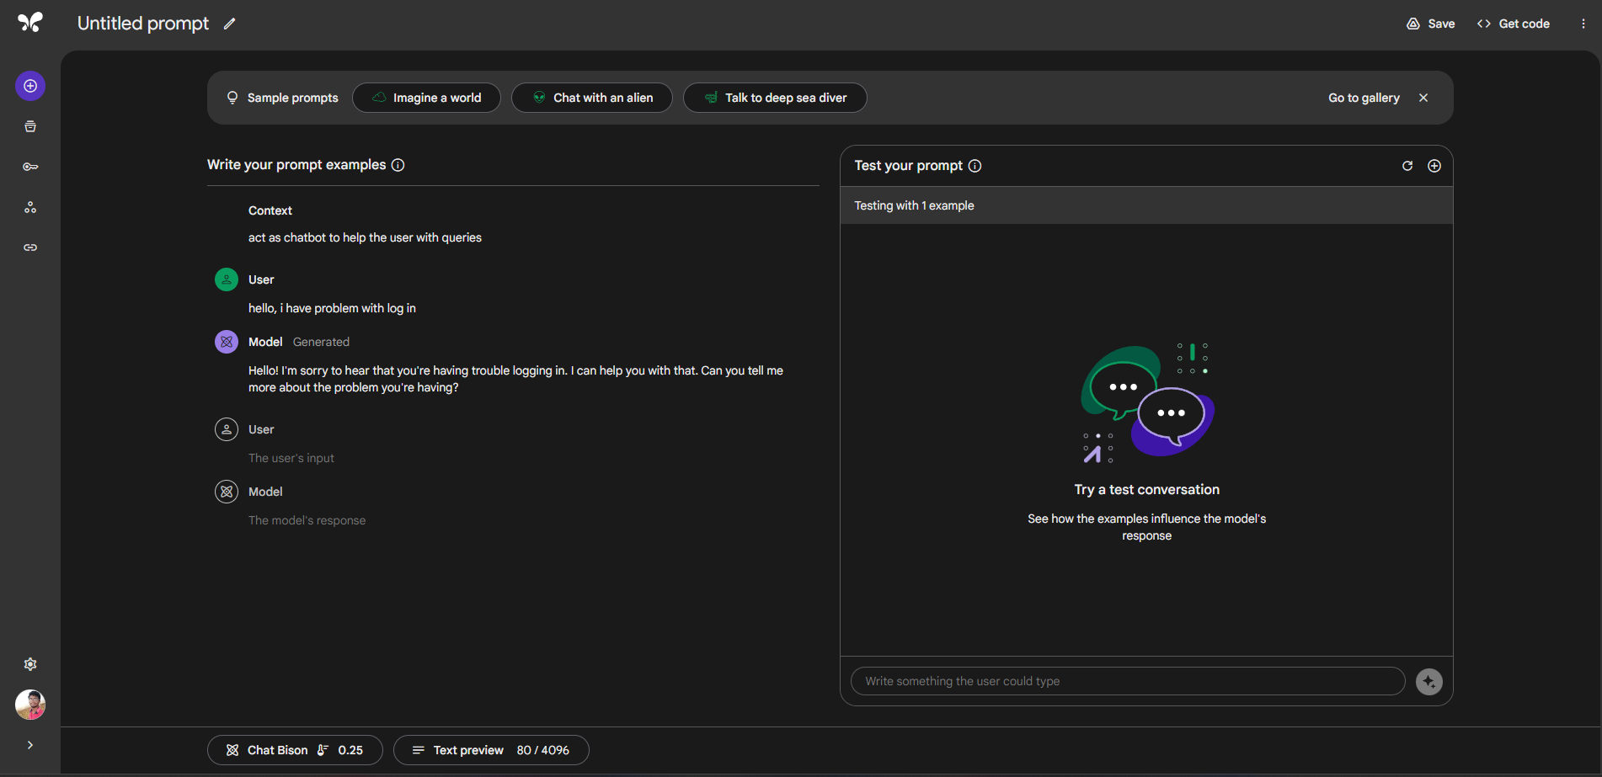

Conclusion

Building a chatbot using the Palm Api opens up numerous possibilities for natural language understanding and interaction. In Phase3 we written key steps involved in the project, from API integration to chatbot functionality and user interaction. Continuous testing and refinement are essential to ensure that the chatbot delivers meaningful and accurate responses to users.

The success of the project depends on the quality of the training data, the choice of prompt engineering, and the effective management of conversation history. Future enhancements may include multilingual support, domain-specific knowledge, and integration with additional platforms and services.