**Create a chatbot in Python**

**Introduction**

In this phase of the project, we focus on selecting a machine learning algorithm, training the model, and evaluating its performance. The aim is to enhance the capabilities of our chatbot through the power of artificial intelligence.

**1. Algorithm Selection**

PaLM 2 is a state-of-the-art large language model (LLM) developed by Google AI. It is a successor to the PaLM LLM, which was released in 2022. PaLM 2 is trained on a massive dataset of text and code, and it is able to perform a wide range of tasks, including:

* Generating text: PaLM 2 can generate text in a variety of formats, including poems, code, scripts, musical pieces, emails, and letters. It can also generate different creative text formats.
* Translating languages: PaLM 2 can translate text between more than 100 languages. It is particularly good at translating nuanced text, such as idioms and poems.
* Answering questions: PaLM 2 can answer questions in a comprehensive and informative way, even if they are open ended, challenging, or strange.
* Coding: PaLM 2 can generate code in a variety of programming languages, including Python, JavaScript, and Java. It is also able to understand and follow code instructions.

**2. Model Training**

**a. Data Preparation**

As there is not data is provided , model will tuned according to the user requirement using Prompt tuning

**b. Training Procedure**

There are two main ways to train a chatbot using PaLM:

* **Prompt tuning:** This is a zero-shot learning approach, where the model is not directly trained on any data. Instead, it is given a set of prompts that describe the desired behavior of the chatbot. For example, one prompt might be "Be a customer service chatbot that is helpful and polite." The model then learns to generate responses that are consistent with these prompts.
* **Fine-tuning:** This is a supervised learning approach, where the model is given a set of training data that consists of pairs of user inputs and desired chatbot responses. The model then learns to generate responses that are similar to the desired responses, given the user inputs.

Prompt tuning is generally faster and easier than fine-tuning, but it may not be as effective for complex tasks. Fine-tuning is more effective, but it requires more training data and can be more computationally expensive.

We are using Prompt tuning for this Project:

The training procedure for prompt tuning is relatively straightforward:

1. Prepare the prompt. The prompt should be clear and concise, and it should describe the desired task and the context in which it should be performed. For example, a prompt for a customer service chatbot might be "Be a customer service chatbot that is helpful and polite."
2. Tune the prompt parameters. Prompt tuningtypically involves a small number of hyperparameters that control how the prompt is interpreted by the LLM. These hyperparameters can be tuned using a simple grid search or other optimization algorithm.
3. Evaluate the model. Once the prompt has been tuned, the model can be evaluated on a held-out test set. This will help to ensure that the model is able to generalize to new data.

**3. Performance Evaluation**

To ensure that the chatbot is providing meaningful and accurate responses, it's vital to evaluate its performance. Several metrics can be considered, including:

**a. Response Quality**

* Assess the quality of text responses generated by the chatbot. Evaluate whether they are contextually relevant and coherent.

**b. Automated Testing**

* Implement automated testing scripts that simulate real-user interactions with the chatbot.
* Evaluate the chatbot's performance across a range of common and edge use cases.

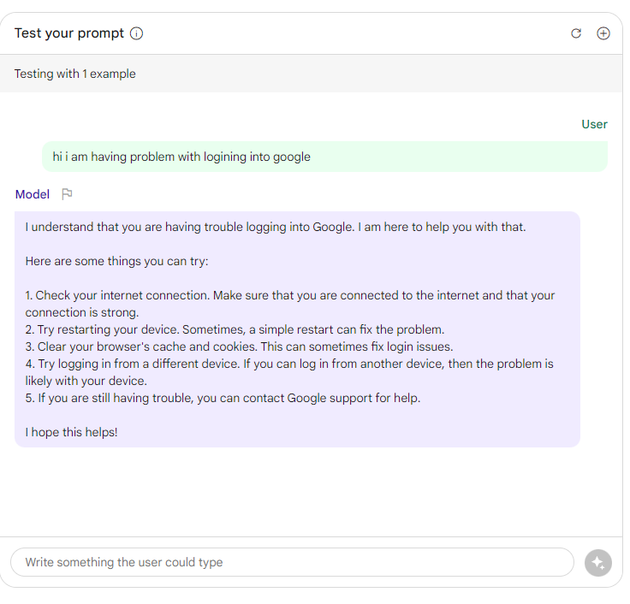

**4. Model Refinement**

Based on the performance evaluation results, make necessary refinements to improve the chatbot's capabilities. This may involve adjusting hyperparameters, expanding the training dataset, or refining the chatbot's responses to specific queries.

**Conclusion**

The selection of a suitable machine learning algorithm, effective model training, and thorough performance evaluation are critical steps in enhancing the capabilities of the chatbot. Continuous refinement and optimization are essential to ensure that the chatbot delivers meaningful and context-aware responses to users.