**Create a chatbot in Python**

**Problem Definition:**

The challenge is to create a chatbot in Python that provides exceptional customer service, answering user queries on a website or application. The objective is to deliver high-quality support to users, ensuring a positive user experience and customer satisfaction.

**Design Thinking Process**

Our approach to solving the problem follows a structured design thinking process:

1. **Empathize**: Understanding the needs of our users and the limitations of our existing chatbot.
2. **Define**: Clearly defining the problem we aim to solve, which is enhancing the chatbot's capabilities using advanced AI.
3. **Ideate**: Brainstorming potential solutions, which led us to the adoption of the PaLM 2 machine learning model.
4. **Prototype**: Developing and testing our chatbot with PaLM 2 to see how well it performs.
5. **Test**: Rigorously testing the chatbot's performance and refining it based on user feedback and automated testing.

**Phases of Development**

**The project is organized into several phases:**

1. **Algorithm Selection**: We selected the PaLM 2 machine learning model as our primary choice due to its versatility in performing a wide range of tasks.
2. **Model Training:** We adopted the prompt tuning approach as our training method to ensure the chatbot responds effectively to user queries.
3. **Performance Evaluation:** We evaluate the chatbot's performance in terms of response quality and automated testing to ensure it meets user expectations.
4. **Model Refinement:** Based on the performance evaluation results, we refine the chatbot to make improvements.

**Dataset Used**

Unlike traditional machine learning projects, our project does not rely on a fixed dataset. Instead, we take advantage of the prompt tuning technique, allowing us to customize the model's behaviour and training based on our project's specific requirements.

**Data Pre-processing and Feature Extraction**

Given the absence of a conventional dataset, our focus shifts from traditional data pre-processing and feature extraction to crafting effective prompts that accurately guide the model's behaviour.

**Algorithm**

PaLM 2 is a state-of-the-art large language model (LLM) developed by Google AI. It is a successor to the PaLM LLM, which was released in 2022. PaLM 2 is trained on a massive dataset of text and code, and it is able to perform a wide range of tasks, including:

* Generating text: PaLM 2 can generate text in a variety of formats, including poems, code, scripts, musical pieces, emails, and letters. It can also generate different creative text formats.
* Translating languages: PaLM 2 can translate text between more than 100 languages. It is particularly good at translating nuanced text, such as idioms and poems.
* Answering questions: PaLM 2 can answer questions in a comprehensive and informative way, even if they are open ended, challenging, or strange.
* Coding: PaLM 2 can generate code in a variety of programming languages, including Python, JavaScript, and Java. It is also able to understand and follow code instructions.

**Model Training**

There are two main ways to train a chatbot using PaLM:

* **Prompt tuning:** This is a zero-shot learning approach, where the model is not directly trained on any data. Instead, it is given a set of prompts that describe the desired behavior of the chatbot. For example, one prompt might be "Be a customer service chatbot that is helpful and polite." The model then learns to generate responses that are consistent with these prompts.
* **Fine-tuning:** This is a supervised learning approach, where the model is given a set of training data that consists of pairs of user inputs and desired chatbot responses. The model then learns to generate responses that are similar to the desired responses, given the user inputs.

Prompt tuning is generally faster and easier than fine-tuning, but it may not be as effective for complex tasks. Fine-tuning is more effective, but it requires more training data and can be more computationally expensive.

We are using Prompt tuning for this Project:

The training procedure for prompt tuning is relatively straightforward:

1. Prepare the prompt. The prompt should be clear and concise, and it should describe the desired task and the context in which it should be performed. For example, a prompt for a customer service chatbot might be "Be a customer service chatbot that is helpful and polite."
2. Tune the prompt parameters. Prompt tuningtypically involves a small number of hyperparameters that control how the prompt is interpreted by the LLM. These hyperparameters can be tuned using a simple grid search or other optimization algorithm.
3. Evaluate the model. Once the prompt has been tuned, the model can be evaluated on a held-out test set. This will help to ensure that the model is able to generalize to new data.

**Evaluation Metrics**

Our evaluation metrics are two-fold:

* **Response Quality**: We evaluate the quality of the text responses generated by the chatbot. The assessment focuses on context, relevance, and coherence.
* **Automated Testing**: By implementing automated testing scripts, we simulate real-user interactions and assess the chatbot's performance across a spectrum of use cases.

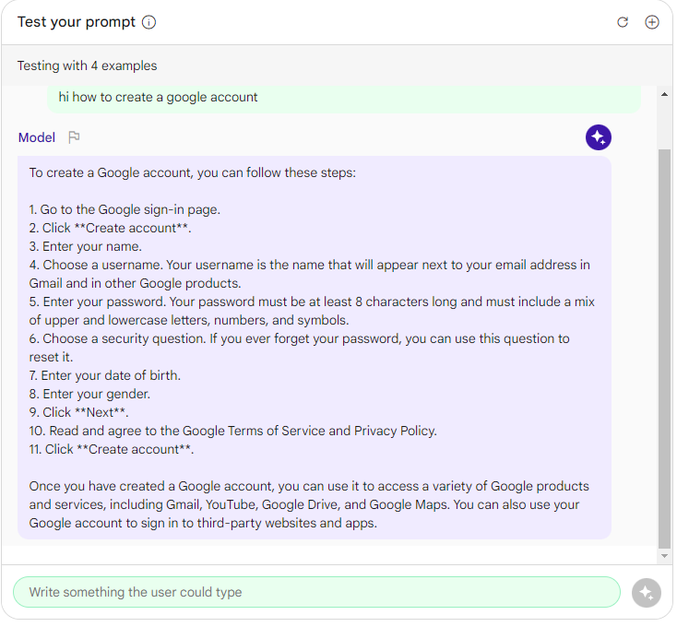

**Conclusion:**

In this project, we embarked on a journey to enhance the capabilities of our chatbot through the application of advanced artificial intelligence. The ultimate goal was to create a chatbot that could understand and generate natural language responses effectively, answer user queries comprehensively, translate languages, and even generate code. We employed a structured design thinking process and divided the project into distinct development phases to achieve this objective.