Design California Ultra-Speed Rail Ticket Reservation System

Functional components:

1. User Registration/Login/Logout
2. Ticket Booking (search, book, cancel)
3. Admin (reset ticket booking information, reset train capacity, cancel a train and rebook)
4. Database (User, Ticket, Train, Station_Schedule, etc)

Architecture Design: Angular4 + SpringBoot

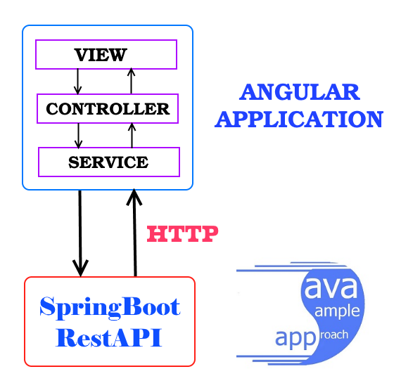

REST API provides:

1. User
   1. CREATE new User (POST)
   2. UPDATE User information (PUT)
   3. VIEW User information (GET)
2. Ticket
   1. CREATE new Ticket (POST)
   2. CANCEL a trip (DELETE)
   3. VIEW Ticket information (GET)
3. Train (for admin)
   1. CANCEL a Train (DELETE)
   2. UPDATE train capacity (PUT)
   3. CREATE a train (POST)