

**Submitted to: Muhammad Kamran**

**Submitted by: Sana Javed**

**Program: Sp18- Mcs- 022**

**Date: 27-04-2019**

**Assignment no # 02**

**Commands:**

**Git Bash:**

Git Bash is a git client for windows you can also run git commands from window commands prompt.

**Git add:**

Add file to staging area.

**Git push:**

Push commit changes to remote server (GitHub in this case).

**Git difftool:**

Shows difference between your local changes and previous version of the file.

**Git difftoal HEAD:**

This command will use after changing in file.

**Git commit:**

That’s Comment your code to local version control database.

Adds your changes to local version control database. You have to still not push these changes to remote server (git hub in this case).

# **SCREENSHOTS:**

**CREATING REPOSITORY:**

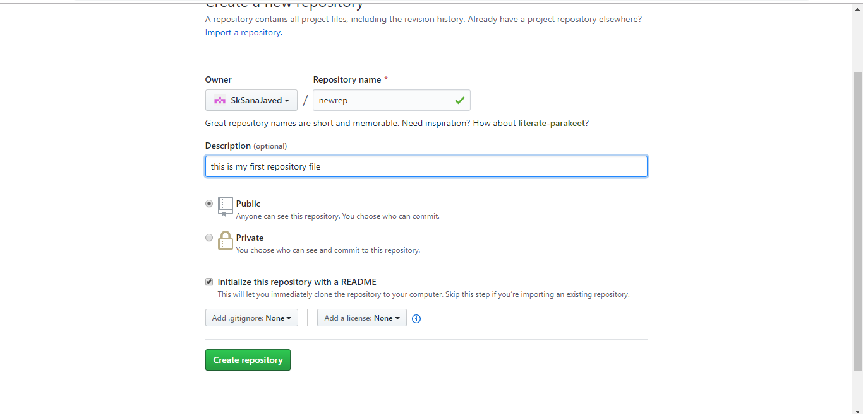

**GIT CLONE:**

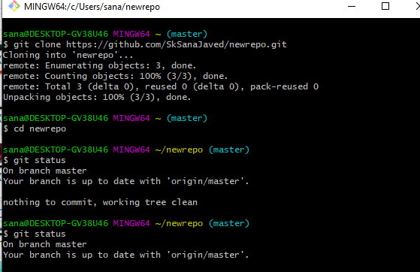

**GIT STATUS:**

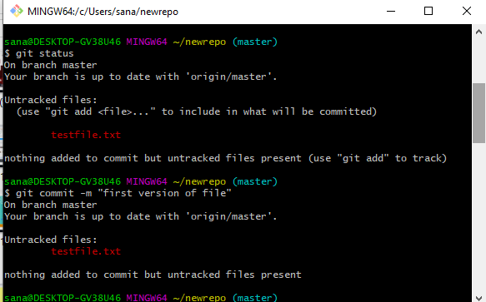

**GIT COMMIT:**

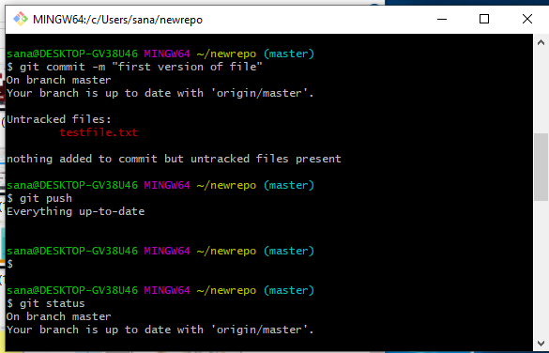

**GIT STATUS AND GIT ADD:**

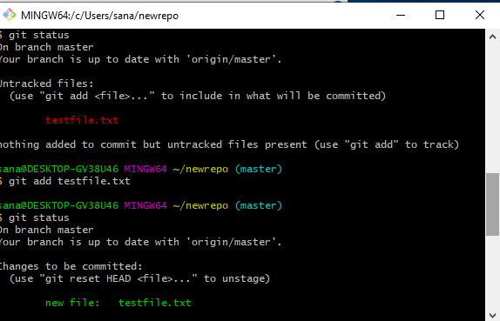

**GIT PULL:**

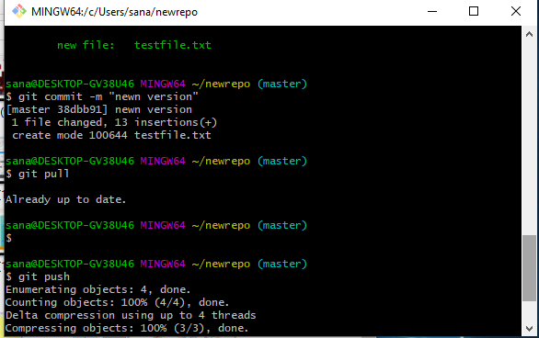

**GIT PUSH:**

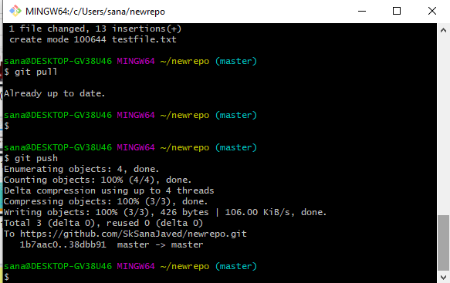

**PUSHED FILE:**

