WEB DESIGN REPORT

(college project)

Year 1, Semester 2

<https://skala-d.github.io/Project/>

Submitted by: *Dominik Skala*

Student number: S00239867

Student group: *D*

Initial proposal

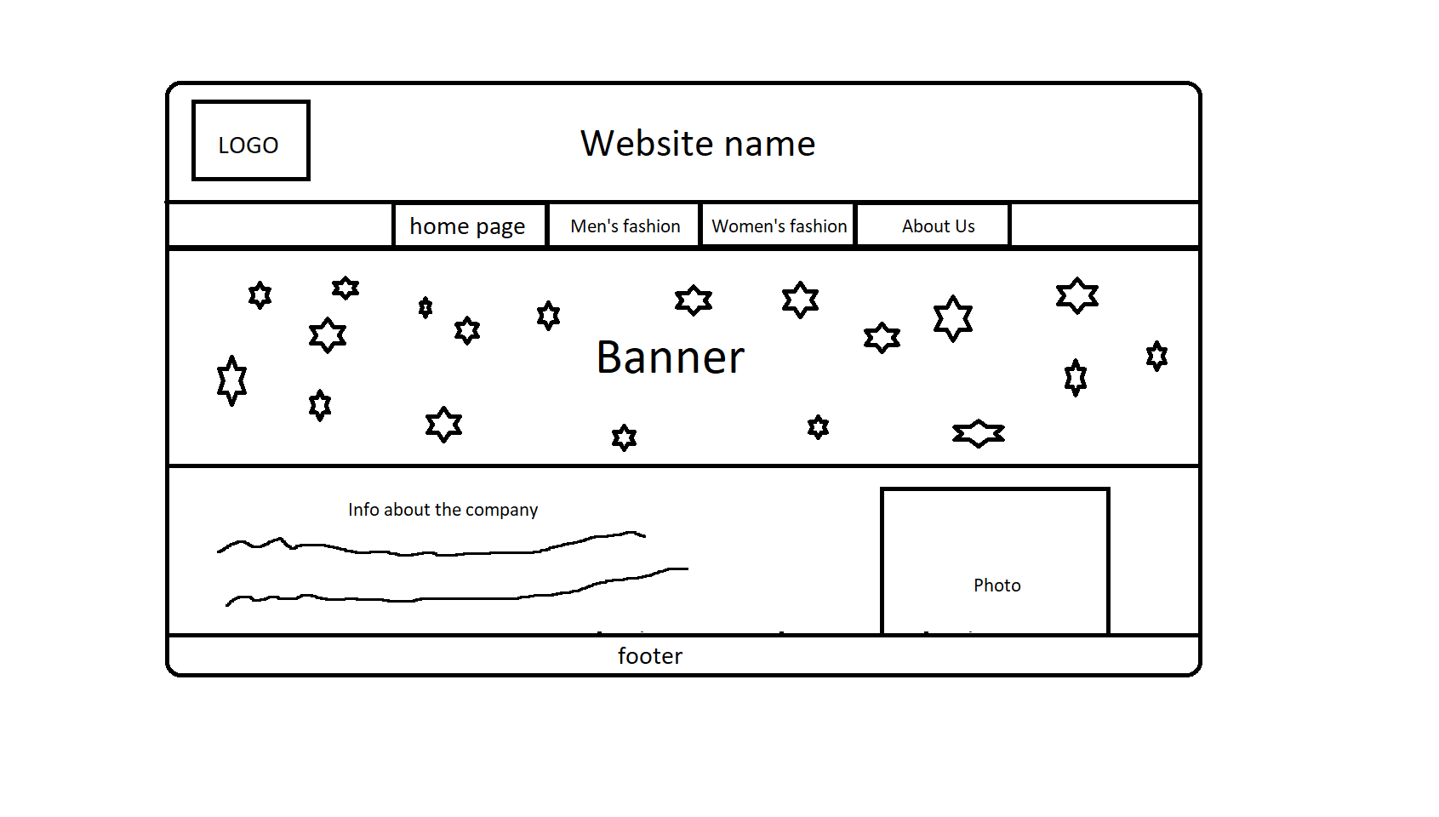

Website checklist

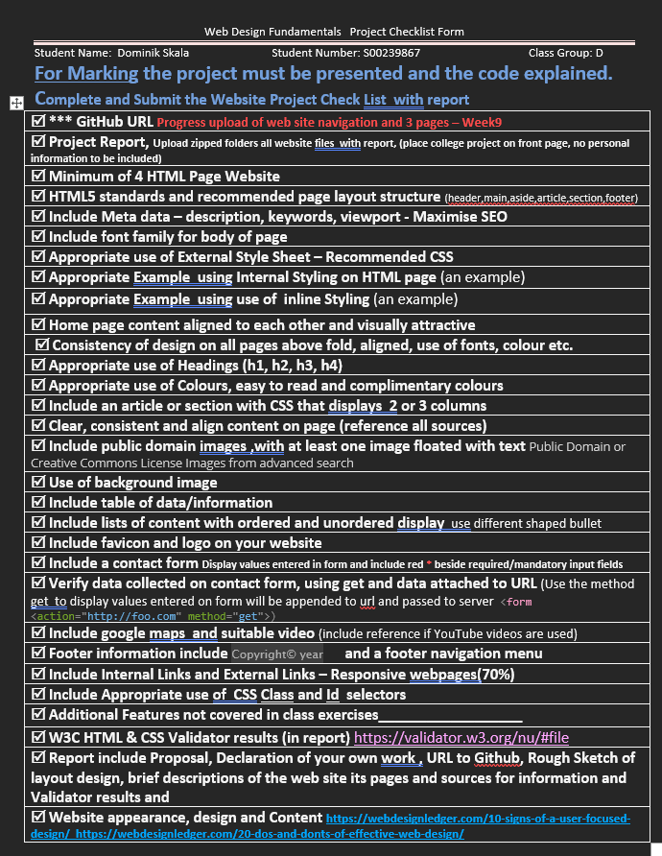

Basic info about all the pages

Home page

The home page serves as an introduction to the website and features a simple design that uses only black and white colors, except for the colorful banner, which was created using [www.canva.com](http://www.canva.com) . Additionally, the page includes basic information about the company and a small website banner, also created using Canva. At the bottom of the page, users can find a footer with 'help and info' and 'direct contact'.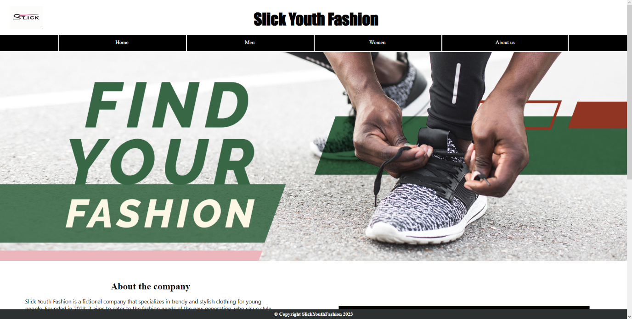

Men + Women pages

The 'Men' page is very similar to the 'Women' page, with the only difference being the background image, product images, product description, and size chart. All product images were downloaded from [www.pixabay.com](http://www.pixabay.com) , and this page does not require attribution when using images. The product descriptions were created by me and were not inspired by any other websites. The page design is similar to the home page, featuring only black and white colors and a footer with 'help and info' and 'direct contact'.

Men

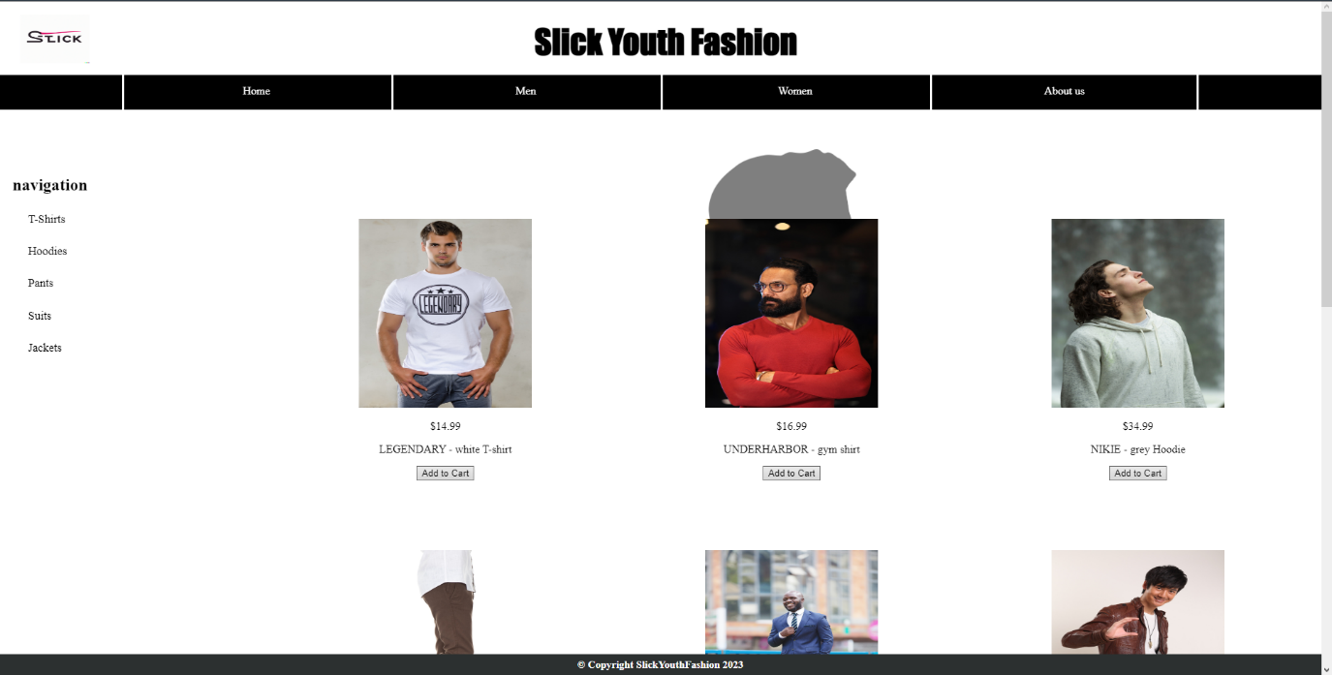

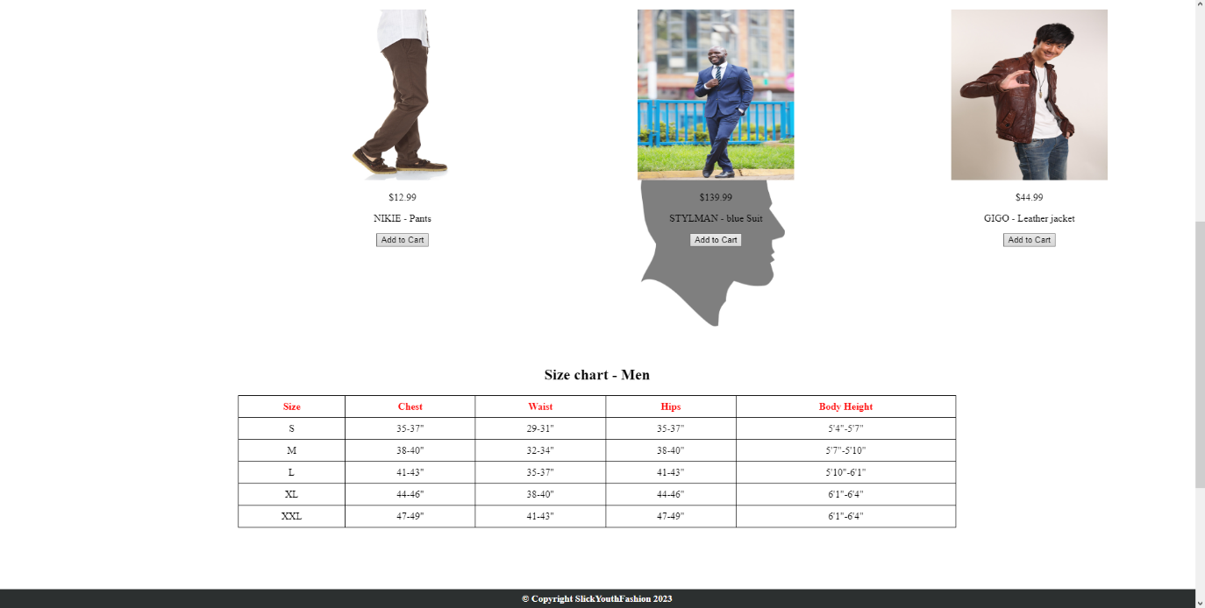

Women 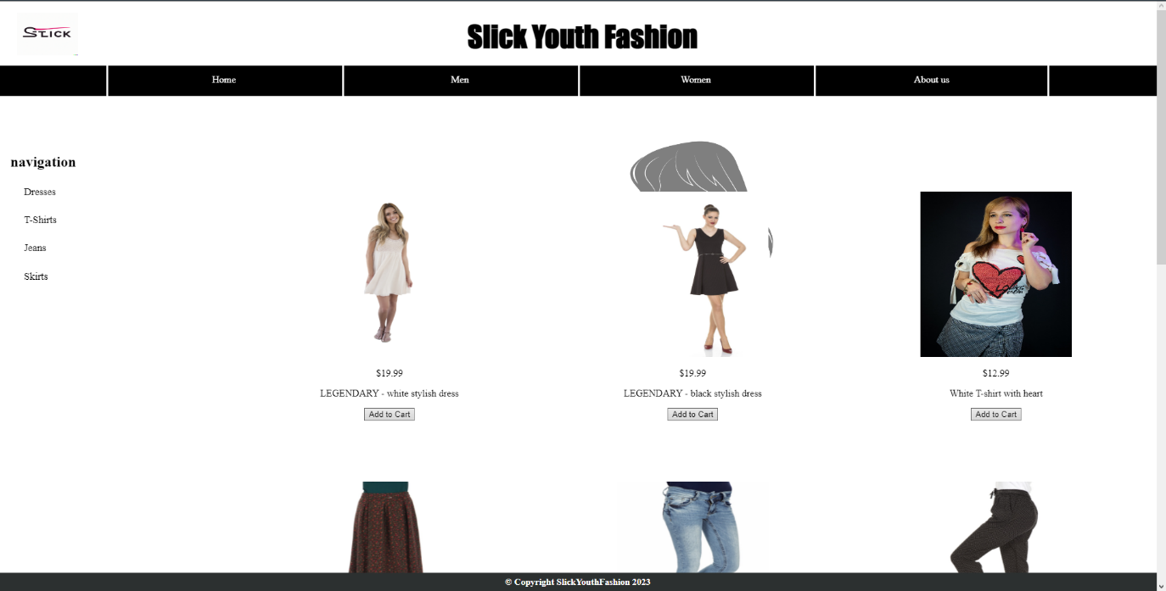

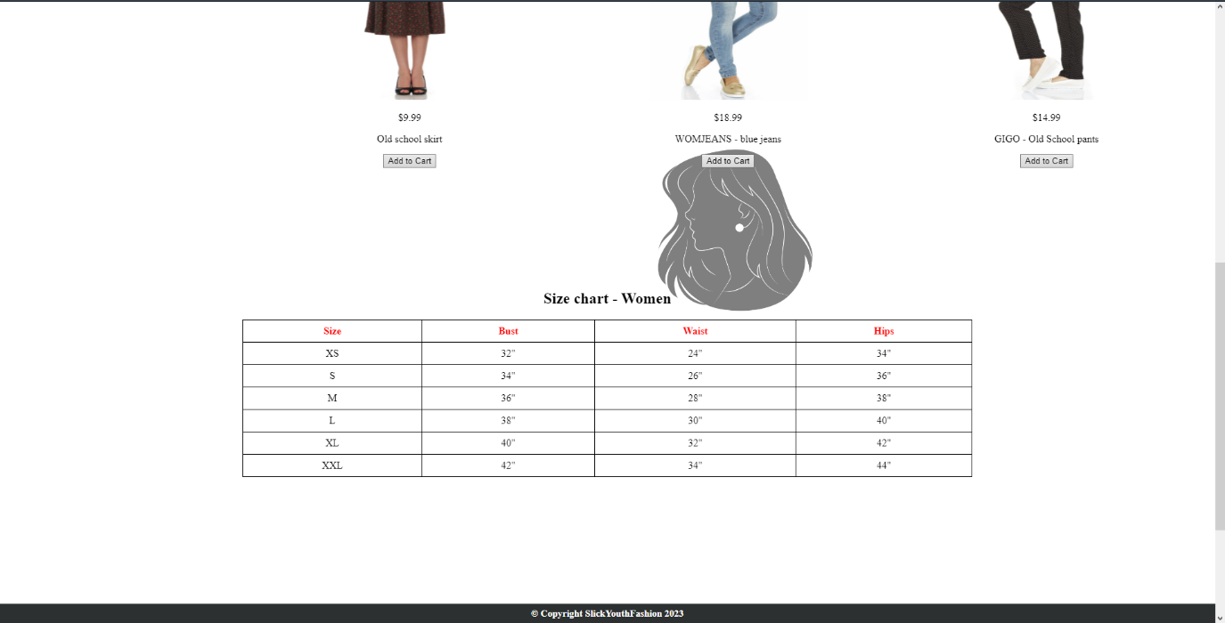

About us page

"This last page uses the same design as all the previous ones. The content on the page includes a contact form, a Google Maps location, direct contact information, and images (also downloaded from Pixabay). Additionally, there is a short YouTube video related to fashion, providing users with a more engaging experience on the page.

All the contact information are made up.

video: <https://youtu.be/UW-lhIBB4Tc> .

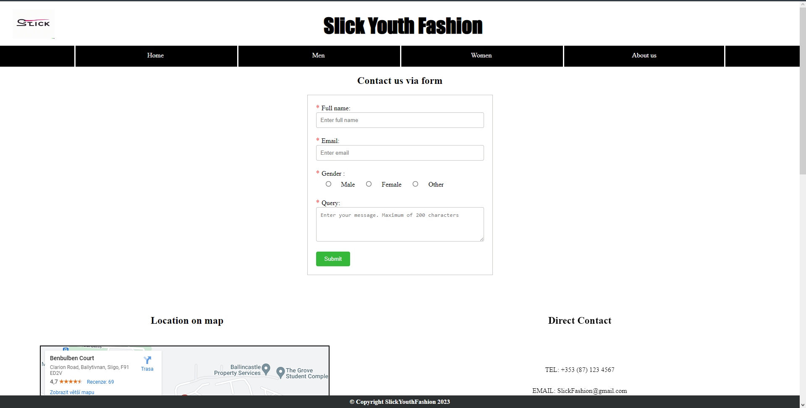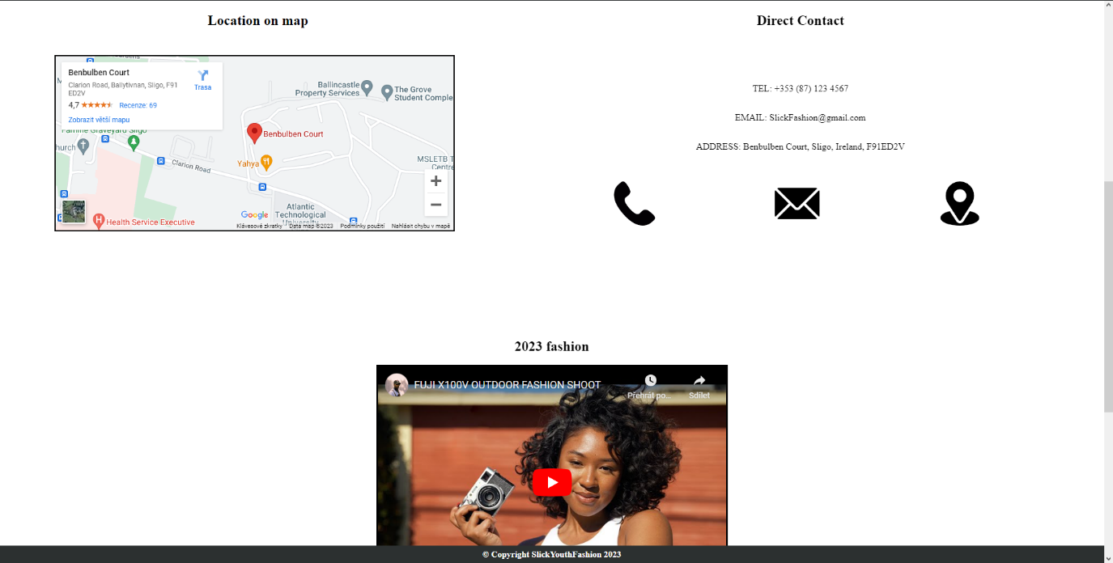

W3C validation results

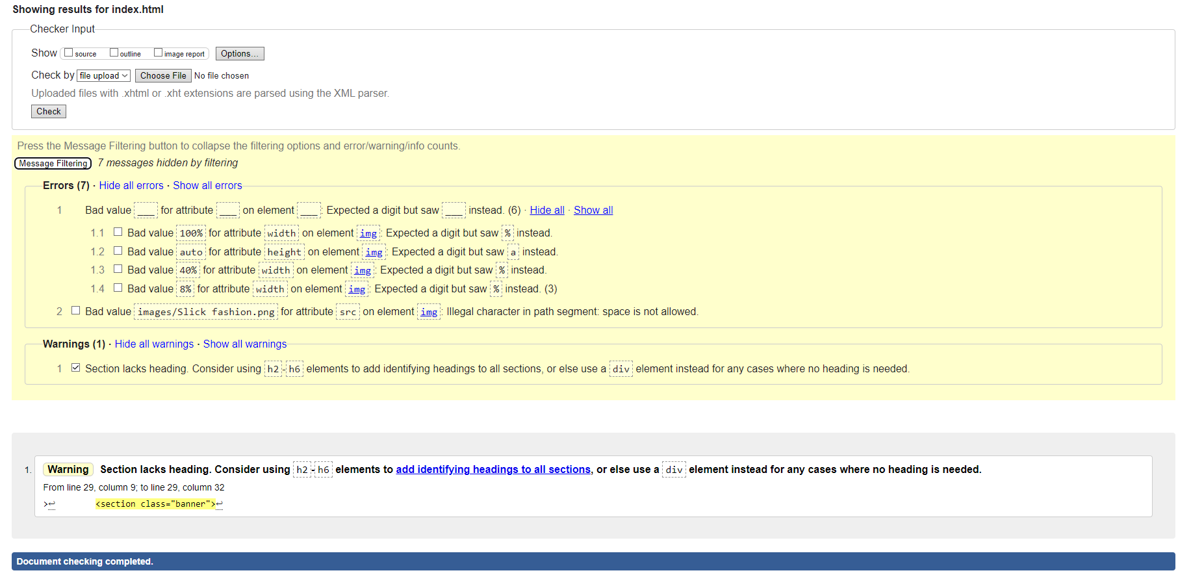Index.html

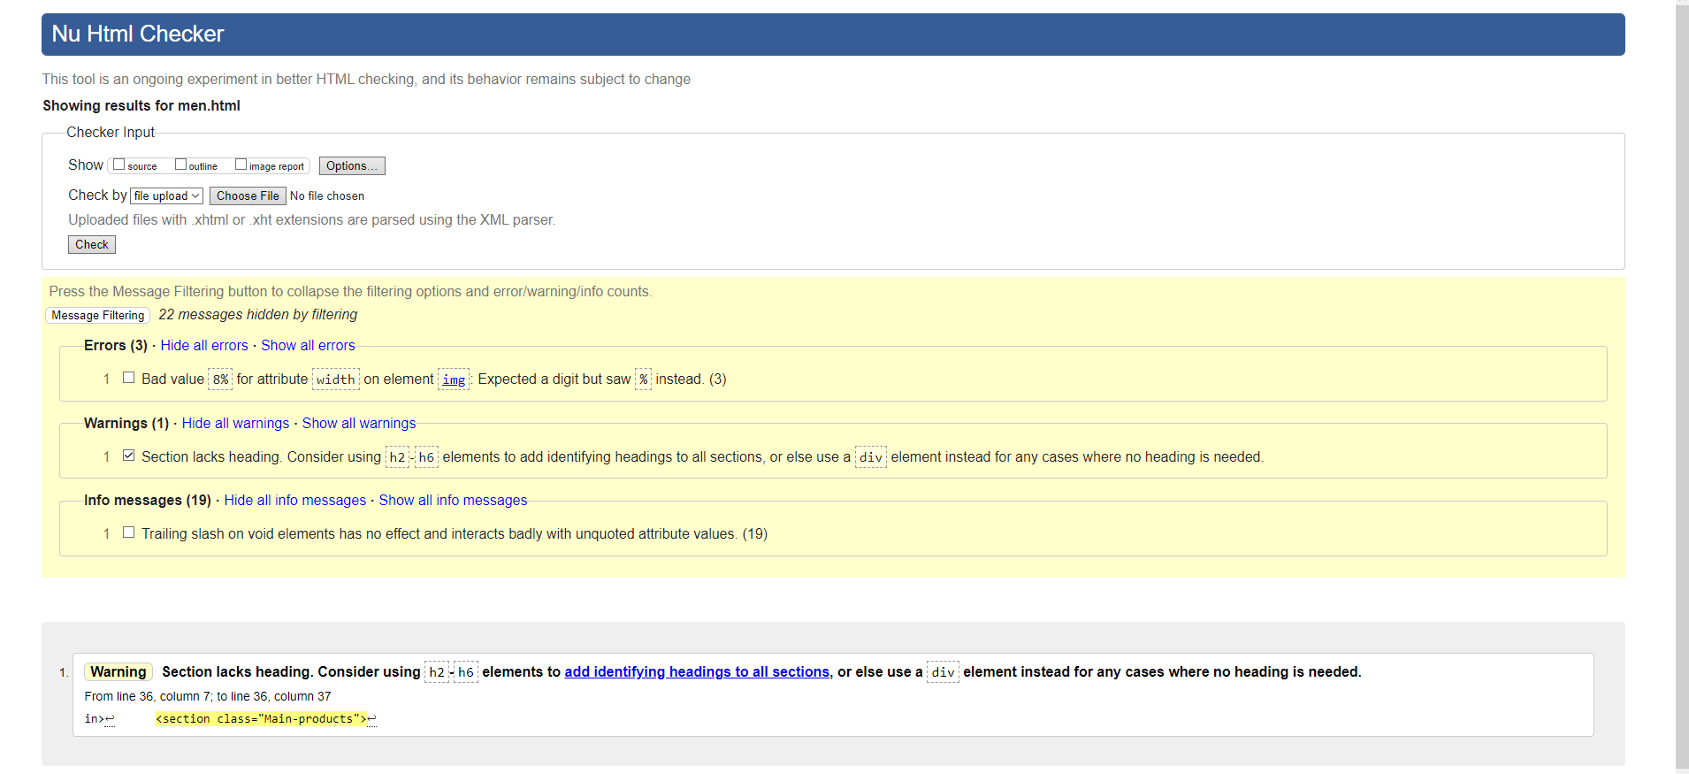Men.html

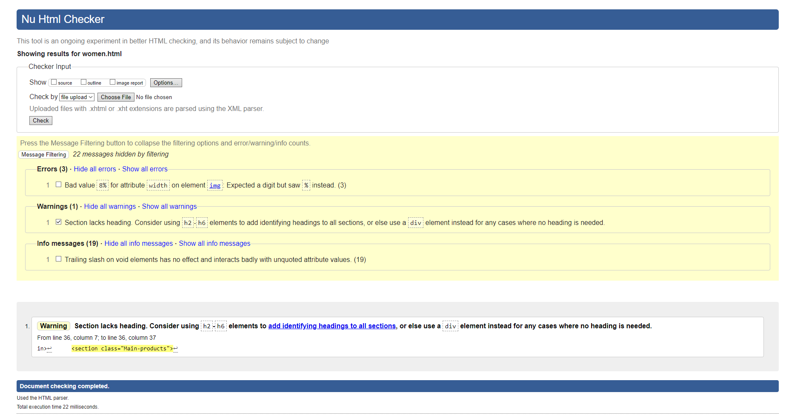Women.html

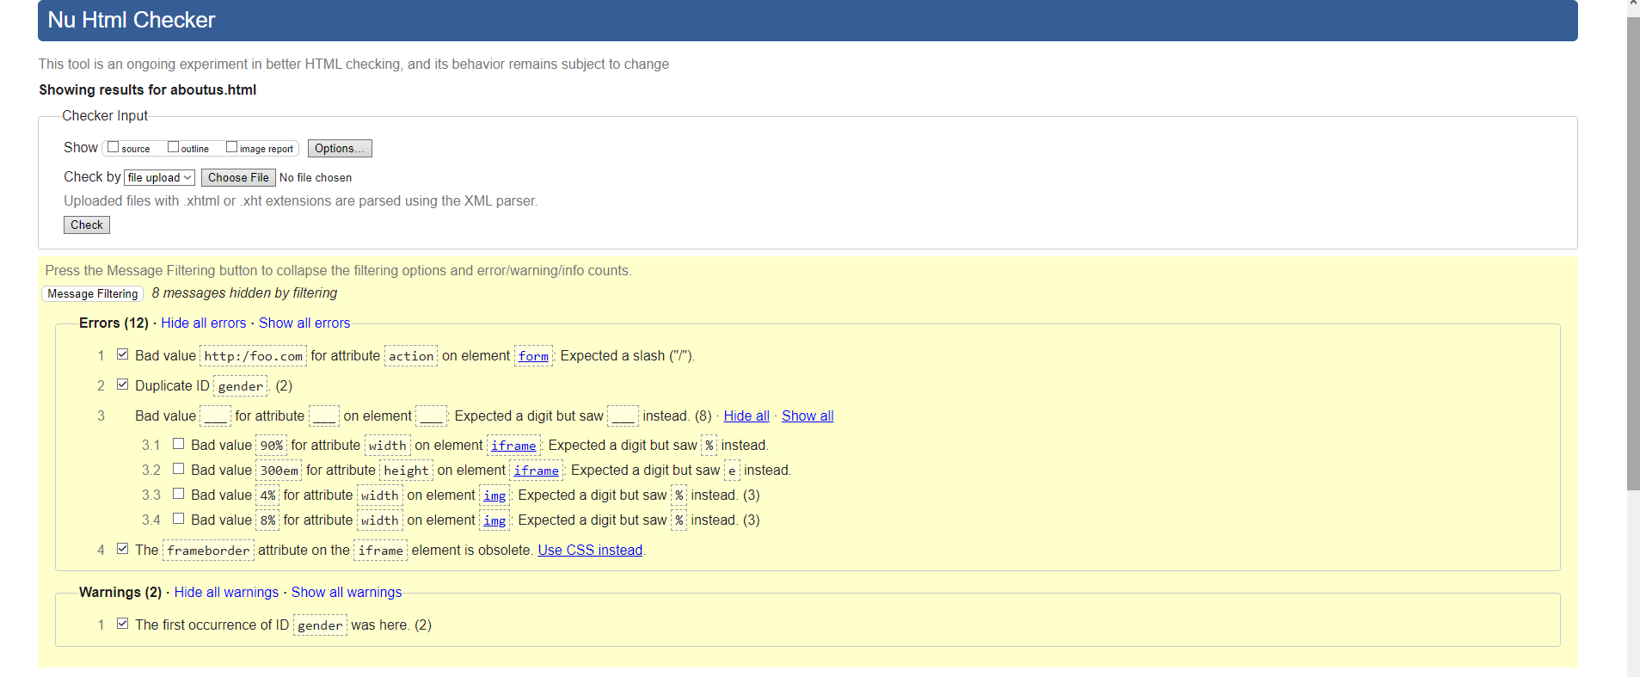Aboutus.html

Declaration of own work

