A Project Report On

Visionlytics
Submitted in partial fulfillment of the requirement for the award of the degree

Bachelor of Computer Application (BCA)

Academic Year 2024 – 25

Skand chaubey Rakchit
92200527266 92200527249

Internal Guide
KD mam



Rajkot-Morbi Road, At & PO : Gauridad, Rajkot 360 003. Gujarat. India.

Faculty of Computer Applications (FCA)



This is to certify that the project work entitled

Visionlytics

submitted in partial fulfillment of the requirement for

the award of the degree of

Bachelor of Computer Application

of the

Marwadi University

is a result of the bonafide work carried out by

Skand Chaubey-92200527266

Rakchit -92200527249

during the academic year 2021-22

Faculty Guide |  | HOD |  | Dean

DECLARATION

I/We hereby declare that this project work entitled Visionlytics is a record done by me.

I also declare that the matter embodied in this project is genuine work done by me and has not been submitted whether to this University or to any other University / Institute for the fulfillment of the requirement of any course of study.

Place :
Date :

Skand chaubey-1 92200527266 Signature : skand
Rakchit -2 92200527249 Signature : Rakchit

CONTENTS

Chapters | Particulars | Page No.
1 | Dataset Overview
2 | LIST OF ANALYSIS  Crimes per City  - Crimes per Crime Domain  - Victim Gender Distribution  - Case Closure Status by City  - Police Deployed by Crime Type  - Crimes by Gender and Weapon Used  - Crime Domain Heatmap by City  - Crimes Over Time  - Victim Gender Analysis  - Age Distribution of Victims  - Police Response Analysis
3 | Tableau  - City -> Report Number  - Report Number -> Crime Domain  - Data Report -> Report Number  - Crime Description -> Report Number  - City -> Crime Description  - Victim Age -> Report Number  - Crime Description -> Police Deployed  - Report Number -> Case Closed
3 | Excel  - City  - Crimes per Domain  - Open vs Closed by City  - Victim Gender  - Crimes by Gender and Weapon Used  - Police Deployed by Crime Description  - Crimes by Date

Project Overview
This project is a data-driven analysis dashboard developed using Microsoft Excel. The focus is on analyzing crime data across various Indian cities to uncover patterns and trends in criminal activities. The dataset, collected in CSV format, contains detailed information on crime types, victim demographics, weapons used, police deployment, and case status.
The objective of the project is to:
- Enable interactive exploration of crime data
- Provide insights through visual charts and pivot tables
- Help identify high-crime areas, common weapons, closure rates, and more
Users can filter data by city, crime domain, gender, and other parameters using slicers. This dashboard not only aids in visual understanding of the data but also supports decision-making and enhances awareness of public safety concerns.

Column Descriptions
- Report Number – Unique identifier for each crime report.
- Date Reported – Date and time when the crime was officially reported.
- Date of Occurrence – Date and time when the crime took place.
- Time of Occurrence – Time of the day the crime occurred.
- City – City in which the crime was recorded.
- Crime Code – Numeric code assigned to each type of crime.
- Crime Description – Description of the type of crime (e.g., Homicide, Theft).
- Victim Age – Age of the victim involved in the incident.
- Victim Gender – Gender of the victim (Male/Female).
- Weapon Used – Type of weapon used in the crime (e.g., Firearm, Knife).
- Crime Domain – Broad category of the crime (e.g., Violent Crime, Property Crime).
- Police Deployed – Number of police personnel deployed to respond to the incident.
- Case Closed – Status indicating whether the case has been closed or remains open.
- Date Case Closed – Date when the case was officially closed (if applicable).

Analysis and Graphs

1 . Crimes per City

This chart represents the total number of crimes reported across different cities in the dataset. By visualizing crime frequency by location, this graph helps identify which cities have the highest concentration of criminal activity.
In the context of the project, this chart is crucial for highlighting urban areas that may require increased security measures or further investigation into the causes of higher crime rates. It supports comparative analysis across geographical regions and provides insights for better crime management policies.

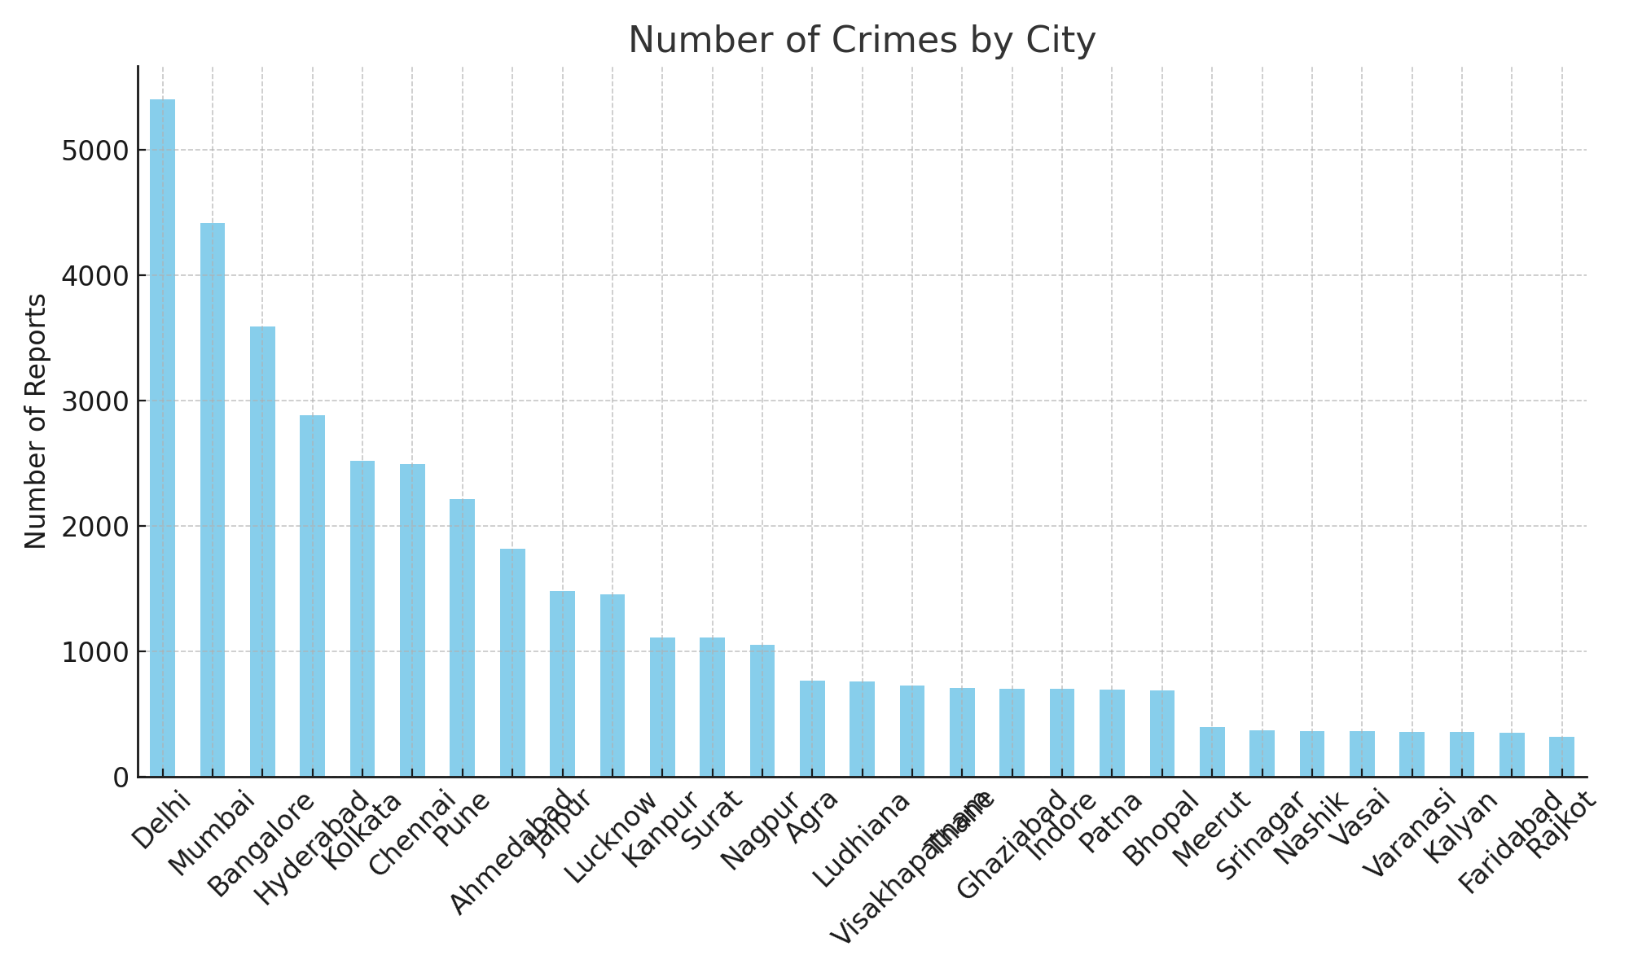

2. Crimes per Crime Domain
This graph shows the distribution of crimes based on their domain categories, such as violent crimes, property crimes, cybercrimes, and others. Each domain groups multiple types of crimes under a broader category, giving a clearer picture of the overall criminal landscape.
In this project, the chart is useful for understanding which types of crimes are more frequent and dominant in the dataset. Policymakers and law enforcement can use this to focus their strategies on the most pressing issues in crime control and prevention.

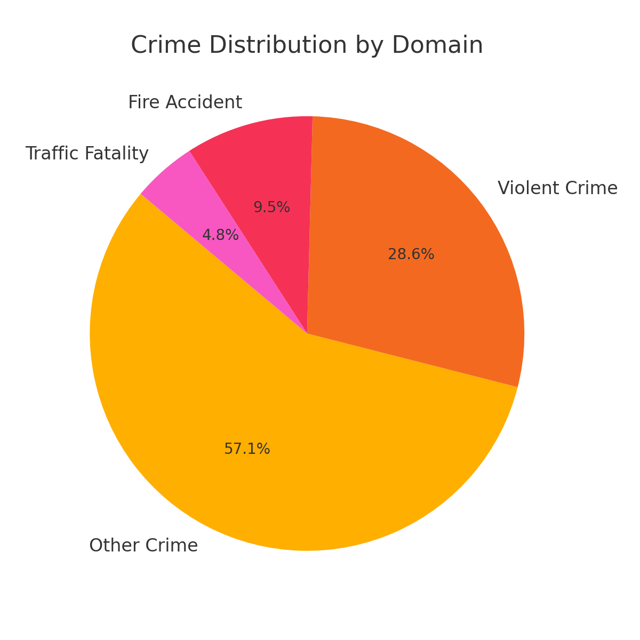

3. Gender-wise Victim Distribution
- This bar or pie chart displays the percentage or count of crimes reported against male and female victims. It offers a comparative analysis of how crime impacts different genders.
Within the project, this graph plays an important role in identifying if one gender is more vulnerable to specific crimes. It aids in the development of gender-sensitive policies, safety campaigns, and crime prevention strategies tailored to affected groups.

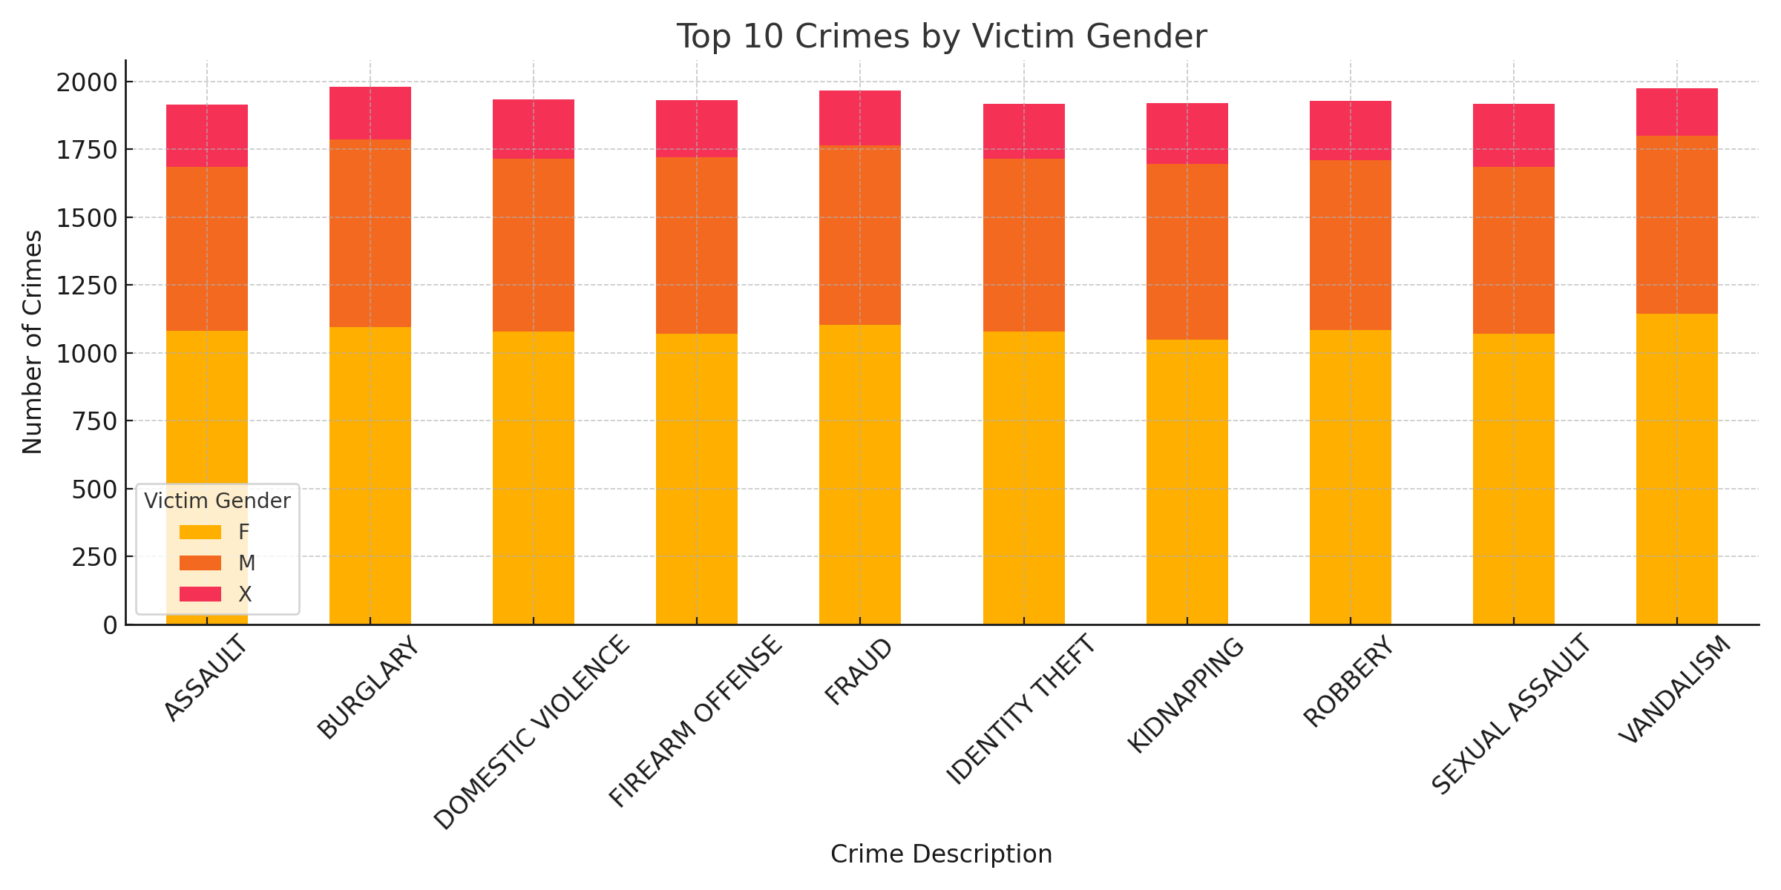

4. Weapon Usage Frequency
This chart illustrates the types of weapons most commonly used during criminal activities. It includes categories like firearms, knives, blunt objects, and others.
From a project perspective, this analysis helps in assessing the level of violence associated with crimes and the availability or use of certain weapons. It provides valuable data for developing laws around weapon control and informs police preparedness.

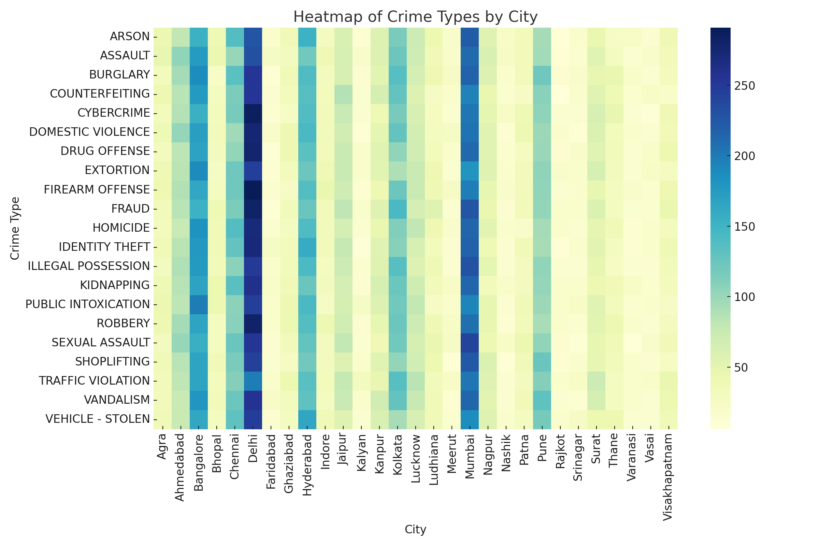

Case Closure Status by City
This 100% stacked column chart displays the proportion of cases that are open versus closed in each city. It helps in evaluating how effectively law enforcement is managing and resolving crime cases.
As part of the analysis, it offers a direct look into the case resolution efficiency of different cities. Areas with a high number of open cases may indicate investigation backlogs or resource shortages, guiding improvements in justice delivery.

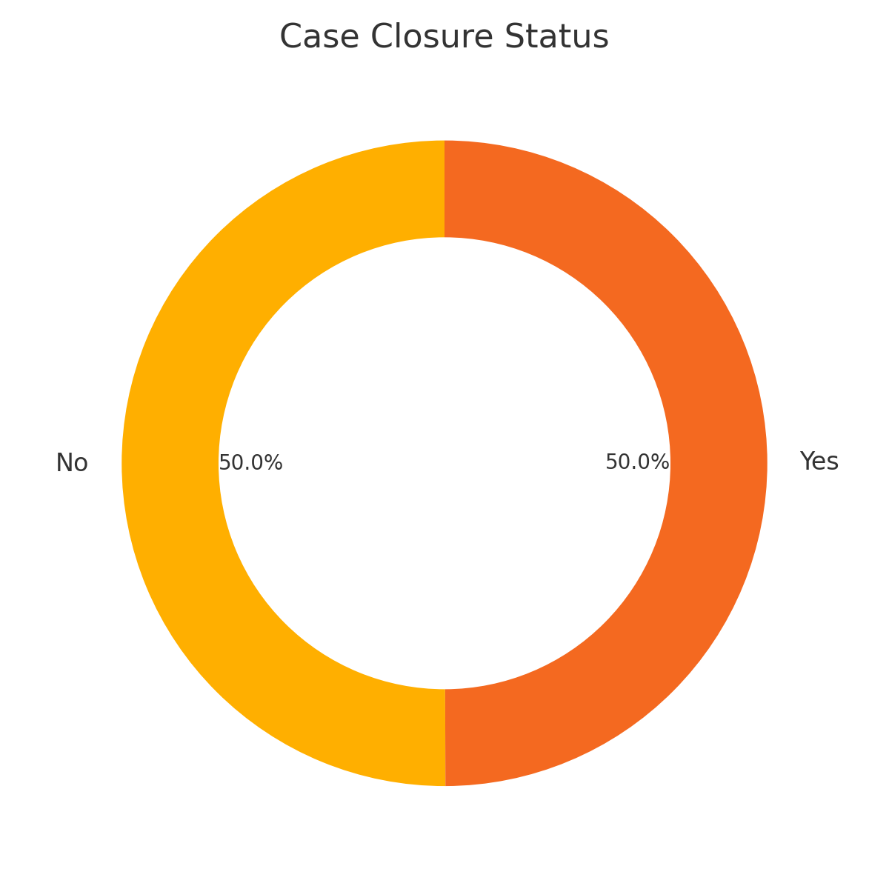

Average Victim Age by City
This line chart shows the average age of victims involved in crimes in various cities. By comparing age ranges across different locations, it provides insight into the demographic most affected by crime.
In this project, it helps in identifying whether crimes target specific age groups, such as youth or elderly individuals. The findings can influence public awareness campaigns and community safety programs tailored to vulnerable age categories.

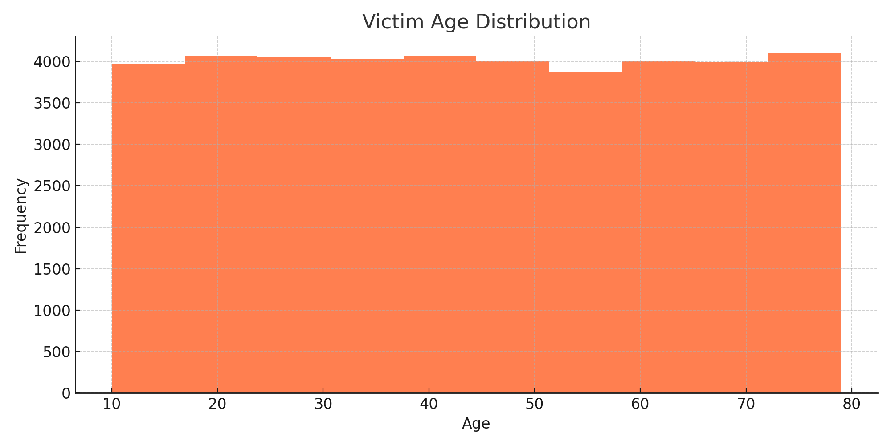

Police Deployed by Crime Type
This bar chart visualizes the average number of police personnel deployed in response to different types of crimes. It reflects the resource intensity required for handling various crime scenarios.
From a project standpoint, this helps in assessing how police deployment is aligned with the severity and nature of crimes. It can be used to recommend adjustments in law enforcement strategies and improve response times.

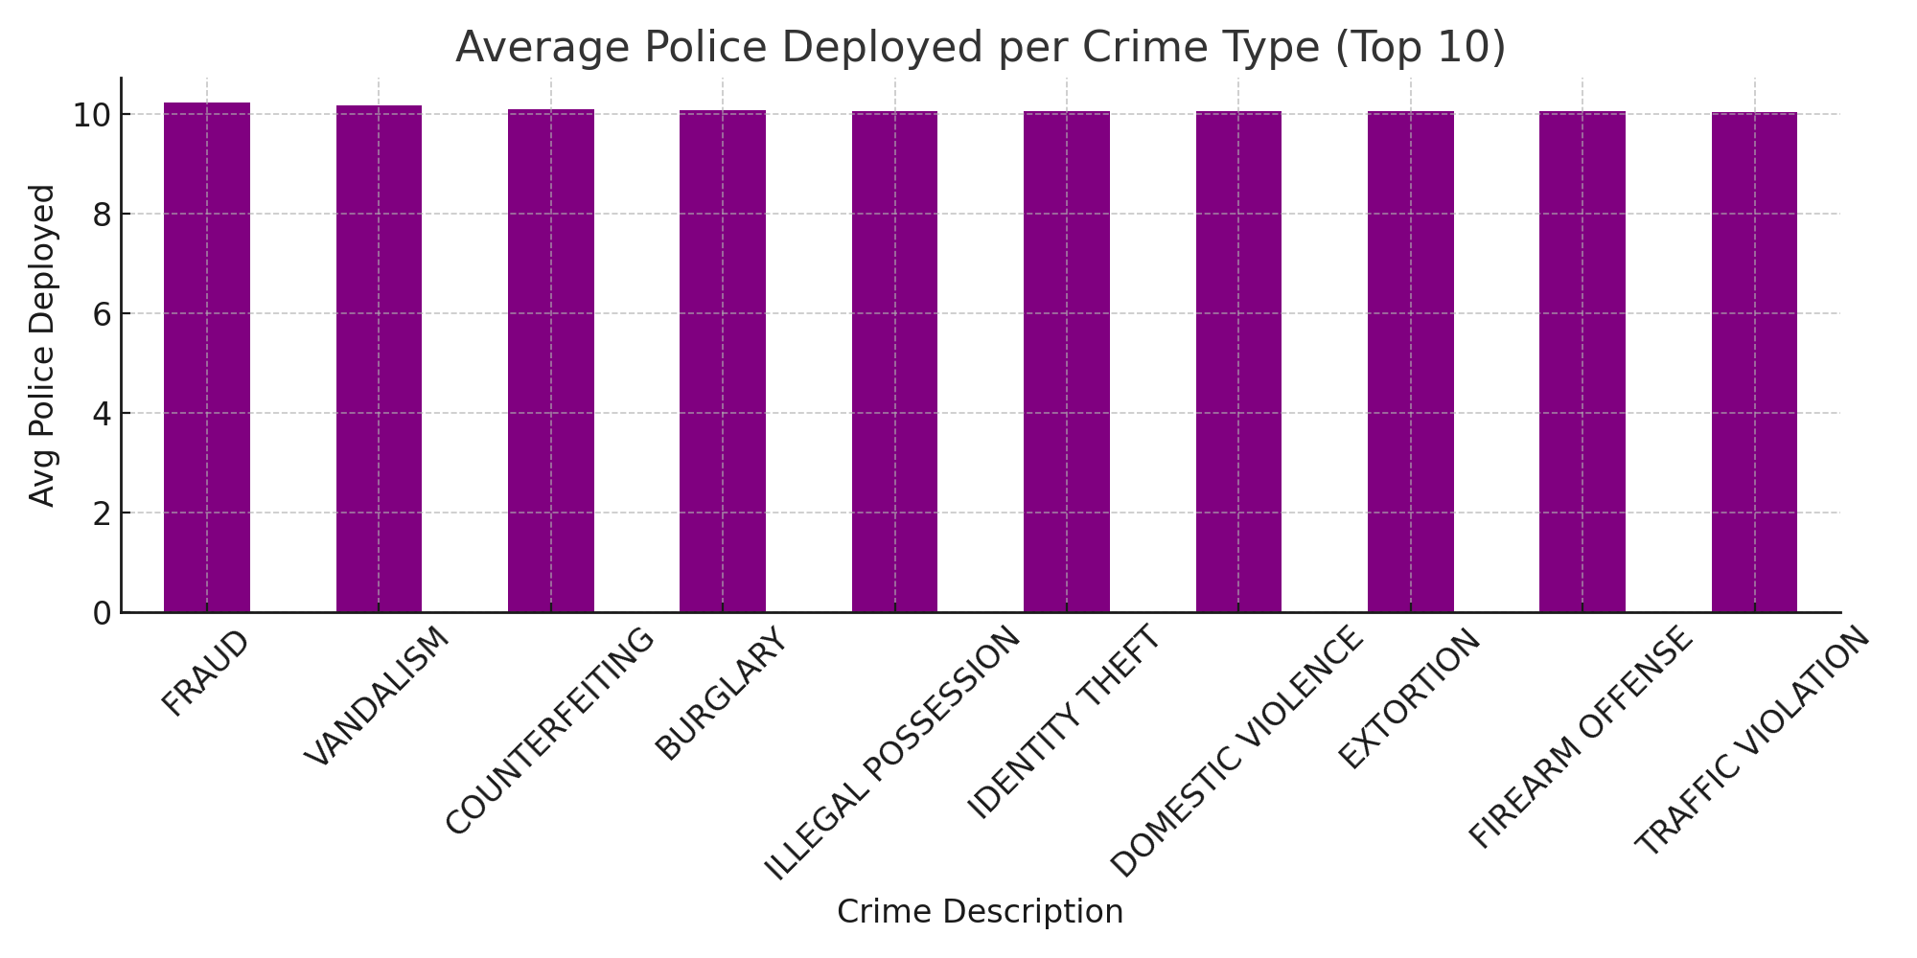

Crimes by Gender and Weapon Used

This clustered column chart cross-analyzes the gender of victims with the weapons used in crimes against them. It reveals any patterns between specific weapon types and the gender of victims.
In the context of analysis, it helps in identifying whether certain types of violence are more commonly directed at men or women. This insight is critical for shaping targeted protection measures and gender-aware policing efforts

Crime Domain Heatmap by City
This pivot-based heatmap shows the intensity of different crime domains across various cities using color gradients. It gives a quick visual overview of how each type of crime is distributed geographically.
For your dashboard project, it provides actionable insights for targeting specific crime types in cities where they are most prevalent. This can support regional crime prevention planning and strategic police deployment.

Tableau & Excel:-
- City -> Report Number

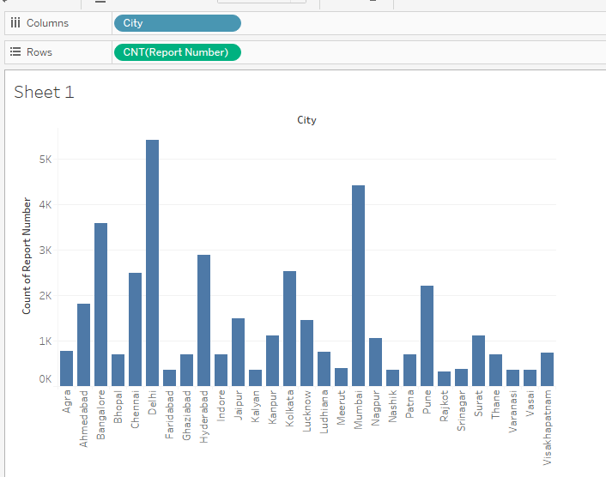
- Report Number -> Crime Domain
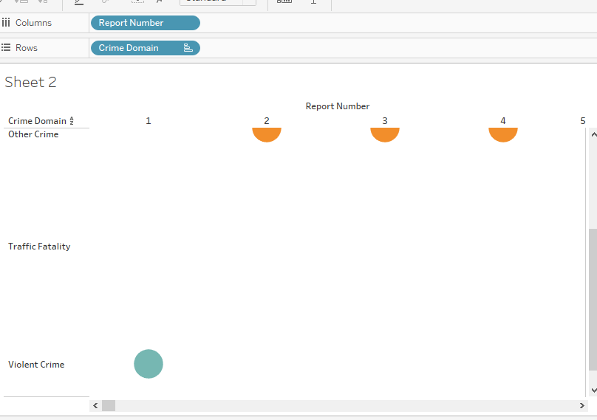
- Data Report

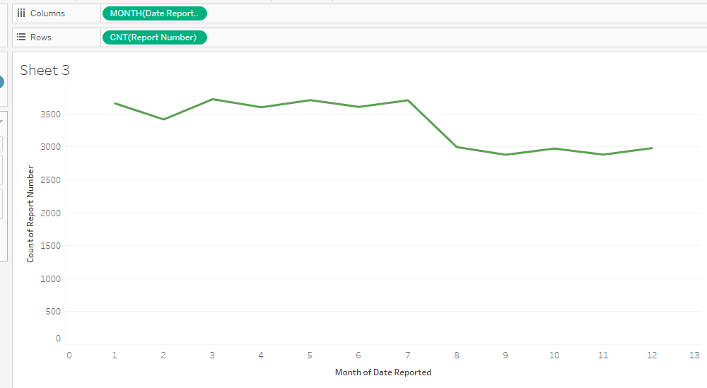

- Crime Description -> Report Number

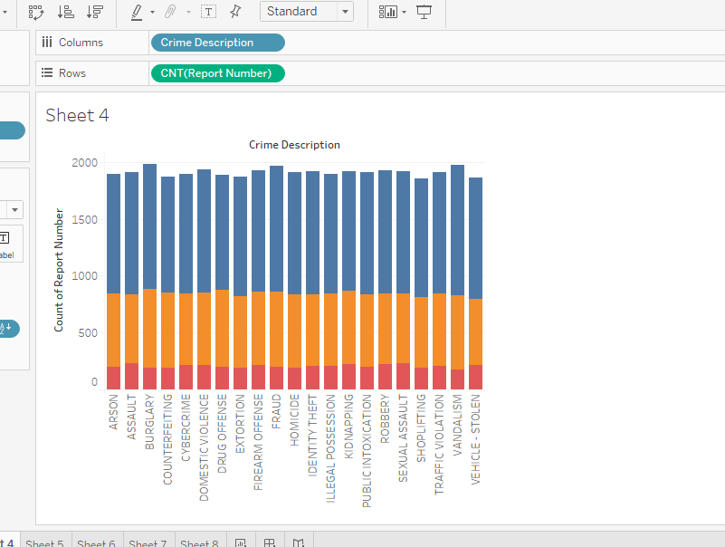

- City -> Crime Description

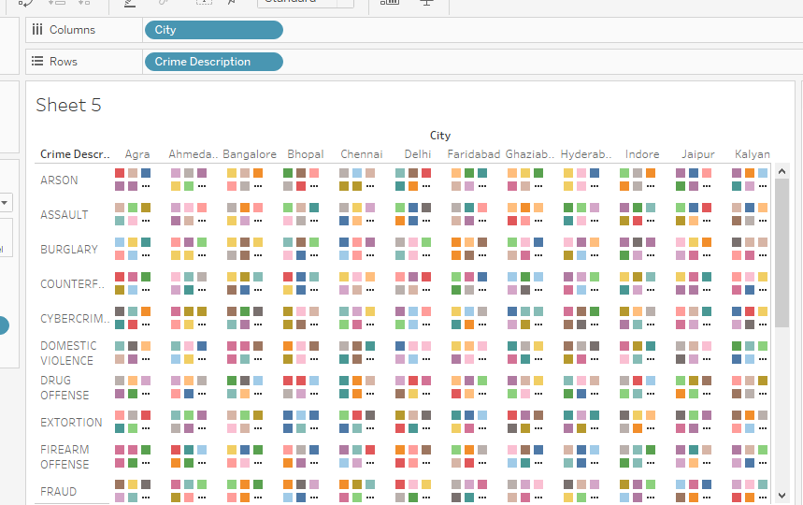

- Crime description -> Police Deployed

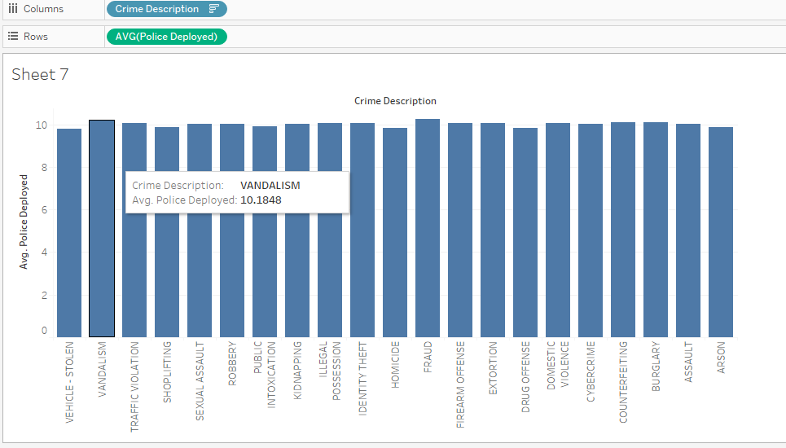
Excel DashBoard : -
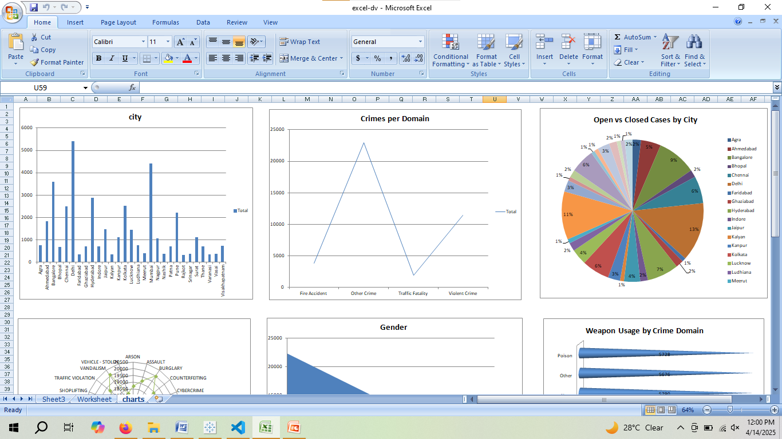

Tableau Dashboard

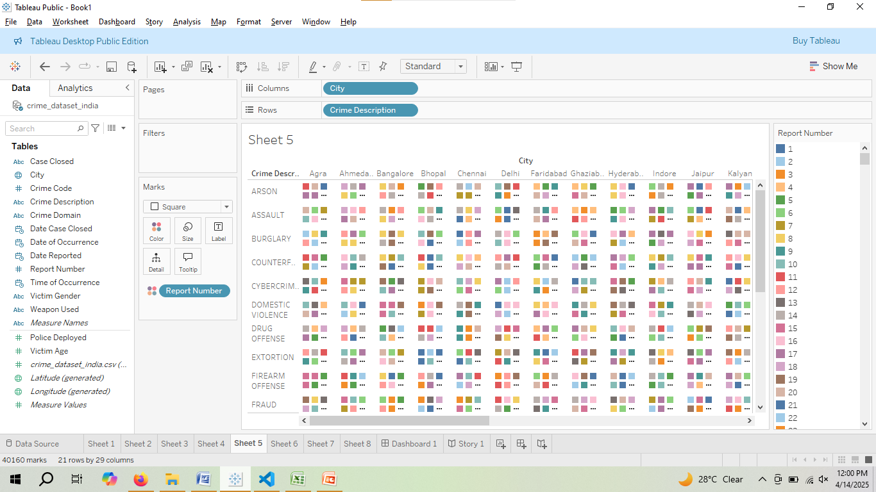
Crime Analysis Dashboard

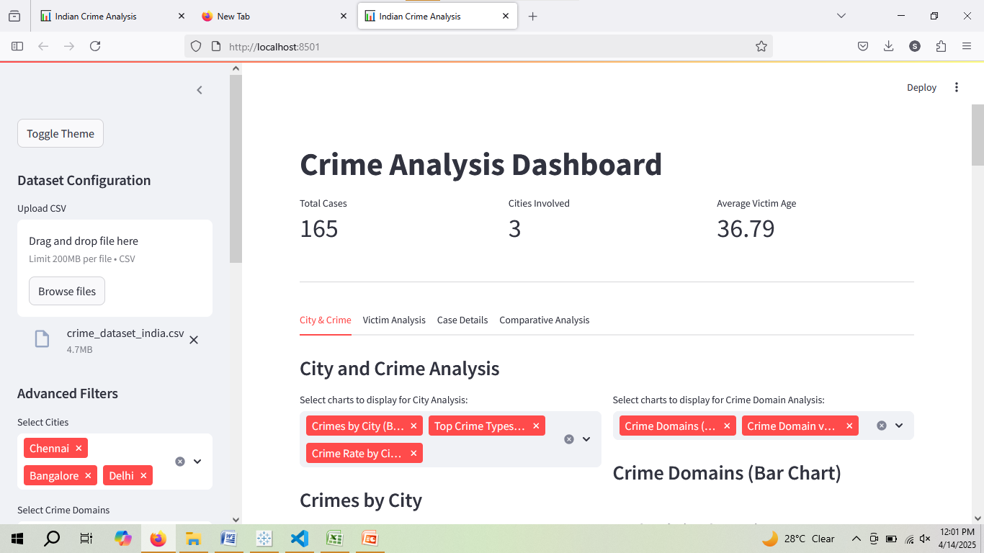

Source Code :-

