VIVEKANANDA COLLEGE OF ENGINEERING & TECHNOLOGY
[A Unit of Vivekananda Vidyavardhaka Sangha Puttur (R)]
Affiliated to Visvesvaraya Technological University and Approved by AICTE New Delhi & Govt. of Karnataka
Nehru Nagar, Puttur - 574203, DK, Karnataka, India

DEPARTMENT OF ARTIFICIAL INTELLIGENCE & MACHINE LEARNING
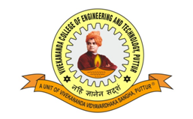
CERTIFICATE
This is to certify that “Integrated Android Application for Dairy Farmers” submitted by Miss. Adithi S, Mr. Kiran K U, Miss. Lipitha M B, Mr. Manoj K S bearing USNs 4VP18CS005, 4VP18CS046, 4VP18CS049 and 4VP18CS052 to the Visvesvaraya Technological University, Belagavi, in partial fulfillment for the award of the degree of Bachelor of Engineering in Artificial Intelligence & Machine Learning is a bonafide record of project work carried out by them under my supervision. The contents of this report, in full or in parts, have not been submitted to any other Institution or University for the award of any degree.

______________________
Signature of the Guide
Prof. Abc
Department of AI
VCET Puttur

