Smart Resource Allocation Advisor

Project submitted for the partial fulfillment of the requirements for the course
CSE 204: Design and Analysis of Algorithms
Offered by the
Department Computer Science and Engineering
School of Engineering and Sciences

Submitted by
1) Velagapudi Hanisha, AP24110010603
2) Ch. Skanda Pranith, AP24110010607
3) Priyanshu Anand, AP24110010609
4) D. Dhanush, AP24110010610
5) K. Smyna, AP24110010611



SRM University–AP
Neerukonda, Mangalagiri, Guntur
Andhra Pradesh – 522 240
[November, 2025]

Contents:
Topics and page numbers
- Introduction
- Background
  - - Why it is relevant
  - - Possible Solution Methods
  - - Summary Table
- Proposed Approach
  - - Overview
  - – Algorithm with Approach
- Results & Discussion:
- Conclusion
- References
Instructions:
- All these sections should present in your project report. You may add additional sections/sub-sections as required.
- Do not change the Title page format
- Do not add any background

1. Introduction:

One of the problems that humans face everyday is the appropriate use of storage. We face it every day like loading luggage into a car, choosing which things to put in your backpack and more.
When multiple valuable items need to be packed in a bag of limited capacity, it’s important to choose the right combination of items. Here’s where “Resource Allocation Advisor” plays a key role. It’s a helper tool designed to assist us in selecting the best possible combination of items.
The purpose of this project is to compare Fast, Greedy based decision making with Optimal, Dynamic Programming (DP) based decision making. By analyzing both approaches, one can understand which method is the best for our current situation. It demonstrates how different algorithms behave when handling resource-allocation based problems, particularly the Fractional Knapsack (Greedy Algorithm) and 0/1 Knapsack (Dynamic Programming)

This helps users understand:
• When and which optimal methods are necessary.
• How the solution changes between greedy and DP.
• How computation times differ.

Many industries also face similar situations where the goal is maximization like:
• Cloud computing: allocating memory/CPU to tasks.
• Inventory management: selecting products for limited shelf space.

Purpose of Project:
• Build a tool that advises users the best way to pack items when space is limited.
• Compare greedy and DP outputs clearly and show profit differences.
• Demonstrate real-world applications of Fractional vs 0/1 Knapsack.

- Background
2.1 Why it is relevant:
You have a set of valuable items, each with a weight and a value. You have a limited capacity container like a safe, suitcase or a backpack. You must choose which items to pack to maximize total value without exceeding capacity.
Real-world relevance
- Emergency kits: choose which items to carry when bag space is limited (first-aid, documents, medicines).
- Cloud / Server Resource Scheduling: assign VMs/tasks to limited server capacity to maximize revenue or throughput.
- Cargo / Logistics: load a vehicle with high-value goods under weight limits.
- Personal packing / moving: optimize what to bring within luggage limits (value = sentimental or resale value).
Many practical systems need fast decisions (greedy selection) while others require optimal allocation (dynamic programming). Understanding the pros and cons (speed, memory, optimality) is a must. Sometimes a near optimal fast selection is acceptable while other times an exact optimum is required.
Eg: Imagine you are going hiking. You have a backpack that can carry only 10 kg. You must pack important survival items such as a jacket, power bank, snacks, shoes, and your laptop. Each item has a different weight and a different level of importance during the trip.

Your goal is simple:
Pack the most useful combination of items without exceeding the backpack’s capacity. You must choose the best set of items from a limited capacity—this is exactly the challenge addressed by resource allocation systems and knapsack algorithms.

Item | Weight (kg) | Value (Importance)
Laptop | 3 | 5
Jacket | 1 | 8
Food | 2 | 9
Power-Bank | 2 | 7

Total Capacity = 10 kg

2.2 Possible solution methods:
There are several well-known methods to solve the Resource Allocation problem (Knapsack problem). Each method has a different strategy, speed, and accuracy. Some methods give fast but approximate results, while others guarantee the best possible solution.
1. Greedy Method (Fractional Knapsack) :
The greedy method selects items based on the highest value-to-weight ratio. It keeps taking the best value per weight item until the capacity is filled. This method works perfectly only when we are allowed to take fractions of items.
- Speed: Very fast
- Accuracy: Optimal only for fractional knapsack
- Where it fails: Not suitable for 0/1 knapsack (whole items only)
- Citation:
  - Greedy solution for fractional knapsack was first introduced by George Dantzig (1957).
2. Dynamic Programming (DP) – Exact 0/1 Solution:
This is the most widely used exact solution for the 0/1 knapsack problem. DP checks all combinations indirectly by building a table of best values for each weight limit.
- Speed: Moderate (depends on capacity value)
- Accuracy: Always gives the optimal solution
- Use when: Capacity is not extremely large
- Citation:
  - Classic DP approach described in “Introduction to Algorithms”(1959).

3. Branch and Bound Method

This method explores possible item combinations using a search tree but prunes branches that cannot lead to a better result. It uses the uses fractional upper bound as upper bound. ^{[2a], [2d]}

- Speed: Faster than brute force in many cases
- Accuracy: Exact

(Honorable Mention) Pisinger's Code ^{[2b], [2c]}

2.3 Summary Table:
Method | Optimal? | Speed | Suitable For
Greedy (Fractional) | Yes (fractional) | Very fast | Fractional knapsack
DP (0/1) | Yes | Medium | Exact solutions
Branch & Bound | Yes | Medium–Fast | Medium item size

- Proposed Approach
Explain the approach with algorithm and flowchart
Explain the system design
(Provide detailed writeup with figures if possible)
3.1 Overview
The proposed system helps users determine the best way to pack valuable items into a limited space (bag, box, storage container, etc.). To optimise space and maximize the total value of items selected, this tool uses two fundamental optimisation techniques:
· 0/1 Knapsack Algorithm (when items cannot be split)
· Fractional Knapsack Algorithm (when items can be partially included)
The system evaluates item weights, values, and capacity constraints, then recommends the optimal packing strategy.

3.2 Approach With Algorithm
A. 0/1 Knapsack Algorithm
Use case: Useful when items cannot be divided (e.g., laptop, camera, watch).
Idea: Dynamic Programming is used to compute the maximum value achievable with the available capacity.
Algorithm Steps:
1. Take item details: value[], weight[], capacity W.
2. Create a DP table dp[n+1][W+1].
3. Initialise the table with zeros.
4. For each item:
  - If current item weight ≤ current capacity → choose max of (value of taking it, value of not taking it)
5. The last cell dp[n][W] gives the optimal value.
6. Trace back to find which items were selected.

B. Fractional Knapsack Algorithm
Use case: Useful when items can be broken into parts (e.g., gold, rice, liquid, cloth material).
Idea: Greedy algorithm based on value-to-weight ratio.
Algorithm Steps:
1. Compute the value/weight ratio for each item.
2. Sort items by decreasing ratio.
3. Pick items until capacity is exhausted.
4. If capacity remains but the item cannot fully fit → take a fraction.
5. Keep track of total value.

- Results & Discussion:
The code was tested out with different weights and values under a total capacity of 10 kg. The program processes each item, computes the profit/weight ratio, sorts items accordingly, selects items using both algorithms, and finally compares their results.
The goal was to evaluate and compare the outcomes of
  - Dynamic Programming (0/1 Knapsack)
  - Greedy Approach (Fractional Knapsack)
Both algorithms received the exact same input and the results were analyzed based on the total value of knapsack.
- The answers were also checked theoretically (as seen below) and the results matched.
- The Greedy Approach gives a higher profit due to its ability in taking item fractions.
- The DP Approach generates an optimal solution when items cannot be divided.
- The difference demonstrates how algorithm choice impacts resource allocation results.

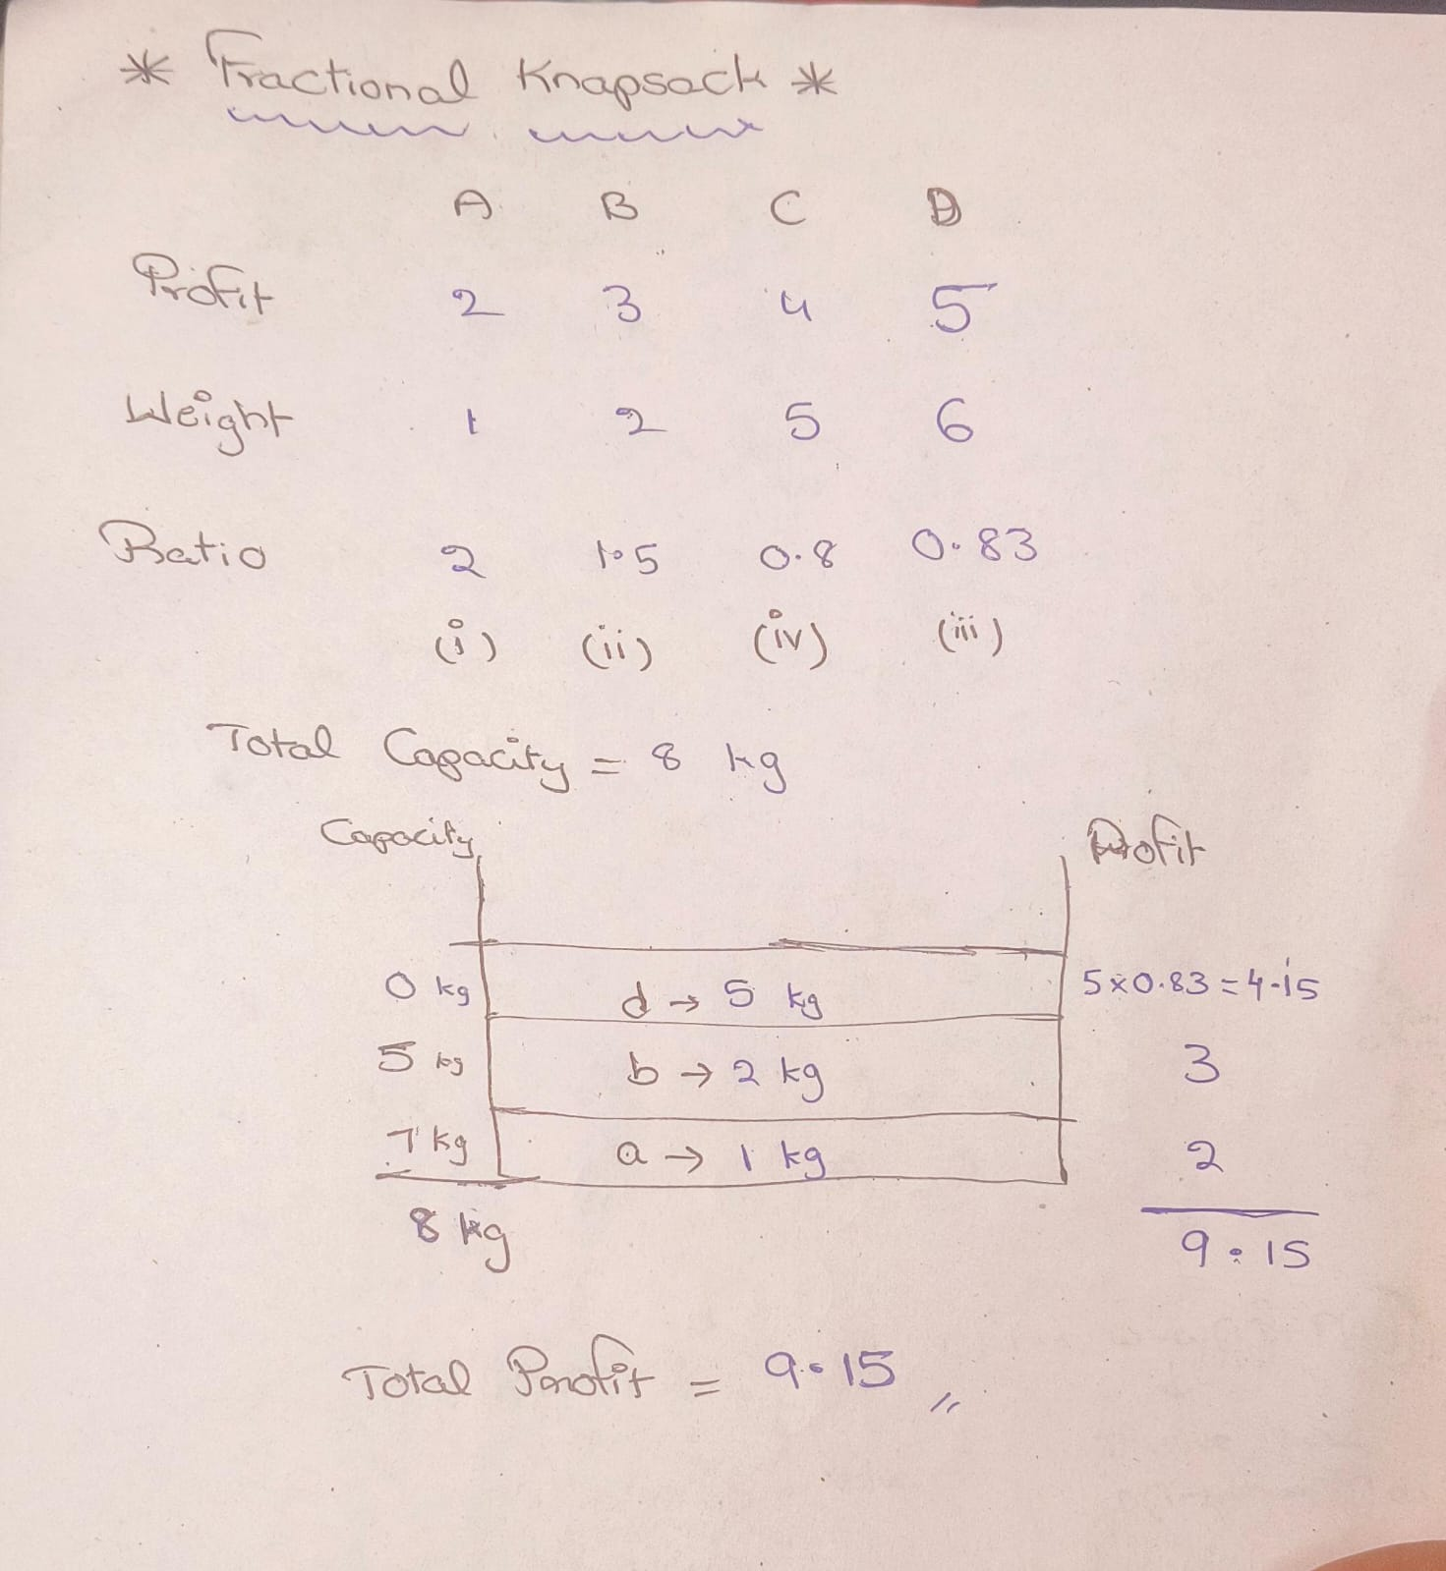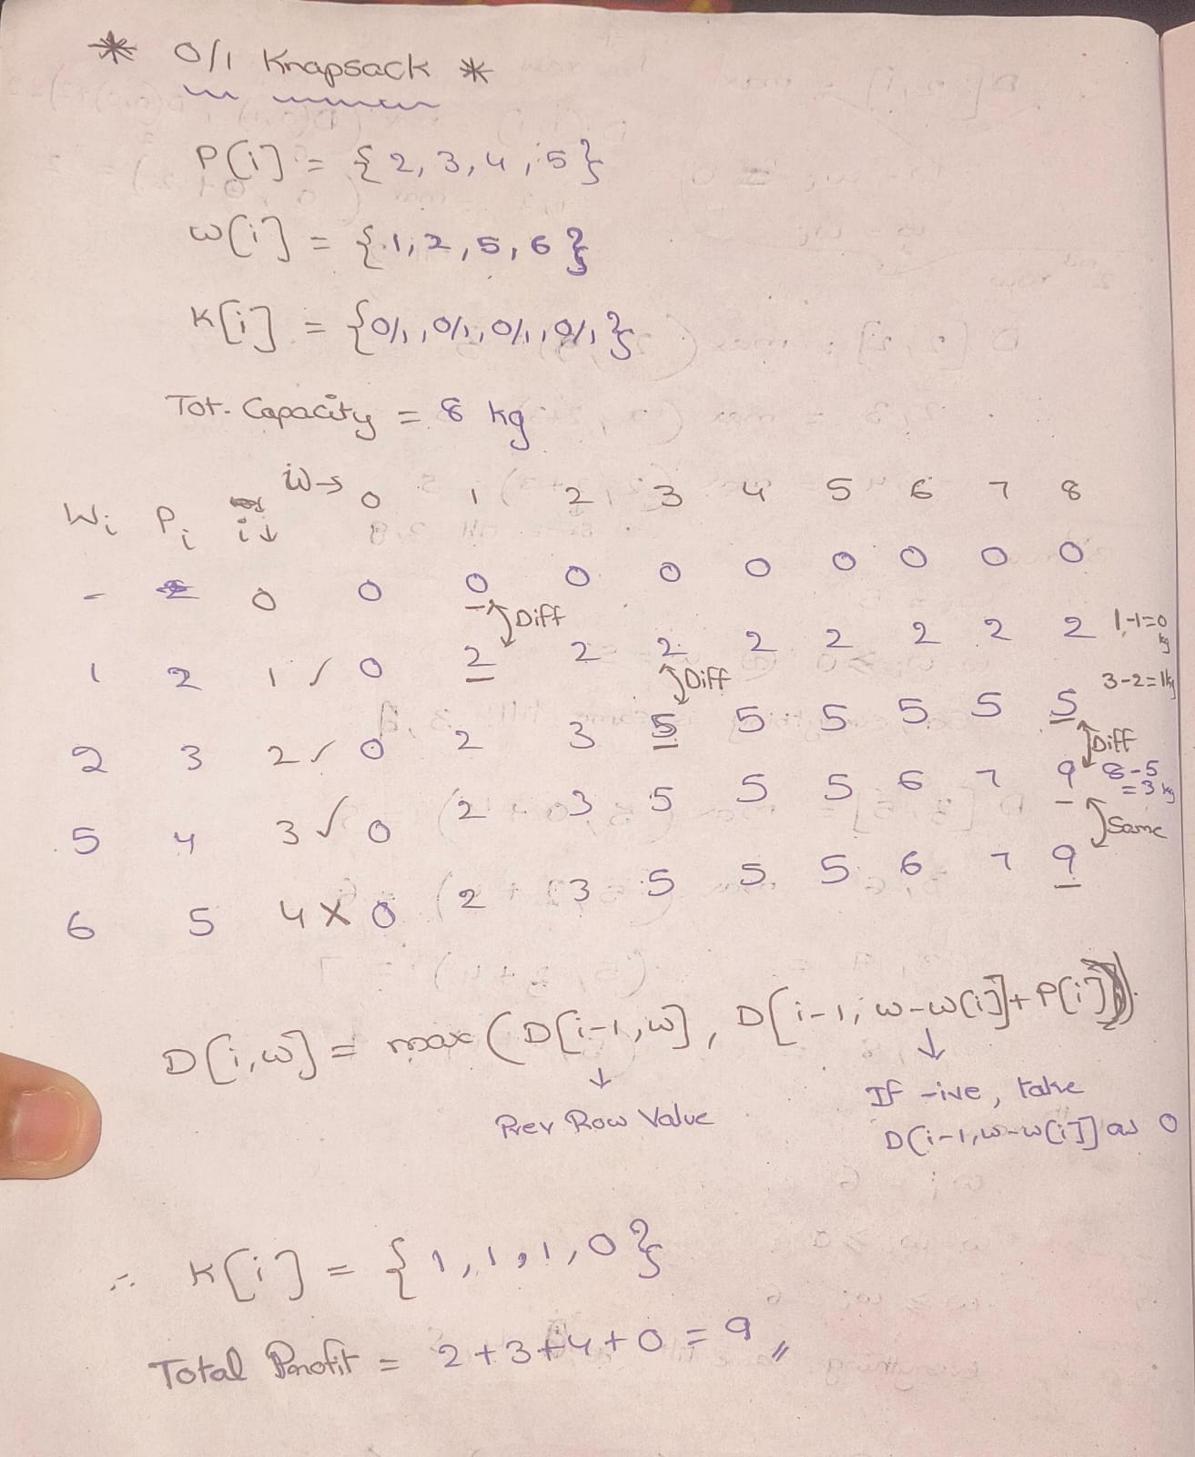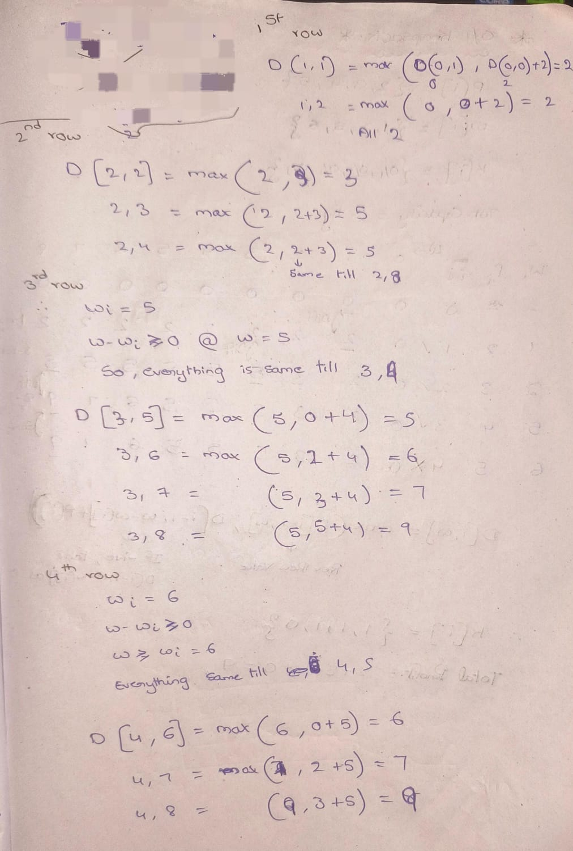 This calculation is done internally. The final table will however, not be printed.

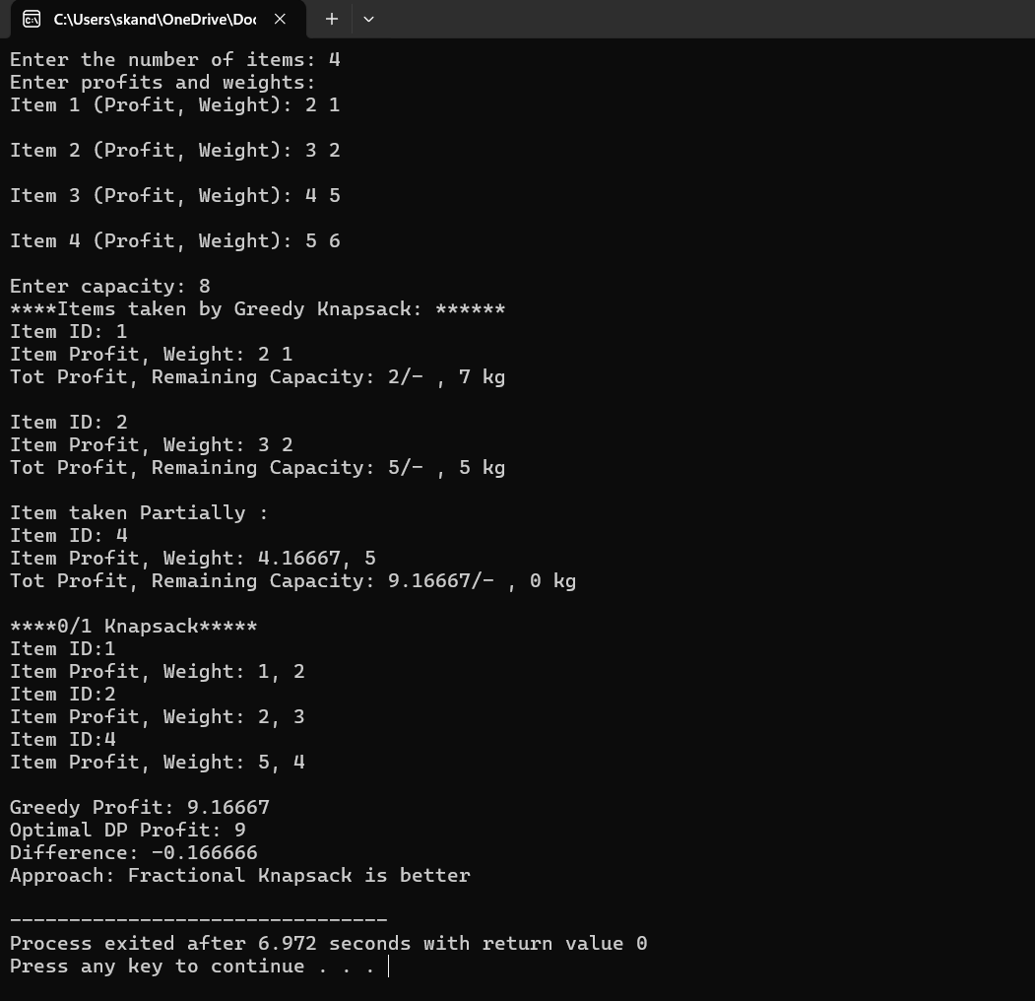

- Conclusion
In this work, we implemented both Fractional Knapsack (Greedy approach) and 0/1 Knapsack (Dynamic Programming approach) in C++ without using vectors or advanced libraries. The program allows users to input item details and capacity, then compares the total profit obtained by both methods. Through this, we achieved a clear understanding of how the fast, greedy selection differs from the optimal DP-based selection.

Achievements
- Implemented Fractional Knapsack using a custom bubble-sort and ratio based greedy selection.
- Implemented 0/1 Knapsack using without vectors.
- Displayed selected items, total profits, and practical comparison between both approaches.
- Demonstrated how greedy may fail in 0/1 cases, whereas DP always ensures that it is optimal
Limitations
- The program uses static arrays, making it inefficient when dealing with very large input sizes.
- Bubble sort is used for ordering items, which is not efficient for large datasets.
- The 0/1 DP algorithm has O(N*W) time and space complexity, so it becomes slow and memory-heavy when capacity is large. ^{[5a]}
- No error handling for invalid inputs (negative values, zero weight, etc.)
Future Work
- Replace bubble sort with a more efficient sorting algorithm (like Quick or Merge sort).
- Extend the program to handle real-world constraints, such as fragile items, groups of items, or multiple knapsacks.
- Add a graphical or tabular visualization of item selection.
- Add file handling for storing and loading item data.
- Create a version of the code that separates logic into functions for better readability and reuse.

- References

^{[2a]} - https://or.stackexchange.com/questions/3077/solving-a-knapsack-problem-with-a-lot-of-items
^{[2b]}- https://or.stackexchange.com/questions/3077/solving-a-knapsack-problem-with-a-lot-of-items
^{[2c]} - https://hjemmesider.diku.dk/~pisinger/codes.html
^{[2d]}- https://www.geeksforgeeks.org/dsa/0-1-knapsack-using-branch-and-bound/

^{[5a]}- https://www.geeksforgeeks.org/dsa/0-1-knapsack-problem-dp-10/

