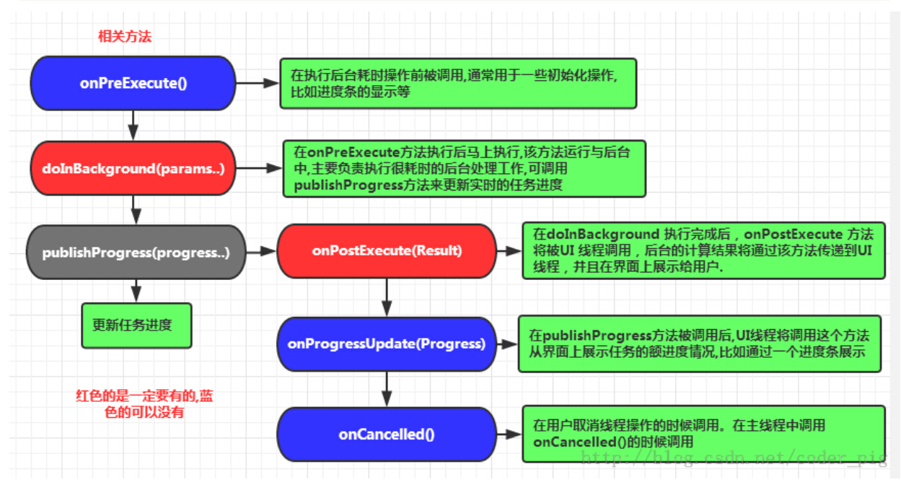

class TestTask extends AsyncTask<Void,Void,String>{

//在异步线程中执行

@Override

protected String doInBackground(Void... params) {

try {

Thread.sleep(2000);

} catch (InterruptedException e) {

e.printStackTrace();

}

String string = "123ABC";

//通知主线程当前进度,触发onProgessUpdate

publishProgress();

return string;

}

//当前切换到主线程，根据传递参数做UI更新

@Override

protected void onProgressUpdate(Void... values) {

Toast.makeText(getApplicationContext(),"我被调用",Toast.LENGTH_LONG).show();

super.onProgressUpdate(values);

}

//主线程准备

@Override

protected void onPreExecute() {

super.onPreExecute();

Toast.makeText(getApplicationContext(),"Start thread!",Toast.LENGTH_LONG).show();

}

//切换到主线程

@Override

protected void onPostExecute(String s) {

btn.setText(s);

}

}