🎯 CUSTOMER SEGMENTATION
5 customer stories, told through data
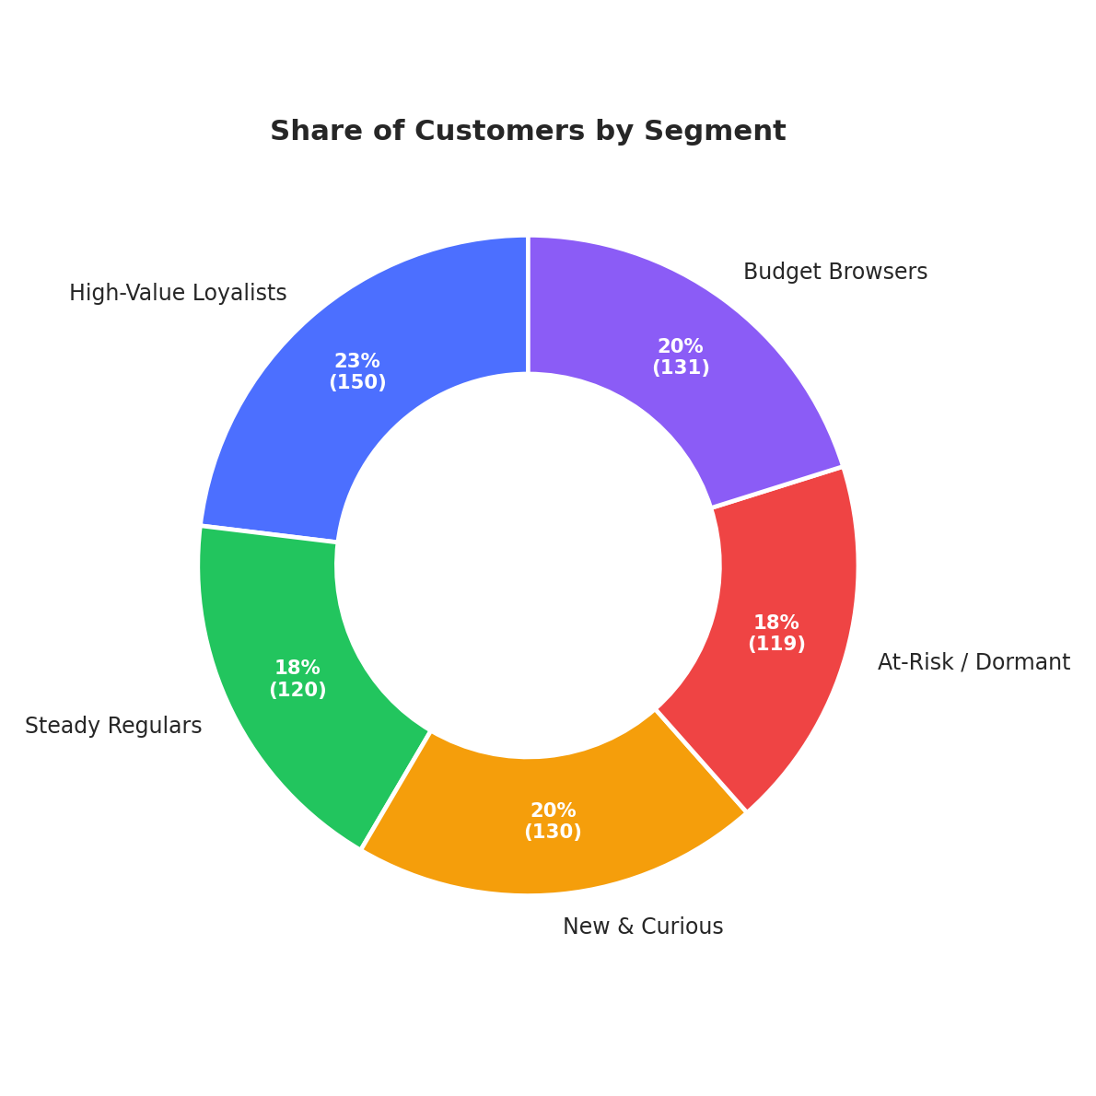
650 customers · K-Means clustering · Due 15 Jul 2026

👀 The Five Segments at a Glance
Every customer falls into one of five groups. Here's the whole story in one page:
👑 | High-Value Loyalists 23.1% · 150 customers  Your best customers — buy often, spend big, never really leave.  $95.9k income · 28 orders/yr · last order 13 days ago | → Protect with VIP perks & early access.

🤝 | Steady Regulars 18.5% · 120 customers  Dependable monthly shoppers — not flashy, just reliable.  $50.3k income · 14 orders/yr · last order 34 days ago | → Bundle offers to lift order size.

🌱 | New & Curious 20% · 130 customers  Young & enthusiastic, still building the habit.  $42.4k income · 10 orders/yr · last order 23 days ago | → Onboarding nudges to build loyalty.

⚠️ | At-Risk / Dormant 18.3% · 119 customers  Used to spend well — gone quiet for 5+ months.  $71.6k income · 3 orders/yr · last order 159 days ago | → Launch a personal win-back campaign.

💰 | Budget Browsers 20.2% · 131 customers  Price-sensitive, occasional shoppers, browsing more than buying.  $36.2k income · 5 orders/yr · last order 96 days ago | → Value deals, not premium upsells.

🗺️ Where Everyone Sits
Income doesn't predict spending — behavior does. High earners can go quiet; modest earners can be your most excited fans.
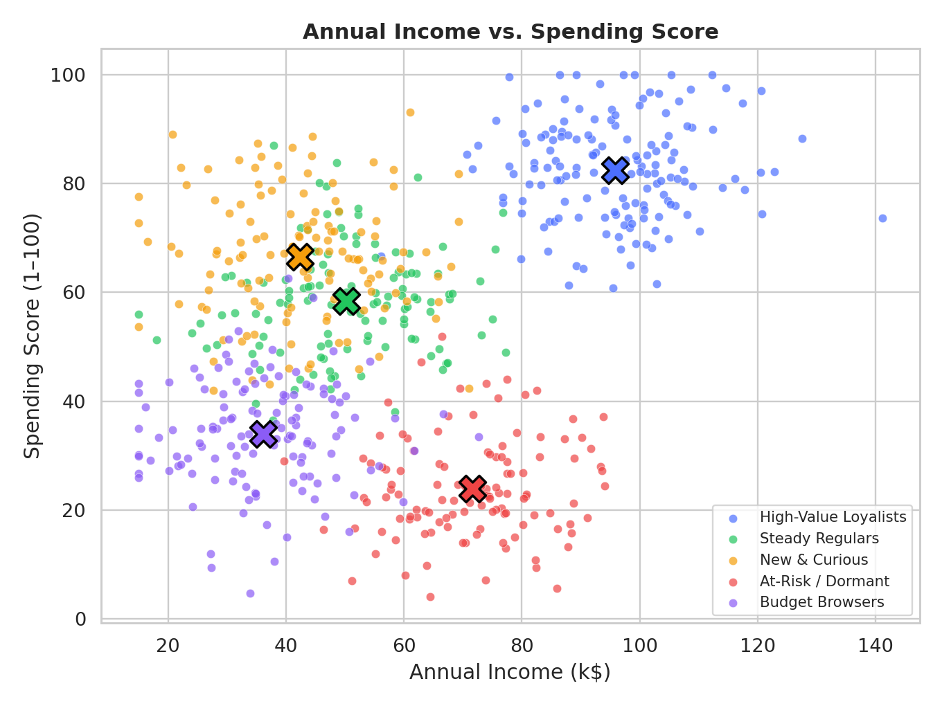
Income vs. spending score, segment centers marked ✖

🔬 Are These Groups Really Different?
Yes — plotted in 2D, the five segments form clean, separate clusters rather than one blur.
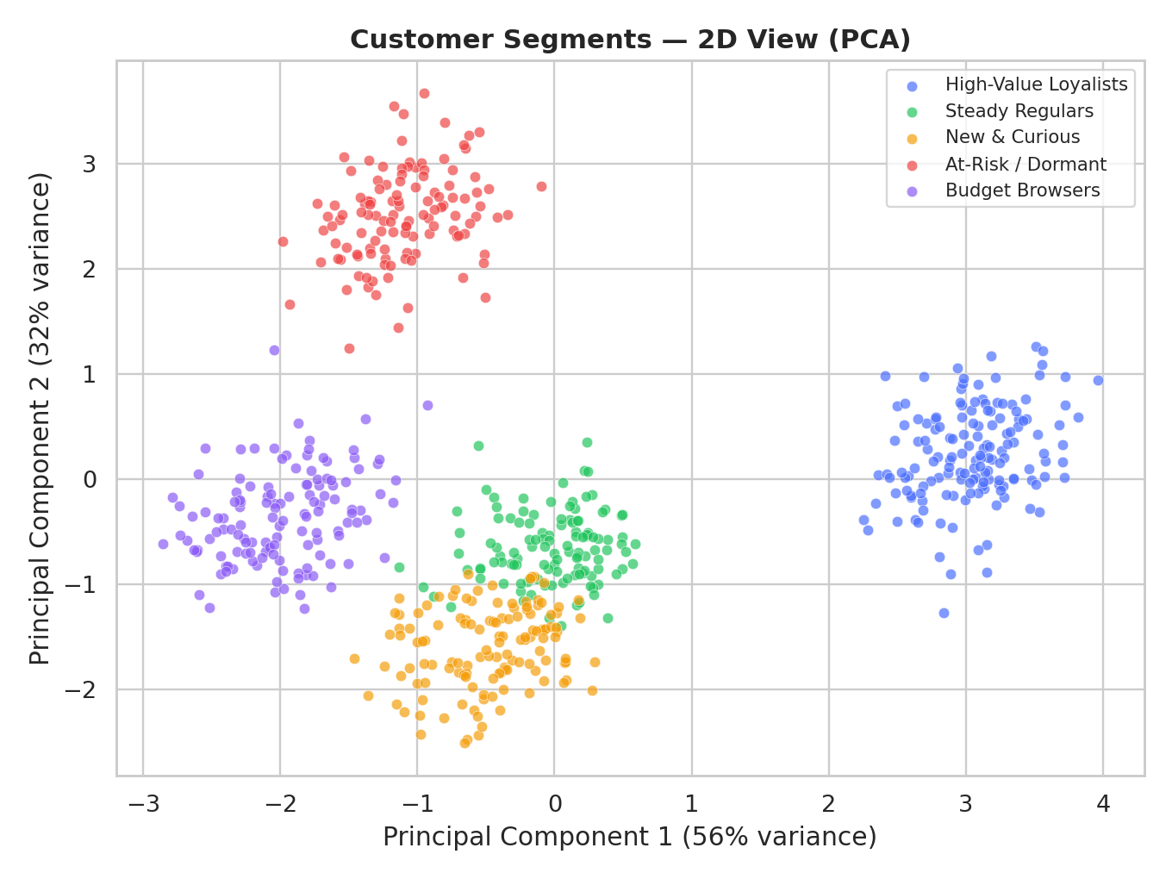
Customer segments in 2D (PCA)

🌡️ What Defines Each Group
Darker red = higher than average, blue = lower. At-Risk/Dormant jumps out immediately on recency.
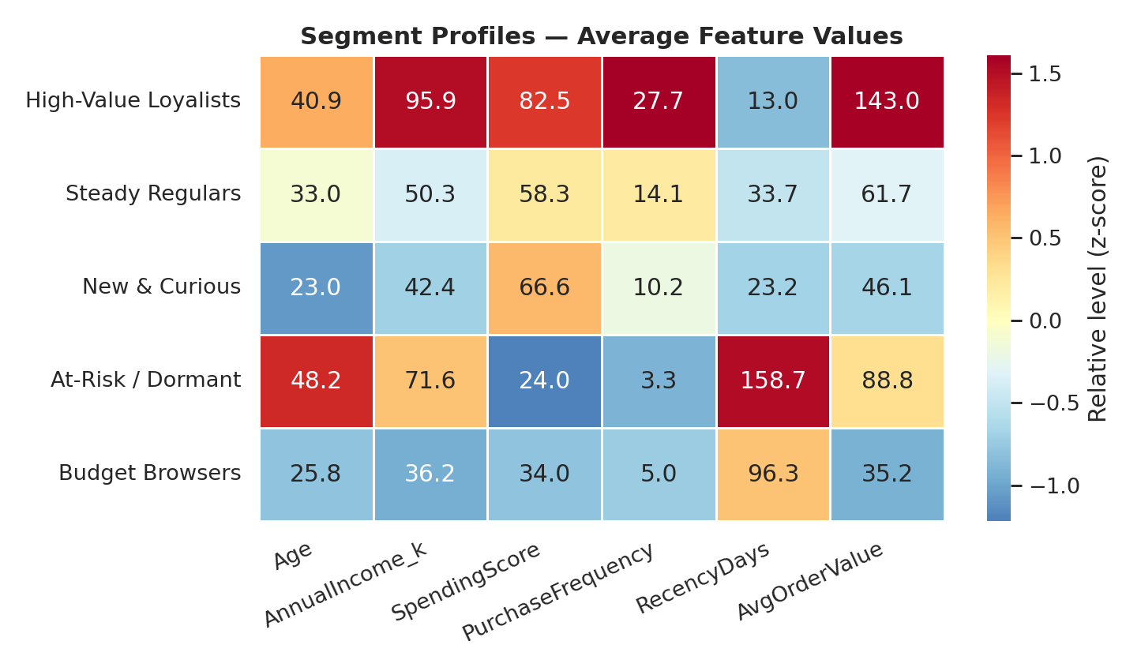
Average feature values by segment

📈 Buying Habits
Loyalists buy often and recently. At-Risk/Dormant customers haven't shown up in months — the biggest opportunity in this report.
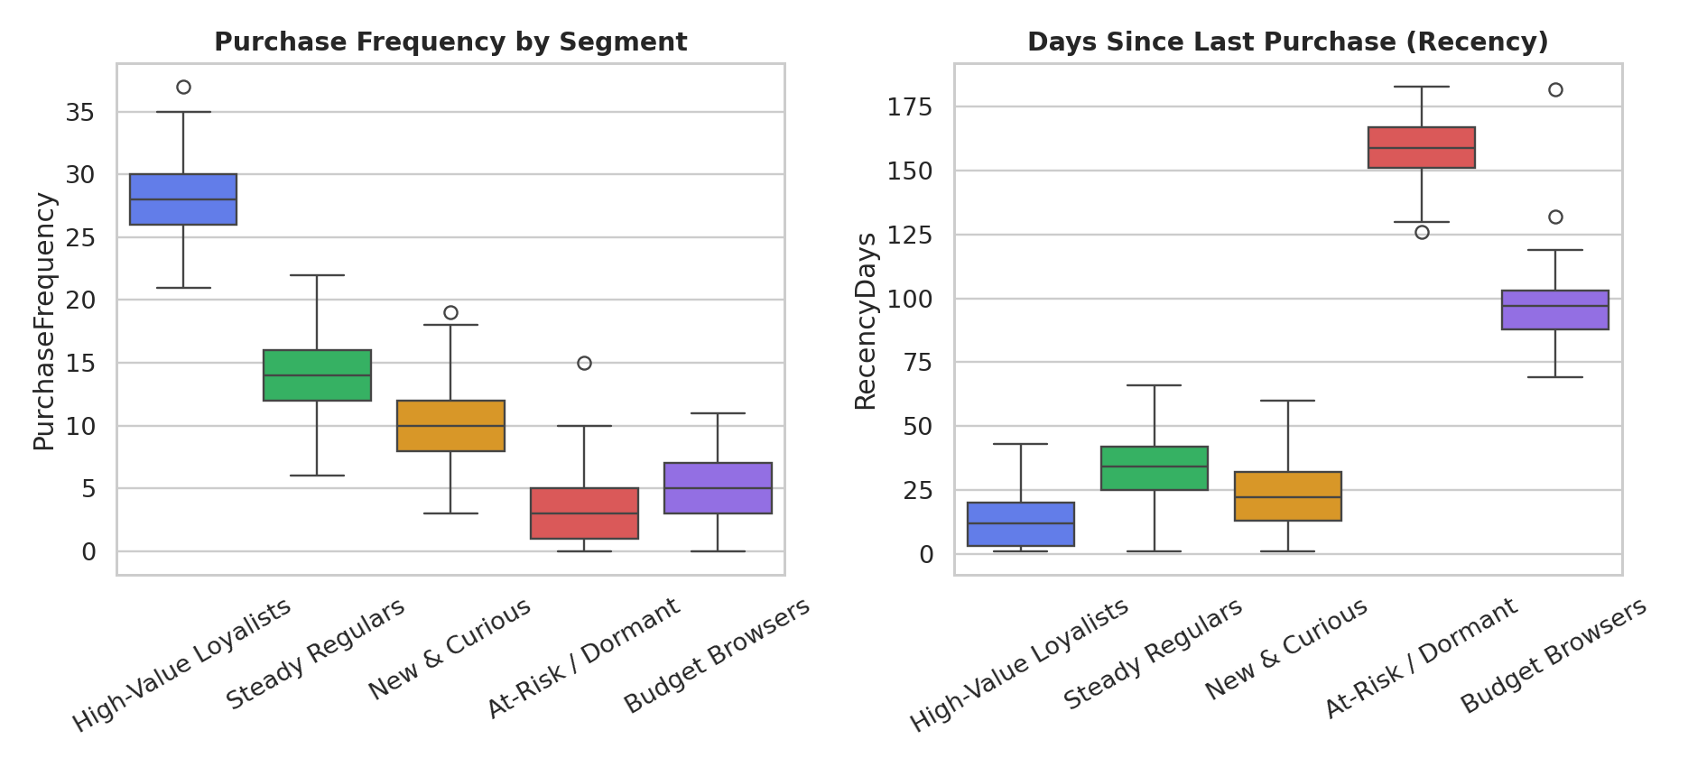
Purchase frequency (left) & recency in days (right)
Category taste shifts by segment too, which should shape what each group sees in marketing.
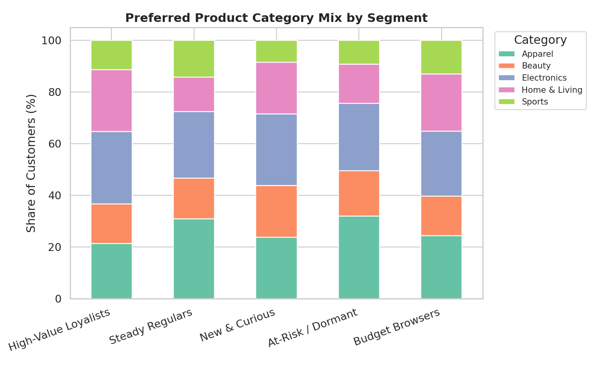
Preferred product category mix by segment

🧪 How This Was Built
Quick version: standardized 6 customer features → tested cluster counts 2-8 → K-Means with k=5 fit best (silhouette score 0.43) → validated visually with PCA. Full pipeline in Python (pandas, scikit-learn).
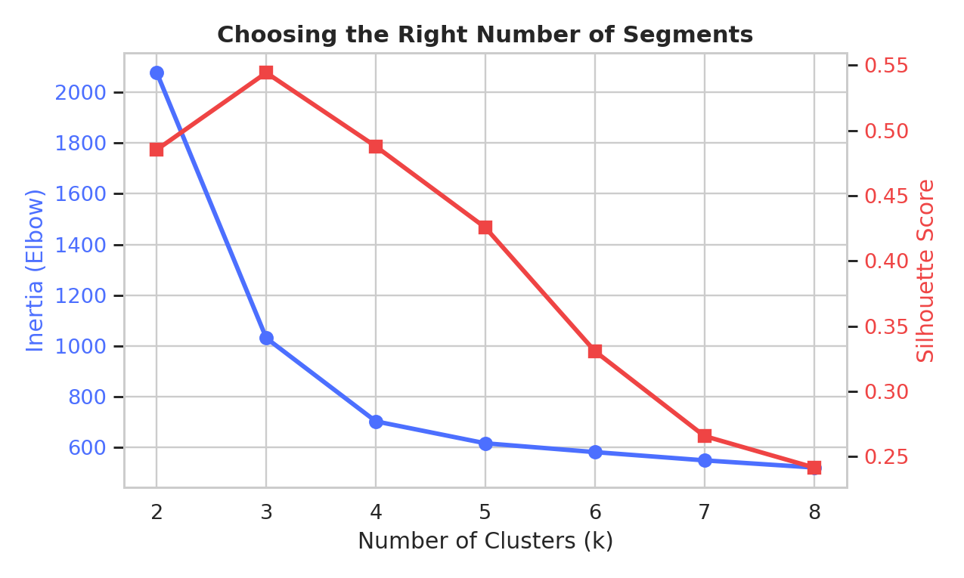
Choosing k = 5 via elbow + silhouette score

✅ What To Do Next
👑 Protect Loyalists | 23% of customers, outsized revenue. VIP tiers > discount codes.
🚨 Win back At-Risk | High past value, 5+ months silent. Personal outreach beats a blast email.
🌱 Nurture New & Curious | Onboarding now can turn them into tomorrow's Loyalists.
💰 Keep it light for Budget Browsers | Value deals convert better than premium upsells here.
🔁 Re-run this quarterly | Behavior shifts — keep segments current, not stale.

Beyond the segments, this project builds real hands-on skill: preparing behavioral data, fitting and validating a clustering model, and turning statistics into a story a marketing team can act on.

