ESP Lab1: Prep Sheet

Signal Modulation by Decimation and Interpolation
Group / Team | Team member 1: | Torben Burandt
ESPL02 / 1 | Team member 2: | Luis Huber
ESPL02 / 1 | Team member 3:
Table 1: Different configurations to be used by different lab groups
Lab group as chosen in myHAW | Down- / Upsampling factor | Chirp, from … to [kHz], length [s] |  | Bat sound $f_{bat}$ | Sampling frequency ADC, DAC $f_{s}$ [kHz] | Polyphases $x_{λ}$ output at DAC CH0 / CH1
ESPL/01 | M=L=3 | 18 … 21 kHz | 2.5 s | 18 kHz | 50 kHz, 50 kHz | $$λ=0 / λ=2$$
ESPL/02 | M=L=4 | 14 … 17 kHz | 3.0 s | 15 kHz | 50 kHz, 50 kHz | $$λ=0 / λ=3$$
ESPL/03 | M=L=5 | 21 … 24 kHz | 2.0 s | 17 kHz | 50 kHz, 50 kHz | $$λ=0 / λ=4$$
ESPL/04 | M=L=5 | 18 … 21 kHz | 3.0 s | 16 kHz | 50 kHz, 50 kHz | $$λ=0 / λ=3$$

Preparation

Creating a Chirp Signal
Add your results, including Matlab code and figures, to the preparation sheet. Explain why you think the result is correct.
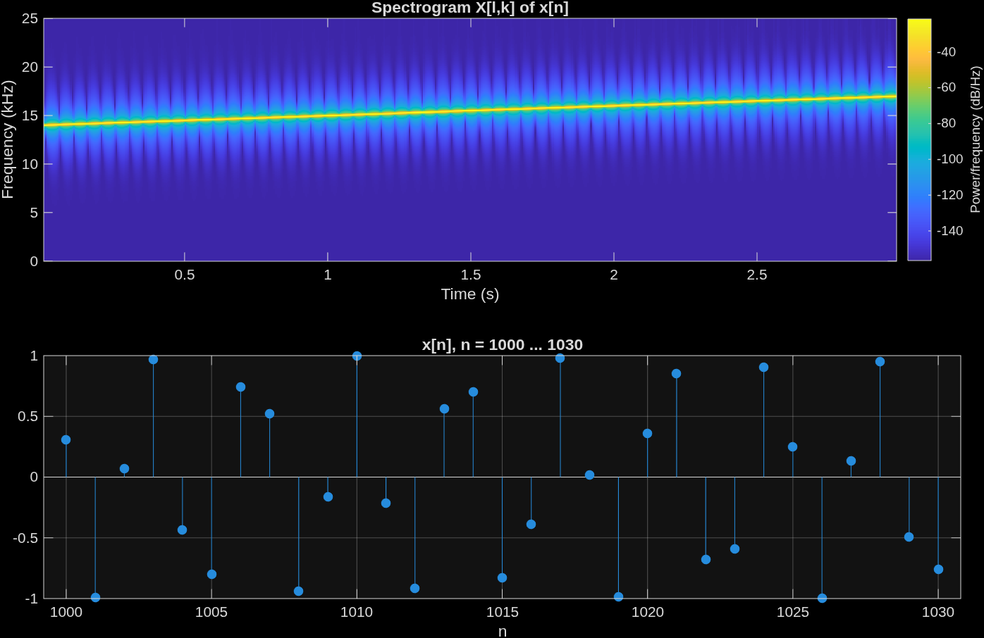

Up trend of a chirp signal, signal cutout matches with sinus waveform
Code see Appandix:
AI usage in section 3.1 – Claude.ai:
“Please makeup a graph in matlab that displays the following chirp signal as spectrogram and a cutout inform of stem plots, use subplots.
… code until line 27 …
“

Downsampling and Polyphase Representation
Add your results, including Matlab code and figures, to the preparation sheet. Explain why you think the result is correct.
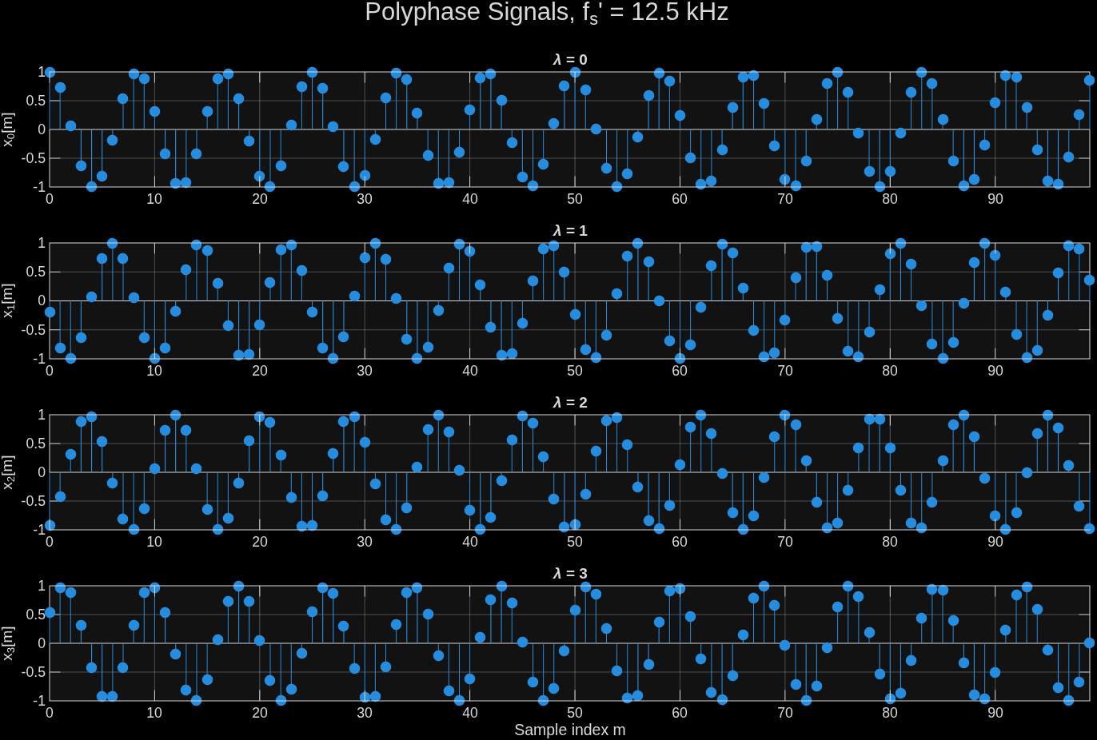

The signal integrity is still visible and the datapoints match the downsampled frequency
AI usage in section 3.2 – Claude.ai:
“Please design the following matlab plot with the code provided below:
display the first 100 samples of the downsampled polyphase signals 𝑥 𝜆 [𝑚], 𝜆 = 0, … 𝑀 − 1 in the domain of the low sampling frequency in 𝑀 subplots one below the other, use stem.
… Code from section 3.2… “

Upsampling without Interpolation Filter
Add your results, including Matlab code and figures, to the preparation sheet. Explain the shape of the spectrogram and provide reasons based on specific frequencies. Assume that a bat sound of $f_{bat}$ (as given in Table 1 for your ESPL group) is fed into the system's ADC. Is it reproduced at the DAC output? If so, at what frequency / frequencies?

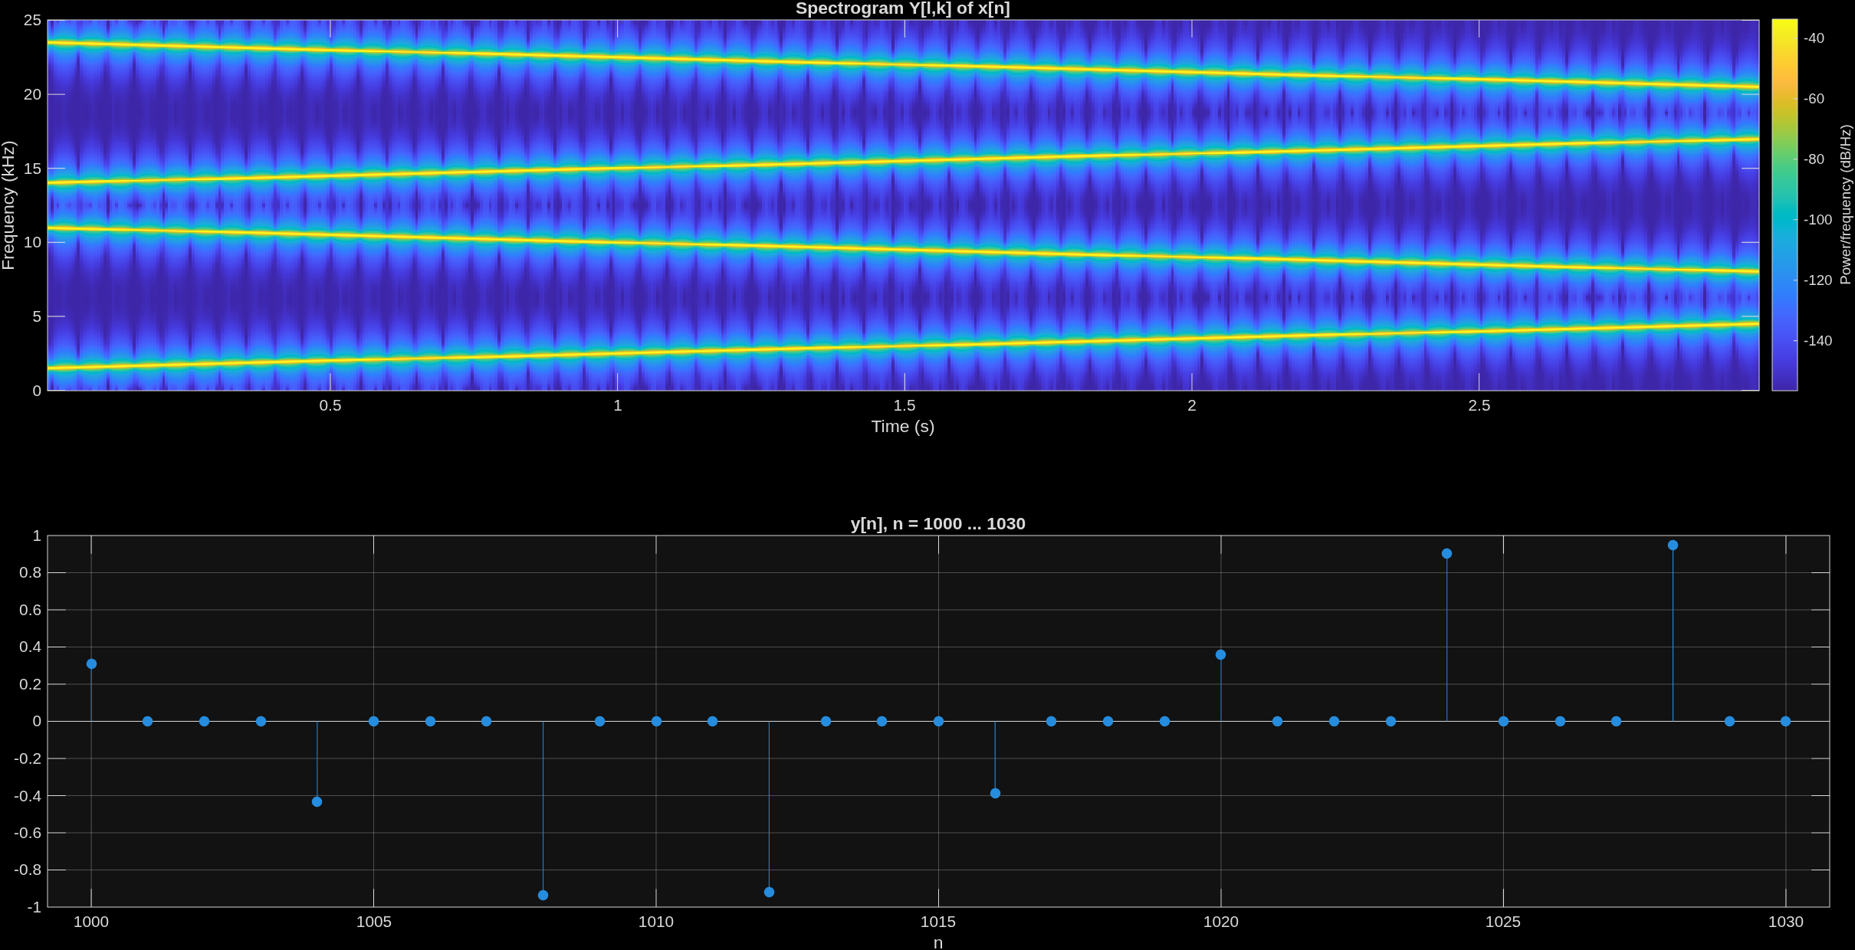
The stem plot(lower plot) shows the upsampling and zero padding between the data points, every 4th point is a sample as defined by L=4.
The spectrogram in the upper part shows the image repetition of the upsampling. For this the interpolation filter will be added in 3.4
A 15kHz bat sound will be downsampled by 4 with fs=50kHz, fs/2 = 25kHz, fs_prime = 50/4 = 12.5kHz, the bat sound will be imaged to 2.5, 10, 22,5, 35 kHz tough our new sampling frequency at f_sprime/4 = 12.5, and f_sprime/2 = 6.25, only 2.5 kHz is in the range of the nyquiest frequency.

AI usage in section 3.3 – Claude.ai:
recycled plot code from 3.1, not new prompt

Applying an Interpolation Filter
Add your results, including Matlab code and figures, to the preparation sheet. Compare the results from 3.3 and 3.4 and explain them.
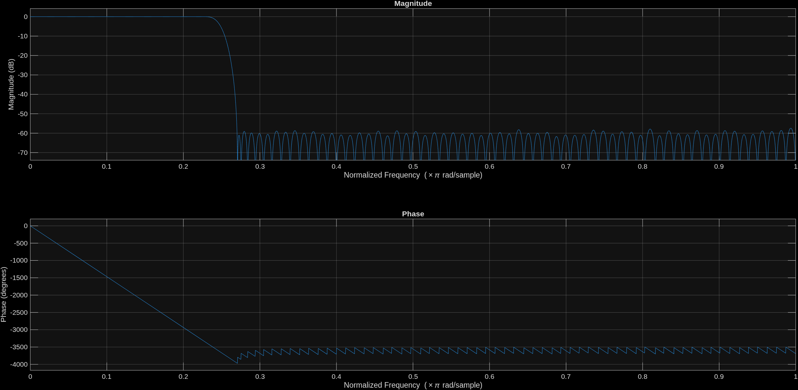
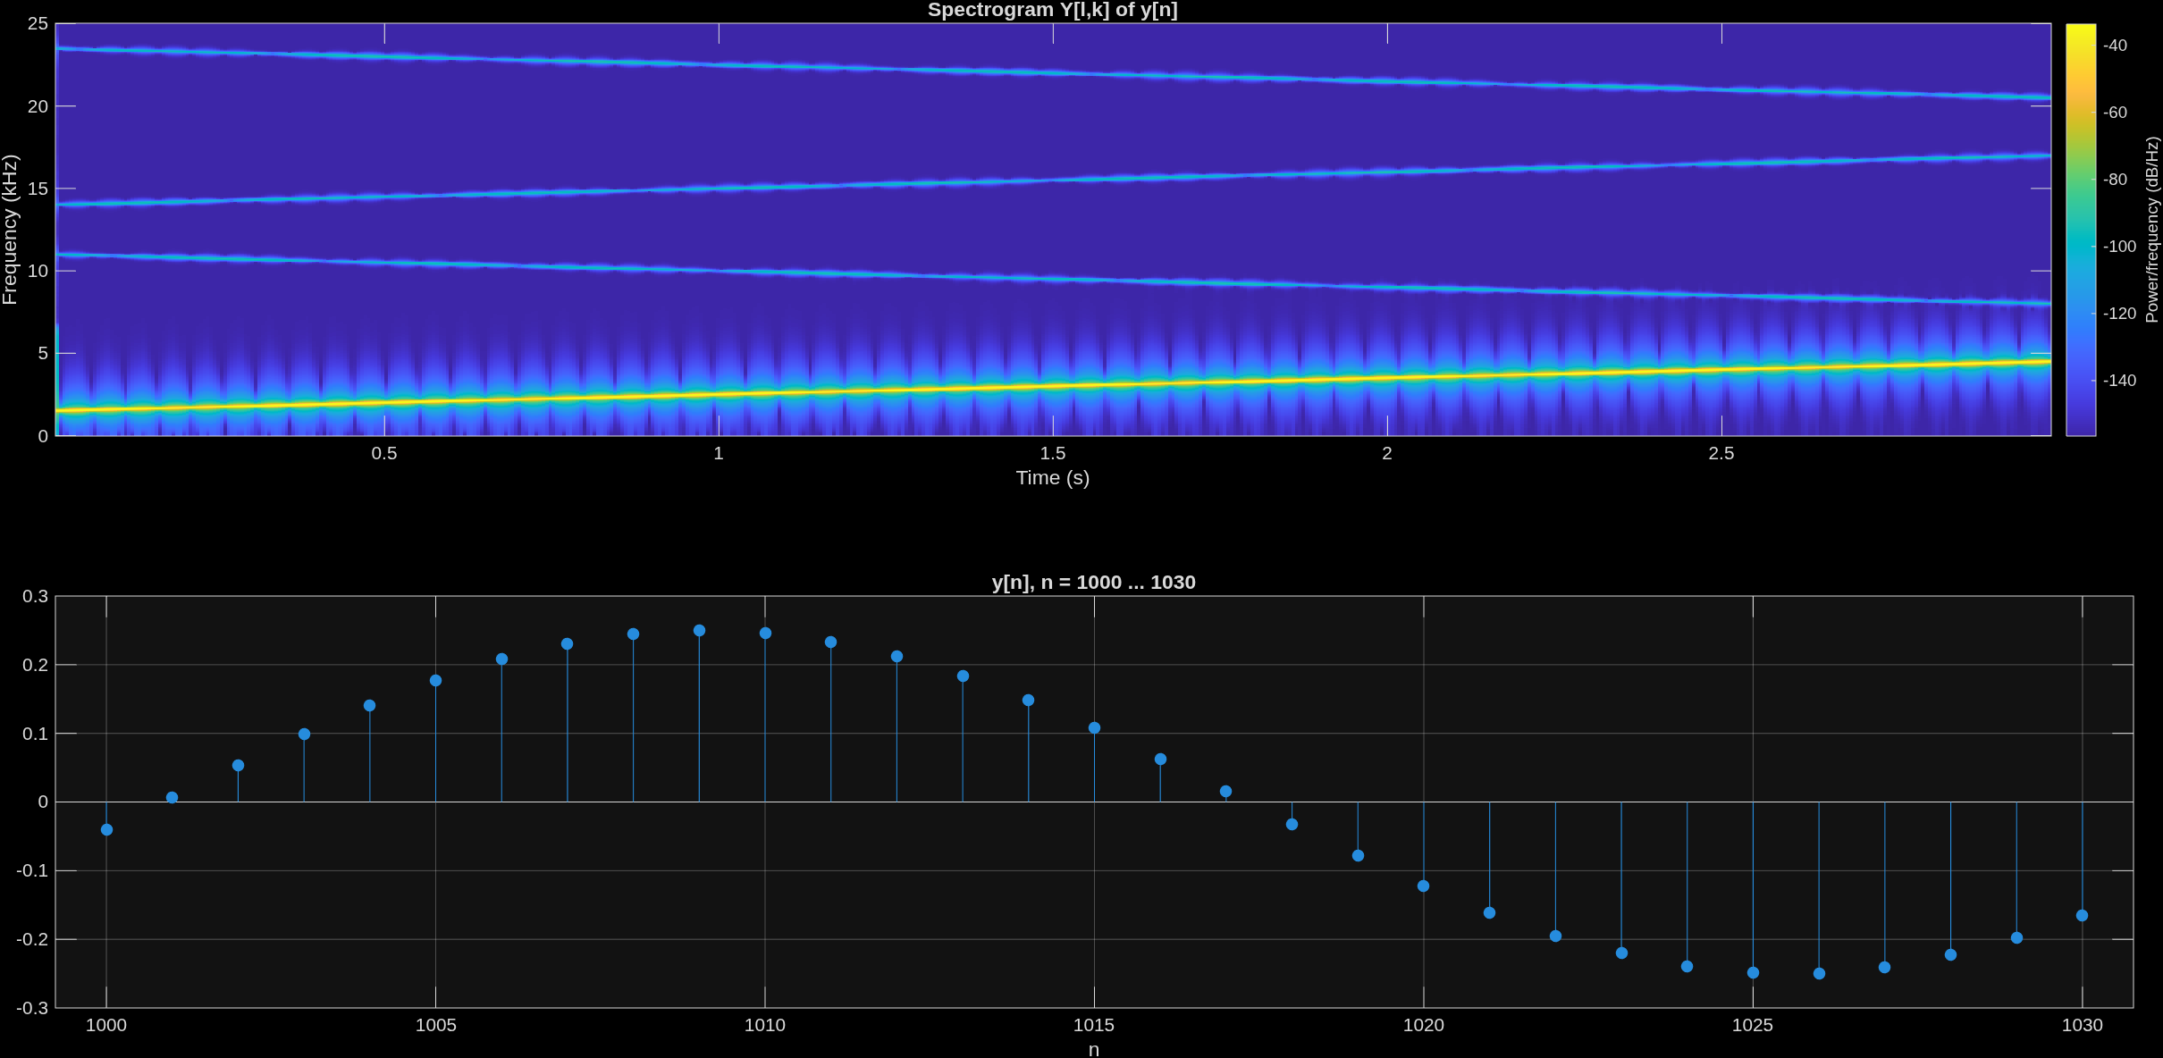
The filter is applicable as design parameters suggests and applies as Anti-Image-Filter in the upsampled signal as seen in the Spectrogram.

Export Filter Coefficients to C
Generate the header file for the filter coefficients of your interpolation filter and bring the file with you to the lab session. How many coefficients does your FIR filter have? Which is the largest and which the smallest value? Do these values fit into 16-bit format? Explain.

Smallest 5.187988281250000e-4 1Q15 = 17, largest 0.2436 1Q15= 8105
16-bit format will be suffiecient for filter coeffiecents, but 163 filter coeffiecents are a lot for filtering, maybe increase/decrease filter requierments to obtain less filter coeffiecents. Would propably end in a less optimal filter.

C Program with Interrupt Handlers
Extend the code for $M$ and $L$ values given in Table 1 for your ESPL group. The polyphases $x_{λ}\left[m\right]$ specified in Table 1 should be fed to the respective DAC outputs. Why is g_PolyWUpdate necessary? Add your C code to the preparation sheet.
g_PolyWUpdate is necessary to obtain the information to which polyphase the current sample belong and to later upsample the signal in correct order.
Code is only a extension of the switch case in ADC and DAC Interrupt example shown below, full code not included to avoid code duplications.
AdcInt()
…
switch (lambda) {
case N:
g_PolyW[N] = g_i16AdcData[ADC0];
g_PolyWUpdate = N;
break;
repeat N times
DacInt()
…
switch (g_PolyWUpdate) {
case 0:
g_i16DacData[0] = g_PolyW[0];
g_i16DacData[1] = 0;
break;
...
repeat N times

The preparation is complete. Congratulations! Please submit the preparation sheet in Moodle before the lab session.

