**Bahria University Islamabad**



**Web System & Technologies**

**Assignment-03**

**Name: Shayan Karim**

**Enroll No: 01-135221-117**

**Class: BS(IT-5A)**

**Introduction:**

SKSales is an innovative e-commerce platform designed to cater to the diverse needs of customers in the real estate sector. With a user-friendly interface and comprehensive features, SKSales aims to streamline the process of buying, selling, renting, and even building houses.

**Website Structure:**

1. **Home Page:** The home page serves as the gateway to the website, offering visitors an overview of the services provided. It includes featured listings, promotions, and quick links to key sections like buying, selling, renting, and building.

2. **About Page:** This section provides insights into the company's background, mission, and values. It builds trust and credibility among potential customers by highlighting the expertise and experience of SKSales in the real estate industry.

3. **Contact Page:** The contact page offers multiple channels for users to get in touch with SKSales, including a contact form, email address, phone number, and physical address. This ensures seamless communication and support for customers.

4. **Buy:** Users can explore a wide range of properties available for purchase, including residential and commercial properties. Advanced search filters allow for easy navigation based on location, price range, amenities, and more.

5**. Sell:** Sellers can list their properties on SKSales, reaching a broad audience of potential buyers. The platform offers tools for creating attractive listings with detailed descriptions, high-quality images, and virtual tours to showcase the property effectively.

6. **Rent:** For those looking to rent properties, SKSales provides a curated selection of rental listings. Users can specify their requirements and preferences to find the perfect rental property, whether it's a house, apartment, or commercial space.

7**. Build:** SKSales goes beyond traditional e-commerce platforms by offering a unique "Build" feature. This allows users to explore options for building custom homes according to their specifications. They can collaborate with architects, contractors, and designers to bring their dream home to life.

**Key Features:**

1. **User-Friendly Interface:** The website features an intuitive interface that makes it easy for users to navigate and find what they're looking for.
2. **Advanced Search:** Robust search filters enable users to refine their search results based on various criteria, ensuring they find properties that meet their specific requirements.
3. **High-Quality Listings:** SKSales prioritizes high-quality listings with detailed descriptions, professional images, and virtual tours to provide users with a comprehensive view of each property.
4. **Secure Transactions:** The platform ensures secure transactions for buyers, sellers, and renters, offering peace of mind throughout the entire process.
5. **Customer Support:** SKSales is committed to providing exceptional customer support, with multiple channels for users to reach out for assistance or inquiries.

**Website Screenshot:**

**Home Page:**

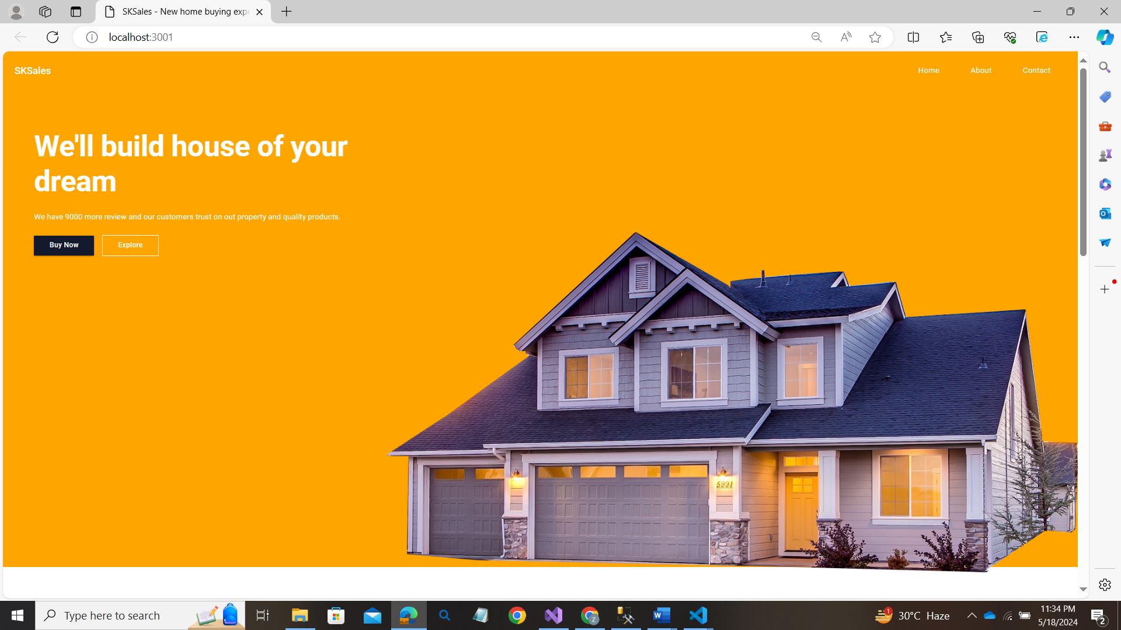

**About Page:**

**Contact Page:**

