Final Project: Linear Algebra for DSML
Submitted by: Sandeep Kaur
Course: DSML – Linear Algebra
Instructor: Jeffrey Lanyon
Student ID: 0438928

1. Introduction
This project explores how algebraic tools—such as standardization, weight vectors, dot products, normalization, and matrix transformations—can be used to build and analyze a simple binary classifier (perceptron).
The project is divided into several stages:
  - Standardizing each variable using z-scores
  - Constructing an initial weight vector w_1using values a,b,c,d
  - Normalizing the weight vector and computing a bias B_1
  - Classifying all observations (Epoch 1)
  - Building a transformation matrix M
  - Obtaining a new weight vector w_2=Mw_1and bias B_2
  - Classifying again (Epoch 2)
  - Comparing the performance between Epoch 1 and Epoch 2
This report describes each step in detail, including formulas, reasoning, interpretation, and classification outcomes.

Here are the steps I used to complete this project:
Step 1: Enter the Data into Excel
I got 10 observations entering my student Id:0438928 with four columns from LACode2.exe
Condition (Normal / Failed), Voltage ,Current, Temperature
This created the base dataset that will be used for all calculations.
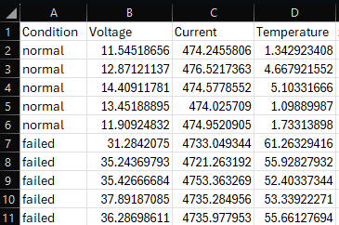

Step 2: Calculate the Means of Each Variable
I calculated the mean of Voltage, Current, and Temperature using the Excel AVERAGE function:
=AVERAGE(B2:B11)
=AVERAGE(C2:C11)
=AVERAGE(D2:D11)
This gave:
Voltage mean = 24.032
Current mean = 2605.326
Temperature mean =29.254

Step 3: Calculate Standard Deviations
I used the sample standard deviation formula:
=STDEV.S(B2:B11)
=STDEV.S(C2:C11)
=STDEV.S(D2:D11)
This gave:
Voltage SD ≈ 11.937
Current SD ≈ 2245.717
Temperature SD ≈ 28.020
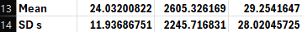

Step 4: Standardize Each Value Using Z-Scores
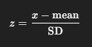
I converted every Voltage, Current, and Temperature value into a z-score using:
General formula :(x-mean)/standard deviation
=(B2-$B$13)/$B$14
=(C2-$C$13)/$C$14
=(D2-$D$13)/$D$14
This standardized the data so that all variables are on the same scale.
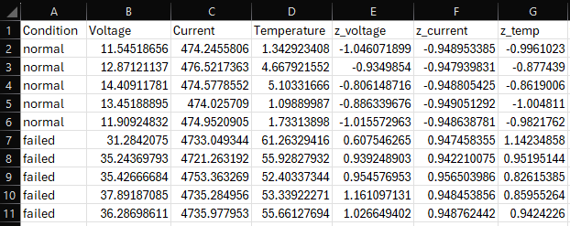

After standardization:
  - All Normal observations received negative z-scores, meaning their Voltages, Currents, and Temperatures are below the overall average.
  - All Failed observations received positive z-scores, meaning failures occur when these values increase above normal.

This confirms a clear pattern:
Higher voltage, higher current, and higher temperature all indicate a higher chance of failure.

Step 5: Set the a, b, c, and d Values
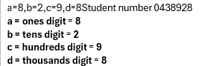

I typed these values into my spreadsheet from my student number:

Step 6: Compute the First Weight Vector w_1
Using the project formula:
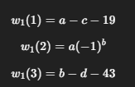
As we know a=8,b=2,c=9,d=8

Excel formulas:
A20 = A17 - C17 - 19
A21 = A17 * (-1)^B17
A22 = B17 - D17 - 43
This produced:
w₁ = [−20, 8, −49]

Step 7: Normalize the Weight Vector w ̂_1
First, I calculated the magnitude of w₁:
C20 = SQRT(A20^2) + (A21^2) + (A22^2))
Result: 53.52569476
Then each weight vector was divided by the magnitude:
B20 = A20/C20
B21 = A21/C20
B22 = A22/C20
This created the unit vector w ̂_1.
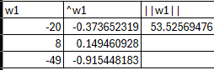

Step 8: Compute the Bias B_1
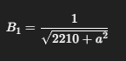
Bias modifies the decision boundary, so data is not forced to go through the origin.
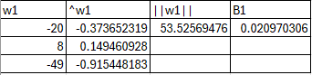

Excel: D20 = 1/SQRT(2210 + (A17)^2)
Result: 0.020970306
Bias ensures the classifier correctly separates the “normal” cloud of points from the “failed” cloud.

Step 9: Compute Epoch 1 Perceptron Scores
Score formula:

Excel:
=(E2*$B$20) + (F2*$B$21) + (G2*$B$22) + $D$20
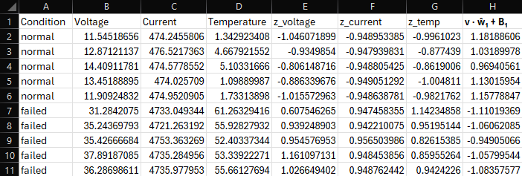

Step 10: Make Epoch 1 Predictions
Project rule:
  - If score ≥ 0 → Normal
  - If score < 0 → Failed

Excel:
=IF(H2>=0,"Normal","Failed")

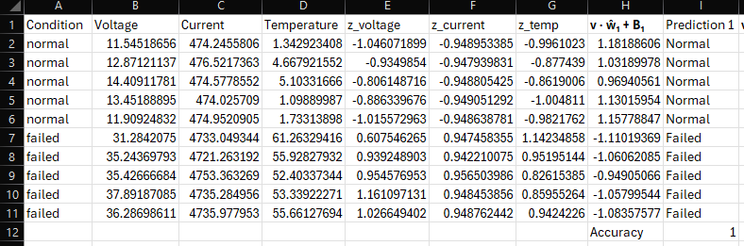

Epoch 1 Results
my results show:
  - All Normal observations had positive scores
  - All Failed observations had negative scores

Step 11: Calculate Epoch 1 Accuracy
Excel:
=SUMPRODUCT (--($A$2:$A$11=I2:I11))/ROWS($A$2:$A$11)
Result:
Accuracy = 1 (100%)

Step 12: Build the Transformation Matrix M
Using :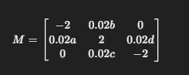
As we know a=8, b=2,c=9,d=8 from student Id
Excel:
A26 = -2
B26 = B17 * 10^-2
C26 = 0

A27 = A17 * 10^-2
B27 = 2
C27 = D17 * 10^-2

A28 = 0
B28 = C17 * 10^-2
C28 = -2

Step 13: Compute the Second Weight Vector w_2=Mw_1
Excel:
A31 = (A26*A20) + (B26*A21) + (C26*A22)
A32 = (A27*A20) + (B27*A21) + (C27*A22)
A33 = (A28*A20) + (B28*A21) + (C28*A22)
Then I computed the magnitude and normalized exactly like w₁.

Step 14: Compute the Second Bias B_2
Using formula: 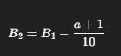

Excel:
D31 = D20 - (A17 + 1)/10
The new bias becomes negative and shifts the decision boundary in the opposite direction.

Step 15: Compute Epoch 2 Perceptron Scores
Formula:
=(E2*$B$31) + (F2*$B$32) + (G2*$B$33) + $D$31

Step 16: Make Epoch 2 Predictions
=IF(J2>=0,"Normal","Failed")
This time:
  - All Normal → Failed
  - All Failed → Normal
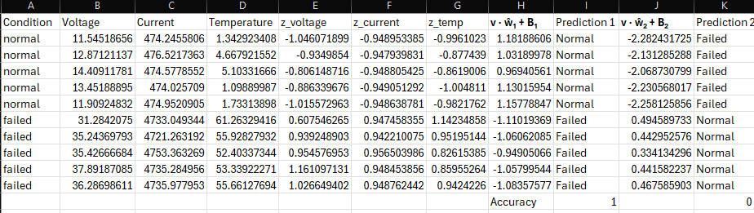
Epoch 2 Results
Opposite behavior occurs:
All Normal rows get negative scores
All Failed rows get positive scores
So the classifier misclassifies every observation.

Step 17: Calculate Epoch 2 Accuracy
=SUMPRODUCT(--($A$2:$A$11=K2:K11))/ROWS($A$2:$A$11)
Result:
0% accuracy

Step 18: Final Interpretation
Epoch 1: 100% accuracy
The original w₁ vector aligns perfectly with the data.
Epoch 2: 0% accuracy
The transformation matrix M flips the direction of the weight vector, reversing classification.
This demonstrates how sensitive perceptron’s are to weight direction and bias.

Final Conclusion
In this project, I learned how standardizing data and using weight vectors affects a perceptron classifier. After calculating the first weight vector and bias, the model worked perfectly and correctly separated all the Normal and Failed cases in Epoch 1. When I applied the transformation matrix to get the second weight vector, the results completely changed, and the model got every prediction wrong in Epoch 2.
This showed me how important the direction of the weight vector and the bias are in classification. A small change in these values can make the model go from 100% accuracy to 0%. Overall, I learned how linear algebra and Excel calculations can be used to understand how simple machine learning models work. Make it standardized way and write at top the project name and my name and teacher name

