Capstone Project – Project Proposal
Sandeep Kaur
Applied Computer Education Department, Red River College Polytechnic
COMP-2702: Data Management
Instructor’s Name: Miguel Guzman
Date Submitted:2026-04-09

Project Description
This project is about analyzing a retail sales dataset from a superstore. The main goal is to understand how the business is performing by looking at sales, profit, customer segments, and product categories. I will use this dataset in Power BI to explore trends, compare different regions, and see which products are doing well and which are not. This project will help me understand how data can be used to support business decision-making.
I am somewhat familiar with this dataset because it has simple and clear columns like Order Date, Category, Sales, and Profit. Each row represents a customer order, which makes it easy to follow the logic of the data. I chose this project because it is based on a real business problem where a company wants to know what works best for them. This is also relevant to my field of data analytics because it helps me practice working with real-world data, building dashboards, and finding useful insights

Business Case
Purpose of the Project
The purpose of this project is to analyze retail sales data to understand how different factors such as region, product category, and customer segment affect sales and profit. This will help identify which areas of the business are performing well and which need improvement.

What I Hope to Learn
- Understand how to work with real-world business data
- Learn how to build a data model in Power BI
- Practice creating dashboards and visualizations
- Identify patterns and trends in sales and profit

Why This Dataset is Relevant
- Contains real business data such as sales, profit, and customer details
- Includes both categorical and numerical data
- Allows time-based analysis using order dates
- Suitable for creating meaningful visualizations

Relevance to My Field (Data Analytics)
This project is relevant to my field because it helps me develop important data analytics skills such as data analysis, visualization, and decision-making support. It also gives me experience working with real-world datasets.

Data Source Documentation:
Dataset URL: https://www.kaggle.com/datasets/vivek468/superstore-dataset-final
Semantic Model
Dataset Normalization
The original dataset is in a single table, so I will normalize it into separate tables based on the type of data. I will use the following tables:

Fact Table
- Fact_Sales
  - Row ID
  - Order ID
  - Order Date
  - Ship Date
  - Customer ID
  - Product ID
  - Postal Code
  - Sales
  - Quantity
  - Discount
  - Profit

Dimension Tables
Dim_Customer
  - Customer ID
  - Customer Name
  - Segment

Dim_Product
  - Product ID
  - Product Name
  - Category
  - Sub-Category

Dim_Location
  - Postal Code
  - Country
  - Region
  - State
  - City

Dim_Date
  - Date
  - Year
  - Quarter
  - Month
  - Month Name

This structure separates transactional data from descriptive data, which helps reduce repetition and makes the dataset easier to manage. It also supports better analysis and visualization in Power BI.

Table Organization and Relationships

The tables in the semantic model will be organized using a star schema, where the Fact_Sales table is the central table and the dimension tables are connected to it. The fact table will store transaction data such as sales, profit, and quantity, while the dimension tables will store descriptive information.
Relationships:
- Fact_Sales → Dim_Customer using Customer ID
- Fact_Sales → Dim_Product using Product ID
- Fact_Sales → Dim_Location using Postal Code
- Fact_Sales → Dim_Date using Order Date
These relationships will be one-to-many, where one record in a dimension table can relate to multiple records in the fact table.
Key Calculations:
- Measure: Total Sales (sum of sales)
- Calculated Column: Profit Category (Profit or Loss)
- Hierarchy: Date hierarchy (Year → Quarter → Month)

Date Table

I will add a separate Dim_Date table to support time-based analysis in Power BI. This table will be created from the Order Date column in the dataset and will include fields such as Date, Year, Quarter, Month, and Month Name.
Using a separate date table will make it easier to analyze sales trends over time and create time-based visualizations. It will also support the date hierarchy used in the report.

Hierarchies, Calculated Columns, and Measures

To enrich the semantic model, the following elements will be implemented:
Hierarchy:
A Date hierarchy with Year, Quarter, and Month will be created to help organize and analyze data over time.
Calculated Column:
A Profit Category column will be added to classify each record as either Profit or Loss, making it easier to compare performance.
Measure:
A Total Sales measure will be created to calculate the total sales value across the dataset, which will be useful for summaries and visualizations in the report.

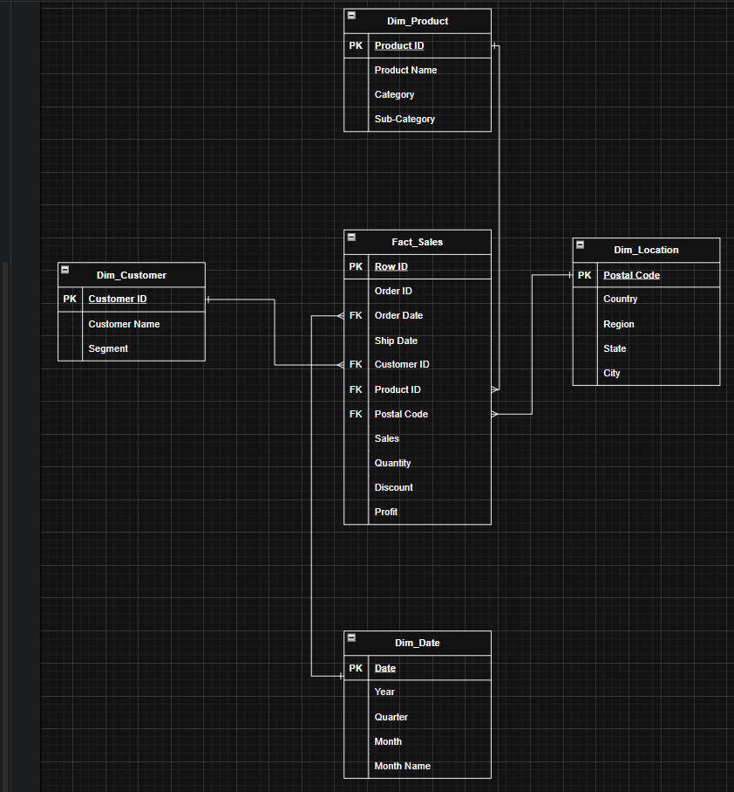

Entity Relationship Diagram (ERD)
The ERD above shows the structure of the semantic model, including the fact table and dimension tables. The Fact_Sales table is connected to all dimension tables using one-to-many relationships based on key columns such as Customer ID, Product ID, Postal Code and Order Date.
The diagram was created using draw.io and includes all tables, columns, and relationships.

Assumptions and Business Rules

The following assumptions and business rules are used to guide the semantic model design:
- Each row in Fact_Sales represents a single transaction
- Each customer is uniquely identified by Customer ID
- Each product is uniquely identified by Product ID
- Each location is identified by Postal Code
- Each order is linked to one customer, one product, one location, and one date
- One customer can have many sales records
- One product can appear in many sales records
- One location can have many sales records
- One date can have many sales records
- The Dim_Date table is created from the Order Date to support time-based analysis
- The model follows a star schema structure, where the fact table is in the center and connected to dimension tables

Analysis
In this project, I plan to perform exploratory and descriptive analysis on the retail sales dataset. I will analyze sales and profit across different dimensions such as region, product category, and customer segment. I will also use time-based analysis to understand how sales and profit change over time using the Order Date.
The key insights I hope to uncover include identifying which products and categories perform the best, which regions generate the highest sales and profit, and how customer segments differ in their purchasing behavior. I also want to understand how discounts affect profit and whether some areas of the business are underperforming. These insights will help provide a better understanding of the business performance.

Power BI Report and Dashboard Design
The Power BI report will be designed to show sales and profit performance using simple and clear visuals. I will focus on analyzing sales by region, category, and customer segment, as well as understanding trends over time using Order Date. The report will be easy to read and will help users quickly understand how the business is performing.
The dashboard will include key summary visuals such as total sales, total profit, and important charts showing trends and comparisons. I will also add slicers to make the report interactive so users can filter data based on region, category, or segment.

Planned Visualizations
- Line Chart
To show sales over time (using Order Date) and identify trends
- Bar Chart
To compare sales or profit by region or category
- Donut Chart
To show sales distribution by customer segment
- Table or Matrix
To display detailed values such as category, sub-category, sales, and profit
- Card (KPI)
To show total sales and total profit as summary values
- Map
To show sales by state or region
- Certified Visual
I will use one Power BI certified visual from the visual marketplace to meet the requirement
- Treemap
To show sales by category and sub-category in a hierarchical view

How the Visuals Help
These visuals will help show trends, comparisons, and patterns in the data. The line chart will show changes over time, the bar chart will compare performance, and the map will show location-based insights. The table and cards will provide detailed and summary information.

Filters, Slicers, and Interactivity

I will include slicers to make the report interactive and easy to use. The slicers will allow users to filter the data based on different fields.
- I will add a Region slicer, which will filter multiple visuals such as the bar chart and line chart
- I may also add a Category or Segment slicer to allow more detailed filtering
These slicers will help users explore the data and focus on specific areas of interest.

Dashboard Visuals

The following visuals from the report will be pinned to the Power BI dashboard:
- Total Sales (Card)
- Total Profit (Card)
- Sales over Time (Line Chart)
- Sales by Region (Bar Chart)
- Sales by Segment (Donut Chart)
These visuals will provide a quick overview of the business performance and help users understand key insights at a glance.

Annex
At this stage, no changes have been made to the project scope. The dataset, semantic model, and planned analysis remain as initially defined. Any changes, if required, will be updated in future milestones after further development and instructor feedback.

