# TASK: FONT TESTER

Write a GUI program that allows a user to test different fonts, font styles, and font sizes within a window. Provide 10 font names of your choice for the user to select within a combo box. Also provide an option for the user to select one of the following font sizes via selection from a combo box: 8, 12, 16, 24, 30, 36, 42, 48. 56. In addition, provide options to display the text as bold and/or italic using checkboxes. If no checkboxes are selected, the text should be displayed in regular font. The text for display/testing should be "Programming is fun" and is required to update dynamically whenever the font name, font size or font style changes.

# REPORT

## Panes

First of all, I made multiple panes for specific functionality, as:

* Boarder pane; to hold all the panes in it (Figure 1).
* Centre pane; for text (Figure 2).
* Top pane; for font name and font size (Figure 3).
* Bottom pane; for font weight and font posture (Figure 4).



Figure 1: Boarder pane to hold all the panes in it.

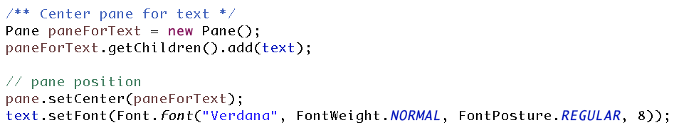

Figure 2: Center pane for text

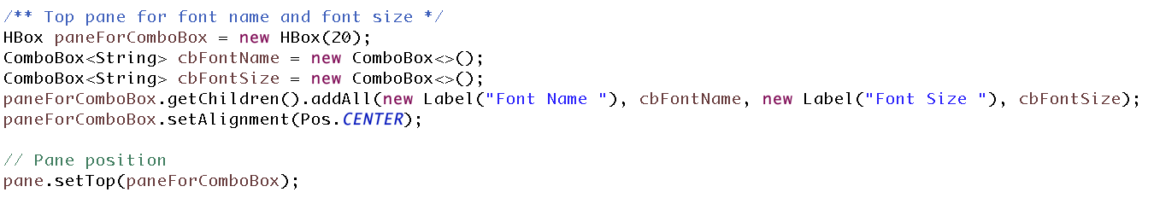

Figure 3: Top pane for font name and font size

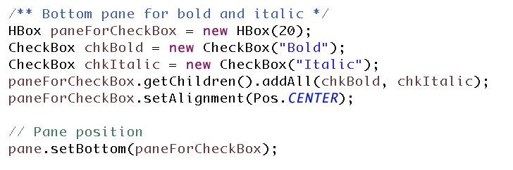

Figure 4: Bottom pane for font weight and font posture.

## Single Event Handler

After that, I made a single event handler (Figure 5), and set actions of all the buttons to same event handler (Figure 6). The single event handler, as shown in Figure 5, checks all the cases if a font is bold/normal, italic/regular, font style and font size and update the font accordingly.

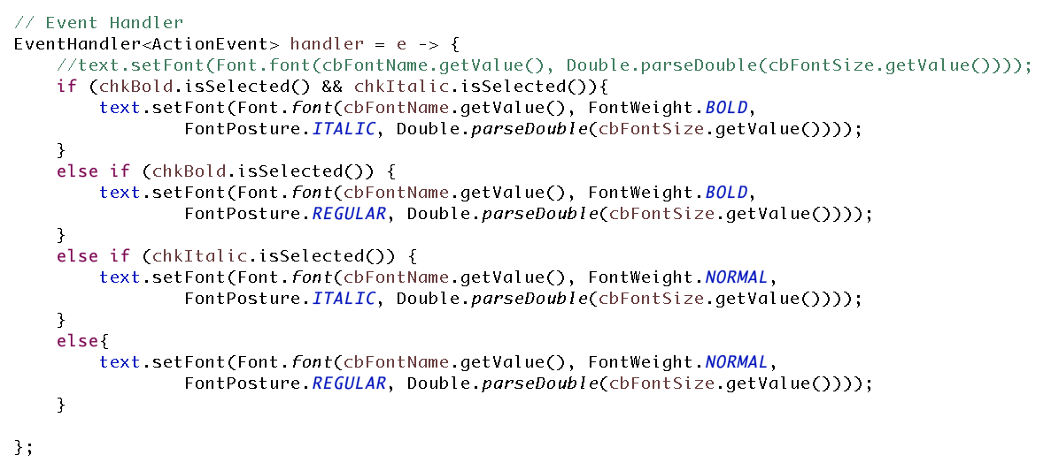

Figure 5: Single event handler for all the buttons.

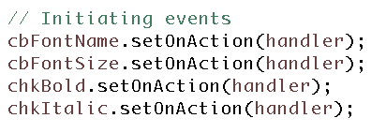

Figure 6: Setting actions of all the buttons to same even handler.

## Font Styles and Font Size

Running the code shows interface as Figure 7

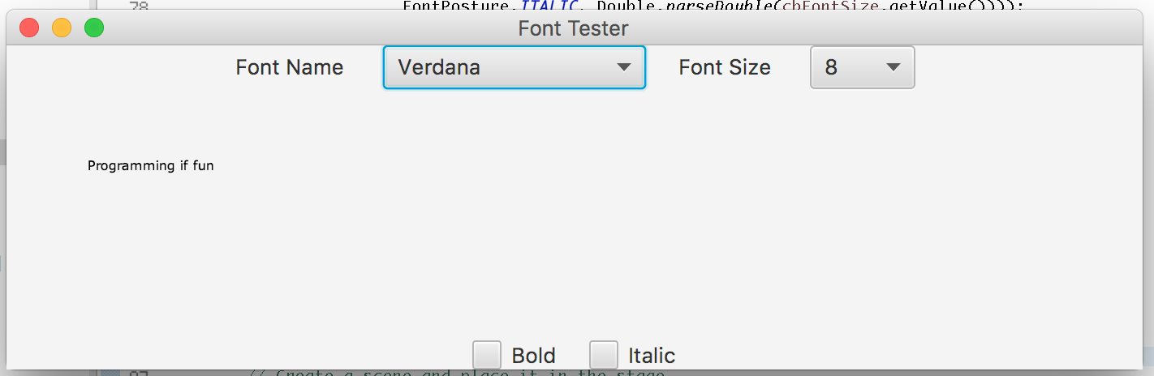

Figure 7: Font tester interface.

The Font tester has 10 font styles (Figure 9) and 9 font sizes (Figure 8).

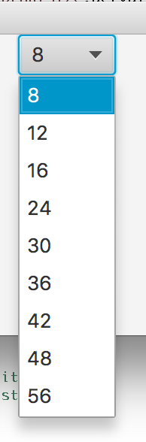

Figure 8: 9 Font sizes

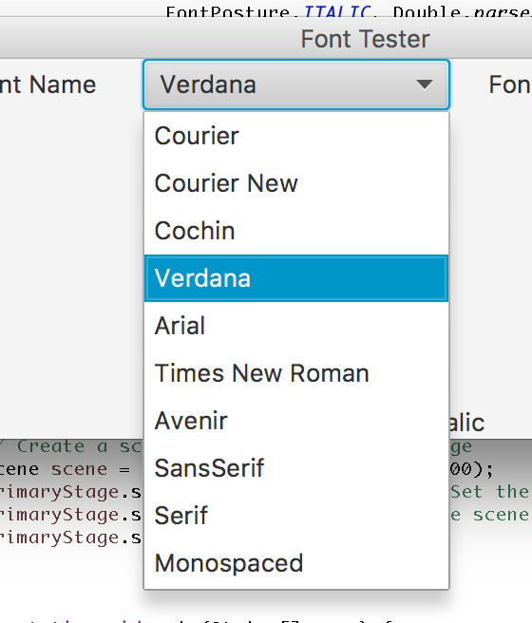

Figure 9: 10 font styles

## Functionality of Interface

Figure 10, Figure 11, Figure 12, Figure 13, Figure 14, Figure 15 and Figure 16 shows different instances of font style, font weight, font posture and font size.

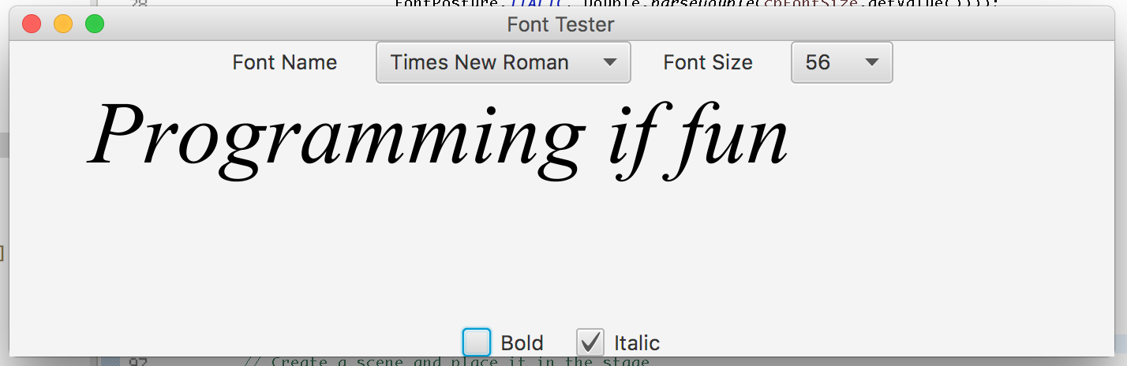

Figure 10 Font[times new Roman, Normal, Italic, 56]

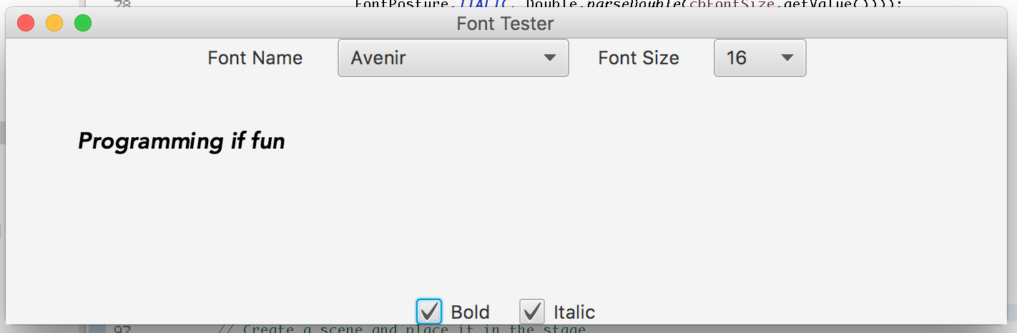

Figure 11 Font[Avenir, Bold, Italic, 16]

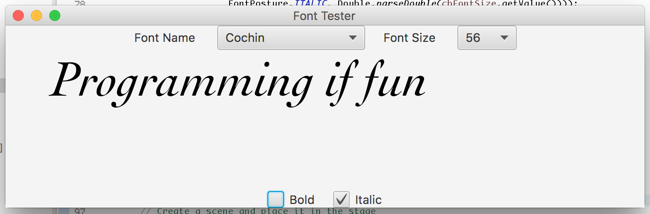

Figure 12 Font[Cochin, Bold, Italic, 56]

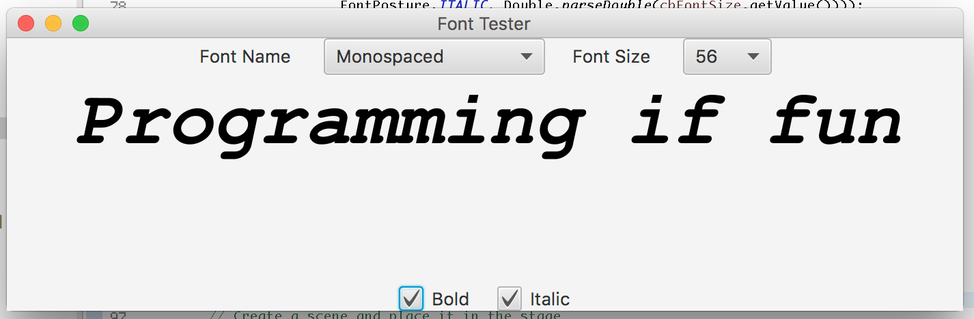

Figure 13 Font[Monospaced, Bold, Italic, 56]

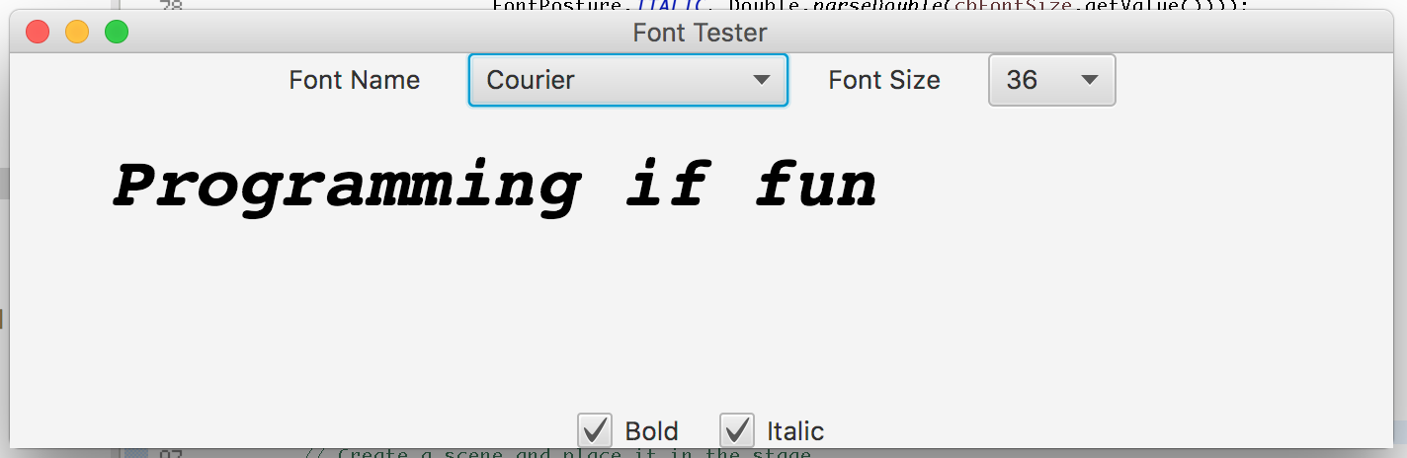

Figure 14: Font[Courier, Bold, Italic, 36]

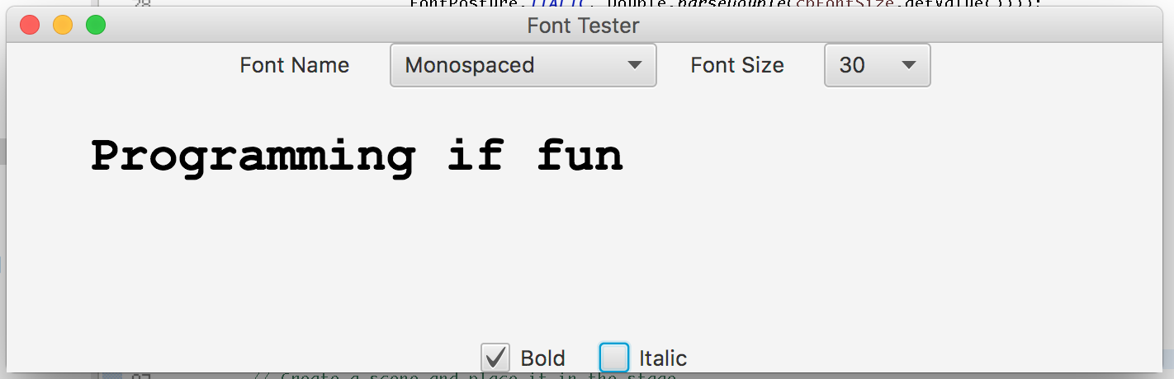

Figure 15 Font[Monospaced, Bold, Regular, 30]

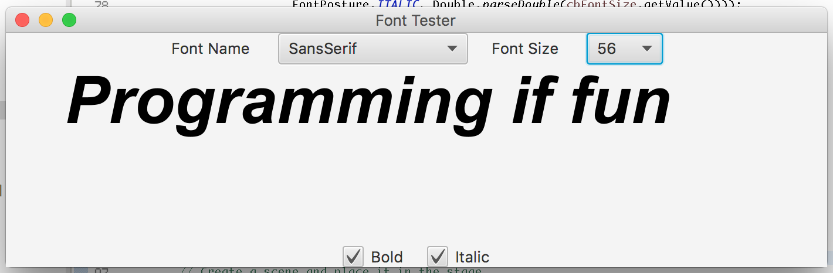

Figure 16 Font[SansSerif, Bold, Italic, 56]

## Complete Screen Shot

Figure 17 shows complete screen shot of the program and shows program runs smoothly with no error in console.

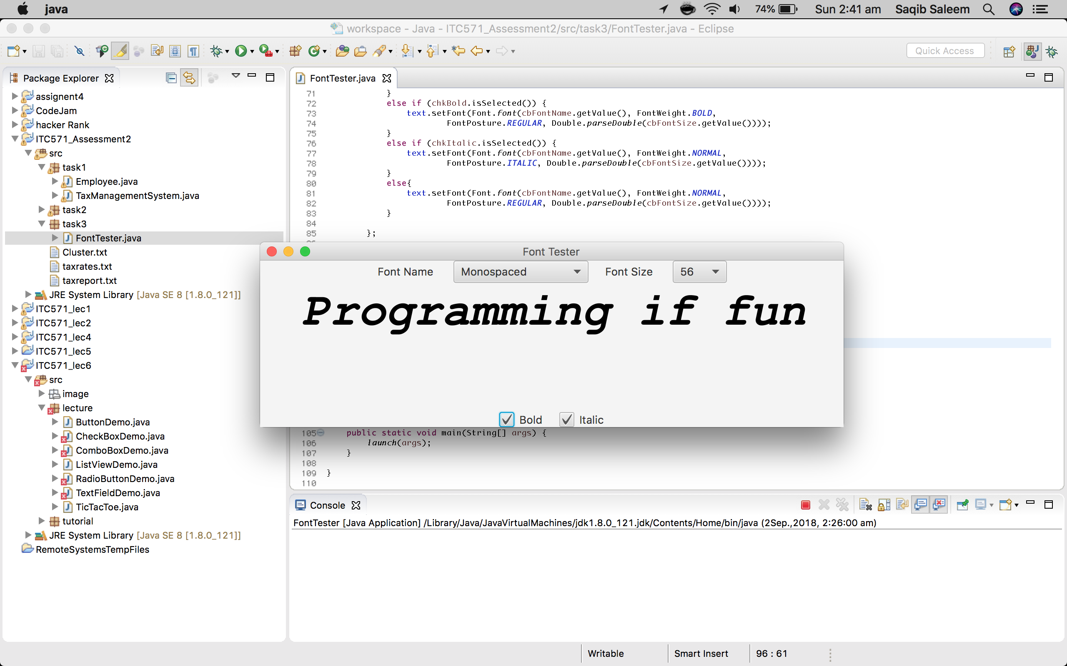

Figure 17: Complete screen shot shows no error in console