# TASK: TAX MANAGEMENT SYSTEM

Write a Java program that will calculate tax for the employees of a company called XYZ. The main menu of the tax calculation program is as follows.

Welcome to Tax Management System of XYZ Please select one of the following options:

1. Calculate tax

2. Search tax

3. Exit

When **1** is selected then the program will calculate the tax of an employee based on the annual income of the employee and tax rates on the income. The tax rates on the income is stored in a file called **taxrates.txt**. The program needs to read the **taxrates.txt** file and store the information in the proper data structure. If the **taxrates.txt** file does not exist in the directory of the source code then the program should ask to provide the **taxrates.txt** file as an input. The format of the **taxrates.txt** file is as follows.

|  |  |
| --- | --- |
| **Taxable Income** | **Tax on Income** |
| 0 – $18,200 | 0 |
| $18,201 – $37,000 | 19c for each $1 over $18,200 |
| $37,001 – $87,000 | $3,572 plus 32.5c for each $1 over $37,000 |
| $87,001 – $180,000 | $19,822 plus 37c for each $1 over $87,000 |
| $180,001 and over | $54,232 plus 45c for each $1 over $180,000 |

The program will take user inputs on Employee ID (4-digit number) and the annual income of the employee (floating-point number with two decimal places). Based on the annual income of the employee the program will then calculate the tax (using the information in **taxrates.txt** file) of the employee. For example, if the annual income of an employee is $100000.00 then the tax of the employee=19822+(100000 - 87000)*0.37= 20303.00.

After calculating the tax of an employee the program will then write the Employee Id, taxable income and tax into a file called **taxreport.txt**. The format of the **taxreport.txt** file is as follows.

Once the tax calculation is done for one employee then the program will ask if XZY wants to calculate the tax for another employee, if yes then the above process will continue again. The program will calculate the tax for as many employees as XYZ wants. However, if XZY does not want to calculate the tax for another employee then the main menu will be displayed.

When **2** is selected then the program will search the tax for an employee using the employee id in the **taxreport.txt** file. However, if the **taxreport.txt** file does not exist in the directory of the source code then the program should ask to provide the **taxreport.txt** file as an input.

If the **taxreport.txt** file contains the multiple tax for the same employee then the program will get the latest tax amount of that employee. If the **taxreport.txt** file does not contain the employee id then the program should give a warning message that the **taxreport.txt** file does not contain the tax of that employee.

|  |  |  |
| --- | --- | --- |
| **Employee ID** | **Taxable Income** | **Tax** |
| 1111 | 100000.00 | 20303.00 |
| 2222 | 90000.00 | 19933.00 |

Once searching tax (based on employee id) is done for one employee then the program will ask if XZY wants to search tax for another employee, if yes then the above process will continue again. The program will search tax for as many employees as XYZ wants. However, if XZY does not want to search tax for another employee then the main menu will be displayed.

When **3** is selected then the program will exit.

File read and write operations need to be done properly. You need to use proper data structure. Input validation also needs to be done.

# REPORT

## File Directory

Two classes Employee.java and TaxmanagementSystem.java are placed in package task1. taxrates.txt and taxreport.txt files are required to run the program which should be placed in src folder of java project (Figure 1).

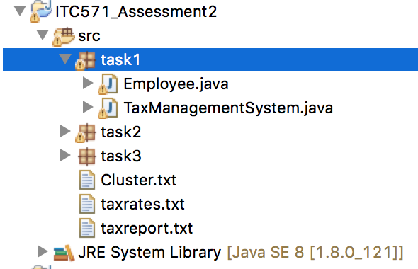

Figure : File directory for task 1

Important Note: If file taxreport.txt is not already present in the src folder, the program will automatically create this file. But sometimes, this file is not visible in eclipse due to some weird reasons. I would recommend, in such case, to manually go to the src folder through terminal/cmdprompt and open the file.

If the file already exist, the program will just update the file.

## Welcome

### Scene and Functionality

Welcome scene; for the main page with three buttons; Calculate Tax, Search tax and Exit (Figure 2).

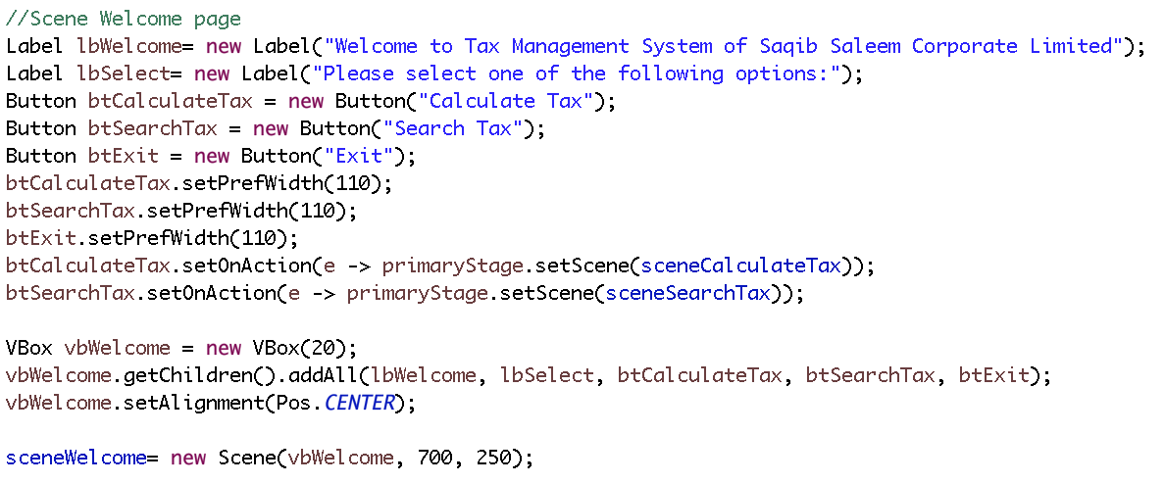

Figure : Main scene to show welcome page.

### Interface

Welcome page contains description of the company and allows users to click on any of three buttons.

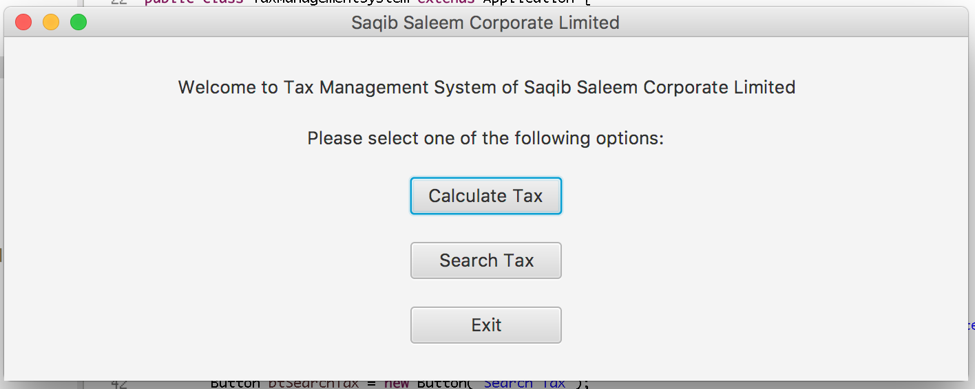

Figure : Interface for main welcome page.

## Calculate Tax

### Scene

Calculate tax scene to put employee ID and annual salary and get the tax (Figure 4).

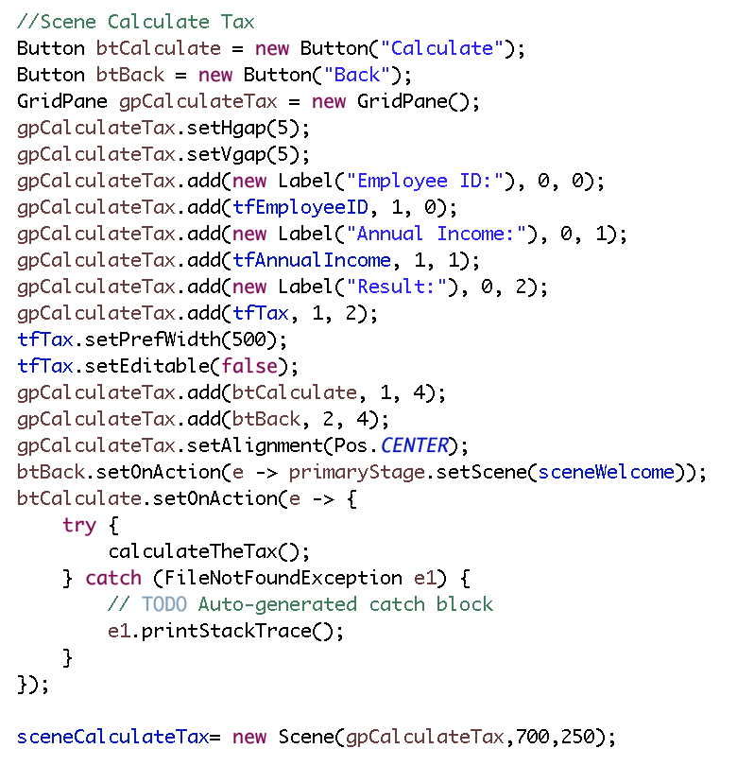

Figure : Scene to implement calculate tax functionality.

### Functionality

Calculate tax method (Figure 5) implements;

* Employee ID length is 4 and it only contain numbers.
* Annual income is floating number with 2 decimal places
* Call function gettax from a separate class Employee.java. this function takes annual income as argument and returns the tax on that income. This function will be explained further in heading 2.3.3 Employee.java below.
* Store the calculated tax in file taxreport.txt and path to this file is src/taxreport.txt.

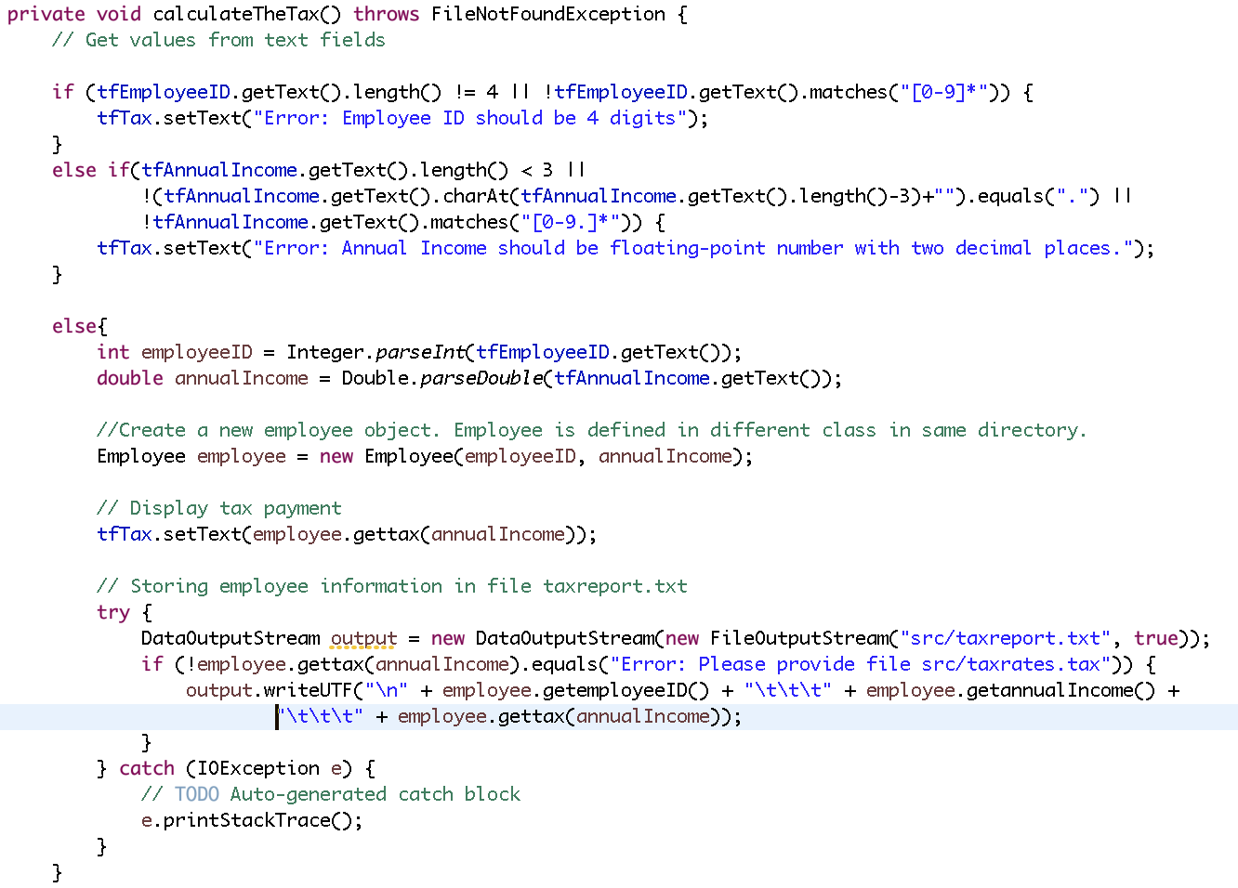

Figure : CalculateTheTax() method

### Employee.java

The most important method of this class is gettax which has following functionalit;

* Creating Navigable map (TreeMap) to store the information from src/taxrates.txt where keys are the lower value of the tax (Figure 6). Important point here is the keys are the values of lower side of the tax brackets. E.g., if the tax bracket is $18,201 – $37,000, the key is 18201.
* Values of the Tree Map are arrays of format [base, limit, percent]. These three variables are extracted from the description taxrates.txt file by a while loop and conditions (Figure 7).
* As it’s a Tree Map, floorEntry() method is used to check in which bracket the annual income of the employee falls (Figure 8).



Figure : Navigable Map to store tax rate information.

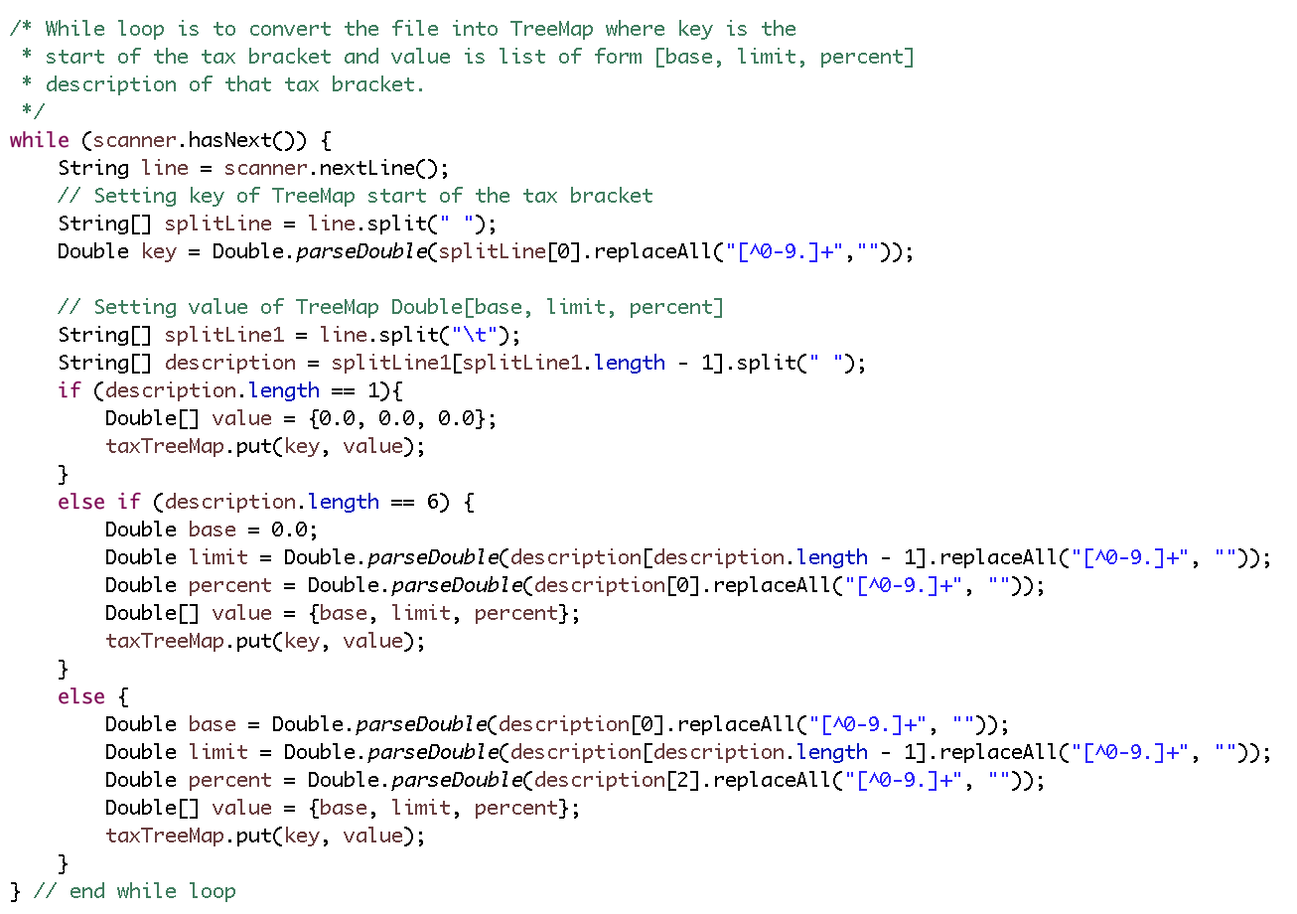

Figure : Extracting information from taxrates.txt file and storing in Tree Map in the for of array[base, limit, percent].

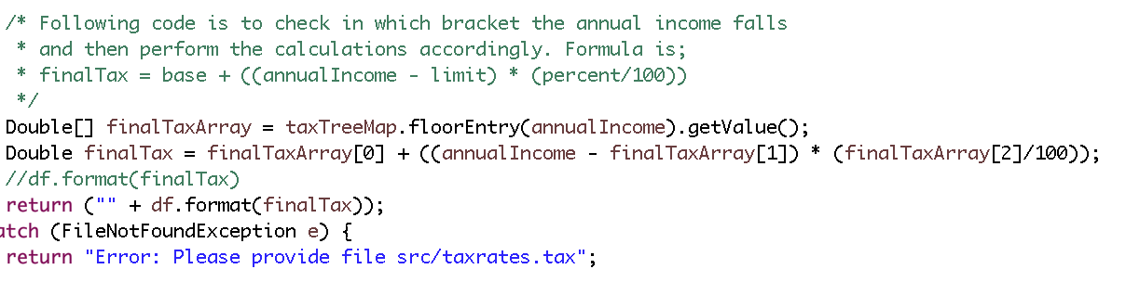

Figure : Calculating the tax according to the tax bracket it falls.

### Interface

, , , , and shows the program gives error for all the cases except employee ID is four digits and annual income is floating number with two decimal places.

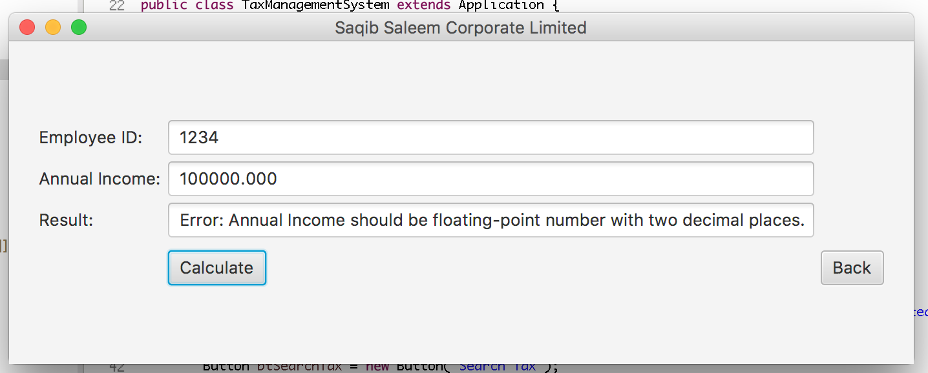

Figure : Error on annual income with 3 decimal places

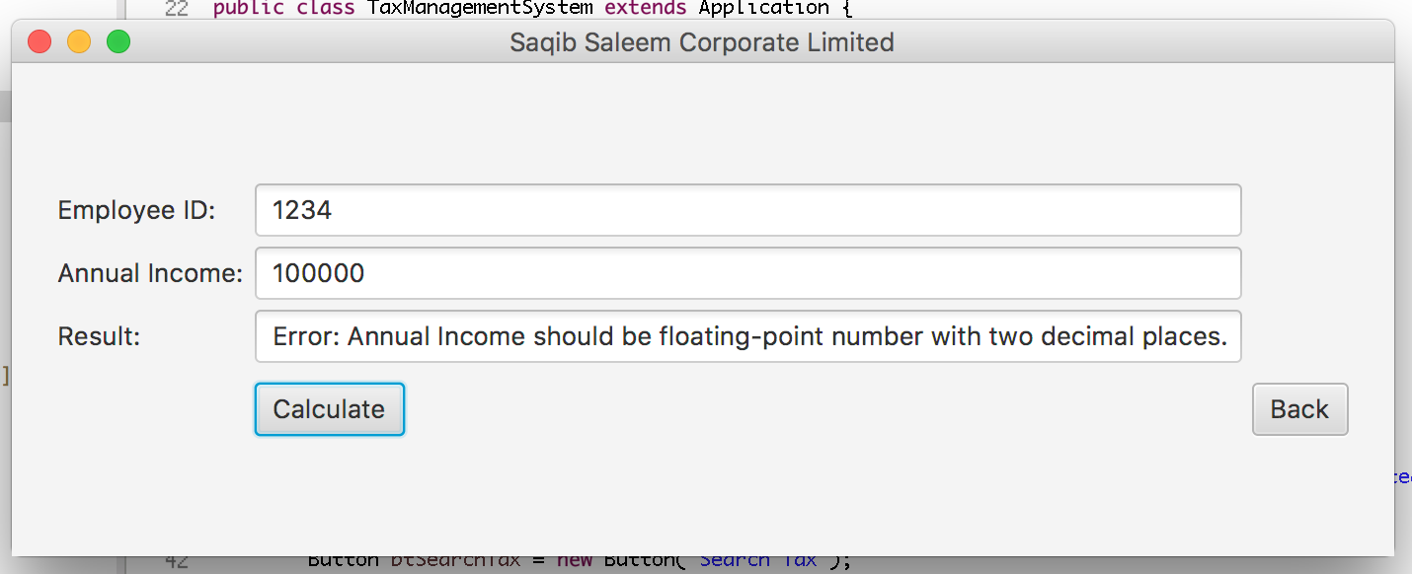

Figure : Error because annual income don't have two decimal places.

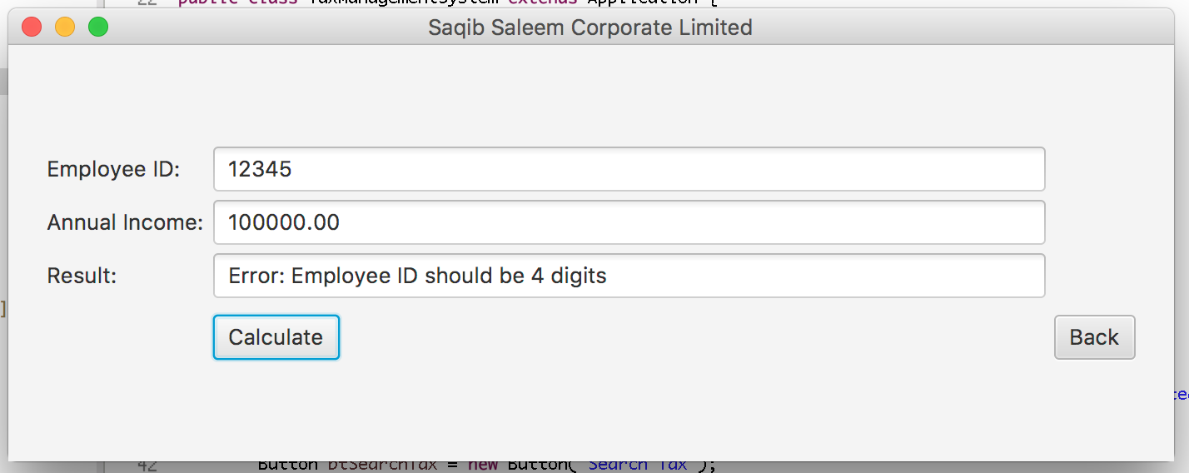

Figure : Error because employee ID is 5 digits

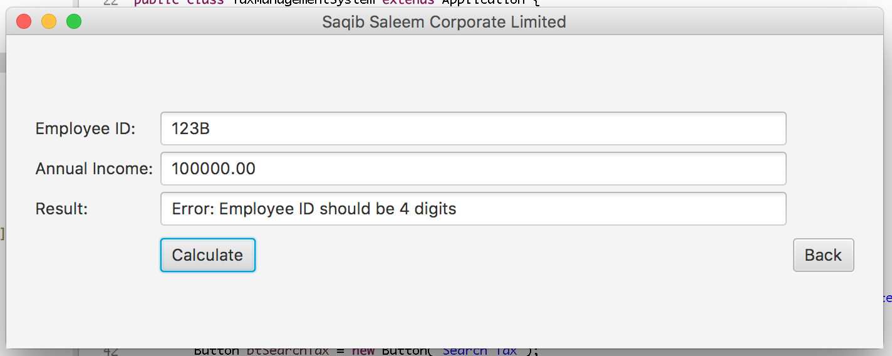

Figure : Error because employee ID contain an alphabet

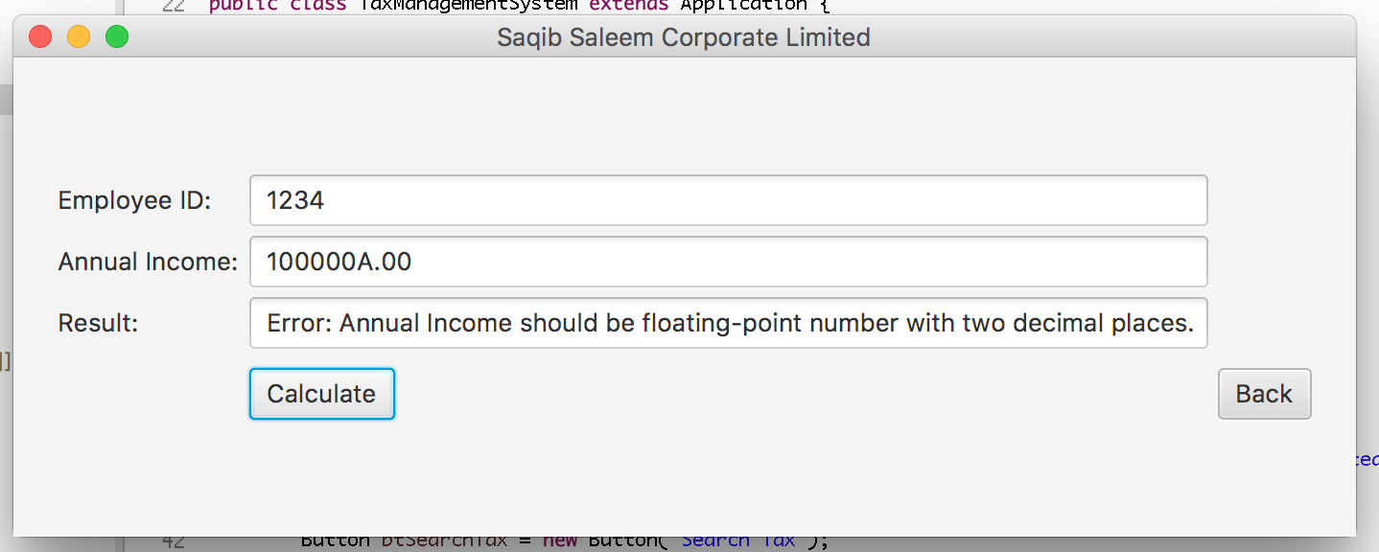

Figure : Error because annual income contains an alphabet.

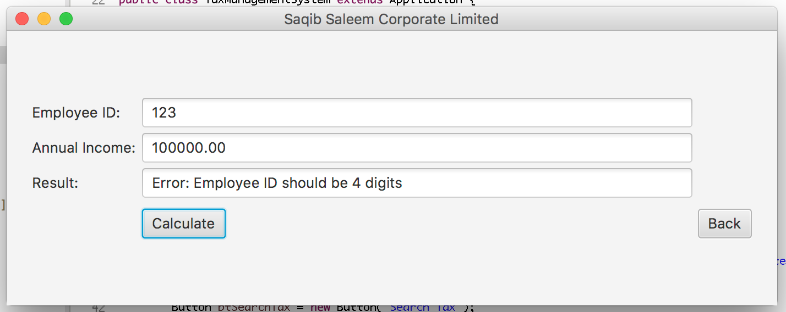

Figure : Error because employee ID is 3 digits

Upon valid entry, program calculates the tax () and stores it in th taxreport.txt file ().

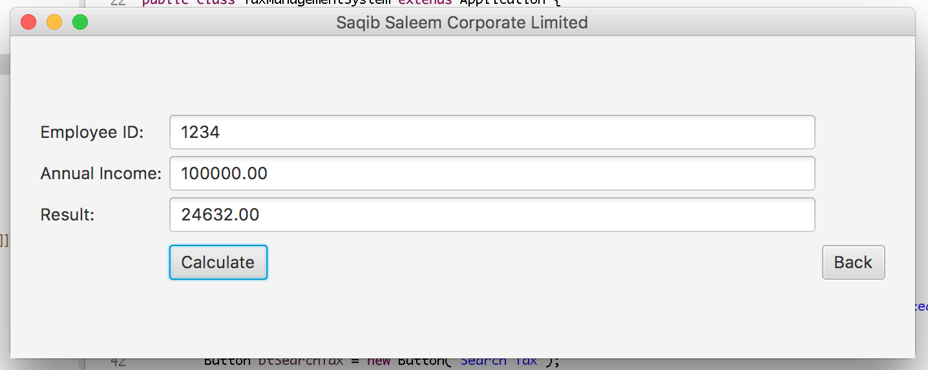

Figure : Right entries calculate tax

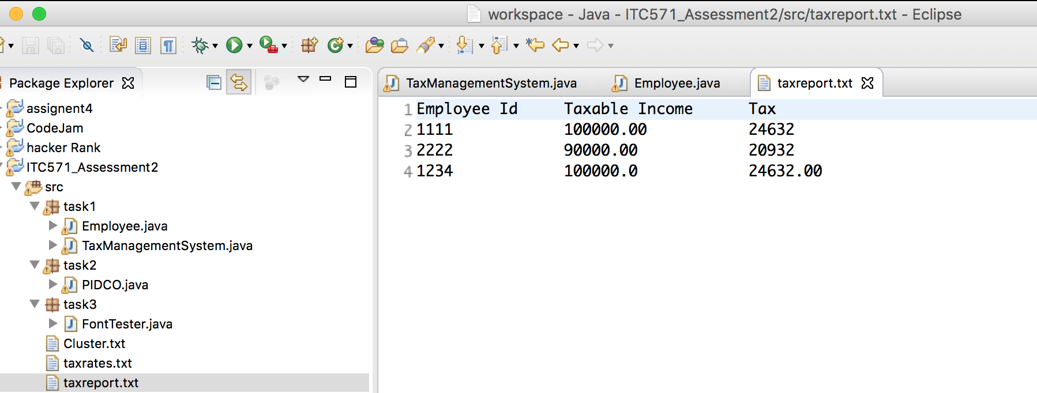

Figure : After calculating, stores the tax in taxreport.txt file

After pressing button “Back”, the program goes to the man welcome screen.

## Search Tax

### Scene

Search tax scene to search the tax of an employee from taxreport.txt (Figure 17).

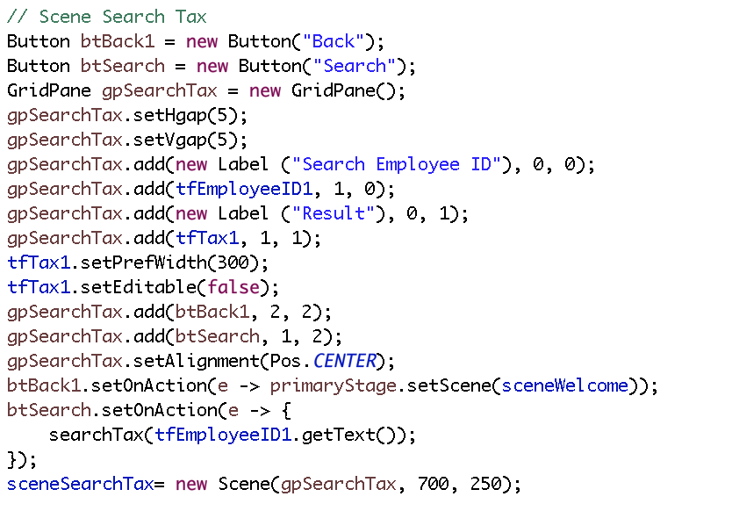

Figure : Scene to implement search tax functionality

### Functionality

Search tax method takes employee ID as argument and search for relevant tax stored in src/taxreport.txt (Figure 18). this method implements following functionality;

* Employee ID length is 4 and it only contain numbers.
* Create a HahMap to to convert data from taxreport.txt into employee ID as key and tax as value.
* If record doesn’t exist, shows “No record found”.
* If file doesn’t exist, shows “Please provide the file src/taxreport.txt in Source Code directory”.

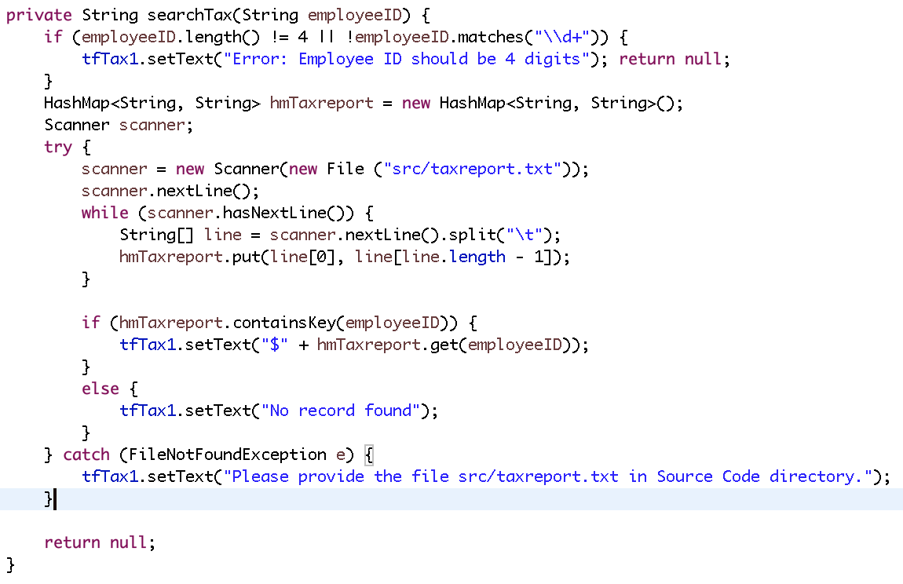

Figure : Search tax method

### Interface

shows error because of invalid employee ID.

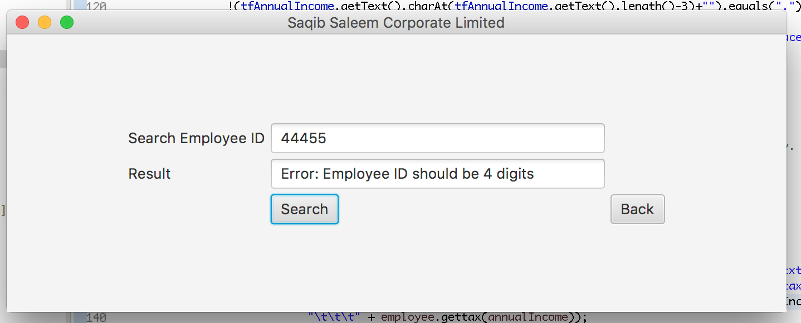

Figure : Error because employee ID is 5 digits long

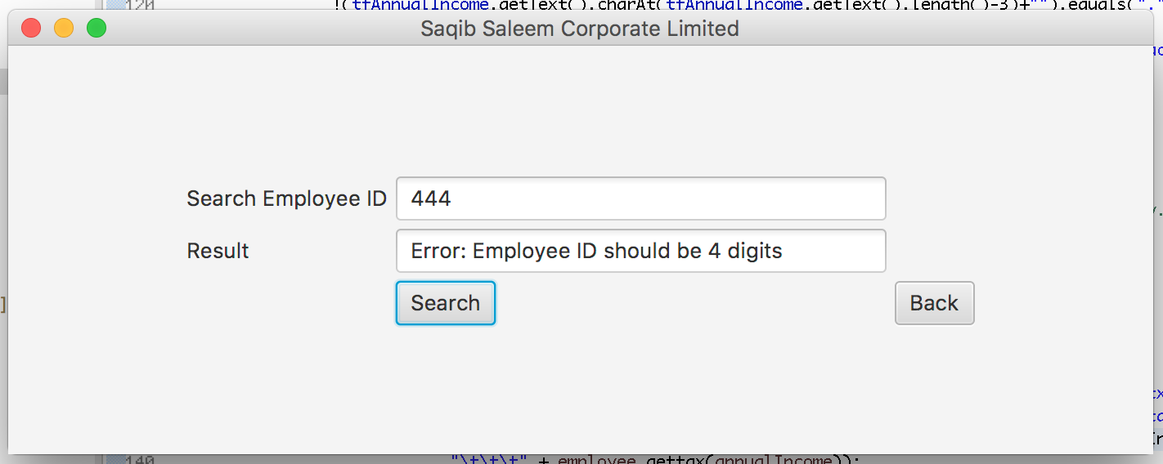

Figure : Error because employee ID is 3 digits long

shows when employee ID record is not in taxreport.txt file, message shows no record found.

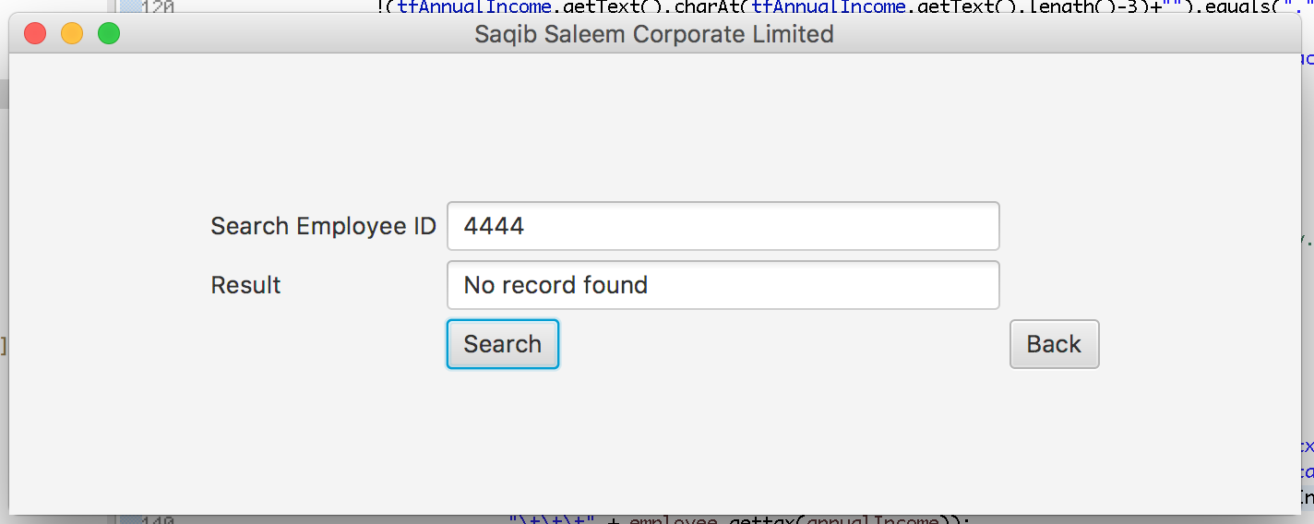

Figure : Shows "No record found" for employee ID 4444

shows when employee ID is present in taxreport.txt file, the program shows the tax of that employee.

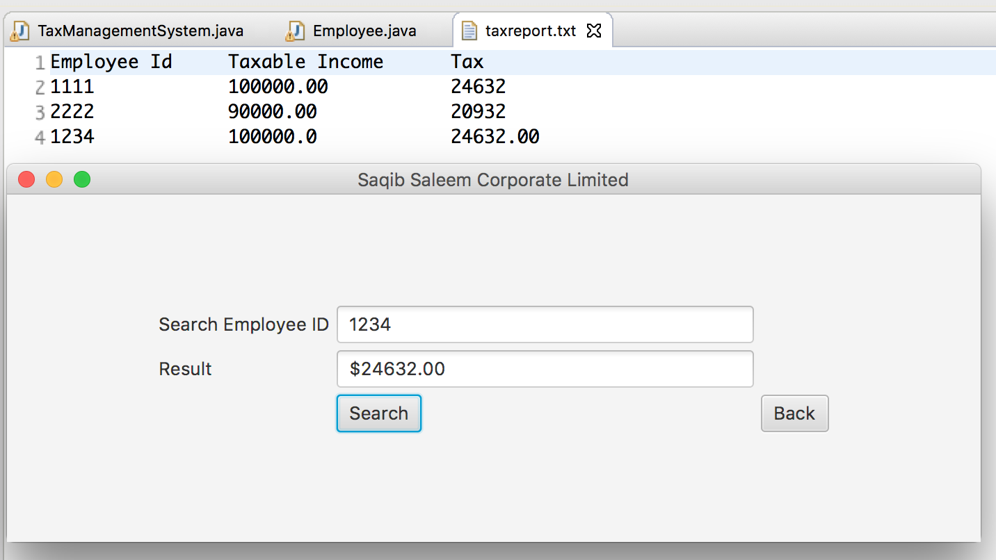

Figure : Shows record for employee ID 1234

After pressing button “Back”, the program goes to the man welcome screen.

## Exit

Program exits when Exit button is clicked (Figure 23).

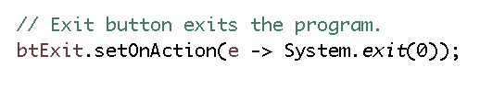

Figure : Program exits when Exit button is clicked

## Complete Screen Shot

shows complete screen shot of the program and shows program runs smoothly with no error in console.

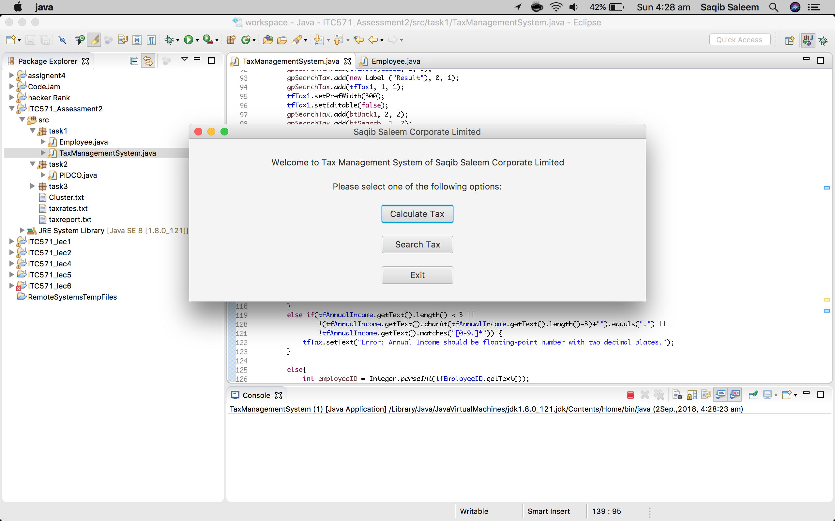

Figure : Complete screenshot task 1