# Task: Traffic light simulation

Write a JAVA program that would simulate traffic lights using the concept of Multithreading. One example is shown in the following figure. Each light has two statuses, "on" and "off". Moreover, the time of each light switching status can be set using the text input box beforehand. If the user clicks on the "Start" button, the program starts to work. While if the "End" button is clicked, the program stops working but not terminates. The program terminates only when the "X" button on right-upper corner. Please note that initially the switching time for each light would be set to "3". As shown in the last column of the following figure, you should also display the text indicating the status of the traffic light.

# REPORT

## User Input

The program asks for user input about time for each light (Figure 1). After inputing the data and pressing start button, the lights start.

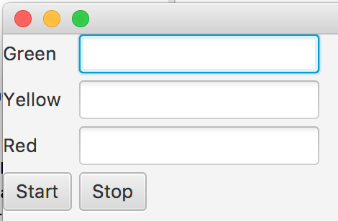

Figure 1: User input for time of each light.

## Start Button

After pressing the start button, the simulation will start, and will continue until user press the stop button (Figure 2, Figure 3 and Figure 4).

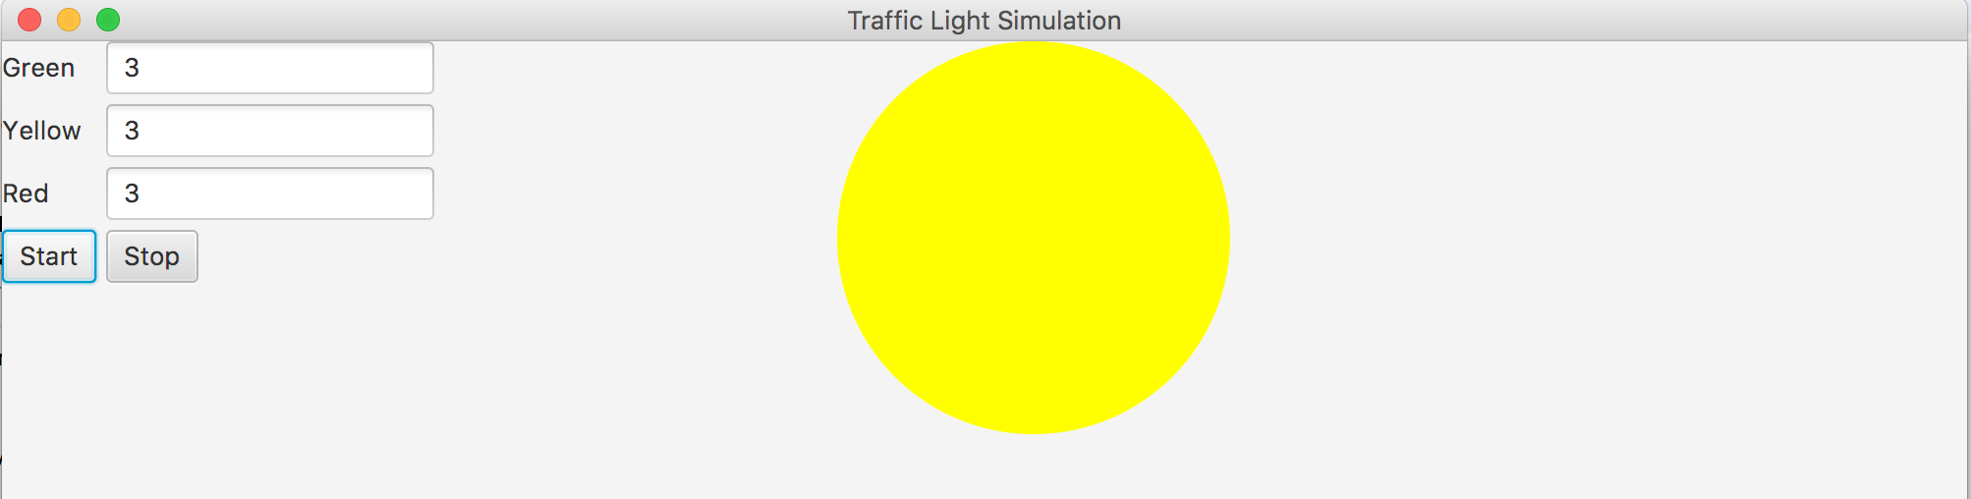

Figure 2: Simulation started (Yellow light).

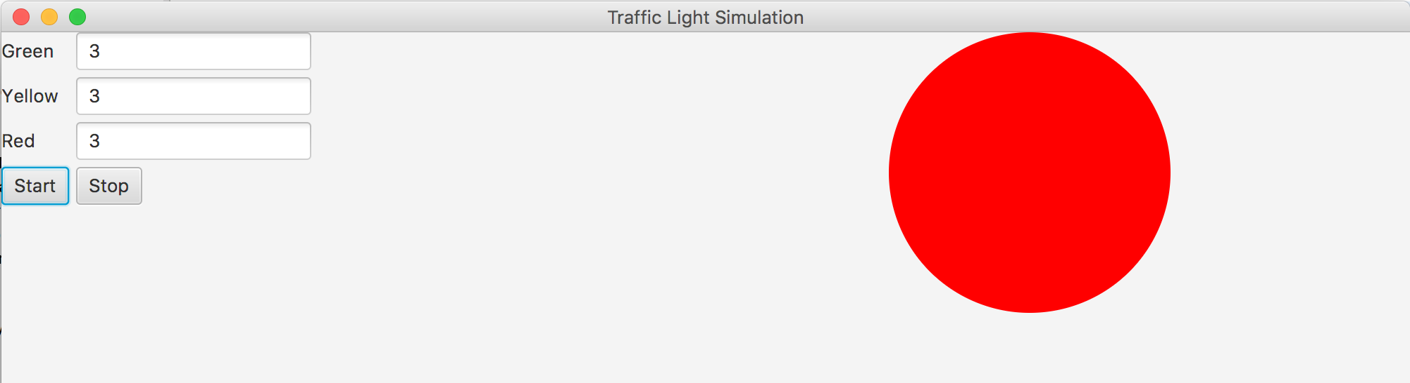

Figure 3: Simulation started (Red light).

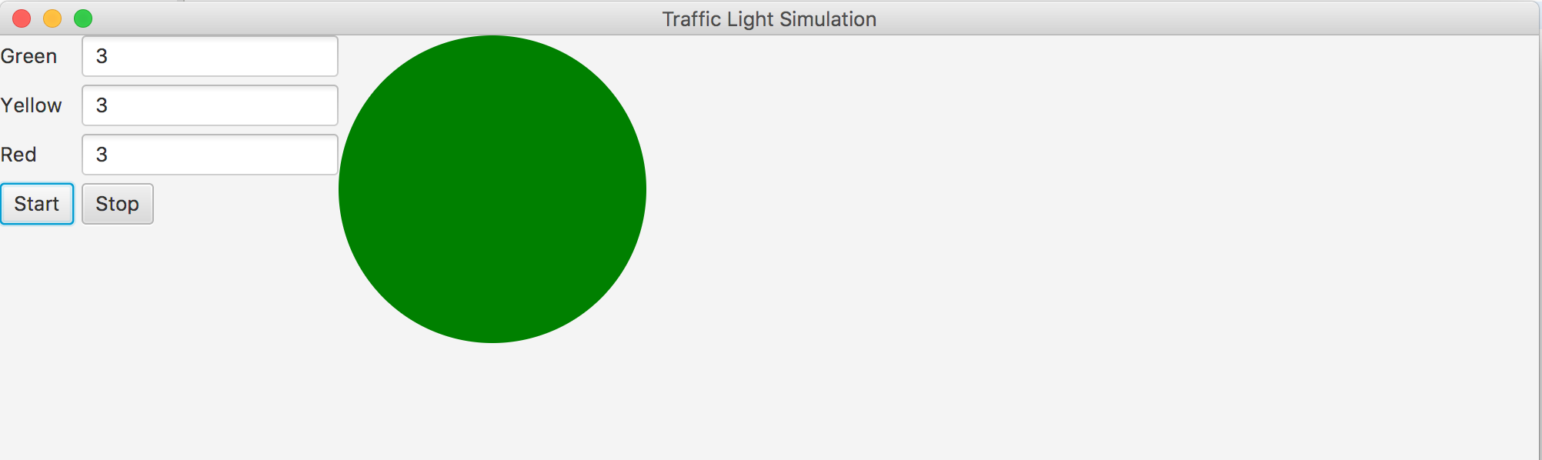

Figure 4: Simulation started (Green light).

## Stop Button

Upon pressing stop button, the program stops working but do not terminate. The program will end only when “x” button is pressed.

## Displaying Text

The text is displayed in the console and updated every second telling about the status of the program (Figure 5).

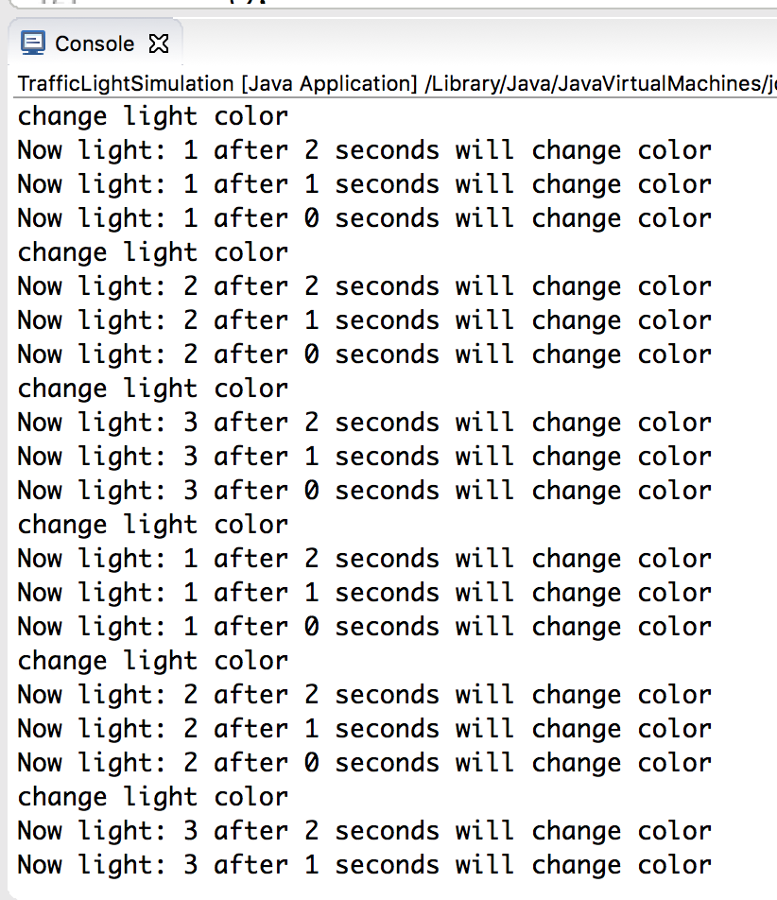

Figure 5: Text in console tells about the status of program.

## Stop -> Change Values -> Start

After pressing stop button, the values of light can be changed and upon pressing start button again, the program will run again as per new values entered, and console will be running as per new values as well (Figure 6).

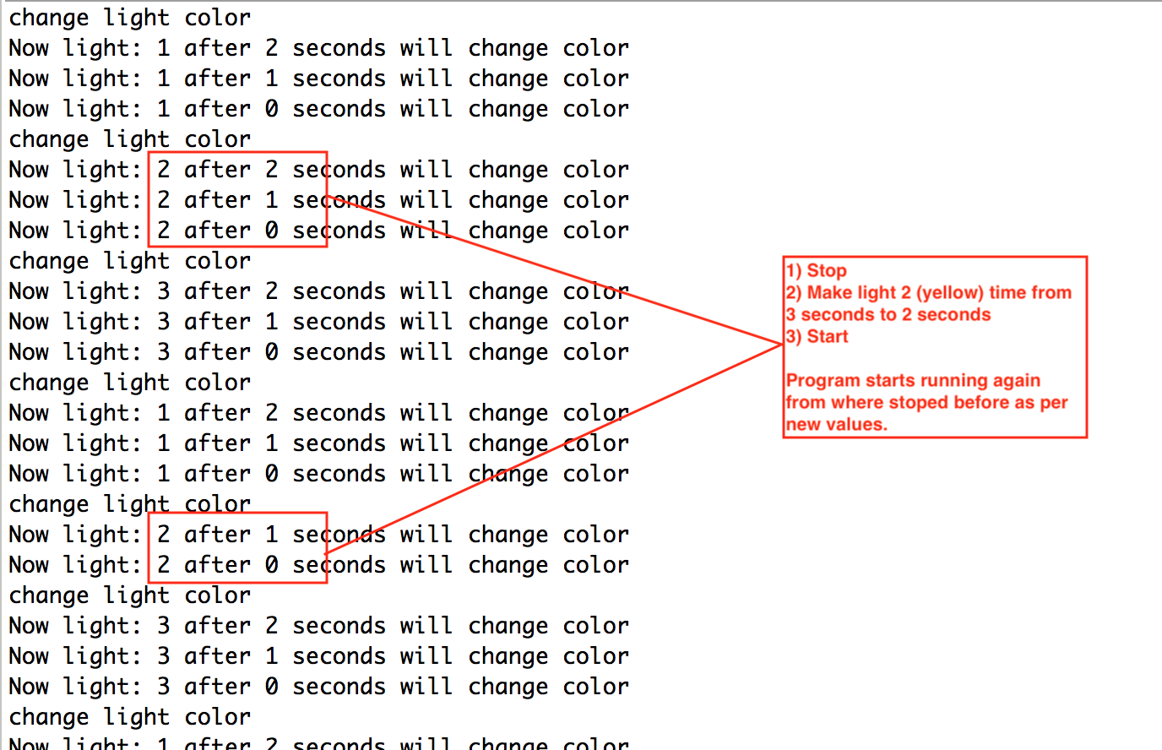

Figure 6: After updating the values, the program runs accordingly.