**A**

**Project Report**

#### On

**“Uni-Connect”**

**SubmittedBy: -**

**Pankaj Kumar Baghel**

**Roll No:2440165012**

**M.Sc.-(IT)4th Semester**

**Guided by:-**

**Dr. Anil Kumar Sharma**

Asst. Professor **& H.O.D**

Department of Information Technology

**Submitted To:**

**ACHARYA PANTH SHRI GRINDH MUNI NAAM SAHEB**

**APSGMNS GOVT. P.G. COLLEGE, KAWARDHA (C.G.)**

*Affiliated to Hemchand Yadav Vishwavidyalaya, Durg (C.G.)*

**In submission of partial fulfillment for the award of the degree of**

**Master of Science** i**n Information Technology**

**Semester: IV**

**From**

## **Hemchand Yadav Vishwavidyalaya, Durg (CG)**

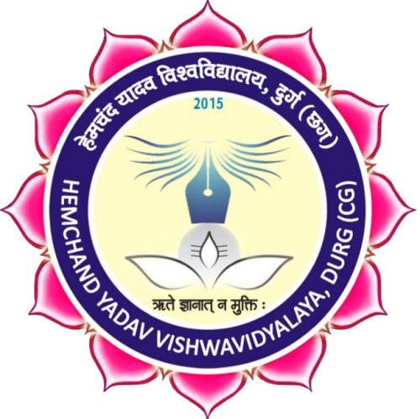

**Session - 2024-25**