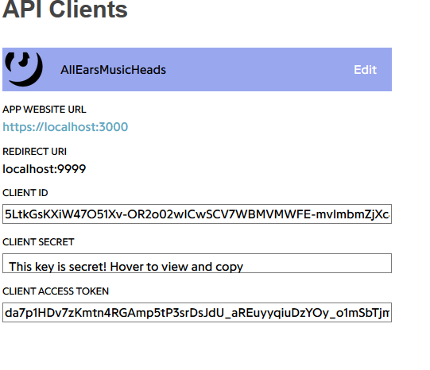

Benutzername: SkeeterG

<http://brianyang.com/how-to-integrate-spotify-and-genius-api-to-easily-crawl-song-lyrics-with-python/>

https://github.com/scf4/lyricist