00

**FINAL ASSESSMENT**

**PRACTICAL TEST**

SESSION II: 2023/2024

**DFP50293 MOBILE APPLICATION DEVELOPMENT**

NAME : Hasrullah bin Yahir

REGISTRATION NO. : 05DDT21F2062

SECTION : DDT 5A

JABATAN TEKNOLOGI MAKLUMAT DAN KOMUNIKASI



**HASRULLAH BIN YAHIR (05DDT21F2062)**

**FINAL ASSESSMENT – MOBILE APPLICATION DEVELOPMENT**

1. activity_main.xml

|  |
| --- |
| <?xml version="1.0" encoding="utf-8"?> <RelativeLayout xmlns:android="http://schemas.android.com/apk/res/android"  xmlns:app="http://schemas.android.com/apk/res-auto"  xmlns:tools="http://schemas.android.com/tools"  android:layout_width="match_parent"  android:layout_height="match_parent"  tools:context=".MainActivity"  android:background="@color/black">   <LinearLayout  android:layout_width="409dp"  android:layout_height="729dp"  android:orientation="vertical"  tools:layout_editor_absoluteX="1dp"  tools:layout_editor_absoluteY="1dp">    <TextView  android:id="@+id/titleLbl"  android:layout_width="match_parent"  android:layout_height="wrap_content"  android:layout_marginLeft="100px"  android:layout_marginRight="100px"  android:layout_marginTop="200px"  android:layout_marginBottom="300px"  android:textSize="100px"  android:textAlignment="center"  android:text="Welcome User!"  android:textColor="@color/white"/>   <TextView  android:id="@+id/nameLbl"  android:layout_width="match_parent"  android:layout_height="wrap_content"  android:layout_marginLeft="100px"  android:layout_marginRight="100px"  android:textSize="50px"  android:textAlignment="center"  android:text="Please enter your full name"  android:textColor="@color/white"/>   <EditText  android:id="@+id/nameTxt"  android:layout_width="match_parent"  android:layout_height="wrap_content"  android:layout_marginLeft="100px"  android:layout_marginRight="100px"  android:layout_marginBottom="100px"  android:textSize="50px"  android:textAlignment="center"  android:ems="10"  android:inputType="text"  android:hint="Your name"  android:backgroundTint="@color/white"  android:textColor="@color/white"/>   <TextView  android:id="@+id/icLbl"  android:layout_width="match_parent"  android:layout_height="wrap_content"  android:layout_marginLeft="100px"  android:layout_marginRight="100px"  android:textSize="50px"  android:textAlignment="center"  android:text="Please enter your IC Number"  android:textColor="@color/white"/>   <EditText  android:id="@+id/icTxt"  android:layout_width="match_parent"  android:layout_height="wrap_content"  android:layout_marginLeft="100px"  android:layout_marginRight="100px"  android:layout_marginBottom="400px"  android:textSize="50px"  android:textAlignment="center"  android:ems="10"  android:inputType="text"  android:hint="010203-04-5678"  android:backgroundTint="@color/white"  android:textColor="@color/white"/>   <Button  android:id="@+id/registerBtn"  android:layout_width="match_parent"  android:layout_height="wrap_content"  android:layout_marginLeft="100px"  android:layout_marginRight="100px"  android:layout_marginBottom="100px"  android:text="Register Now"  android:textColor="@color/black"  android:backgroundTint="@color/white"/>   </LinearLayout>  </RelativeLayout> |

1. MainActivity.java

|  |
| --- |
| package com.example.finalassesment;  import androidx.appcompat.app.AppCompatActivity;  import android.content.Intent; import android.os.Bundle; import android.view.View; import android.widget.EditText; import android.widget.Button; import android.widget.Toast;  public class MainActivity extends AppCompatActivity {  EditText nameTxt, icTxt;  Button registerBtn;   @Override  protected void onCreate(Bundle savedInstanceState) {  super.onCreate(savedInstanceState);  setContentView(R.layout.*activity_main*);   nameTxt = findViewById(R.id.*nameTxt*);  icTxt = findViewById(R.id.*icTxt*);   registerBtn = findViewById(R.id.*registerBtn*);  registerBtn.setOnClickListener(new View.OnClickListener() {  @Override  public void onClick(View v) {  String name = nameTxt.getText().toString();  String ic = icTxt.getText().toString();   Toast.*makeText*(MainActivity.this, "Your profile has successfully updated", Toast.*LENGTH_SHORT*).show();  Intent intent = new Intent(MainActivity.this, ProfileActivity.class);  intent.putExtra("nameTxt", name);  intent.putExtra("icTxt", ic);  startActivity(intent);  }  });  }  } |

1. activity_profile.xml

|  |
| --- |
| <?xml version="1.0" encoding="utf-8"?> <RelativeLayout xmlns:android="http://schemas.android.com/apk/res/android"  xmlns:tools="http://schemas.android.com/tools"  xmlns:app="http://schemas.android.com/apk/res-auto"  android:layout_width="match_parent"  android:layout_height="match_parent"  tools:context=".ProfileActivity"  tools:ignore="ExtraText"  android:background="@color/black">   <LinearLayout  android:layout_width="match_parent"  android:layout_height="match_parent"  android:orientation="vertical">   <TextView  android:id="@+id/titleLbl"  android:layout_width="match_parent"  android:layout_height="wrap_content"  android:layout_marginLeft="100px"  android:layout_marginRight="100px"  android:layout_marginTop="200px"  android:layout_marginBottom="50px"  android:textSize="100px"  android:textAlignment="center"  android:text="Profile Page"  android:textColor="@color/white"/>    <ImageView  android:id="@+id/pfp"  android:layout_width="wrap_content"  android:layout_height="223dp"  android:layout_marginLeft="250px"  android:layout_marginTop="50px"  android:layout_marginRight="250px"  android:layout_marginBottom="50px"  android:clickable="true"  android:contentDescription="@string/app_name"  app:srcCompat="@drawable/pfp" />   <TextView  android:id="@+id/nameLbl"  android:layout_width="match_parent"  android:layout_height="wrap_content"  android:layout_marginLeft="100px"  android:layout_marginRight="100px"  android:textSize="50px"  android:textAlignment="center"  android:text="Your full name:"  android:textColor="@color/white"/>   <TextView  android:id="@+id/nameView"  android:layout_width="match_parent"  android:layout_height="wrap_content"  android:layout_marginLeft="100px"  android:layout_marginRight="100px"  android:layout_marginBottom="100px"  android:textSize="50px"  android:textAlignment="center"  android:textColor="@color/white"/>   <TextView  android:id="@+id/icLbl"  android:layout_width="match_parent"  android:layout_height="wrap_content"  android:layout_marginLeft="100px"  android:layout_marginRight="100px"  android:textSize="50px"  android:textAlignment="center"  android:text="Your IC number:"  android:textColor="@color/white"/>   <TextView  android:id="@+id/icView"  android:layout_width="match_parent"  android:layout_height="wrap_content"  android:layout_marginLeft="100px"  android:layout_marginRight="100px"  android:layout_marginBottom="100px"  android:textSize="50px"  android:textAlignment="center"  android:textColor="@color/white"/>   <Button  android:id="@+id/changeBtn"  android:layout_width="match_parent"  android:layout_height="wrap_content"  android:layout_marginLeft="100px"  android:layout_marginRight="100px"  android:layout_marginBottom="100px"  android:text="Change User"  android:textColor="@color/black"  android:backgroundTint="@color/white"/>  </LinearLayout> </RelativeLayout> |

1. ProfileActivty.java

|  |
| --- |
| package com.example.finalassesment;  import androidx.appcompat.app.AppCompatActivity;  import android.os.Bundle; import android.view.View; import android.widget.TextView; import android.widget.Button; import android.content.Intent;  public class ProfileActivity extends AppCompatActivity {  TextView nameView, icView;  Button changeBtn;   @Override  protected void onCreate(Bundle savedInstanceState) {  super.onCreate(savedInstanceState);  setContentView(R.layout.*activity_profile*);   nameView = findViewById(R.id.*nameView*);  icView = findViewById(R.id.*icView*);  changeBtn = findViewById(R.id.*changeBtn*);   String user = getIntent().getStringExtra("nameTxt");  String ic = getIntent().getStringExtra("icTxt");  nameView.setText(user);  icView.setText(ic);   changeBtn.setOnClickListener(new View.OnClickListener() {  @Override  public void onClick(View v) {  Intent intent = new Intent(ProfileActivity.this,  MainActivity.class);  startActivity(intent);  }  });  } } |

1. 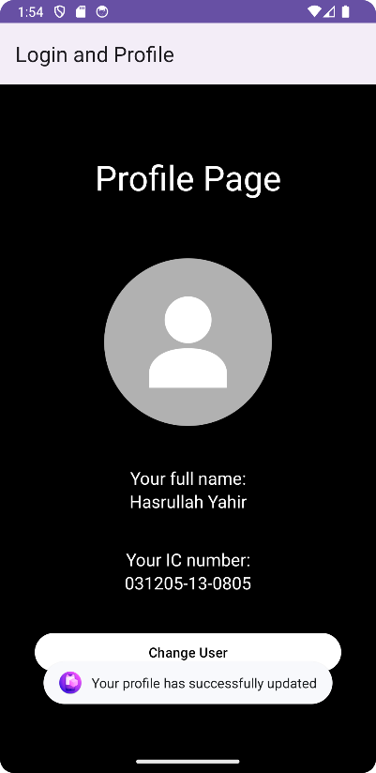Output

