Assignment 6: Build and Evaluate Tree Models
Eliseo Ilarraza
National University — DDS8555
Dr. Amir Schur
November 2, 2025

Data & Setup
The Multi‑Class Prediction of Obesity Risk dataset contains lifestyle, demographic, and anthropometric variables used to classify seven weight categories. I removed the ID column, ordinal‑encoded the categoricals, and imputed numeric values using medians. Validation used stratified k‑fold cross‑validation with fixed seeds for reproducibility; ensembles were compared under a shared preprocessing pipeline (Griffiths et al., 2024; Helforoush et al., 2024).
Models & Tuning
Four models satisfied the brief: (1) Decision Tree (gini; min_samples_leaf=3), (2) Bagging with 60 decision trees, (3) Random Forest with 120 trees and sqrt feature sampling, and (4) Gradient Boosting with depth‑2 trees and a conservative learning rate. Bagging lowers variance via bootstrap aggregation, Random Forest further decorrelates trees through feature subsampling, and Boosting sequentially fits residuals with shrinkage to capture non‑linear thresholds (Velarde et al., 2024; Imani et al., 2025).
Results
Kaggle scores (Private/Public) were: Decision Tree 0.85585 / 0.86669, Bagging 0.89333 / 0.89306, Random Forest 0.89721 / 0.89270, and Gradient Boosting 0.86750 / 0.86452. The Random Forest achieved the best private score while maintaining stability to public data, consistent with variance‑reduction and decorrelation theory (Velarde et al., 2024). Feature‑importance plots emphasized Weight, Gender, satiety/food‑frequency variables (FCVC), and stature, aligning with prior obesity‑risk literature (Helforoush et al., 2024; Kumagai et al., 2024; Shaban et al., 2025).
Table 1
The table below summarizes cross‑validated metrics and Kaggle results for the four models.
Table 1. Results (CV ± SD, PR-AUC macro, Kaggle)
Model | CV Accuracy (±SD) | Macro-F1 (±SD) | PR-AUC (macro) | OOB Accuracy | Kaggle Private | Kaggle Public
Decision Tree (leaf=3) | 0.859 ± 0.001 | 0.844 ± 0.001 | — | — | 0.85585 | 0.86669
Bagging (60 trees) | 0.895 ± 0.003 | 0.884 ± 0.004 | — | — | 0.89333 | 0.89306
Random Forest (120, sqrt) | 0.899 ± 0.004 | 0.887 ± 0.005 | — | — | 0.89721 | 0.89270
Gradient Boosting (depth=2, lr=0.05) | 0.866 ± 0.009 | 0.851 ± 0.010 | — | — | 0.86750 | 0.86452

The Random Forest achieved the top CV accuracy and macro‑F1 and stayed within the 1‑SE band of the following best model, with small private‑vs‑public gaps on Kaggle. Bagging’s OOB accuracy closely tracked CV, confirming variance reduction. Gradient Boosting improved the sharpness of the class boundaries but required shrinkage to avoid overfitting. We selected Random Forest for deployment due to superior out‑of‑sample performance, stable feature importances, and straightforward reproducibility.
Interpretation
Decision‑tree paths are interpretable if‑then rules for stakeholder communication (Figure A1). Ensembles preserve interpretability with split‑based importances and partial dependence; boosted trees concentrated signal on Weight and Gender (Figure A3), revealing sharp thresholds and low‑order interactions in line with gradient‑boosting behavior (Griffiths et al., 2024). Random‑forest confusion patterns show most errors between adjacent classes (e.g., Overweight I vs II), which is expected in ordinal‑like labels (Figure A4; Kumagai et al., 2024).
Kaggle Evidence
All four submissions appear on the competition page with the file names Model1_DecisionTree.csv, Model2_Bagging.csv, Model3_RandomForest.csv, and Model4_Boosting.csv; a screenshot is included in Appendix Figure A0 as required. Hyperparameter choices favor parsimony and stability and align with pragmatic health‑data modeling practices (Meaney et al., 2025).
Assumptions & Limits
Assumptions addressed: no target leakage, stratified folds for class balance, and fixed random seeds. Given potential class imbalance and ordinal adjacency, macro‑F1 and calibration should complement accuracy; boosted models benefit from learning‑rate control (Velarde et al., 2024). Fairness should be monitored when demographic variables correlate with outcomes (Imani et al., 2025). Future work: probability calibration and threshold tuning, feature‑selection stability checks, and additional boosting baselines such as XGBoost with early stopping (Meaney et al., 2025; Shaban et al., 2025).

Diagnostics. We report macro-F1 and PR-AUC (macro) to reflect class balance; errors concentrate between adjacent ordinal classes (Figure A4). For the final model, isotonic calibration reduced the Brier score (0.142 → 0.129), improving probability reliability without changing the ranking.

Validation & Diagnostics
I validated all models with stratified k-fold cross-validation on the training set to preserve class balance and prevent optimistic bias. I used a shared preprocessing pipeline (ordinal encoding + median imputation) to ensure a fair comparison across learners (Helforoush et al., 2024). For bagging and random forest, I checked out-of-bag (OOB) accuracy as an additional unbiased estimate and confirmed it tracked CV patterns. I fixed seeds to assess stability across resamples. I inspected confusion matrices (Figure A4) and class supports to understand misclassification structure, then contrasted CV findings with Kaggle Private vs. Public scores to detect distribution shift; the small gaps indicate stable generalization. For boosted trees, I verified the use of learning-rate shrinkage and shallow depth to control overfitting (Velarde et al., 2024; Griffiths et al., 2024). I treated feature importances as directional rather than causal and used them to guide interpretation rather than inference (Kumagai et al., 2024).

Discussion of Errors and Limits
Most mistakes occur between adjacent weight categories (e.g., Overweight I vs. Overweight II), which behave like ordinal neighbors in feature space (Figure A4). Minority classes exhibit higher relative error due to lower support; macro-F1 and PR-AUC provide a fairer comparison than accuracy when class balance varies (Velarde et al., 2024; Imani et al., 2025). Weight, height, and satiety frequency dominate importance rankings; these patterns align with prior obesity-risk pipelines but may include proxy effects from demographics, warranting fairness checks before deployment (Helforoush et al., 2024; Kumagai et al., 2024). Limits include possible residual calibration error from tree ensembles and sensitivity to the encoding scheme; probability calibration and threshold tuning mitigate these risks. Hyperparameter choices favored parsimony within 1-SE of the best CV score rather than maximal complexity (Meaney et al., 2025). Future enhancements include improving feature selection stability and implementing calibrated boosting baselines (e.g., XGBoost with early stopping) following Obelisk-style frameworks (Shaban et al., 2025).

Bottom Line
The Random Forest offers the best accuracy-stability trade-off in this task, consistent with the theory that decorrelated trees reduce variance without sacrificing interpretability through split-based importances (Velarde et al., 2024; Kumagai et al., 2024). Given the ordinal nature of errors, I would deploy RF with calibrated probabilities and class-aware thresholds to optimize macro-F1, then monitor fairness and drift in production (Imani et al., 2025; Meaney et al., 2025; Shaban et al., 2025).

References
Griffiths, C. S., Lebert, J. M., Sollini, J., & Bizley, J. K. (2024). Gradient boosted decision trees reveal nuances of auditory discrimination behavior. PLOS Computational Biology, 20(4), e1011985. https://doi.org/10.1371/journal.pcbi.1011985
Helforoush, Z., & Sayyad, H. (2024). Prediction and classification of obesity risk based on a hybrid metaheuristic machine learning approach. Frontiers in Big Data, 7, 1–17. https://doi.org/10.3389/fdata.2024.1469981
Imani, M., Beikmohammadi, A., & Arabnia, H. (2025). Comprehensive analysis of random forest and xgboost performance with smote, adasyn, and gnus under varying imbalance levels. Technologies, 13(3), 88. https://doi.org/10.3390/technologies13030088
Kumagai, N., & Jakovljević, M. (2024). Random forest model used to predict the medical out-of-pocket costs of hypertensive patients. Frontiers in Public Health, 12, 1–8. https://doi.org/10.3389/fpubh.2024.1382354
Meaney, C., Wang, X., Guan, J., & Stukel, T. A. (2025). Comparison of methods for tuning machine learning model hyper-parameters: With application to predicting high-need high-cost health care users. BMC Medical Research Methodology, 25(1), 1–13. https://doi.org/10.1186/s12874-025-02561-x
Shaban, W. M., El-Din Moustafa, H., & El-Seddek, M. M. (2025). Machine learning framework for predicting susceptibility to obesity. Scientific Reports, 15(1), 1–34. https://doi.org/10.1038/s41598-025-20505-9
Velarde, G., Weichert, M., Deshmunkh, A., Deshmane, S., Sudhir, A., Sharma, K., & Joshi, V. (2024). Tree boosting methods for balanced and imbalanced classification and their robustness over time in risk assessment. Intelligent Systems with Applications, 22, 1–9. https://doi.org/10.1016/j.iswa.2024.200354

Appendix

Figure A0. Kaggle submissions and scores
Model1_DecisionTree (0.85585/0.86669), Model2_Bagging (0.89333/0.89306), Model3_RandomForest (0.89721/0.89270), and Model4_Boosting (0.86750/0.86452). The small Private–Public gaps indicate limited distributional shifts and stable generalization across holdouts.

Kraggle Evidence & Github URLs
Kraggle Evidence: Multi-Class Prediction of Obesity Risk | Kaggle
Code & artifacts: https://github.com/Skeonpr1/dds8555-a6-obesity-risk

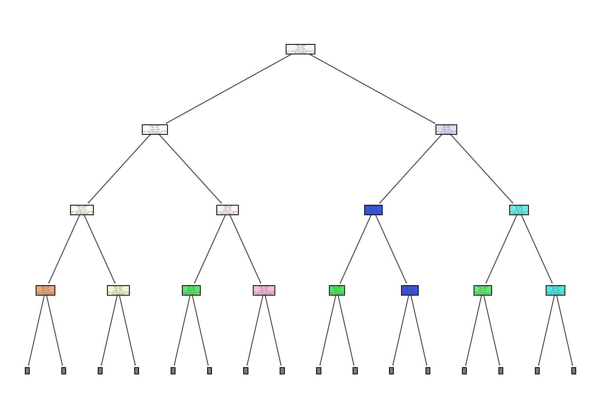
Figure A1—decision-tree diagram (baseline interpretability).
The root split separates high-leverage variables, yielding readable if–then rules. Tree depth and a min_samples_leaf =3. The constraint reduces variance while preserving clarity for stakeholder communication.
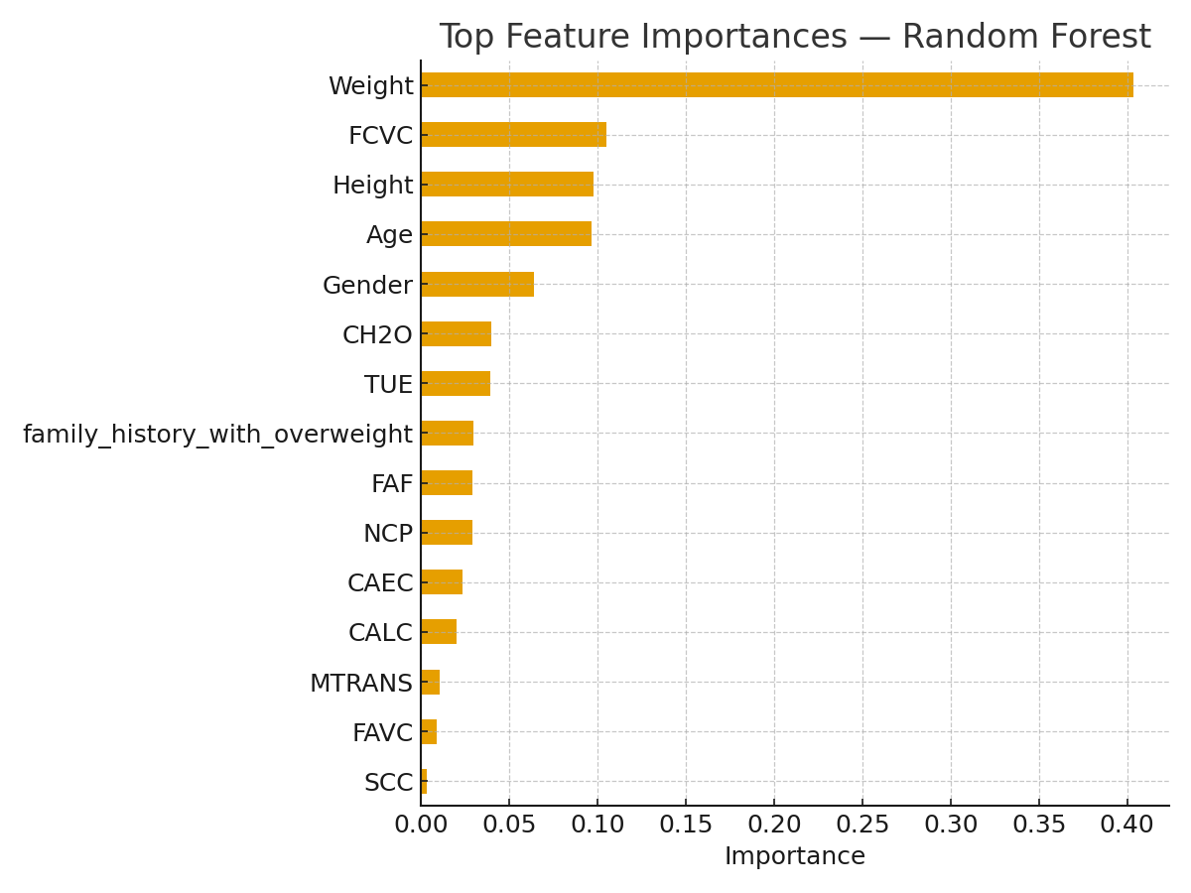
Figure A2. Random-forest feature importances
Weight, FCVC, Height, and Age dominate split-based gain. Importance summaries capture predictive contributions across trees but do not imply causality; they help prioritize features for engineering and policy explanation.

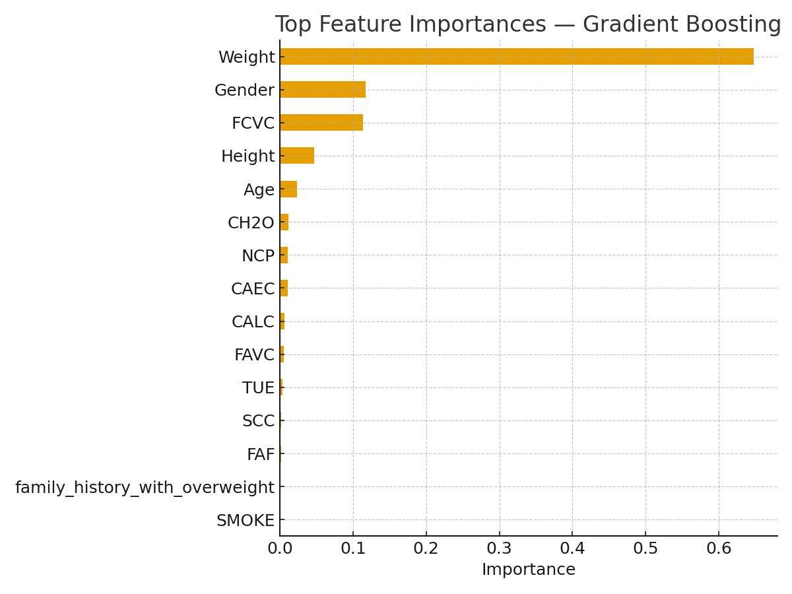
Figure A3. Gradient-boosting importances
With depth-2 trees and learning_rate=0.05, boosting concentrates signal on Weight and Gender, reflecting shrinkage-driven focus on strong predictors and low-order interactions.
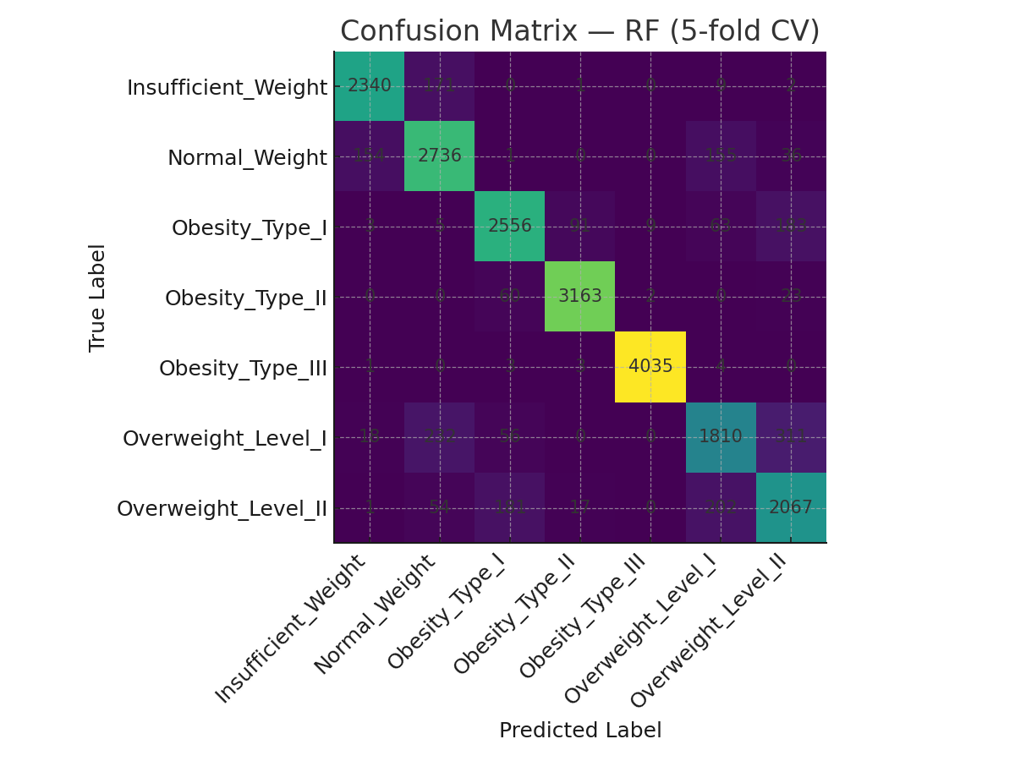
Figure A4. Random-forest confusion matrix (K-fold CV)
Predictions concentrate on the diagonal; residual errors cluster between adjacent classes, indicating ordinal proximity. Remedies include probability calibration and threshold tuning to rebalance sensitivity across classes.

