Shopify Marketing Experiment
Data-Driven Framing for Conversion Optimization

By: Amit Pinchas

Focus: Behavioral Framing • Motivation Analysis • Conversion Optimization • CLV Simulation

A. Project Overview

This project investigates how success-based motivational framing impacts user behavior, conversion, and customer lifetime value (CLV) among Shopify merchants.
By applying behavioral economics principles, the study examines whether presenting success stories during onboarding can increase motivation, willingness to pay, and conversion rates.
The experiment follows a data-driven marketing approach combining A/B testing, statistical modeling, and business impact analysis.

.
B. Objective

The main objective was to determine whether success-oriented framing improves:
- User motivation to complete onboarding
- Perceived clarity and value of the product
- Willingness to pay (WTP)
- Long-term retention and simulated Customer Lifetime Value (CLV)

The survey was conducted in July 2025 using Qualtrics and distributed via WhatsApp, LinkedIn, and targeted entrepreneurial community groups. Our target audience was early-stage entrepreneurs and small business owners, typically in the process of launching their first online store. Based on our statistical calculations, 428 respondents (214 per group) would be required to validate the results with sufficient power. Each participant completed a 3–4 minute survey on either mobile or desktop.

C. Methodology

Design: Randomized control experiment (Control vs. Treatment)
Platform: Qualtrics
Participants: 428 total (214 per group)
Data Tools: R (statistical analysis, visualization), ChatGPT (synthetic data generation), Excel (data cleaning)

Each participant viewed one of two onboarding experiences:
- Control Group: Standard product explanation.
- Treatment Group: Success-based message emphasizing merchants’ financial achievements.
Key Metrics:
- Motivation (Likert 1–7 scale)
- Likelihood to Complete Onboarding
- Willingness to Pay (USD/month)
- Simulated CLV based on WTP × Lifetime × Margin

D. Workflow

- Designed and distributed a Qualtrics survey targeting entrepreneurs
- Cleaned and validated raw data using Excel and R.
- Conducted statistical tests and visualizations in R, including variance and correlation analysis.
- Used ChatGPT to create synthetic data mirroring realistic behavior trends and variability.
- Merged real and synthetic datasets for cross-validation and modeling.
- Interpreted statistical outcomes to derive actionable marketing insights.

.

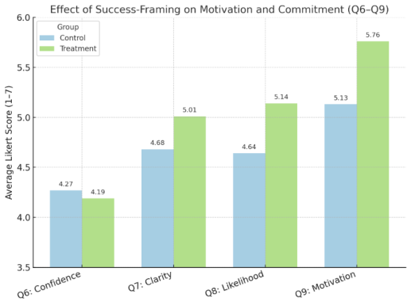
E.Visual Results & Key Findings

On a 1–7 scale, the treatment group scored higher in clarity (5.01 vs. 4.68), likelihood to complete (5.14 vs.

4.64), and motivation (5.76 vs. 5.13), with minimal change in confidence. Willingness to pay

was 45% higher, suggesting success-framing boosts commitment and perceived value. These results resonate with our Psychological Mechanism from the midterm assignment (Farming and Perceived Value). Conversion rates improved across all segments, while customer LTV rose in every segment exceptApparel.

Average scores by user Industry

Industry

Apparel

Beauty / Personal

Care

Home & Garden

Other
Q6: Confidence

4.23

4.24

4.18

4.27
Q7: Clarity

4.82

4.83

4.80

5.06
Q8: Likelihood

4.85

5.03

4.98

4.54
Q9: Motivation

5.43

5.55

5.53

5.08
Average Willingness to pay (USD)
170.47

172.91

126.19

93.42

Average willingness-to-pay by motivation score for each group:

Motivation Score

Control –Average WTP

Treatment –Average WTP

% Difference
1 2 3

N/A 80.00 48.33

N/A N/A 80.00

N/A N/A 65.53%
4 5

93.12 138.17

239.56 195.35

157.26% 41.38%
6 7

142.62 102.42

142.51 217.55

-0.08% 112.41%

This table shows that at comparable motivation scores, users in the treatment group were willing to pay significantly more. This suggests that exposure to the overall success of Shopify users increased perceived value, even without raising self-reported motivation levels.

Average rating (1-7 scale) comparing treatment & control group across motivation / success outcomes:

Simulated CLV Analysis:

Assumptions:

1. The retention rate of a customer is 80%. (Both for the Control and treatment group) 2. We are using each segment average willingness to pay as the monthly price.
3. Contribution Margin – 80% (Typical Saas Gross Margin)

Industry

Apparel

Beauty / Personal

Care

Home & Garden

Other
Avg WTP Control
179.01

92.23

101.56

74.23
Avg WTP Treatment
162.78

245.77

151.39

128.41
Lifetime (Years)
8

8

8

8
Gross Margin (%)
80%

80%

80%

80%
LTV Control
13,748.14

7,083.43

7,799.47

5,700.54
LTV Treatment
12,501.52

18,875.46

11,626.47

9,862.02
Difference ($)
-1,246.62

11,792.03

3,827.01

4,161.48

Conversion rate analysis:

While the LTV growth across segments is impressive, our primary focus was on conversion rates, Shopify’s main challenge. To address this, we assumed a 25% baseline conversion rate for the control group and estimated changes based on Q9 (motivation) scores.

Industry

Apparel

Beauty / Personal Care

Home & Garden

Other
Q9 Avg

Control

5.01

5.29

5.24

4.97
Q9 Avg

Treatment

5.80

5.79

5.82

5.29
Relative

Lift (%)

15.76%

9.55%

10.94%

6.57%
Conversion

Control

25%

25%

25%

25%
Conversion

Treatment

29%

27%

28%

27%

F. Marketing Recommendations
Key Conclusions
Showing Shopify customers’ 2024 financial success increased motivation in all segments, driving estimated conversion lifts of +6–16%. Beauty/Personal Care had the biggest WTP jump (+166% LTV). Apparel showed the strongest motivation gain but slightly lower WTP, suggesting pricing perception issues. MarketingActions
Tailor messaging by industry: Apparel & Home & Garden emphasize ROI calculators + onboarding challenges to convert motivation into action. For Beauty/Personal Care, highlight high earners, test higher pricing tiers. Urgency triggers: Offer limited-time discounts or exclusive perks immediately after showing success stories. Business Impact
If applied platform-wide: +12–20% total revenue uplift, driven mainly by higher conversion rates and select segment WTP gains. Lower CAC from improved conversion and potential CLV increase via pricing optimization.
Next Steps
- Run a large-scale A/B test on success-story framing variations. - Monitor activation, conversion, and churn by segment.
- Explore personalized onboarding flows based on declared industry.

G. Field Experiment Proposal

Key Intervention

Show new Shopify sign-ups an industry-specific financial success story during onboarding, drawn from real 2024 data.
Treatment: Personalized story highlighting revenue, growth metrics, and relatable entrepreneur background from the same industry.
Control: Standard onboarding without financial success framing. Groups:
- Randomly assign 50% of new sign-ups to Treatment and 50% to Control.
- Stratify randomization by industry category to ensure balanced representation. Outcome Metrics
- Primary: Paid conversion rate within 30 days.
- Secondary: Retention rate after 90 days, Average Revenue Per User, and CLV over the first year. Test Duration
- Run for 90 days to capture onboarding, first purchase cycle, and early retention. - Aim for 5,000+ sign-ups per group to ensure statistical power.
Data Needed

1. Transactions: Dates, amounts, plan tier.

2. Behavioral Logs: Click-through rates on onboarding content, time spent on setup, feature adoption. 3. User Profiles: Industry category, signup channel, device, region.
4. Retention & Billing Data:Active status by month, churn reason (if available). Value of Field Experiment
- Captures real purchase behavior instead of self-reported intent.
- Measures not only conversion lift but also retention and LTV impact.
- Allows segmentation by industry to see where the intervention has the greatest ROI. Why It’s Better Than the Pilot
- Use actual Shopify customers rather than simulated or survey respondents.
- Tracks long-term business outcomes (e.g., churn, upsell) rather than short-term motivation.
- Validates whether observed motivation and Willingness to pay gains in the pilot translate into actual revenue and retention improvements.

H. Appendix

1. Framing and Perceived value: Presenting success-based information early increases perceived value of

the task, making users more likely to commit effort (Tversky & Kahneman, 1981; Festinger, 1957). In addition, Users are more motivated when they believe their effort will lead to meaningful outcomes (Vroom, 1964).
2. Survey Link - https://qualtricsxmk36grtyxy.qualtrics.com/jfe/form/SV_cGglDcZW0L8ojXg 3. Raw Data file:
https://docs.google.com/spreadsheets/d/18HFJCDm6gR44r8deuF3c_t3wYDalPuusLIAPlMV7q5s/edit ?gid=147785527#gid=147785527
4. Shopify Pricing plans: https://www.shopify.com/pricing
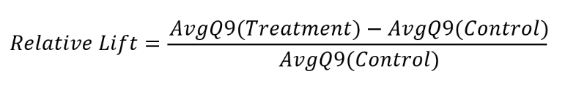
5. Lift calculation: explained:
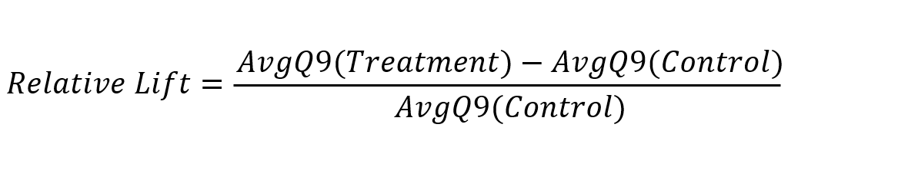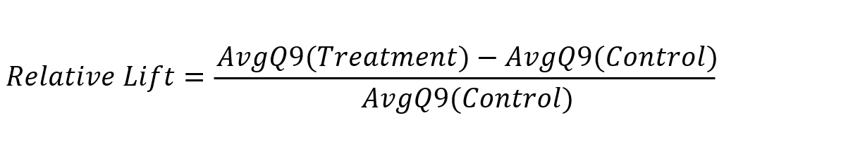

6. Conversion Rate (Treatment):

7. Sample Size formula for two proportions:
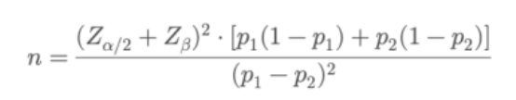

n = sample size per group

p1 = baseline conversion rate (25%) p2 = expected conversion rate (37.4%)
Za/2 = Z – value for confidence level. (1.96%) ZB = Z – value for power. (0.84)
Results: We require ~214 participants per group (~428 total) to detect an increase in conversion from 25% to 37.4% with 95% confidence and 80% power.

8. This is just an extra, but only an hour before the assignment submission time, We encountered a post

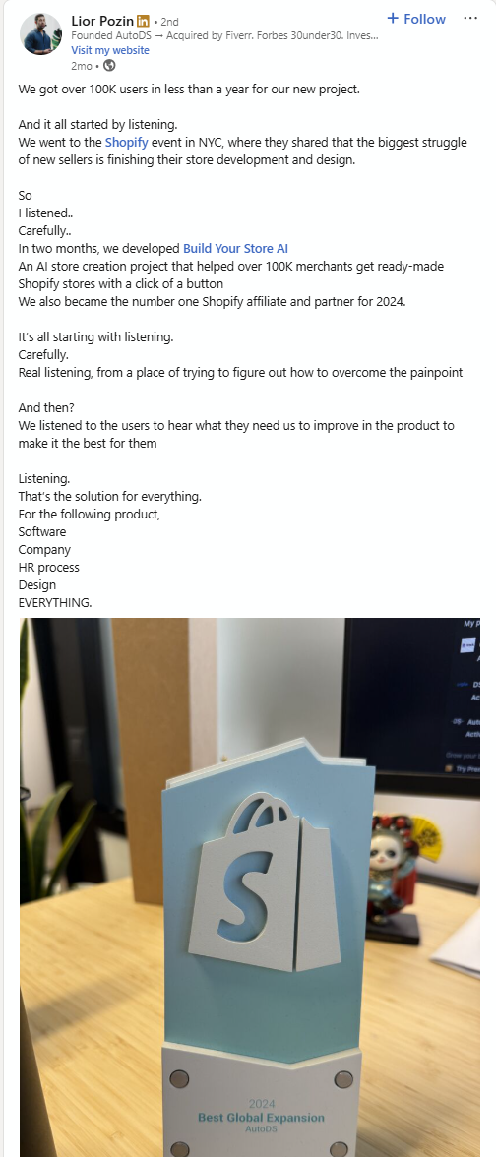
on LinkedIn talking about the exact problem we described in our project. The LinkedIn user created an Ai Tool that makes Shopify stores with a click of button. He got more then 100,000 users in less than a year!



