CS1760 ADV OBJECT ORIENTED PROGRAMMING

Assignment 2 Part 2

# Task

Create a simple GUI interface that allows the user to choose different shapes to be displayed.

# Method

Use Scene Builder (or equivalent) to create the Assign2Draw.fxml which draws an interface in a window of about 800 x 800. The window uses a **GridPane**, a **Pane** and a **TextField** placed on a **BorderPane**. The 4x4 **GridPane** contains 6 **Labels**, 4 **TextFields**, 3 **RadioButtons**, a **Combo** **Box**, a **ColorPicker** and a **Button.**

Top of the window:

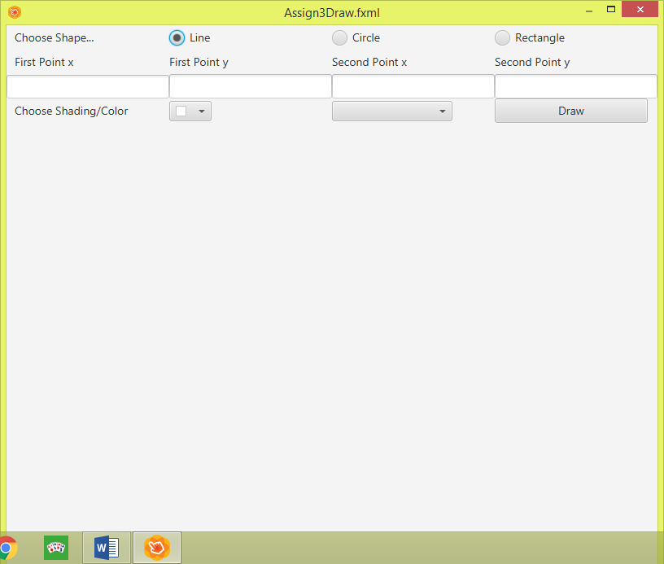

Create classes Assign3Draw.java and Assign3DrawController.java

The shapes will be drawn in the Pane and error messages will be displayed in the Text Field at the bottom of the window. The user will make the following choices:

* Choose the shape
* Enter co-ordinates of two points for a line OR

Enter center co-ordinates and radius for a circle OR  
Enter top-left coordinates, width and height for a rectangle

* Choose color (from **ColorPicker**) and shading (Full, Light or Empty) from **Combo Box**

Then the user will click the **Button** and the correct shape will be drawn.

You will need to handle the following events

* Clicking one of the **RadioButtons**
* Choosing from the **ColorPicker**
* Choosing from the **ComboBox**
* Clicking on the **Draw Button**

**Turning in the Assignment**

This assignment is due on Monday 10 February. Upload one FXML file and all **java** and **class** files to CourseWeb, preferably all zipped in a project. Also turn in a folder containing printouts of all source code and a completed Assignment Information Sheet.

# Notes

1. Possible shadings are Dark (normal fill), Light (half the darkness of Dark), Empty (white fill) and are for fills of rectangle and circle.
2. Remember that you must create a **ToggleGroup** in SceneBuilderfor the **RadioButtons** so that they are mutually exclusive - only one **RadioButton** can be chosen at a time.
3. The text in the Labels above the 4 TextFields will change based on which shape is chosen. For a Circle you need only 3 Labels and 3 TextField so the last ones should disappear.
4. Use an instance variable to track which kind of shape is to be drawn, an instance variable for whether shape is Solid or Outline and an instance variable for the width of the line.

5. You must handle all possible problems relating to entering data in the TextFields. This includes leaving any of them blank, entering numbers for points that would be outside the pane, entering numbers that would create a shape that is outside the pane. If you want to create your own exceptions classes you can.