**Contents**

1 Configure SCPI-Devices 2

1.1 Adding a new device type 2

1.1.1 Name the new device type 2

1.1.2 Add a command to the device-type 2

1.1.3 Command parameter types 2

1.1.4 Command priority 3

1.2 Adding a new device to the Sequence 3

1.2.1 Find the device IP and PORT 3

1.2.2 Add a new device 3

1.3 Edit a device 4

2 Add an operation 4

2.1 Preconfigure operation parameter 4

2.2 Specific operation configuration 4

2.2.1 Custom command configuration 4

2.2.2 Number command configuration 4

3 Modifying existing operations 5

3.1 Edit operation 5

3.2 Delete operation 5

3.3 Move operation 5

4 Start a sequence 5

5 Manage sequences 6

5.1 Save a configured sequence 6

5.2 Load a configured sequence 6

5.3 Create a new sequence 7

6 Additional information 7

# Configure SCPI-Devices

## Adding a new device type

To be able to create a sequence you need to add a device. This device is based on a predefined device type. To create such a device type you must navigate to “**Edit**” → “**Add device-type**”.

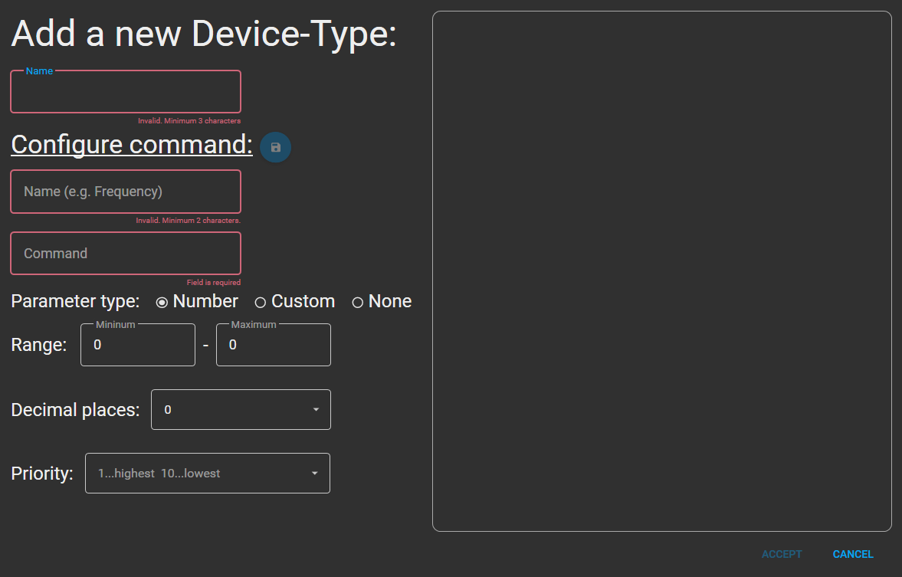

### Name the new device type

Each device-type must have a **unique name**. To name it, just type in the name in the text box.

### Add a command to the device-type

Once you named your new device-type, you can start with **assigning commands** to it.

In the first two text boxes you can **name** the command and enter the command string. It is recommended to assign the names according to a structure.

To **save** a command, click the blue save button.

### Command parameter types

#### None

If the parameter type none is selected the command is created as a **read-only** command. It can only be used to receive data from the device.

#### Number

If the parameter type number is selected, the command can be given a **number** corresponding to the **specified range** and **decimal digits**.

#### Custom

If the parameter type custom is selected, **various selection parameters can be set**. The **name** determines how the parameter is **displayed**, and the field “**command parameter**” defines which **string** actually corresponds to the parameter given to the **command**.

Once you are finished defining a custom parameter you must click the **blue button** with a **plus**. Now you can add a new custom parameter or save the command with the blue save button.

### Command priority

If you add a number- or custom-command you have the possibility to set a priority. This determines the position of the command in the operation.

This can be useful, for example, if you want to change the voltage and the current limit in an operation. In this way, you can ensure that the current limit is set before the voltage is increased.

## Adding a new device to the Sequence

### Find the device IP and PORT

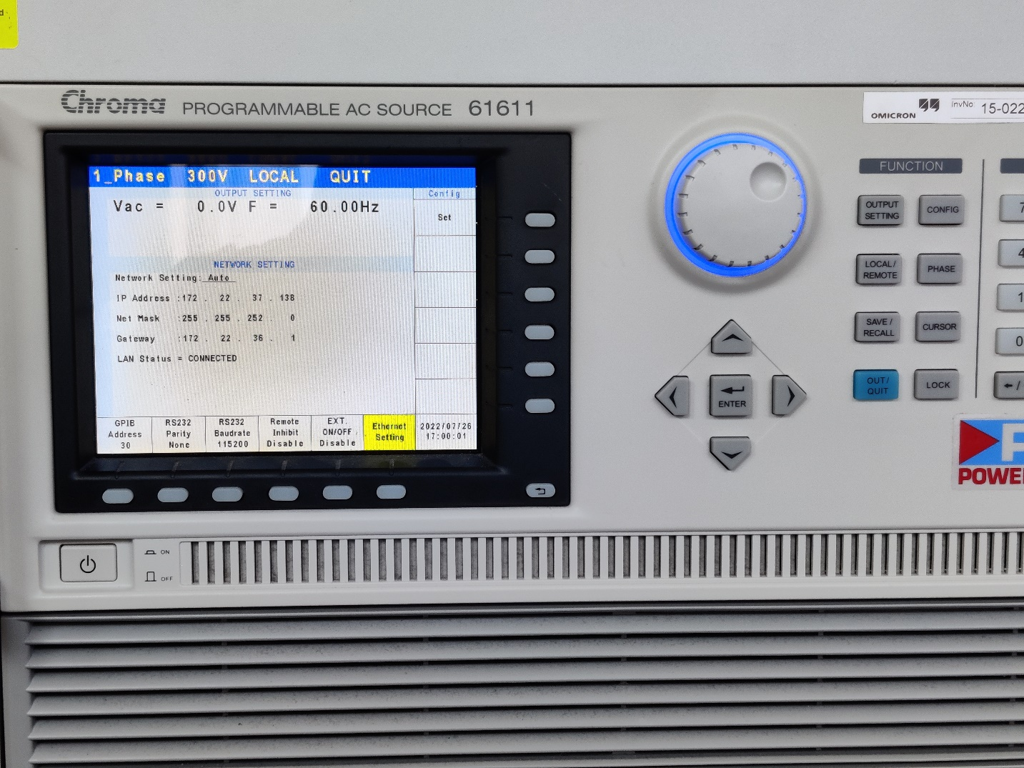

The easiest way to find out the **IP-Address** of a device is to go into the “**Ethernet Settings**”.

Note: Most local-area-networks devices get their IPs from a DHCP server, which means that it can change after re-verifying in the network. To edit a device TCPIP see: 1.2 Edit a device

To find out the **PORT** of the device the easiest way search for it in the manual of the specific device. The default PORT for Chroma devices is **2101**.

### Add a new device

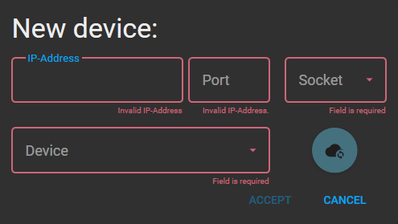To add a new device, you must click on the plus button next to the headline “Devices:”. Once you clicked it a window shows up where you can define the IP-address, PORT, Socket (usually “SOCKET”) and the device type. To save the device click on the accept button.

If you want to check the connection, you can click on the blue check button.

## Edit a device

If you load a saved sequence, the actual IP of a device could have changed. To change this IP in the sequence you can click on “Settings” button next to each device.

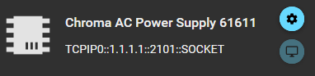

Once you have clicked the button you will get to the window from 1.2.2 Add a new device.

# Add an operation

To add a new operation to the current sequence you must click the blue button “Add operation” in the sequence column.

Once you are finished with the configuration and you have entered all necessary values you can save the operation by clicking “Accept”

## Preconfigure operation parameter

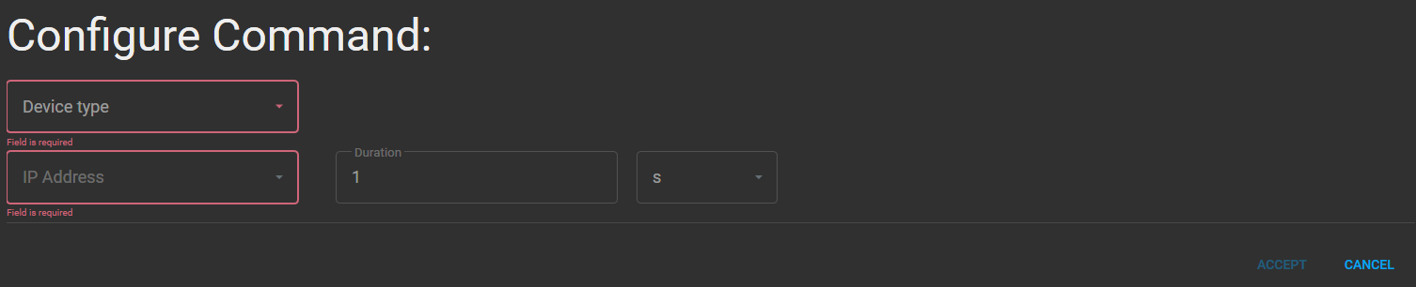

In the preconfiguration you can select the device type, ip-address of the device and the operation duration.

## Specific operation configuration

Once you have selected device type and ip-address the window will expand to the device-type specific configuration.

### Custom command configuration

To add a custom command to the operation you can choose the parameter you wish from the associated combo box.

If a command is added to the operation the command name will change its color to white.

To remove a custom command from the operation just select “*Unselected*” in the combo-box. The command will be removed, and the command name will change its color back to gray.

### Number command configuration

To add a number command to the operation you must type in the number to the associated text box. Make sure that the number satisfies the defined validation.

# Modifying existing operations

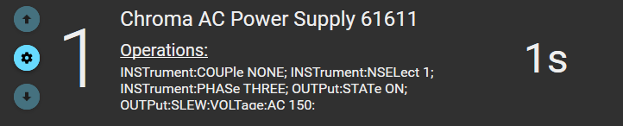

To modify an operation in the sequence list you can use the blue buttons to the right of the operation.

## Edit operation

To edit an operation, you must click on the middle blue button. Once you have pressed the button, a window opens in which you can make the configuration as in 2.1 Preconfigure operation parameter and 2.2 Specific operation configuration. Once you have done your changes, press “Accept” to save and close the window.

## Delete operation

To delete an operation, you must click on the middle blue button. Once you have pressed the button, a window opens in which you can make the configuration as in 2.1 Preconfigure operation parameter and 2.2 Specific operation configuration. To now delete the operation, click on the “Delete” button next to the “Accept” button.

## Move operation

To move an operation, you must click on the top or bottom blue button, depending if you wish to move the operation up or down in the sequence.

# Start a sequence

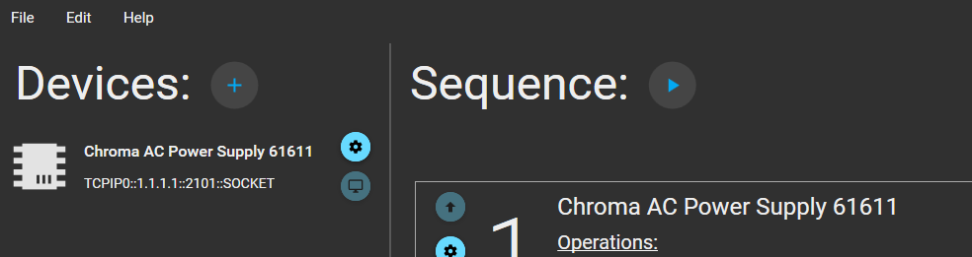

To start a sequence, you must click the “Start” button next to the headline “Sequence:”.

Once you have pressed the button, the connection to all devices used in this sequence is first checked and then the sequence is started.

You will see the progress of execution on a progress bar. In the text block to the right of the sequence list you can see live the commands that are sent to the device.

# Manage sequences

## Save a configured sequence

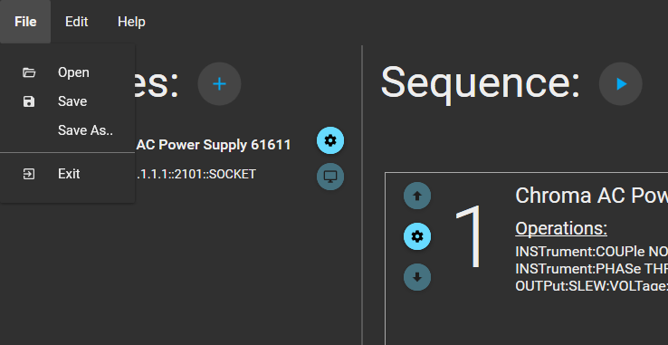

To safe a sequence you must click the “Save” button in the file column of the navigation bar, select a location to save, select a name and click “Save”.

## Load a configured sequence



To load a saved sequence, you must click the “Load” button in the file column of the navigation bar, select your “.seq” sequence file, and click “Open”.

## Create a new sequence

If you want to unload the current sequence to create a new one you must click “New” in the file column of the navigation bar. A blank workspace is now available for a new sequence.

# Additional information

The function to create a new device type is very experimental. If you make a mistake, it cannot be undone or edited after saving it in the program. To undo or edit this, please go to the application folder and make the change to “devicetypes.json”.

Please excuse the circumstances.