Ein Bild, das Himmel, Radioteleskop, Radar, draußen enthält.

Ground Station

for the SatNOGS-Network

Thank you for your interest in our thesis. To provide you with a comprehensive yet concise overview of the content of our thesis, we will attempt to briefly describe the key points here.

Initial Situation

Ein Bild, das Screenshot, Raumfahrzeug, Nacht enthält.

In 2024, the SpaceTeam of the Vienna University of Technology launches their latest satellite, STS1, into low Earth orbit. The sensor data transmitted by the satellite is evaluated by the ground station and then displayed in real-time on a graphical user interface.

Render of the STS1

The SatNOGS-Network

As the STS1 satellite is not synchronized with the rotation of the Earth, there is only a specific time window to receive data with a stationary antenna. To enable continuous data reception, global satellite coverage is necessary.

SatNOGS provides an open-source solution that allows any ground station operator registered in this network to use other ground stations registered in the network for reception.

Ein Bild, das Waffe, Schwert, Gelände, Im Haus enthält.

QFH-Antenna

An essential component of the ground station is the antenna, which enables the reception of data transmitted by electromagnetic waves. Such an antenna is to be designed, built, and characterized for the 430MHz/70cm band as part of the thesis.

This antenna has already been successfully constructed and tested.

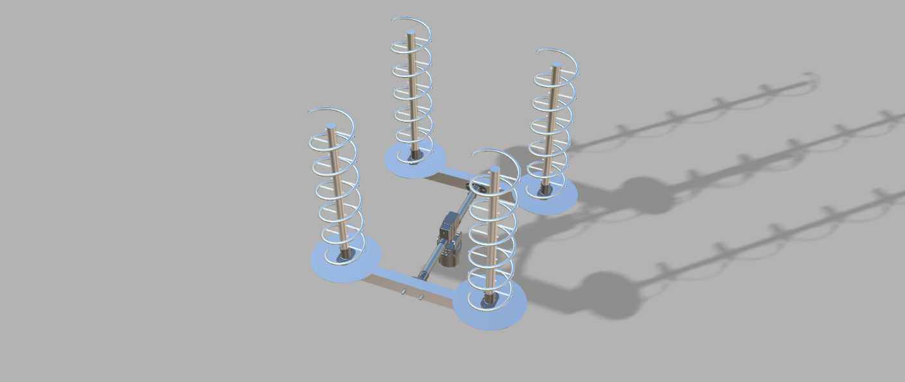

Render of the Antenna-Array

**HTL Rankweil**

6830 Rankweil

Negrellistraße 50

**Contact**

Gabriel Ritter Jakob Metzler

gabriel.ritter@student.htl-rankweil.at jakob.metzler@student.htl-rankweil.at

0681/20722361 0664/4131127

The complete QFH-Antenna

The helix array consists of four individual helical antennas, which together can achieve high directivity and ensure reliable reception.

Currently, we are engaged in constructing these helical antennas. The antenna has already been calculated, digitally designed, and simulated. Furthermore, we have found a sponsor to bend the spiral.

The biggest hurdle at the moment is the financial resources, as the structural elements are expensive.

The Helix-Array