Dit svar

**Afleveringsopgave**

Mandatory Assignment 1: Dicts og Sets.

In this mandatory assignment you will work with Dictionaries and Sets.

The task is for you to first familiarize yourself with, and subsequently show that you understand and can use both data structures.

There is no specific material to read, but you must find relevant information on the subject yourself.

None of the assignments or how to solve them have been covered in the teachnings so far. It will come later, so you are one your own, and remember that if you can not solve a task or solve a task in the right way does not mean that you failed. If you try you will also pass the mandatory assignment.

Once you have done that, solve the tasks below.

Hand-in

You must submit your answers no later than 15:45 today.

Subsequently, you will receive a notofication from Fronter with a link to one of your fellow students' assignments, which you must do a code review of. You must have made this review before 12.00 on monday 27-02-2022). The task is not fully solved until you have done this.

** If you do not gett a notification, then please go to the hand-in folder here on fronter today after 15:45.

You must submit one assignment**.py.txt**file containing all assignments.

Fronter will not allow you to submit .py files therefore you will need to add .txt as a file extension (.py.txt).

(Example: script.py becomes script.py.txt)

PS. The assignments should be self explainatory, you will not get help to the assignment from me (Claus).

Assignments:

1. Model an organisation of employees, management and board of directors in 3 sets.

Board of directors: Benny, Hans, Tine, Mille, Torben, Troels, Søren

Management: Tine, Trunte, Rane

Employees: Niels, Anna, Tine, Ole, Trunte, Bent, Rane, Allan, Stine, Claus, James, Lars

* who in the board of directors is not an employee?
* who in the board of directors is also an employee?
* how many of the management is also member of the board?
* All members of the managent also an employee
* All members of the management also in the board?
* Who is an employee, member of the management, and a member of the board?
* Who of the employee is neither a memeber or the board or management?

1. Using a list comprehension create a list of tuples from the folowing datastructure

{‘a’: ‘Alpha’, ‘b’ : ‘Beta’, ‘g’: ‘Gamma’}

1. From these 2 sets:

{'a', 'e', 'i', 'o', 'u', 'y'}

{'a', 'e', 'i', 'o', 'u', 'y', 'æ' ,'ø', 'å'}

Of the 2 sets create a:

Union



Symmetric Difference

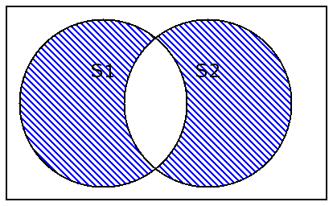

Difference

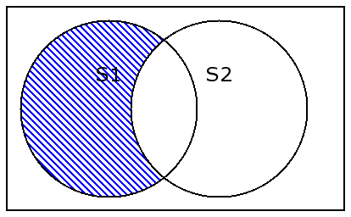

disjoint

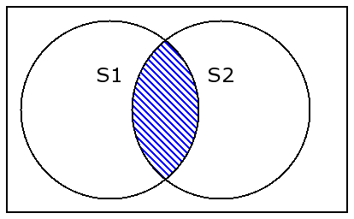

1. Date Decoder.

A date of the form 8-MAR-85 includes the name of the month, which must be translated to a number.

Create a dict suitable for decoding month names to numbers.

Create a function which uses string operations to split the date into 3 items using the "-" character.

Translate the month, correct the year to include all of the digits.

The function will accept a date in the "dd-MMM-yy" format and respond with a tuple of ( y , m , d ).

[**Besvar opgave**](https://assignment.itslearning.com/Answer.aspx?LearningObjectId=341963582&LearningObjectInstanceId=481999236&MobileBrowser=NotDefined&UserId=149927578)