**ID:** BUG-001

**Title:** 404 error when following the hyperlink in the product description.

**Project:** OpenCartWeb

**Version:** 1.7.2

**Author**: Anastasia Skichko

**Date:** November 16, 2024

**Priority:** Medium

**Severity:** Major

**Status:** Open

**Environment:**

Browser: Google Chrome 130.0.6723.117

OS: Windows 10 Pro x64

Device: PC

**Steps to Reproduce:**

1. Open the product page: <https://www.opencart.com/index.php?route=marketplace/extension/info&extension_id=38358>.

2. Click the hyperlink "Limits, terms and eligibility criteria apply" in the product description.

**Expected Result:**  
The user is redirected to the page: <https://www.paypal.com/uk/legalhub/useragreement-full#pp-seller-protection>.

**Actual Result:**  
A "404 Not Found" error page is displayed.

**Attachments:**  
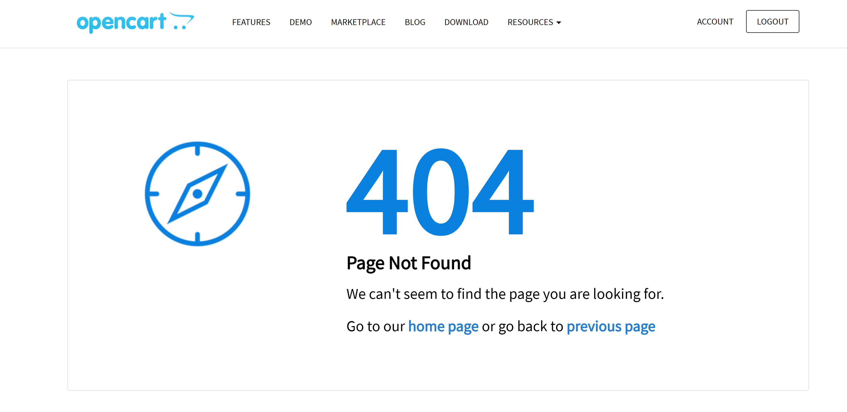

**ID:** BUG-002

**Title:** Missing notification for comment submission to moderation queue.

**Project:** OpenCartWeb

**Version:** 1.7.2

**Author**: Anastasia Skichko

**Date:** November 16, 2024

**Priority:** Low

**Severity:** Minor

**Status:** Open

**Environment:**

Browser: Google Chrome 130.0.6723.117

OS: Windows 10 Pro x64

Device: PC

**Steps to Reproduce:**

1. Navigate to the product page: <https://www.opencart.com/index.php?route=marketplace/extension/info&extension_id=38358>.

2. Fill in the "Leave your comment" field with data from Test_Data.xlsx (Comment).

3. Press the "COMMENT" button.

**Expected Result:**  
The message "Your comment has been added to our moderation queue!" is displayed.

**Actual Result:**  
The notification message about comment submission to the moderation queue is missing.

**ID:** BUG-003

**Title:** Incorrect display of search results with invalid data.

**Project:** OpenCartWeb

**Version:** 1.7.2

**Author**: Anastasia Skichko

**Date:** November 16, 2024

**Priority:** Low

**Severity:** Minor

**Status:** Resolved

**Environment:**

Browser: Google Chrome 130.0.6723.117

OS: Windows 10 Pro x64

Device: PC

**Steps to Reproduce:**

1. Open the product selection page: <https://www.opencart.com/index.php?route=marketplace/extension>.

2. Enter invalid data in the search bar from Test_Data.xlsx (unS).

3. Press the search button.

**Expected Result:**  
An empty store field is displayed with a message indicating no results were found.

**Actual Result:**  
The user is redirected to the product selection page.

**Attachments:**  
