# Dpi Mobile Agent Portal Modification Requirement Document

Prepared by Boris Furman, Affilia Corp, [bfurman@affilia.com](mailto:bfurman@affilia.com) (214) 335 4143

## Background

The goal of the project is to allow Dpi Mobile to print lifeline documents, allow customers sign, submit trouble tickets and replenish minutes

The project will also allow Affilia team to get familiar with H20 code base.

## Missing information to complete document

### Overgroup

1. Provide exact flow and html code on how to sign without print. What fields must be recorded and stored
2. Provide html code on how to sign documents
3. Supply code example or specify how information about signing of the lifeline document is saved in H2O
4. Supply third party pdf tool used in the code

### Affilia

1. Research trouble ticket work flow in H20 and create mockup flow for agent portal.
2. Design a mockup of the page for step 7 customer signup process that would show how customer will be asked to sign and print documents
3. Design mockup based on existing customer page to add signup
4. Design mockup based on existing customer page to add trouble ticket management
5. ~~Research work flow in H2O of minute replenishment and modify existing customer page mockup~~

## Sign and Print Lifeline Documents

1. Sign lifeline documents without printing
   1. TODO: Need exact flow on how to sign without printing (Overgroup)
2. Print lifeline document
   1. PDF document must be pre populated
   2. Agent prints document and gives it to a customer to be signed
3. Sign and print lifeline documents
   1. TODO: Need exact flow on how to sign without printing (Overgroup)
   2. Agent prints document and gives it to a customer to be signed

### Implementation details

#### Customer Signup

1. If during signup, it was selected that customer requires assistance, then add extra step 7– Sign Documents
2. When agent gets to step 7, he must be able to either
   1. Print pre populated lifeline document
   2. Allow customer sign without printing
   3. Sign and print
   4. System must record the fact that lifeline documents are signed and only then allow to go to next step
   5. TODO: Need design of the screen

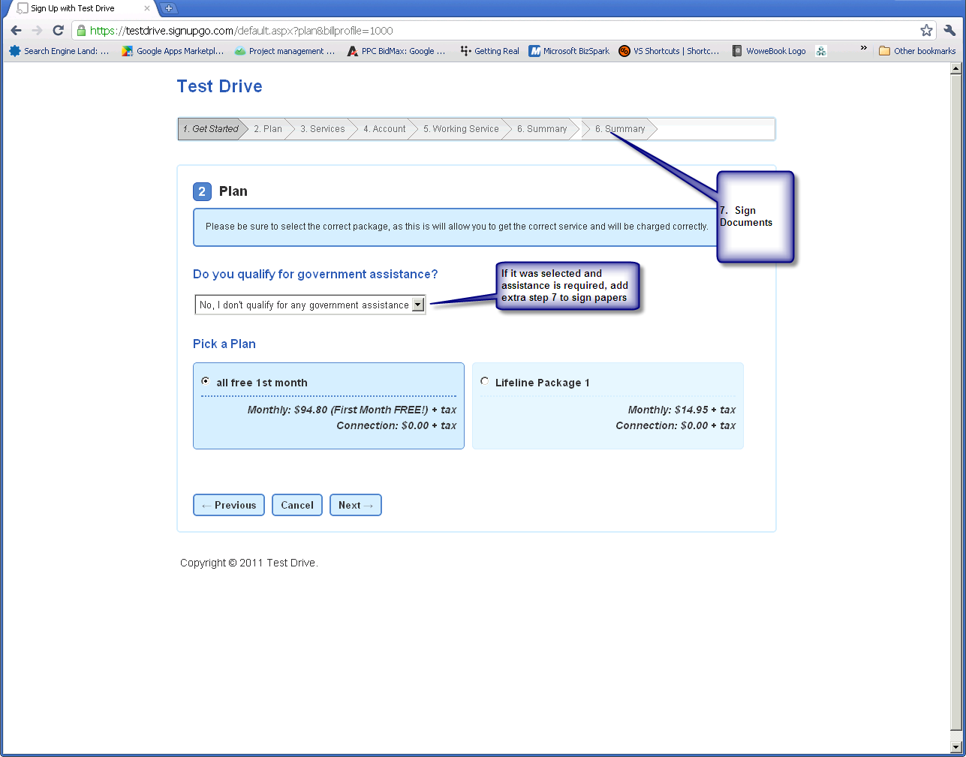

#### Customer management

1. Modify existing customer page. Add sign, sign and print and print functionality for lifeline forms. TODO: Design exact layout and flow
2. System must record the fact of signing Lifeline document. (Overgroup will specify how to do it)

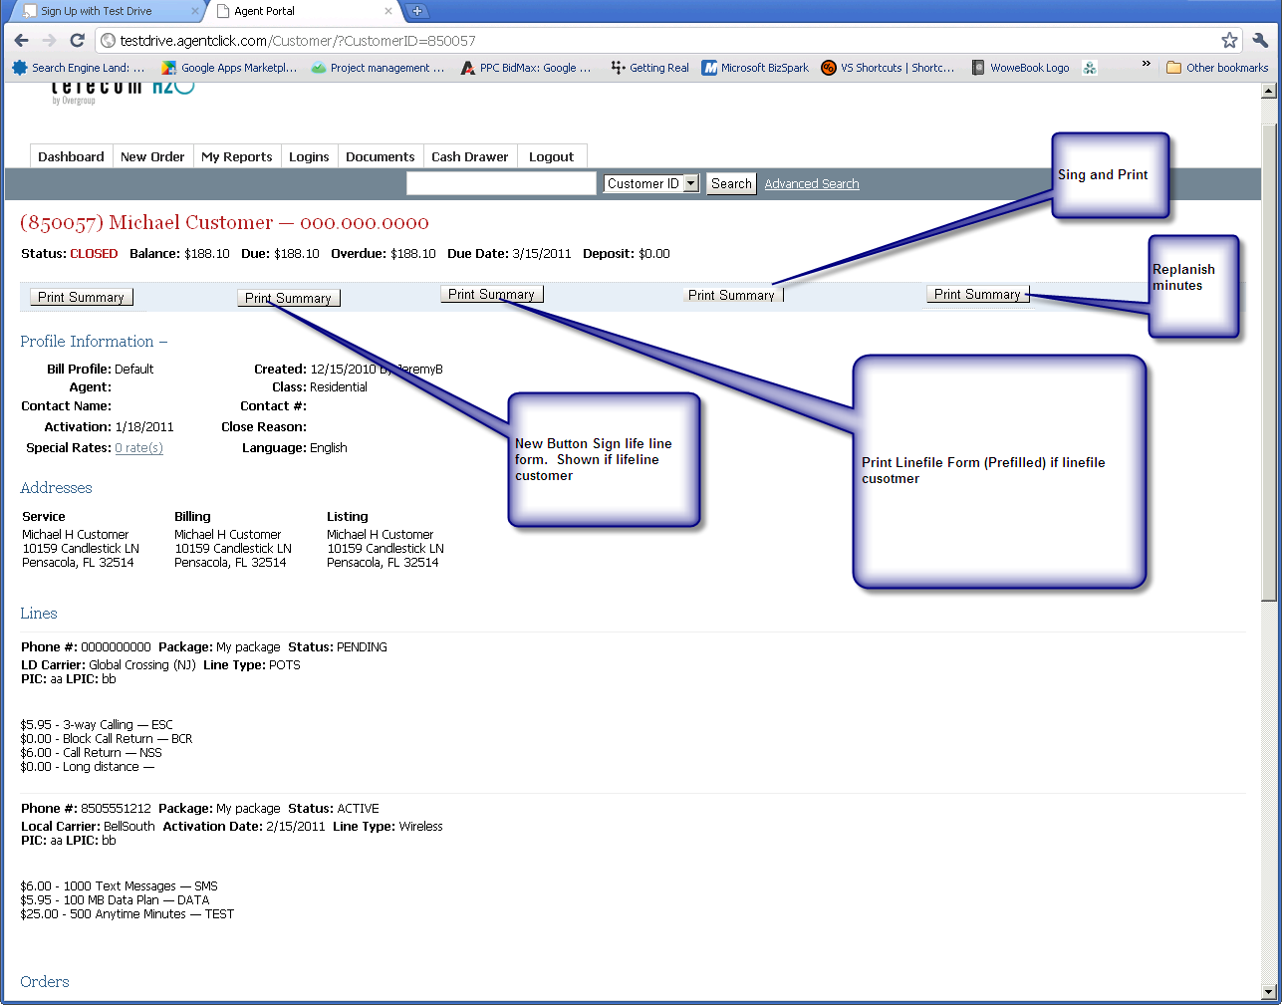

## Trouble ticket management

1. Agent must be able to submit trouble ticket for customer on customer screen
   1. Fields
      1. Contact Name – Default customer First Name Last Name - required
      2. Contact # - optional
      3. Email – optional
      4. Service – Required
      5. Status – don’t show just default to open
      6. Description – required
2. Agent must be able to find information about Trouble ticket by customer and date
   1. Show fields
      1. Ticket Number
      2. Description
      3. Status
      4. Date Open
      5. Line
      6. Date Resolved
      7. Resolution

### Implementation Details

1. Research work flow

## Minute Replenishment

1. Agent must be able to add minutes to existing customer account.
2. TODO: Research work flow in H2O and create mockup screen