Dalworth Smart Schedule

Draft Requirement Document

Dec 2008 c

Prepared By:
Boris Furman
bfurman@affilia.com
(214) 335-4143


Table of Contents

Document scope 4
Application Overview 4
Company Goals 4
Dalworth Users 4
Technical Architecture requirement 6
Modules 6
Dalworth Clean customer business rules 7
Projects (services) that can by created for or by Dalworth Clean technician (need to elaborate) 8
Business rules 8
Dalworth clean scheduling rules 8
Duration rules – need elaboration 9
Visit value rules 9
Driving distance rules – very tenative 9
Scheduling algorithm description 9
Rank description 9
Input parameters 9
Output 10
Flow 10
Sales Application description 10
UC-Create new visit 10
UC-Create project 12
UC-Configure Carpet 12
UC-Configure Wood 15
UC-Configure Rug 15
UC-Configure Tile 15
UC-Configure Oriental Rug 15
UC-Configure Duct 15
UC-Schedule Visit 15
UC-Schedule Visit Manual – need elaboration 16
UC-Review Visit 16
UC-Order copy 16
UC-Order Rework 16
UC-Edit Order 16
Manager Application description – need a lot of elaboration 17
UC-Define Cells 17
UC – Define availability 17
UC- View booking status 17
UC-Update status 17
?????? 17
Servman synchronization issues that are not solved yet 17
Phase 1 scope 17
Iterations 18
First iteration -3 weeks 18
Hours? 18
Tasks 18

Document scope
Only main idea of smart scheduling is explained. Not all the use cases are identified. Identified use cases are not completely documented.

Application Overview
Smart Schedule would enforce company’s current business rules and would make decision process of sales representative very easy and intuitive. As a result, Dalworth expects to realize business benefits such increasing customer satisfaction, increasing profits by scheduling more jobs, franchisee retention and rewards

Company Goals
- Provide consistency in scheduling rules
- Increase density of jobs
- Increase average order amount
- Increase appeal of being Dalworth Clean franchisee
- Provide incentive for technicians to move up the rank
- Reduce miles driven by technicians
- Simplify process of scheduling jobs and reduce number sales representative involved in booking process

Dalworth Users
- Company Owner
  - Reviews capacity for each date (available, allocated). How do you measure capacity?
  - Reviews statistics, reports – to be defined
- Technician
  - Manages his info such as
    - Personal info
    - Hourly rate
    - Manages his calendar
    - Creates new visit , reschedule visit
    - Prohibited by cancelling visit
    - Create event to block time from being assigned a job (doctor appointment , vacation, sick etc)
    - Dispatches his own jobs
  - Franchisee Technician – technician that has bought Dalworth Franchise
    - Has exclusive customers
    - Gets preferential treatment when jobs are assigned vs. contractor
    - Each franchisee has unique rank that shows his performance against other franchisees
    - Each franchisee assigned scheduling rank (1-3)
  - Contractor Technician – technician that did not buy Dalworth Franchise.
    - Does not have exclusive customers
    - Assigned jobs only if it was not possible to assign jobs to franchisee
    - Each contractor has unique rank that shows his performance against other contractors
    - Each contractor assigned scheduling rank (1-3)
- Manager
  - Defines pricing
  - Manages ad sources
  - Manages technician info such as
    - Is Technician franchisee or contractor
    - Defines rank for each technician
    - Personal info
    - Service that technician can perform
    - Hourly rate
    - Zip codes that each technician is assigned to service
    - Manages technician availability
    - Determines date of busy season. Busy season affects scheduling logic such as in busy season
- Sales Person
  - Creates new visits
- Customer support
  - Cancel visits
  - Reschedule visits
  - Answer customers questions – look at history
  - Books Reworks
- Dispatcher
  - Dispatches visits
  - Marks arrivals
  - Receives ETC
  - Completes visits
- Customer – end customer who receives service
  - Has a rank based on how many times he used the services of Dalworth Clean, what services he used, average bill amount and house tax value
  - Can book his visit online
  - Can be assigned as exclusive customer to franchisee
  - May have multiple locations and multiple names (Husband, wife, etc)

Technical Architecture requirement

Application must communicate with Servman by synchronizing visit and customer information

Modules

Smart Schedule
Servman

QuickBooks

Customer Portal
Franchisee Portal

- Smart Schedule – schedule and dispatch module
- Servman – existing application
- Franchisee portal – web site for franchisees
- Customer portal – web site for customers

Dalworth Clean customer business rules
- If customer has never used Dalworth Clean, he is new customer
- If Customer was assigned as exclusive to franchisee but never used franchisee for 3 years, he is new customer and can be given to any franchisee
- If Franchisee already serviced customer once and customer was not exclusive to any other franchisee and customer in zip code that franchisee services, customer becomes exclusive to franchisee. All efforts are made to book job to the franchisee
- If Customer is exclusive customer but franchisee cannot perform the job that customer is asked for and the job was given and completed by another technician, customer’s exclusivity to moved to the franchisee who did last job. Original franchisee is notified that exclusivity is lost
- On any job competed by franchisee to new customer , 60% of revenue goes to Dalworth and 40% to franchisee
- For exclusive customers system calculates rates based on how long customer remains exclusive and how much money they spent. Can go down to 70% franchisee 30% Dalworth
- If customer is a new customer and requests specific franchisee, franchisee by name, for the first job performed franchisee gets extra 20% (60% to franchisee and 40% to Dalworth)
- NEW RULE NOT YET IN PRODUCTION If customer is a new customer and requests specific franchisee but this franchisee cannot service the area , requested franchisee can give this customer to other franchisee that service that area. In this case, original franchisee gets 10% from the job competed, franchisee that completed the jobs gets 50% and Dalworth gets 40%. Customer is becoming exclusive for the franchisee requested
- If customer requests not to use the franchisee, franchisee loses exclusivity and is notified of the reason.
- Customer can have only one franchisee that is exclusive
- If customer has multiple locations, and some of them in the zip codes where franchisee is not providing service, exclusive franchisee makes the following decision
  - Do the job himself
  - Give job to another franchisee and split the commission with that other franchisee – Need to elaborate.

Projects (services) that can by created for or by Dalworth Clean technician (need to elaborate)
- Dalworth Residential - customer given exact time
  - Carpet Cleaning
    - # of Rooms
    - Options
  - Rug cleaning – rugs cleaned at the customer location
    - # of Rugs, shape, size
    - Options
  - Wood floor cleaning
    - # of Rooms
  - Upholstery cleaning
    - ??
  - Stone cleaning
    - ???
  - Miscellaneous
- Dalworth Commercial – need to elaborate
  - Carpet cleaning
- Duct cleaning – customer is given exact time
  - Done by specialized contractors

- Construction – customer is given a date of service but not time
  - Creates quote request for Construction department
- Oriental Rug cleaning – customer is given only a date of service but not time
  - Creates request to pickup oriental rug by Rug Cleaning department
- Content – customers given a date of service but not time
  - Creates request for content department

Business rules
The algorithm is based on the rules. Each rule has weight assigned to it. When system determines which technician to give job in each time frame, system always assigns technician with the highest rank. After each time frame is assigned, system ranks all the time frames that are possible and show which of them are more desirable and provides advice to Sales Rep by color coding each time frame

Dalworth clean scheduling rules
- If assignment was done manually (overwritten by customer service ), this assignment cannot be moved by system without prompt
- If customer is exclusive to franchisee, franchisee must do the job if it is possible
- Job is assigned to technician that services this zip code
- Technician must be able to perform service requested
- Today is better than tomorrow. Schedule jobs as soon as possible.
- Best job always goes to franchisee with highest rank
- Best job always goes to franchisee
- If system not in busy season, Always try to book empty slot and avoid moving jobs from technician
- If no contractor or franchisee assigned to zip code can do the service, assign job to technician form adjacent zip codes. All the rules apply
- Minimize driving. Assign jobs to the best technician based on driving distance rank
- If all conditions are equal, random technician gets the job

Duration rules – need elaboration
- What kind of projects
- What is hourly rate for each project by the franchisee

Visit value rules
- Rank of the customer. Customer rank determined by number of times he used Dalworth Clean and average amount paid each visit
- Estimated property value of the house
- Services requested. More services are better
- Estimated total value of the visit

Driving distance rules – very tenative
- If there is a job near before or after the visit it is good
- If first visit, how close it is from entry point of the technician
- If visit is far from other visits, try to spread it as far as possible of there are at least 2 days before visit date and not in busy mode.

Scheduling algorithm description

Rank description
Rank is determine by the following number
N1-N2-N3N4-N5-N6
Where
N1 – 1 if customer is exclusive to franchisee, 0 otherwise
N2 - 1 if technician if franchisee, 0 if contractor
N3N4 – two digits number of rank of the technician. 0 – 99. Higher is better
N5 – 1 if no other visit has to move to put this visit in, 0 if some of the visits have to move
N6 – driving distance rating 0-9, 9 is the best , 0 is worst

Input parameters
- Visit date
- Visit Address
- Visit value rank (1-9)
- List of services requested
- Exclusive Franchisee (optional)
- Exclude technician (optional) – which technician to exclude
- Estimated time needed

Output
List of available appointment options for each time frame
- Time Frame (8-10, 10-12..)
- Rank (code)
- Color (dark green - best, green, yellow, orange, red – try to avoid)
- Technician that will do this job

Flow
- System determines which technicians can service requested zip code and can complete project based on list of services requested
- System analyzes how much time each technician need to complete visit based on technician’s hourly rate
- For each time frame
    - Initialize Time Frame Rank to 0
    - For each technician order by franchisee (first franchisee) and rate
      - Determine if its possible for this technician to do this job by him having empty slot or by moving his current job. Job cannot be moved if manual or exclusive customer or job present is better than this current job
      - If technician if exclusive to this customer set his N1 to 1
      - If technician is franchisee , set his N2 to 1
      - Insert rate of the technician
      - If some other job need to move, set N5 to 0, otherwise set N5 to 1
      - Set N6 to driving rank ( 0-9) 9 is the best
    - Select the best technician for each time frame
- Compare rank of each time frame and color code the greatest rank as green, middle as yellow and the worst as red

Not included yet
- Move to outside of zone

Sales Application description

Screenshots

http://www.affilia.com/db/DalworthClean/NewOrder.html#UC – Create pr

UC-Create new visit

Flow
- Customer calls to create new visit
- Sales rep asks name and zip code
- Sales rep asks “Have you used us before?”
- System checks if this zip code can be serviced. If it cannot be, system alerts sales rep but still allows to take an order (Q: What technician to pick if we don’t service this zipcode)?
- System shows Customer info screen with the following information:
  - Customer address
  - Customer summary
    - Rank
    - Average over size
    - Project types
    - Premium Services used
    - Pet info
  - Customer note
  - Exclusive or not
  - Recent projects
- 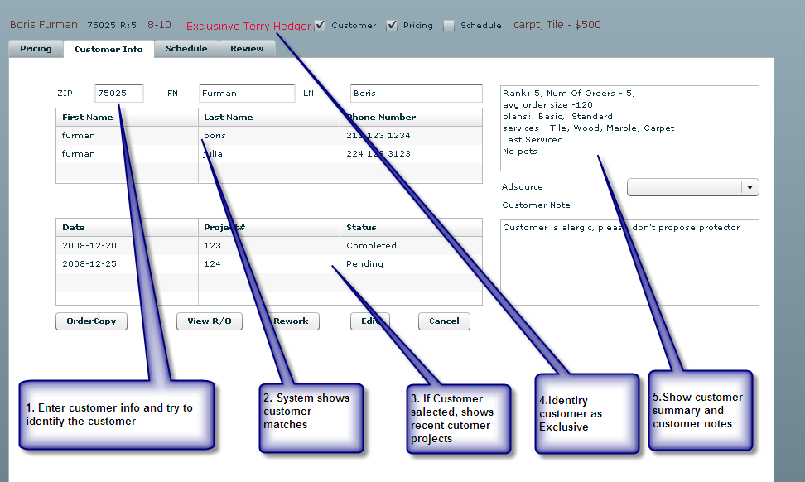
- Technician may collect all the customer info or move on to create pricing and then come back and finish this screen
- In any order customer technician may
  - Take information about customer order by executing use case UC- Create Project
  - Lookup a customer or create new customer
  - Look at what time available and schedule visit executing UC-Determine Time Availability. If UC-CreateProject is not executed yet, system shows available times considering 2 hour timeframe. Once UC-Create Project is executed, system must go through scheduling again and remember preferred time frame.

UC-Create project
- Sales rep goes to the price screen
- 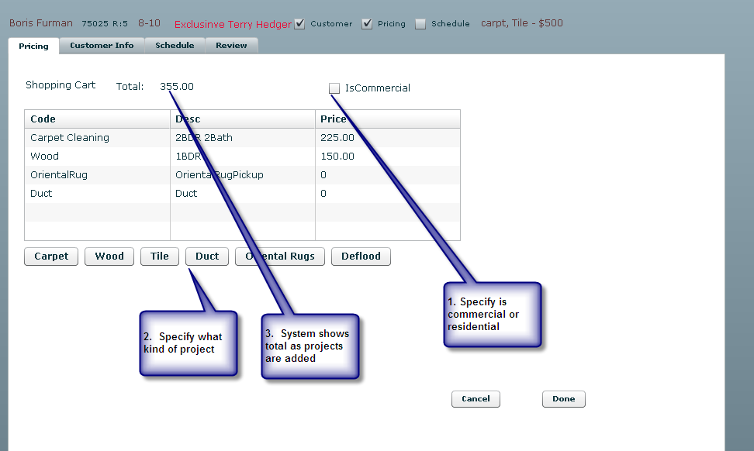
- Sales rep specify if it is commercial or residential customer
- Sales selects type of project and goes to configure that project
  - Execute UC-Configure Carpet
  - Execute UC-Configure Wood
  - Execute UC-Configure Tile
  - Execute UC-Configure Duct
  - Execute UC-Configure Oriental Rug
  - Execute UC-Configure Deflood
- After project is added , it is shown in the grid

UC-Configure Carpet
- Sales rep click on “Carpet”
- 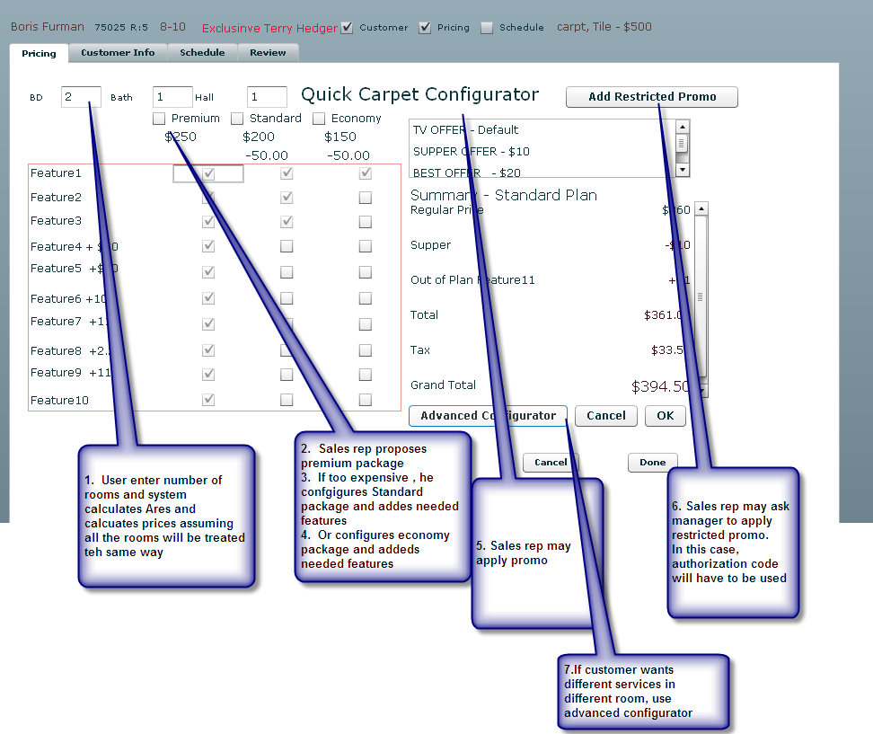
- Sales rep enter number of rooms and system calculates area and prices for different packages
- Sales rep proposes Premium, standard or economy based on customer history trying to up sell one step up
- Sales rep may apply promo based on how customer heard about Dalworth
- If sales rep feels he need to go lower on price , he asks manager for authorization to issue restricted promo
- IF sales rep wants to configure different features for different rooms sales rep uses Advanced Configurator
  - 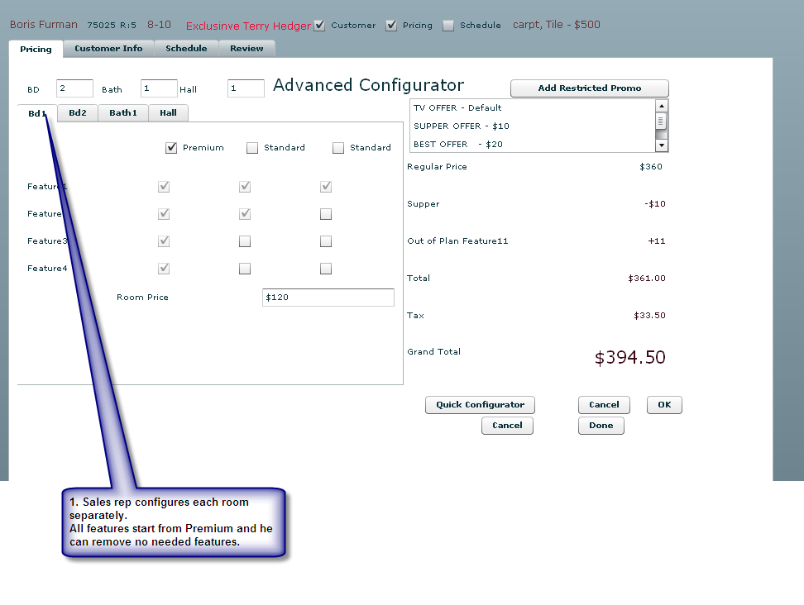

UC-Configure Wood

UC-Configure Rug

UC-Configure Tile

UC-Configure Oriental Rug

UC-Configure Duct

UC-Schedule Visit
- 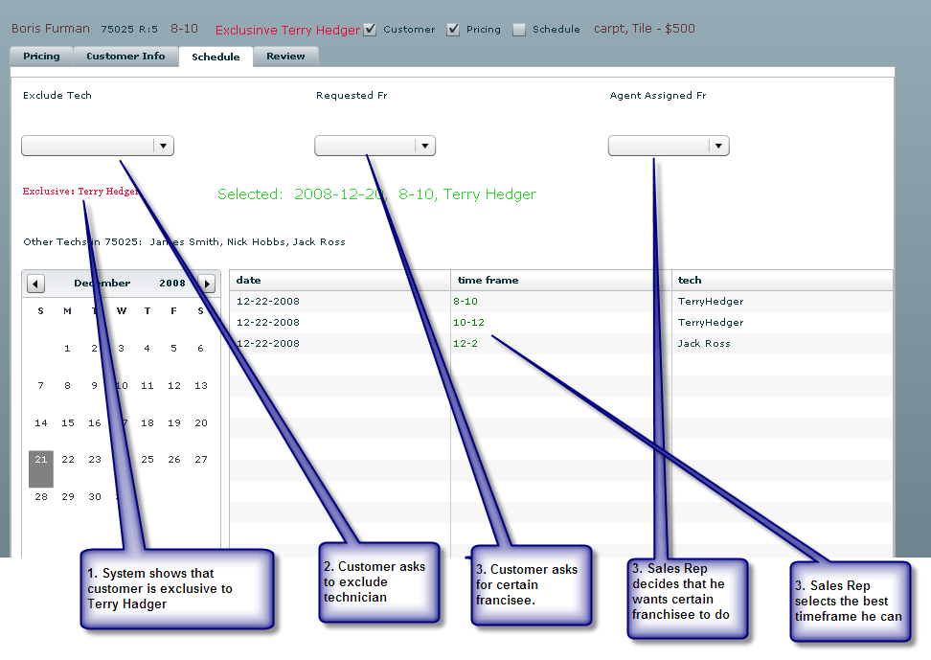
- Sales rep selects date that customer is asking and system shows him time frames 3 days before and 3 days after
- Sales rep may specify which technicians must be excluded based on customer request
- Sales rep may want certain technician do this job based on conversation with the customer
- Customer may ask for Franchisee by name
- System shows to Sales rep all the franchisees that can services this zip code
- System shows if this customer is exclusive.
- If Sales rep assigned a job to technician that is not exclusive, sales rep must write a note explaining why. Franchisee may or may not loose exclusivity depending on the reason
- If appointment is scheduled for same date, during phase 1, sales rep will just enter time frame based on what dispatcher has told him.

UC-Schedule Visit Manual – need elaboration
- Manager selects that he wants to make manual visit assignment and disregard smart schedule logic. Manual assignment tickets cannot be moved.

UC-Review Visit
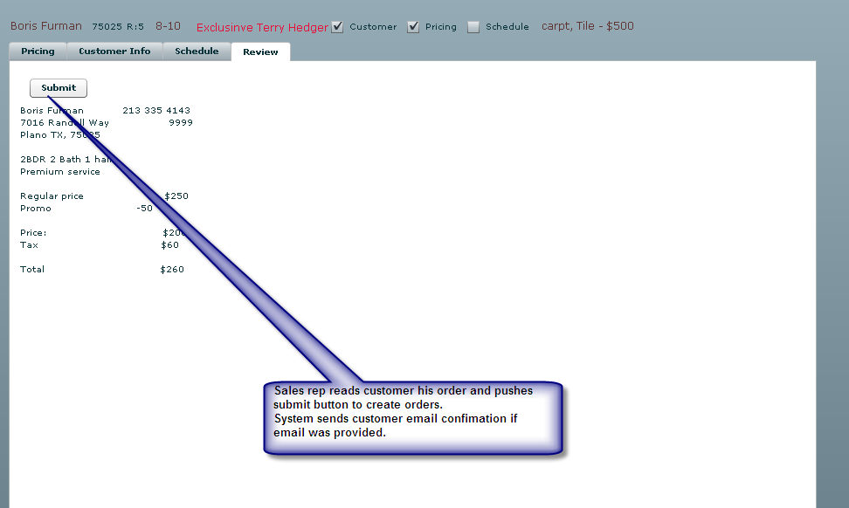
- Sales rep reads information back to customer
- Pushes “Submit” button.
- System shows Project numbers generated (may be multiple carpet, duct)
- System sends email to customer with the confirmation of the order.

UC-Order copy
- Sales rep selects previous complete order and asks to create new order
- Sales rep may come and modify all order parameters before submit

UC-Order Rework
- Sales rep must select completed project
- Sales rep selects “rework”
- System create new visit with all the information about the project.

UC-Edit Order
- Customer calls and wants to reschedule or modify his order or sales rep calls customer and want to modify or reschedule
- Sales rep can modify any order info and reschedule
- System must record who modified order, reason why and when

Manager Application description – need a lot of elaboration
Manager must be able to review dashboard and see how the jobs are scheduled

UC-Define Cells
Manager must which technicians he wants to see on dashboard together

UC – Define availability
Manager defines which technician’s available hours

UC- View booking status
Manager selects date and can see booking status how orders are shown on the board.

UC-Update status
Application must sync with Servman and check current date status every 5 min

??????

Servman synchronization issues that are not solved yet
- Create carpet cleaning order
- Import information about exclusivity of customers
- Import customer rank
- Order rework
- Create duct cleaning order
- Notify Servman that customer became exclusive to franchisee
- Notify Servman that franchisee lost exclusivity
- We assume that all pricing will come from smart schedule. No pricing data will be taken from servman
- ????? Need to make sure list of complete
- All orders from public site will be put manually into smart schedule. If time frame requested cannot be worked out, customer service will contact the customer to modify time frames.

Phase 1 scope
- All scheduling decisions – new orders, reschedule, cancel, failed will be done by Smart Schedule, Servman functionality will not be used
- Dispatch, close orders , synchronization with accounting will be done by Servman
- If Dispatcher will need to reschedule order , he will have to use Smart Schedule
- If Sales rep needs to schedule a job for today/tomorrow, Sales rep will check with dispatch and dispatch will tell him what time to use
- Smart Schedule will build Servman queues for today/tomorrow automatically. Dispatchers will not have to build queues
- Smart Schedule would allow printing of tickets for each technician for today and tomorrow. So dispatchers will not need to think where to put them on board
- Franchisee web site will be unchanged.
- Customer web site will be unchanged

Iterations

First iteration -3 weeks

Hours?

Tasks
- Elaborate phase 1 requirement to make it as close to final as possible
- Identify all the communication with Servman and needed for phase 1 and implement them utilizing XML files as data sources
- Create all possible GUI flow prototypes for sales rep module and approve user experience with Dalworth
- Design scheduling algorithm and test it with historical data, document it and approve it with Dalworth
- Document pricing
- Design database changes and schema and agree for the phone phase

- Sales App Prototype

  - Create prototype for create new order and sync it with Servman. Prototype scope:
    - Assumptions:
      - Assume all technicians have the same hourly rate for all services
      - Only do 1 service – carpet cleaning in one price – basic
      - Manually enter number or areas
      - No exclusivity
    - Flow
      - Select customer
      - Select service. Initially Carpet cleaning basic
      - Enter number of areas (1, 2 , 1/5)
      - Calculate price
      - Calculate how long it would take to do the job based on technician rate ( same for all technicians $125 / h)
      - System looks at available technicians in this zip code and can do this job
      - System shows screen for timeframes that can be used. Green, Yellow, Red selected randomly
        - Time Frame (8-10)
        - Technician _ Terry Hedger
        - Rank - Green, Yellow , Red
        - Exclusive or not (for now by default not exclusive)
      - Sales rep selects any of the choices
      - System sync ticket into Servman
    - Management Prototype – needs elaboration
      - Manager has ability to look at the tech schedule and see this visit booked at his schedule
      - Modify dashboard to slide to show technicians
      - All technicians are on dashboard
      - Add dropdown that can be typed in , select technician and slide to his board
      - Dashboard should reflect the length of the visit

Second Iteration - 3 weeks
Deliverables:
Working application with partially implemented algorithm
Goals:
- Partially implement scheduling algorithm. Take into account exclusivity rules, moving rules but not distance rules
- Design pricing and implement pricing for carpet cleaning
- Elaborate phase 1 requirement to make it as close to final as possible
- Update code to do the following
  - Assumptions:
    - Different technicians have different rates on different operations
    - Support more than one service and sync them to servman
    - Manually enter number of areas
  - Flow
    - Select customer
    - Select service. Initially Carpet cleaning basic
    - Enter number of areas
    - Calculate how long it would take to do the job based on technician rate for each operations
    - System looks at available technicians in this zip code
    - System shows screen for timeframes that can be used. Green, Yellow, Red selected based on implemented alrorithm
      - Time Frame (8-10)
      - Technician _ Terry Hedger
      - Rank - Green, Yellow , Red
      - Exclusive or not (for now by default not exclusive)
    - Sales rep selects any of the choices
    - System sync ticket into Servman
    - Sales rep has ability to look at the tech schedule and see this visit booked at his schedule

Third Iteration - 3 weeks
Deliverables:
Goals:
- Scheduling algorithm completely implemented.
- Pricing completed implemented
- Elaborate phase 1 requirement to make it as close to final as possible
- Update code to do the following
  - Assumptions:
    - Different technicians have different rates on different operations
    - Support all services sync to Servman
    - Support entry of arias based on codes
    - Support advance carpet configurator
  - Flow
    - Select customer
    - Select services and determine prices (completely implemented)
    - Enter number of areas
    - Calculate how long it would take to do the job based on technician rate for each operations
    - System looks at available technicians in this zip code
    - System shows screen for timeframes that can be used. Green, Yellow, Red selected based on completed alrorithm
      - Time Frame (8-10)
      - Technician _ Terry Hedger
      - Rank - Green, Yellow , Red
      - Exclusive or not (for now by default not exclusive)
    - Sales rep selects any of the choices
    - System sync ticket into Servman
    - Sales rep has ability to look at the tech schedule and see this visit booked at his schedule

Forth Iteration - 3 weeks
Deliverables:
Production release of Phase 1 of smart schedule
Goals:
- Scheduling algorithm completely implemented.
- Pricing completed implemented
- Elaborate phase 1 requirement to make it as close to final as possible
- Integration into production, do dry runs and tests to make sure everything’s woks.
- Last minute changes
- Create requirement doc for phase 2
- Update code to do the following
  - Assumptions:
    - Implement Reschedule
    - Implement Cancel
    - Book rework from original visit
    - Different technicians have different rates on different operations
    - Support all services sync to Servman
    - Support entry of arias based on codes
  - Flow
    - Select customer
    - Select services and determine prices (completely implemented)
    - Enter number of areas
    - Calculate how long it would take to do the job based on technician rate for each operations
    - System looks at available technicians in this zip code
    - System shows screen for timeframes that can be used. Green, Yellow, Red selected based on completed algorithm
      - Time Frame (8-10)
      - Technician - Terry Hedger
      - Rank - Green, Yellow , Red
      - Exclusive or not (for now by default not exclusive)
    - Sales rep selects any of the choices
    - System sync ticket into Servman
    - Sales rep has ability to look at the tech schedule and see this visit booked at his schedule
  - Implement Management application so that manager can see dashboard for many cells. Need to discuss tomorrow exactly how it should look like

