Existing application steps
Todo:
Add picture of web site that shows schedule of each franchisee for exclusive customer
Need to make pictures of scheduling exclusive customer to another technician and see how he will be notified that exclusivity is lost.
Figure out what is missing from here.

Questions:
What is keep it clean? How does it have any effect
Customer rank. How it is calculated and what effect it has

- Sales rep selects new carpet cleaning order
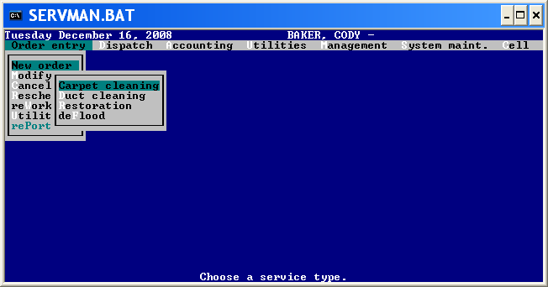
- Sales rep selects Residential carpet cleaning order
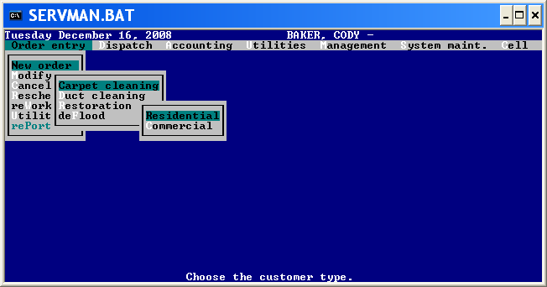
- Enter zip code.
- System shows franchisees that can do the job in this zip code
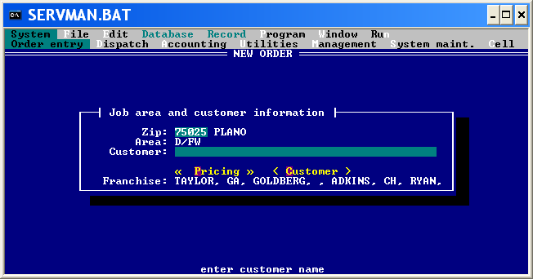
- Select a customer
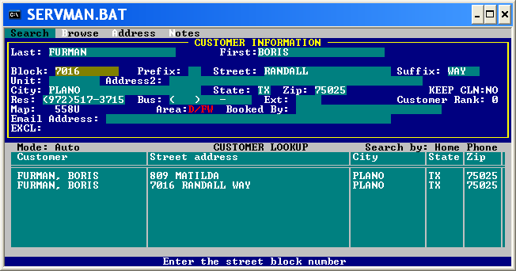

- If customer is not exclusive, select existing visit and try to book visit closest to the existing visit
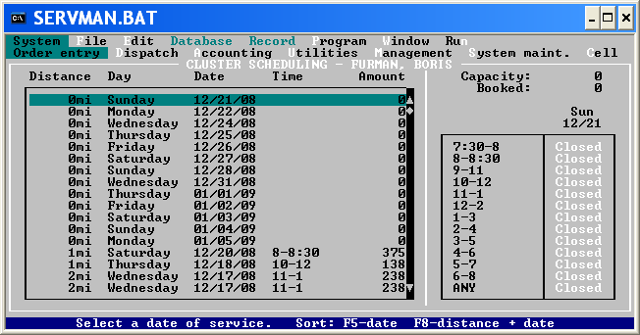
- If customer is exclusive
  - Look if time frame is available
  - Look at the web site make sure that exclusive franchisee has opening in the time frame requested
- If customer requests franchisee by name, use ad source REF/Tech and specify franchisee
- If sale rep wants this franchisee to do the job, use ad source REF/Agent and specify franchisee
- Select time frame
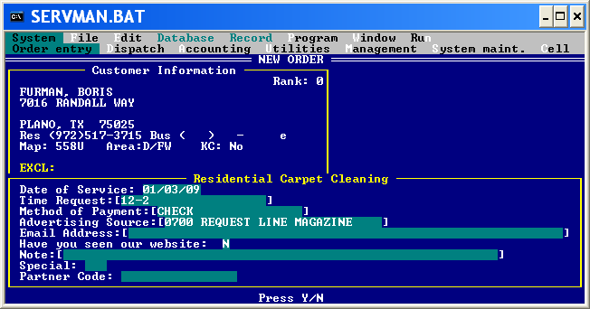
- Select pricing and services
  - Select type of service
  - IF carpet cleaning, select description that calculates number of areas
  - Select pricing plan
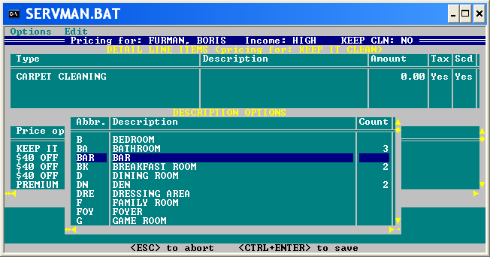

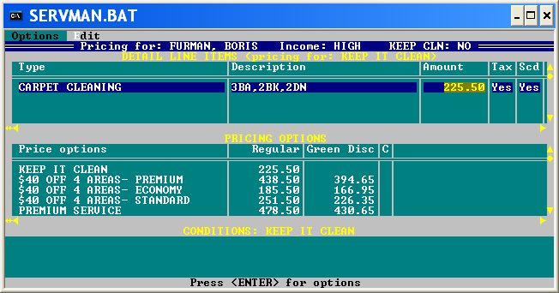

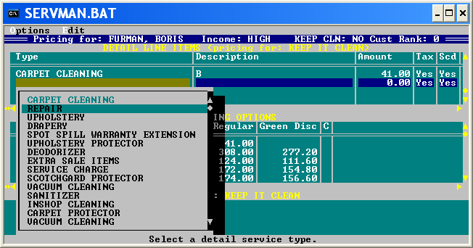

- Add other services to the same customer like duct cleaning, rug pickup or end
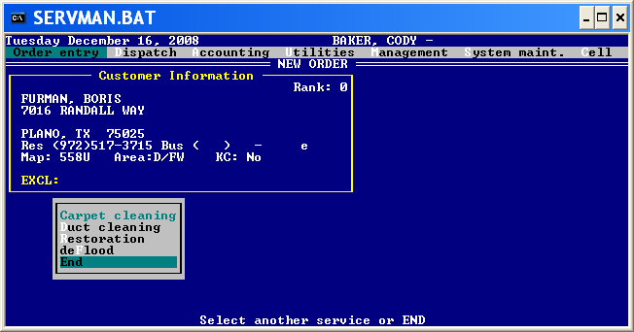

Customer rank – Once a year Dalworth makes query to get all customers that had service in the last 5 years order by money spend desc

They take customers that may top 20% of revenue and make then Rank5, … Rank 1.
This info is imported into Servman and is not used only shown.

Keep it clean – no logic associated now with it.

Dispatcher responsibilities now:

- Confirms today’s / tomorrows visits
- Puts tickets on boards
- Builds queues based on how tickets are put on board
- Dispatches jobs. Some Franchisees dispatch jobs themselves via web site. Contractors never dispatch jobs
- Marks ETC. Alternatively ETC can be updated via web site or auto dialer
- Monitors ETC. If he sees that technician is late, calls customer and reschedule technician for the same date. Trying to put at the same time
- If needs to reschedule for next date, transfers it to customer service
- Puts notes on tickets – need to figure out what we do with notes.
- Looks if he can call a customer and reschedule him to get better schedule

