Servman tables used
hresi_cc, custmast, h_order, ad_src, contmast, spec_hd, h_reject, dresi_cc, techschd

Open Questions
- Rework – how to do it.
- Add commercial customer screen
- Exclusivity , how it is shown
- Ordering
- Duct cleaning. Looks like Extra Sale Item, Central Vacuum system and Air Purifier has the same description item selection. Is this true?
- Duct Cleaning – Video camera inspection. Is this a separate service? Can technician go do video camera inspection and charge for it without doing duct cleaning? Do we need to select Video inspection pricing option?

Tables that are important
AD_SRC – list of ad sources
Acronym | Short name
Description | Description of the table
Group id | Grouped into type of adsource – TV, Internet , etc. Informaiton is located in ad_group table
AREA_ID | Which area this ad source apply
ID_CODE | Used in tables to say that this adsource is selected. Pretty much PK
Active | If active
ReferTech | 0, 1, 2 – 0 technician is not allowed, 1 technician is required, 2 – technician is optional
Techrefer | True if technician is possible for this ad source. Show list of names with it
Expc_flag | After order is booked , franchisee would become exlusive to the selected Franchisee even before job is completed. Even if customer was exclusive to the other franchisee
Custmast
Cust_stat | C – customer , P – prospect. Prospect if customer only booked lost appointment but never created any jobs.
WebVisit | During order , csr asks if customer ever seen web site. If he is, T,
CleanNum | Partner number. From previous referral program.
NoEmail | Customer does not want email ads
Excl_cont | Franchisee that is exclusive for this customer. Company id of this franchisee Constmast.cont_id
Rank | 0-5 customer rank

Contmast - list of companies that represent technicians. Company may have 1+ technicians.

Cont_id | Contractor company id. This is what is used on custmast to say that the customer is exclusive
Area_id | Area where this company provides service
Cont_type | - Independent (contractor), 2 – Dalworth (employees of Dalworth itself, now only 1 person) 3 – Franchise
Primary_tech | Primary technician id from techmast that is shown on customer order screen to show who is exclusive for this customer.

Techmast – list of technicians belonging to the company

Area – defines areas – dallas, houston, Austin, grason county
Area_id
Name
Rcc_min | Minimum price for Residential carpet cleaning order
DC_MIN | Duct cleaning minimum price

Zip_data – connects zip code with area and Mapsco book
Zip
Area_id | Area
Mapbook
City
State

Company – list of companies – Dalworth companies
Company_id | Id of the company
Long name
Short name

Techschd – technician schedule for each day. Promise field shows how many jobs he promised to do.

Tech_zip connection between contmast and zip codes they are assigned
Tech_id | Technician id from techmast that can service this zip code
Zip | Zip code
At_large | T – this franchisee assigned to this area “AT LARGE” meaning it is not his area but he can do it if nobody else with At_large = ‘F’ not available.  F – it is his area
Cont_id | Contractor id from cont_mast.cont_id

Servgrp – connects service to the area
Servrgp_id
Area_id
Longname | Name of the service
Servgrno | Service group number

Servtype – type of services – residential CC, commercialCC, duct, Deflood, etc
ServTypeId | Id
Long name | Name of service
Servrgp_id | Service group id – connection to service group
Company_id | Connection which company to use.

Pricing tables
RCC_DT – detail item form Residential carpet cleaning

TYPE | Name of the option
TYPE_ID | Type_id is used on d_resi to specify which option
BOOK | T if booking agent can see it. If F then only accounting can see it
ACTIVE | If active or not
REVENUE | T if apply to revenue. No application for us now
APPLY2MP | T if Appy to minimum price. If false, the cost of the item does not apply to the minimum price
EXTRASALE | T then it is extra sale item. For reporting purposes
SERVCHARGE | If T then this item is a service charge
DEFCOMM | Default commission. Not applicable now
INVPICKUP | T if this item is an inventory pickup item
CF_SPOTCLN | Care free spot clean keep , not applicable
CF_FILTER | Care free filter. Not applicable
GROUP_ID | Relates to group table but has no meaning
SCHDDISC | T If this item apply to schedule discount.
INTERNET | If this item visible on the internet
VISIBLE | If this item visible on the intenet
DEF_DESC | Default description Describes what exactly this item is about
NOTES | Shown in the internet
WEB_NAME | Internet name

CCC_DT – detail items for commercial carpet cleaning
Dc_dt - detail items Duct cleaning
Df_dt - detail items Deflood

Auto_prc – list of items that are autpriced
SERVTYPE | Servtype.ServTypeId
DTSERVTYPE | TYPE_ID from RCC_DT or CCC_DT or DC_DT or DF_DT depending on SERVTYPE value

Unit spec – list of options shown in the dropdown for auto priced items. Need to check for auto_prc table if the item is autopriced before show dropdown
SERVTYPE | Servtype.ServTypeId
DTSERVTYPE | TYPE_ID from RCC_DT or CCC_DT or DC_DT or DF_DT depending on SERVTYPE value
AREA_ID | Area of service
ABBR | Abbreviation. Shortcut name
DESC | Description of the choice
UNIT_SIZE | How many units this item means.
UNIT_PRICE | Price per unit. Not used here
Internet | If shown on the internet
Note | Full descriptin
Order | Order shown in the drop down box
SCHDDISC
AREA_ID | Area.area_id
SCHED1 | Percent amount of sched1 discount
SCHED2 | Percent amount of sched2 discount
SCHED3 | Percent amount of sched3 discount
INETDISC1 | Interenet Disc 1 percent amount (orders from internet get higher percent) not used
INETDISC2 | Interenet Disc 12 percent amount (orders from internet get higher percent) not used
INETDISC3 | Interenet Disc 1 percent amount (orders from internet get higher percent) not used
DAYSADV1 | Days in advance to apply discount 1
DAYSADV2 | Days in advance to apply discount 2
DAYSADV3 | Days in advance to apply discount 3

PRC_SPECIAL – define basic prices per unit
SERVTYPE | SERVTYPE.SERVTYPE_ID
DTSERVTYPE | TYPE_ID from RCC_DT or CCC_DT or DC_DT or DF_DT depending on SERVTYPE value
AREA_ID | Area.area_id
DESC | Description
Price | Price per unit

SPEC_HD - definition of specials ( in reality price plans)
SPEC_ID | Id of the special
NAME | Name of the special
SERVTYPE | Servtype.ServTypeId
AREA_ID | Area.AreaId
DISPLAY | TRUE If displayed on default selection. If item is active but display is False, then user has to click S to show all and then this special will show.
START | Start date. If not set, then use display to use it or not
END | End date
SCHED1 | 0 not allowed , 1 allowed, 2 mandatory
SCHED2 | 0 not allowed , 1 allowed, 2 mandatory
SCHED3 | 0 not allowed , 1 allowed, 2 mandatory
ACTIVE | T if active
REPLACED | When spec is updated, new records and created and original is marked as replaced
P_ORDER | Order shown in the list (display order)
USE_MP | Use minimum price. Need to figure it out
CARE_FREE | If this special can be used for Keep it clean items.
INTERNET | F if cannot be used on the interente
IMAGE_FILE | Not important
DESC | Description
PACKAGE | Only used for reporting. Indicates which package it is part of

SPEC_DT – detail of the special.
SPEC_ID | SPEC_HD.SPEC_ID
DTSERVTPE | TYPE_ID from RCC_DT or CCC_DT or DC_DT or DF_DT depending on SERVTYPE value
NUM_UNITS | How many units needs to be used to be able to apply this discount
MIN_PRICE | Minimum price of the item to apply this discount
UNIT_FREE | How many units you get free (clean 5 units and get 1 free)
PERC_OFF | Percent off for this special
A_OFF_PRC | Amount off unit price
A_OFF_UNIT | ???
FIX_PRICE | fix price for special. This is the price used for the special.
IN_ADJ | NOT USED
APPLY_ADJ | NOT USED
ALLOW_ADJ | NOT USED
CONDITIONS | Verbal description on what special includes
ADD_AMT | Additional rooms that are not part of special . For example 4 room for 100 and plus 30 dollar each add room.
ADD_PERC | Add this pct to additional room
DESC | Description

Orders
S_agent – list Agent for commercial job.
S_agent | Agent id
Agent_name | Name of the agent
Active | Active or not

h_order
 |  | NEW
TICKET_NUM |  | X
CUST_ID |  | X
ALT_ADDR | T if m_alt_ad contains alternative address
CONTACT | Last name and frist name from commercial CC customer screen | X
DATE | Service date | X
TIME | Service time | X
PAGE | Mapsco page | X
GRID | Mapsco grid | X
AREA_ID
SERV_TYPE | 1 – Residental Carpet cleaning, 2 – Duct Cleaning, 4- Deflood, 5 Commercial
TRAN_TYPE | 1 – ORDER 2- REWORK 3- LOST APP 4-ESTIMATE
COMP_TYPE | - Not completed, ,1-Normal, 2- Cancel, 3 - Converted (for Estimate), 5 – Expired (Estimates and Lost app)
COMPANY | Company assigned to do it contmast.contid
TECH_ID | Check assigned
AMOUNT | Closed amount
TRAN_STAT | Status – 1 – PENDING, 2- ASSIGNED, 3 – DISPATCHED, 4- CALLBACK, 5 – COMPLETED, 6 – ACCOUNTING 7 – CLOSED
CLOSER_ID
RECVE_AMT | Received amount from customer
PR_DATE | Payroll date
ZIP
BOOKBY | BOOKED BY field (text entry in customer screen)
MAPBOOK | Zip_data.dbf link
REMCALL
COMPANYID | Company table. What type of company.company_id
ORDER_CONF | If customer received email for order confirmation
CANC_CONF | Cancel confirmation . Order was cancelled, if email confirm cancel was send
RSCHD_CONF
DONE_CONF
QT_REQSTED | Quote requested. Lost appointment was booked. Customer requested email information about quote to him.
QT_DONE
QT_CONVREQ
CLEANCNUM | Partner number from misc screen.
SURVEY_REM
E_OFFER
REMINDER
EXP_CRED | Exclusivity. ‘T’ if when tech did the job, he was exclusive
DONE_EREF
S_AGENT | Account managers for commercial jobs

Excl_log – log of exclusivity changes

LOG_DATE | When
LOG_TIME | Time
TICKET_NUM | fOptional ticket number that caused change of exclusivity
CUST_ID | Customer
TECH_ID | Tech_id – technician that caused change of exclusivity
CONT_ID | Contractor that has customer exclusive
ACTION | A – added – U – unassigned exclusivity
CAUSE | ??
MADE_BY | Dispatcher name rights.username
REASON | Reason for switch

H_REJECT - describes when ticket is rejected, to which ticket it is changed.
TICKET_NUM
REJECT_TKT
D_COMPLAIN
COMP_TYPE
D_COMPLETE
COMMENTS
DESCRIPT
TRAN_TYPE

h_resi_cc
TICKET_NUM | Ticket number
CUST_ID | Custmust.cust_id
REJECTED | 1 – job has rework assigned. (reworked)
TRANS_NUM | TICKET NUMBER OF REWORK OR CONVERTED ESTIMATE
CSR_ID | Rights.dbf – who booked the order
AD_SOURCE | Ad_src – add source
ALT_ADDR | T if m_alt_ad contains link to alternavity address
TECH_REFER | Technician that was selected in ad source. Will get exclusivity
D_1st_CALL | Original order date
T_1st_CALL | Original order time
D_SCHEDULE | Service date
T_SCHEDULE | Service time . From timeslot.dbf’
D_DISPATCH | Date dispatch
T_DISPATCH | Time dispatch
D_COMPLETE | Date complete
T_COMPLETE | Time complete
TRAN_TYPE | 1 – ORDER 2- REWORK 3- LOST APP 4.ESTIMATE
TRAN_STAT | Not completed, ,1-Normal, 2- Cancel, 3 - Converted (for Estimate), 5 – Expired (Estimates and Lost app)
COMP_TYPE | 0 Not completed, ,1-Normal, 2- Cancel, 3 - Converted (for Estimate), 5 – Expired (Estimates and Lost app)
CANC_TYPE | Cancel type 0 – not cancelled,1 - not cancelled, 2 – Technician , 3 – Customer
MOP | Method of payment. Key to mop.dbf
AMOUNT | Closing amount (before tax)
RESCHED_NUM | Number of times order rescheduled
COMPANY | Contmast.cont_id – contractor who did the job
TECH_ID | Technician who did the job techmast.tech_id
B_PERSON | User id from rights.dbf who booked the order
L_PERSON | User id who last modified job from rights.dbf
C_PERSON | User who cancelled the job rights.dbf
NOTE | Notes printed on ticket
SPECIAL1 | Not used
GRADE | Not used
TAX_PERC | Coty_tax.dbf - tax percent
SPEC_ID | Spec_hdr.spec_id – price plan used
SD_NAME | Schedule discount name – SCHED1 or SCHED2 if discount applied otherwise LIST_PRC
SD_AMT | Schedule discount amount if schedule discount is applied
MIN_PRC | Minimum price applied
MP_USED | T if minimum price was used
BTID | ??
COMPANYID | Foreign key to company.dbf
COMP_REFER | Company referred. Not used
REPEAT | ??
CC_NUM | Not used
CC_EXPDATE | Not used
DL_NUM | Not used
CC_EXPDATE | Not used
DL_DOB | Not used
AUTH_CODE | Not used
T_ARRIVAL | Time of arrival

Dresi_cc
TICKET_NUM
SERV_TYPE | RCC_DT.TYPE_ID type of the item
ITEM_NUM | Order item number
NOTE | Abbreviated for auto calc items from unitspec.dbf
Amount | Line item amount
EXEMPT | tax exempted. User can set it on pricing screen.
INFRAN | Not used
ORIG_BOOK | Was it from original booking. When accounting adds it , this field would be false. During booking always put ‘T’
COMMISSION | If tech got commission for this line item. Adjusted in accounting
ENTER_BY | B for booking A for accounting
AUTO_PRC | T if this detail is auto priced.
PRC_TYPE | U for unit price, I for item priced Item priced is not used. If no autopricing then put nothing.
NUM_UNITS | Number of units if unit priced
UNIT_PRC | Price per unit from prc_special
BASE_PRC | Not used
USER_ADJ | Not used
MANU_TYPE
MANU_AMT
PART_UNITS | Sum of unit priced items which is less than 1 unit. Not used.
APPLY2MP | T If applied towards minimum price.
SCHDDISC | RCC_DT.APPY2MP – if this detail apply to minimum price.
RS_COST | Entered during accounting.

timeslot.dbf
mop.dbf – method of payment.
City_tax – tax ratings per city

Exlusivity – NEED MORE ELABORATION
When new customer is assigned to franchisee and franchisee competes the job, the becomes exclusive. In this case custmas is updated, but order is closed as not exclusive (h_order.expcred = false). If new customer required technician by specifying ad source with expc_flag = ‘T” then order is marked as exclusive h_order.expcred = ‘T’
All other orders to this customer completed by this tech will be marked as exclusive orders h_order.expcref’T’ if tech still exclusive
When tech looses or gains exclusivity system records it in the table excl_log

Pricing

Each order detail can be either auto – priced or not. If item is not auto priced, then CSR must be able to enter the prices manually during order completion. If item is priced (defined in auto_prc table), pricing will be calculated by system based on number or areas it is provided. Each auto priced item has default price defined in prc_special table. When pricing special is selected and is defined for this item type, price will be overridden by pricing special.
Pricing special consists of header (spec_hd) and detail spec_dt. In addition to the pricing special , addition “Green” discount may be applied, Green discount is to make incentive to the customer to book 5 days in advance instead of now. The reason Dalworth wants to book them 5 days in advance because they want more flexibility to schedule them. However since they don’t really see schedule and it does not makes sense.
While pricing management system allows all kind of fancy way to setup price plans, in reality what is used is only a small subset of it.
Each price special can be define by
- Number of units affected by the special
- Number of units given free
- Price of the special – Fixed price
- Amount charged for each additional unit.
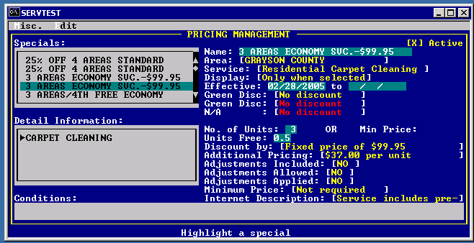
For example for the special called “3 AREAS ECONOMY SVC .-$99.95”
Header Info
- Name – name of the special
- Area – defined in Grayson county area
- Service – For residential carpet cleaning
- Display – only when selected, meaning that it will not be shown during ordering. Only when ALT+S it will show it in the list of options.
- Effective – when it starts and stops. If not stop, effective indefinite
- Greed discount – if green discount can be applied on top of this special.
Detail Info
- Special
If Residential CC order is priced less then area.RCC_MIN(minimum price), it will apply minimum price from RCC_MIN. Duct cleaning also has minimum defined at ared.DCC_MIN

Order creation

Order composition
Usually CSR books an empty order and then comes to screen where they go in any sequence to book different part of the order –
1. Customer – customer information
2. Order – information about order items
3. Misc – information like scheduling , ad source, payment, notes
4. Review is the report that customer is read before order is closed to make sure everything is correct.
4. After Customer, Order, Misc is completed, SRC can complete the order and save it as Order, Lost Appointment or Estimate
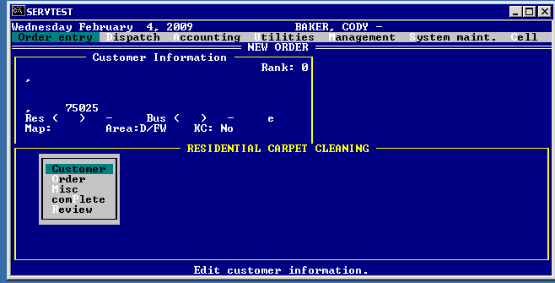

Booking new order

Initial screen
Fields of interest
- Enter zip code, customer name, system shows
  - list of franchisees that can service this zip code.
  - Area
  - Franchisees that can be service this area
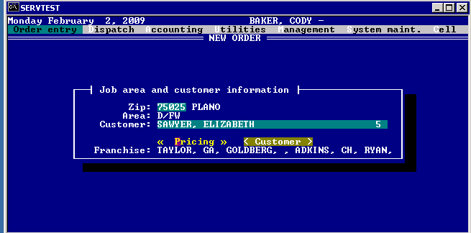

SQL:
SELECT cont_id from tech_zip WHERE zip = '75025' – get all contractor companies
SELECT prime_tech from contmast WHERE contId = 292
SELECT prime_tech from contmast WHERE cont_Id in ('292', '293')
SELECT tech_name from techmast WHERE tech_id = '716' – returns ‘Golbert Rick’

Customer

- System allows to either select existing customer or create new customer. If customer is exclusive, system shows which Franchisee it is exclusive for. Fields of interest
  - Keep CLN – not used.
  - Booked By – just can type anything and it ends up in horder. No real meaning
  - EXCL: Keck, Dennis – Custmast.excl_cont has id from techmast of primary technician from the company. Techmast has the name of the technician
    - SELECT excl_cont from custmast WHERE cust_id = '284064'
    - SELECT prime_tech from contmast WHERE cont_id = '298'
    - SELECT tech_name from techmast WHERE tech_id = '475' – returns ‘Keck, DENNIS’

  - Customer Rank – in custmast – calculated by batch process that runs 4 times a year. We can be notified when has run so we can update customers.
SQL:
SELECT * from custmast WHERE cust_id = '284064' – customer info
SELECT excl_cont from custmast WHERE cust_id = '284064'

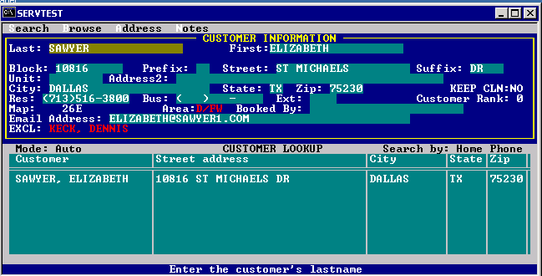

Misc
Information about ad source, service date, payments
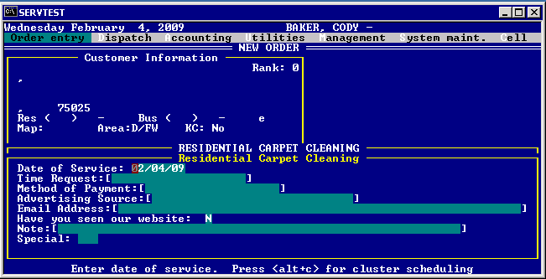
- CSR click on Date of serviced and system shows screen with Cluster schedule
- CSR selects date based on cluster schedule information
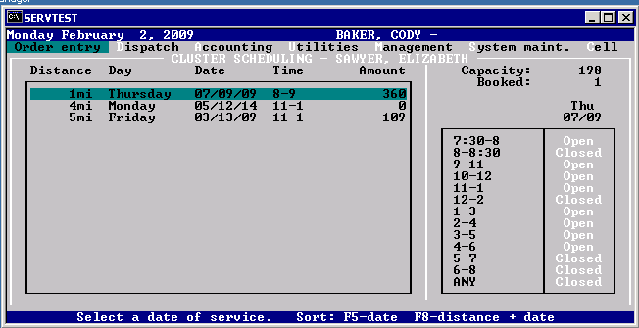
  - System shows dates with appointment close to that address
  - CSR selects and date and selects time frame based on if time frame is open or closed. Even if timeframe is closed , CSR still can select that date
- CSR selects ad sources. Some ad sources have special meaning.
  - Ad sources may allow to enter technician “ SELECT * from ad_src WHERE Techrefer = .T.”
  - For some ad sources, customer becomes exclusive after order is booked to selected Franchisee “SELECT * from ad_src WHERE expc_flag = .T.”
  - Some referrals allow you to enter technician. Some also if selected, make customer exclusive to this technician.
  - Active referrals in DFW that which customer exclusivity “SELECT * from ad_src WHERE Techrefer = .T. and Active = .T. and Area_id = 'D/FW' AND ReferTech = 1 AND Expc_flag = .T.”
    - REF CLEANER – customer has asked for technician by name
    - ONLINE ORDER – FRANCHISEE – customer booked order on franchisee web site
    - EREF7 – REFERRAL ONE ROOM FREE – franchisee sends email to some customers and they got it from email and asked for this franchisee

- Method of payment is not entered during booking
- Have you seen our web site – CSR is asking customer if he even been to the web site.
- Notes- notes left on the ticket
- Special – any 3 letter code can be put here. Not used for anything particular. Usually CSR puts OLO – online order ( they enter order from web site here manually) and OR for oriental rug.

Review
Customer is read order summary before completion
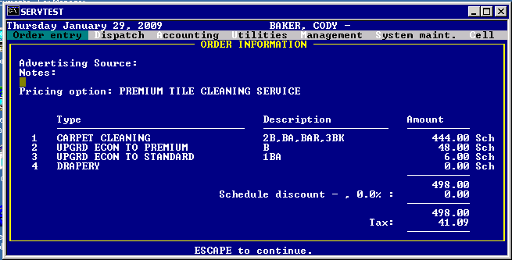

Order

Create new CC Residential order
Line items associated with CC Residential

Carpet Cleaning
Repair – repair of carpet
Upholstery
Drapery
Stop Spill warranty Extension
Upholstery Protection
Deodorizer
Extra sale items
Service charge
Scatchguard protection
Vacuum cleaning
Sanitizer
Inshop cleaning
Carpet protection
Vacuum cleaning
Ultra dry cleaning
Miscellaneous
Car interior
Inventory pickup
Edge / baseboard
Mini blind cleaning
Furniture moving
Drying fans
Hardwood cleaning
Tile cleaning
Marble cleaning
Preferred customer discount
Pet Treatment
Rugs
Upgrade Economy to Premium
Upgrade Standard to Premium
Upgrade Econ to Standard
On time guarantee
Keep it clean rooms
Keep it clean service
Dry steam cleaning
Portable unit
Onboard water – need to have our own water since customer does not have it. CC option
Concrete cleaning
Spotting kit
Hard Wood Refurbishing
Vinyl
Free spotting kit
Mattress cleaning
Free Room
Gift Certificate – sell gift certificate – goes with everything .

Service | Option | Description
Carpet Cleaning
 | Deodorizer
 | Scatchguard protection | Chemical protection
 | Vacuum cleaning
 | Sanitizer
 | Carpet protection
 | Ultra dry cleaning
 | Edge / baseboard
 | Furniture moving
 | Drying fans | Use drying fans as part of cleaning
 | Dry steam cleaning
 | Portable unit | Job requires portable unit (second floor, etc)
 | Onboard water | need to have our own water since customer does not have it
 | Free Room | Offer to clean one room free
Repair |  | Carpet repair
Upholstery |  | Couch , chair cleaning
 | Upholstery Protection | Chemical treatment
 | Mattress cleaning
 | Scatchguard protection
Drapery
 | Scatchguard protection
Stop Spill warranty Extension |  | Customer had warranty and got a spill, Dalworth will go and clean it for free
Inshop cleaning |  | Customer comes and Dalworth cleaning his car at Dalworth premises
Miscellaneous

Car Interior |  | Go to customer premise to clean his car
Inventory pickup |  | Go pickup some inventory items from customer site
Tile Cleaning
Marble cleaning

Pet Treatment

Rugs |  | Go to customer and clean rugs. Different from oriental rug that restoration is doing
Keep it clean service |  | Recurring service plan. Basically touch up.
 | Keep it clean rooms- auto priced
Concrete cleaning |  | Cleaning of concrete
Hard Wood Refurbishing |  | Send hard wood
Vinyl
Mattress cleaning

Hardwood cleaning |  | Clean hard wood
Mini blind cleaning

Options that can go with any service
 | Service Charge | Customer is out of range so Dalworth has to charge him extra
 | Preferred customer discount | Customer service manager must approve it
 | On time guarantee
 | Spotting kit | Give a way as promotion
 | Miscellaneous | Anything based on description
 | Gift Certificate | Sell gift certificate

- Create new order
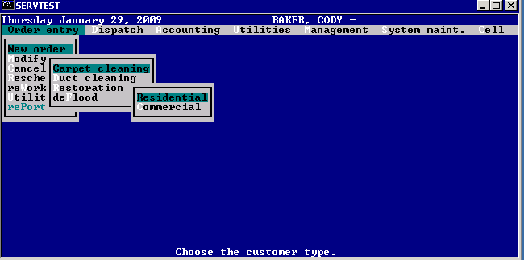
- Select carpet cleaning service
- Select number of areas to clean
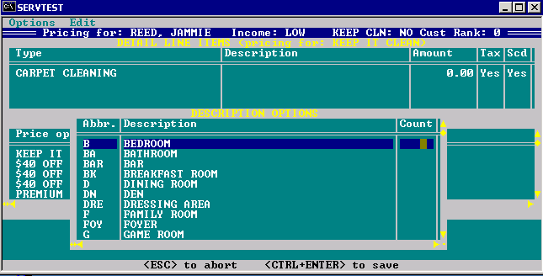
- System prices based on the first pricing plan shown. No logic here
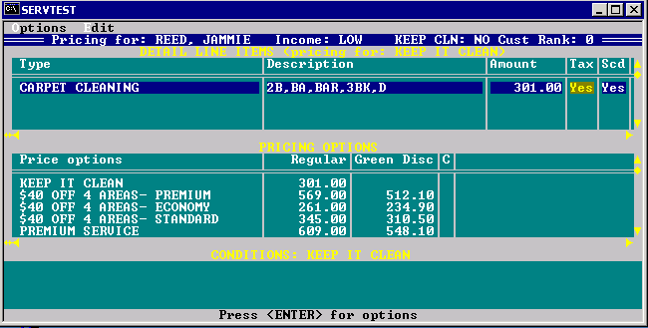

- Customer agent may change pricing plan. Only active plans are shown. Now “Premium option is selected”
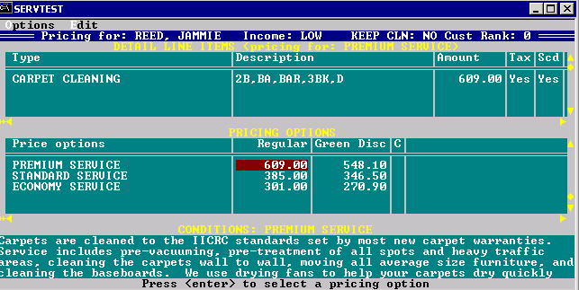
- Customer is asking to make only 1 bedroom premium , 1 bath standard and the rest economy
Servman requires that all the room be in the cheapest package and the rest are upgrades.
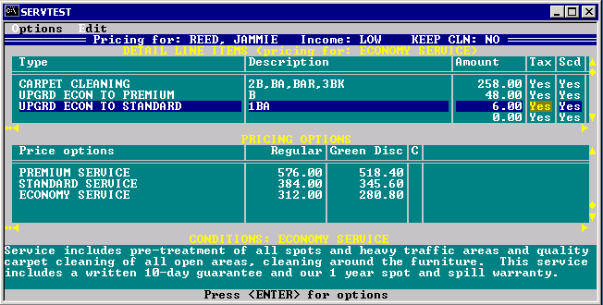
- Customer is asking to add extra service to the room that is not part of the package. System does not do any auto pricing.
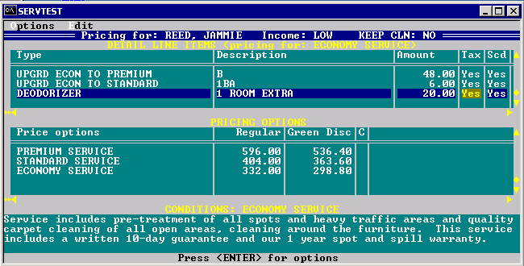
- Customer may ask for pricing plan that is not available any more. It can be selected by sales rep.
(ALT + S) Sales rep changes display from F to T. This pricing plan is only shown during this order.
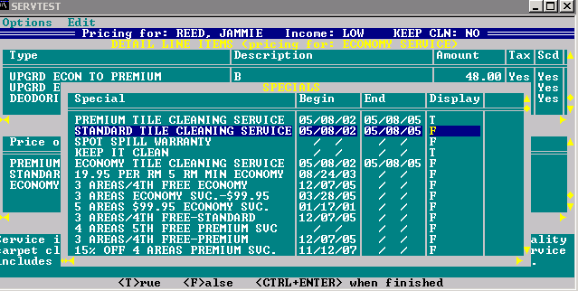

- Sales rep may add extra services that are not auto priced and put prices in it manually. Servman does not auto price any other service for carpet cleaning other then carpet cleaning.

Create new keep it clean residential order
Technician goes and does touch up. 35 is the charge for keep it clean plus $5 per area
- Select keep it clean service
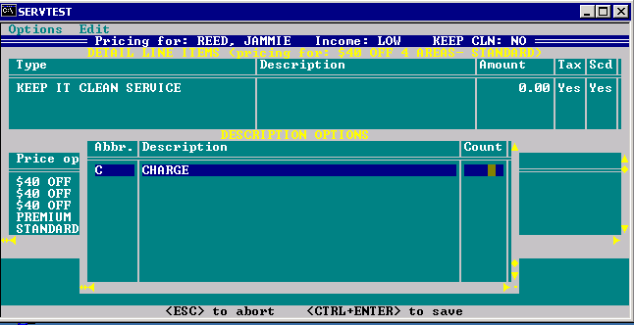
- Select 1 for charge, meaning 1 charge. Should never be anything other then 1.
- Select how many room to do keep it clean
- 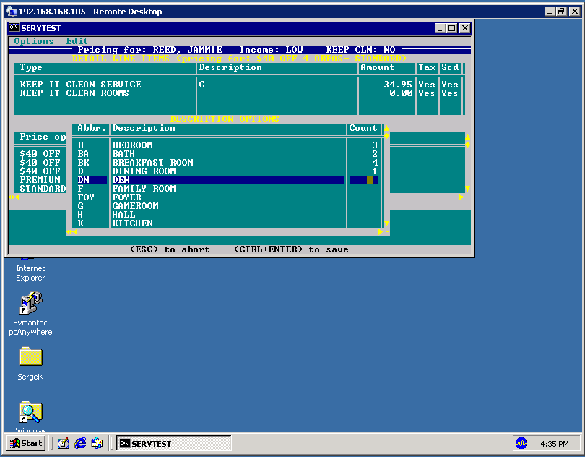
- Select price plan “Keep it clean”
- Keep it clean cannot be together with carpet cleaning.
- 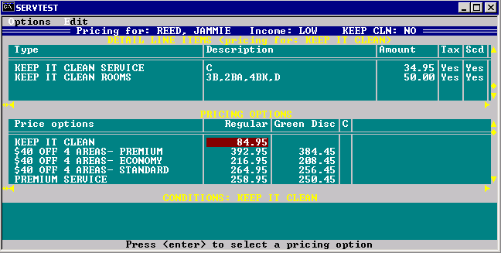

Create new commercial carpet cleaning order
Same as residential other then no auto price and pricing plans available. Prices are set by hand and usually booked as an estimate.
Once estimate is closed, then the price from the estimate is used to close the job.

Carefree spot cleaning – deprecated, not used.
Carefree filter cleaning – deprecated, not used
Master series carpet protect
Desenfectant

Carpet Cleaning
Repair –
Upholstery
Drapery
Upholstery Protection
Deodorizer
Extra sale items
Service charge
Scatchguard protection
Vacuum cleaning
Inshop cleaning
Carpet protection
Ultra dry cleaning
Miscellaneous
Inventory pickup
Tile cleaning
Marble cleaning
Portable unit

Service | Option | Description
Carpet Cleaning
 | Deodorizer
 | Extra Sale Items
 | Service Charge
 | Scatchguard protection
 | Vacuum cleaning
 | Carpet protection
 | Ultra dry cleaning
 | Portable Unit
Repair |  | Carpet repair
Upholstery
Drapery
Inshop cleaning
Miscellaneous
Inventory Pickup
Tile cleaning
Marble cleaning
Options that go with anything
 | Service charge
 | Miscellaneous

Create new duct cleaning order
If there are any lost appointments, estimates from carpet cleaning, it does not show up. If there is a lost app or estimate for duct cleaning, then it would show.
Systems and vents are autopriced.
Systems – number of ac systems in the house
Vents – number of vents in the hours.
Price is set per system.
+ Each went depends on pricing options.
Service | Option | Description
Duct Cleaning
 | Systems – Required, Autocalculated. Added only once | Number of systems to service
 | Vents – required, autocalculated  Added once | Number of vents in the house
 | Antimicrobal Treatment, optional
AIR PURIFIER
How is this used?
Can be added many times with different options.
Central vacuum cleaner system
Same options as AIR Purifier ?

` | Service charge | Traveling too far. Extra charge for coming
 | Extra sale item. | Extra item to be sold during visit.  Same as Air Purifier?  Brush  Filter  Mat  Pad  Rake  Revitalizer  Spotting kit  Vaccuum Cleaner
 | Miscellaneous
 | Inventory pickup
 | VIDEO camera inspection | Camera inserted in ducts.
Video camera inspection |  | Can be booked in its own visit.  Price option should be video camera inspection.

Create Duct cleaning order
- Add system and select number of systems
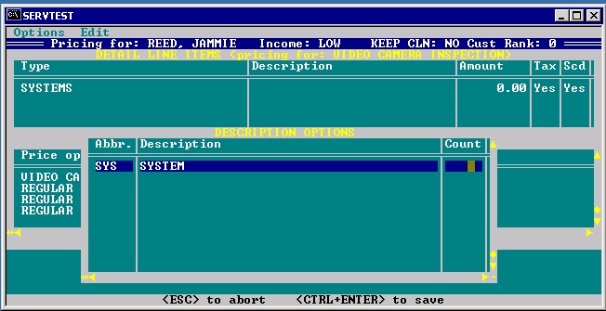
- Add vents
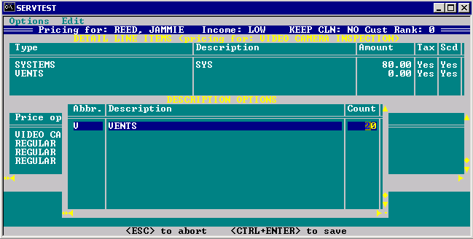
- Select pricing plan
Pricing plan modifies the price only per vent. The price per system stays constant.
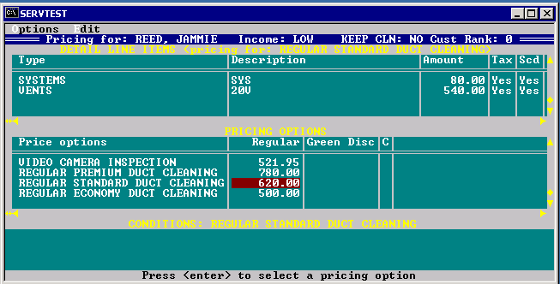
- Air purifier – description predefined, price is not autocalculated
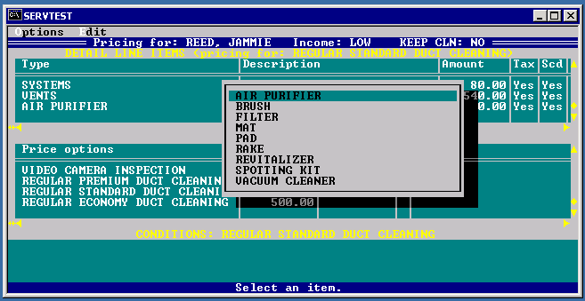

Create video camera inpection visit.
- Same thing other then only item is Video camera inspection and price option is selected video camera inspection., During order close, other items can be added like Duct cleaning and vents.

Order Completion

- Order is completed as either order , lost appointment or estimate.
- Lost appointment can be completed without all the required fields populated. Orders and estimates must have all the required fields populated.
- If order contains auto calculated amount (price was quoted to the customer) order most likely to close as order not estimate. If order does not contain any auto calculated amount, order typically is closed as estimate.
  - Lost appointment is a situation when customer did not like the price. Saved in case customer may come back
    - Make sure that it is lost appointment
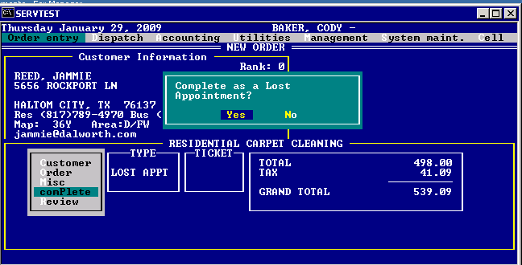

  - Estimate – customer needs estimate before committing to the job. Estimate can be converted later to job of cancelled
  - Order – customer wants to do the service. So it is closed as actual order

- System asks if another service can be created other than the one that already created or end
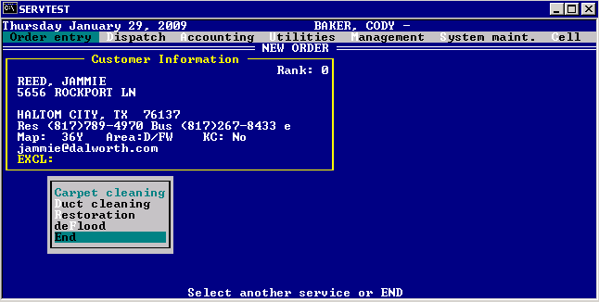
- Lost appointment can be converted back to the job or estimate.
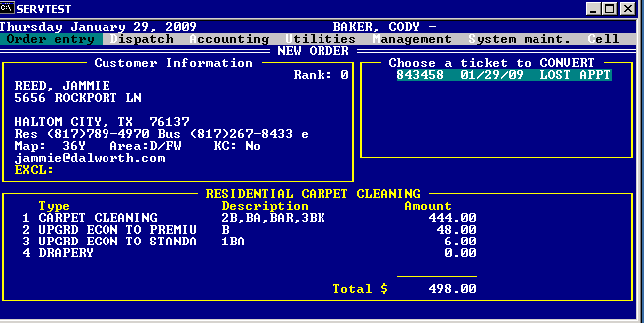

- Sales rep sees all the information entered on lost appointment and can add or remove things from it and close the ticket
- Lost appointment expire in 90 days
- If price plans change, Dalworth still apply prices on lost appointment.
- Sales rep may convert lost app to lost appointment, right now it creates new lost app. But it should update existing lost app.
- Sales rep may convert lost app to estimate
- Estimate completion
  - Estimate is scheduled and completed. When complete, dispatch gets a warning that it is estimate only
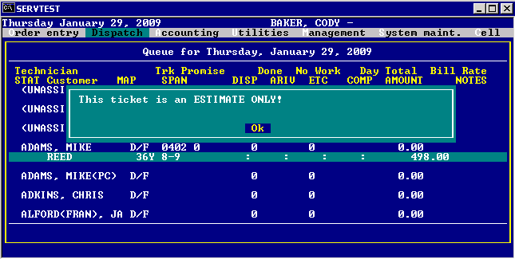
  - System is asking how to complete this estimate – Regular, cancel or reschedule
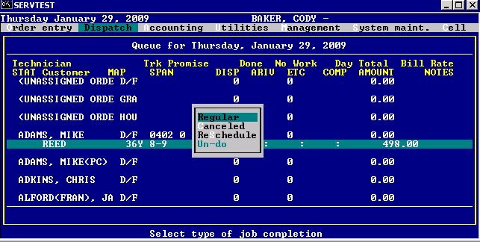
  - Estimate is completed
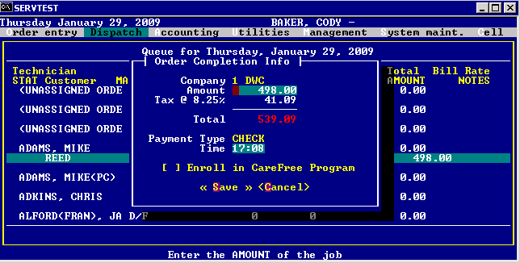
  - Dispatcher is asked if create order (meaning job is staring ) or not
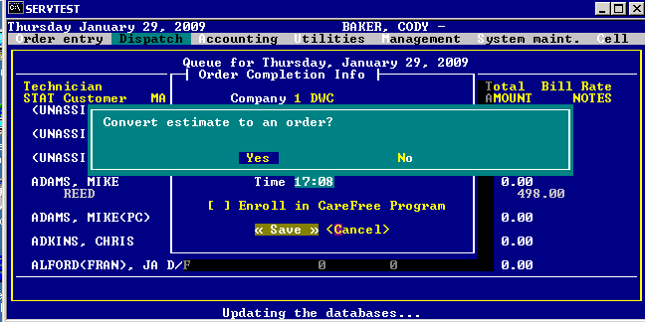
  - Dispatcher selects “YES”
    - TODO: Add pictures
  - Dispatcher selects “NO”
    - Estimate is closed but no job was done. Meaning customer rejected the job
    - If customer calls back and creates new order, estimate is shown in the list of option so customer service can select it end it and create order from it.

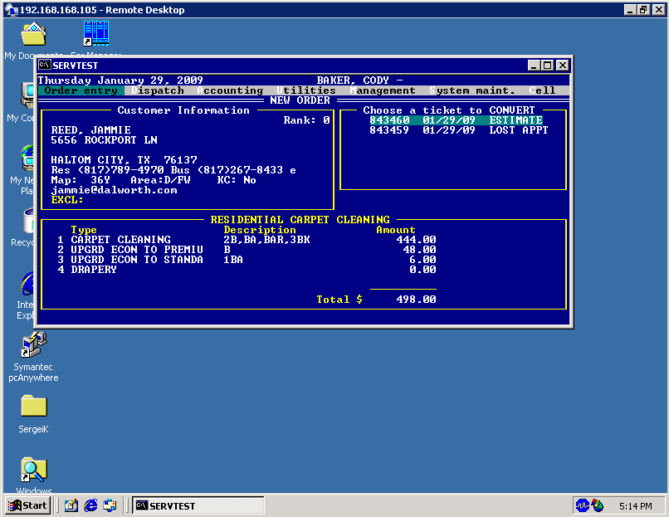

Order create sql
- Determine which company to use based on zip code provided
  - Find area from zip_data
  - Find which servgroup_id it is based on area and name of the service form servgrp
  - Find company select company_id from servtype where longname = ‘ResidentialCC’ and servgroupid =1

Order modify
Allows order modifications for all pending (not dispatched orders)

Order cancel
Allows to cancel orders for all orders that are not dispatched yet

Reschedule
Allows reschedule of non dispatched orders. Same as modify process. Just a short cut

Rework
Rework because customer complains. Rework may be assigned to any technician, not necessarily to the technician who did the job. Dispatcher tries to send the same technician. Accounting processes rework to take money from the technician that did the job originally and split it with the technician who did the rework.

